Music  Create your own musical instrument using materials from your house. If you have an old cardboard box you can make your own guitar.  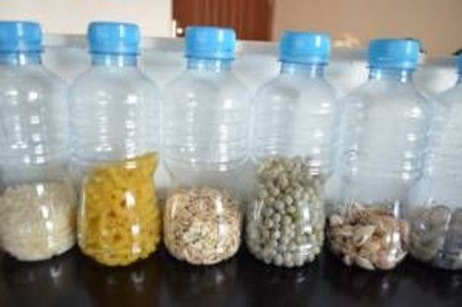  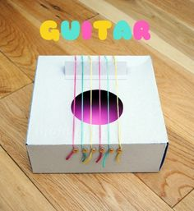 | Dance  Find out about different kinds of dances. Can you list 5 different kinds of dances? Ask an adult to let you watch videos of the dances and think about which one you like best.  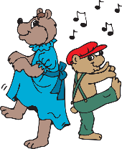 | Art  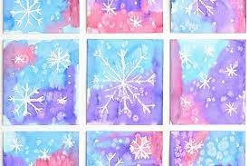  Create a winter scene picture using different materials that you can find in your house. You can use pens or pencils or anything else that you can find in your house.  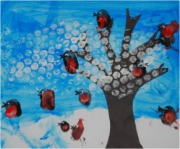
Drama  Act out your favourite story and perform it to someone else. Can they guess the story you are performing?  Put on a puppet show using different toys from around your house.  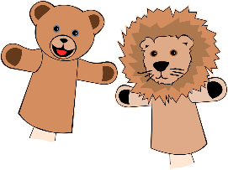 | Musical Chairs or Statues  Ask everyone in your family to join in a game of musical chairs.  Play a game of musical statues.  Dance to the music and FREEZE when it stops.  Each family member picks their favourite piece of music to play and everybody dances to each song. Be serious or silly. Which song did you enjoy dancing to the most? | Art  Colour Mixing  If you have paints at home, try mixing the colours together on paper. Before you mix each colour try to predict what new colour they will make.  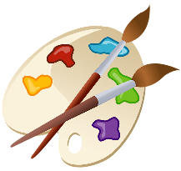  Mix together:  - blue and yellow  - yellow and red  - blue and red
Expressive Arts Activity Grid

