Moon Diary
LI: to observe and record the moon

Record what the moon looks like each night and what time you looked at it, draw a picture to show the shape of it.
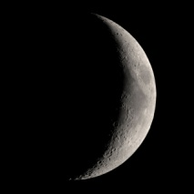
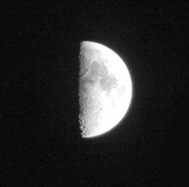
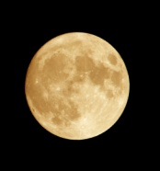
Full moon? Half moon? Crescent moon?

Date: | Date: | Date: | Date:
Date: | Date: | Date: | Date:
Date: | Date: | Date: | Date:
Date: | Date: | Date: | Date:

