Make Your Own Tartan Craft
This very messy craft gives children an idea of how tartan patterns are formed. If you are doing this as a group activity, provide a large collection of ribbons and fabric and you will be surprised how many different variations of tartan you will get!
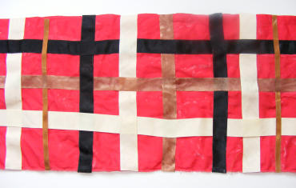
You will need:
Fabric
Ribbons
Fabric glue
Instructions:
Cut 3 or 4 lengths of ribbon the same length as your fabric and lots of pieces the length of the fabric width.
Glue the long pieces of ribbon along the length of the fabric.
Quickly glue the shorter pieces along the width weaving in and out of the longer pieces. The ribbons will be movable until the glue dries, so you will have to be fairly quick.
When your fabric is dry trim any overhanging ribbons.

Tartan Painting
Scotland is, of course, famous for its tartans. Why not have a go at designing your own with this tartan painting idea?
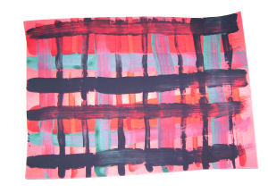
You will need:
Paper
Paint
Different size paint brushes
Instructions:
To create your very own tartan, simply use 3 or 4 colours and paint horizontal and vertical stripes in a grid pattern. Use different size paintbrushes so that you have different width stripes.

