Revision Sheet 2 – E***
- Write the number twelve.

- Write the number that comes before 12.

- What is the difference between 5 and 3?

- Add together 4 and 3.

- Tick the biggest number 11 5 17

- Tick the smallest number 15 5 19

- what is 1 + 5 + 4?

- Colour in half of this shape

- Colour in a quarter of this shape.

- I have 4 sweets. I gave half to my friend how many did I give to my friend?

- What is half of ten?

- Put these flowers in bunches of 2, how many bunches do you have?

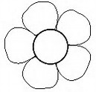

- Tick the £1 coin 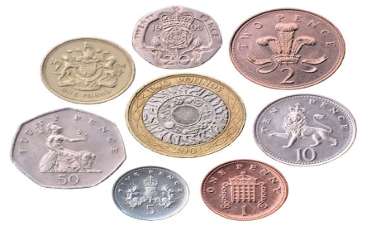

- Write the times shown on the clocks below

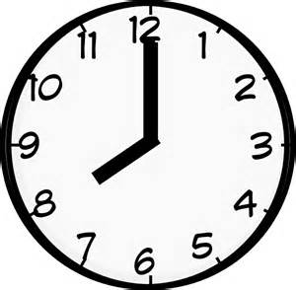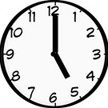

- Colour the longest pencil green and the shortest pencil blue.
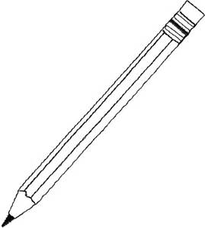

- The apple costs 7p. Colour the coins you would use to pay for the apple.
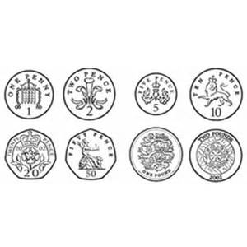
- Complete the pattern

