Revision Sheet – E***
- Write the number nineteen.

- Write the number sixteen.

- Write the number that comes after 12.

- Write the number that comes before 16.

- What is 4 add 3?

- Add together 3 and 7.

- Tick the biggest number 12 15 19

- Tick the smallest number 13 15 9

- what is 2 + 3 +6

- Colour in half of this shape

- Colour in a quarter of this shape.

- There are 9 apples and 3 bananas in the fruit bowl. How many more apples are there?

- There are 9 chimpanzees and 6 apes, how many more apes are there?

- Put these flowers in bunches of 4, how many bunches do you have?

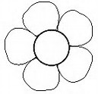

- Tick the 20p coin
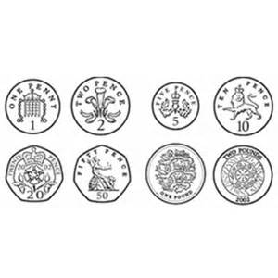
- Write the times shown on the clocks below

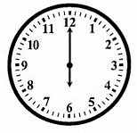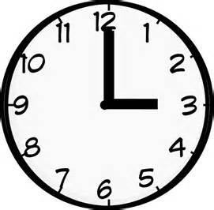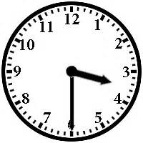

- Match the shape to its name.

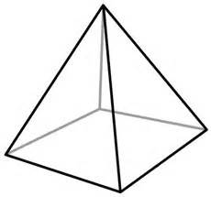
cube
cuboid
cylinder
pyramid
sphere

