Revision Sheet 18 – Level One*

1. There are 4 children at each table. There are 6 tables. How many children are there?
2. How many days are there in 2 weeks?
3. Draw one line of symmetry on this shape.
4. What coins do I need to make up 16p?
5. Double 6.
6. Find the difference between 20 and 7.
7. **_____** + 3 = 15
8. If 16 – 9 = 7, what is 16 – 7?
9. Complete the sequence: **32, 28 ,24, ___, 16, ___, 8, 4**
10. 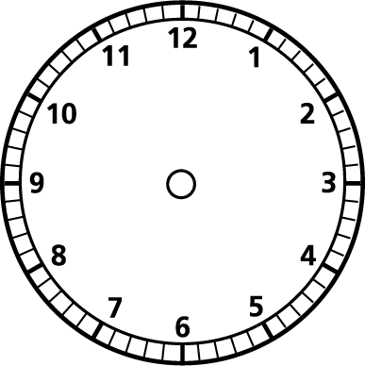Halve 6.
11. The clock says 4 o’clock. Draw the hands.
12. There are 18 children in a class. The class is split into 2’s. How many groups?
13. How many sides does a rectangle have?
14. Draw a rectangle?
15. Draw a triangle which does NOT have a right angle? (use a ruler!)
16. If you get 3 sweets in a pack, how many packs do I need to buy to get 15 sweets?
17. Find a quarter of 12.
18. Is **46** closer to 40 or 50?
19. If we have lunch at 12:00 and eat for 30 minutes, when do we finish lunch?
20. If I start school at 9am and have break at 10.00am, how long am I in class for?