Revision Sheet 17 – Level One*

1. List coins to make up 18p
2. Which month comes after December?
3. Name this shape.
4. How many right angles does this triangle have?
5. Share 25 between 5.
6. Find the total of ten and eight and two.
7. 17 + ___ = 20
8. Find the difference between 19 and 8.
9. Complete the sequence: **84, 74, 64, ___, 44, ___, 24, ___**
10. 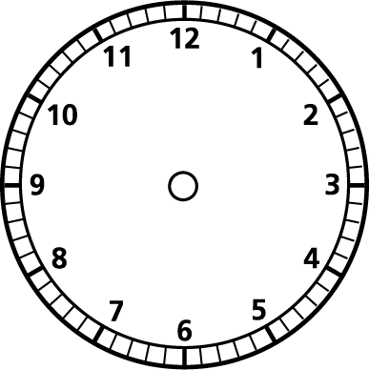Find half of 8.
11. The time is 10 o’clock. Draw the hands.
12. Draw a line longer than this one.  
    _______________
13. How many days are in July?
14. What change do I get from 20p if I spend 3p?
15. What is 2 lots of 7?
16. There are 24 children in P5 and they have to be split into equal teams of 4

How many teams are there?

1. What is double 7?
2. Is **64** closer to 60 or 70?

1. 14÷2=
2. 32÷4=