Revision Sheet 16 – Level One*

1. If you spend 12p, what change do you get from 15p?
2. Which month comes before April?
3. Name this shape.
4. How many right angles does this rectangle have?
5. Share 16 between 4.
6. Find the total of ten and nine and two.
7. 8 + ___ = 19
8. Find the difference between 17 and 6.
9. Complete the sequence: **82, 84, 86, ___, 90, ___, 94, ___**
10. 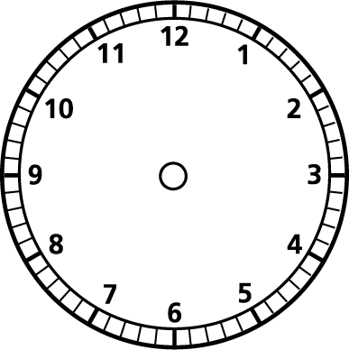Find half of 14.
11. Draw the time 6 o’clock on this clock.
12. Draw a line shorter than this one.  
    _______________
13. How many days are in January?
14. How much altogether? 20+1p=
15. What is 3 lots of 7?
16. Linsay has a cake and she cuts it into 4 equal pieces.

What fraction is each piece.?

1. Find a half of 10.
2. Is **98** closer to 90 or 100?

1. Which sport was the most popular with the girls?
2. How many boys and girls enjoyed swimming best?