Revision Sheet – E**
- Write the number nine.

- Write the number four.

- Write the number that comes after 5.

- Write the number that comes before 8.

- Tick the biggest number 3 5 8

- Tick the smallest number 3 5 8

- Add together 2 and 2.

- What is 5 take away 2?

- What is 3 less than 5?

- What is 1 + 2 +2

- Colour in half of this shape

- Colour in a quarter of this shape.

- There are 4 apples and 2 bananas in the fruit bowl. How many more apples are there?

- There are 5 elephants and 3 giraffes at the zoo how many more elephants are there?

- Tick the bigger shape

- Colour the rectangle

- Complete the patterns
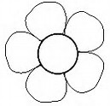

- Tick the 2p coin
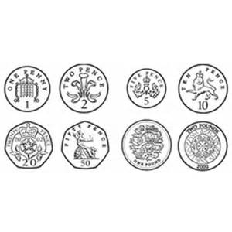
- Write the times shown on the clocks below

