vv

Make a word for each middle vowel sound.
Draw a picture to match each word.
 | 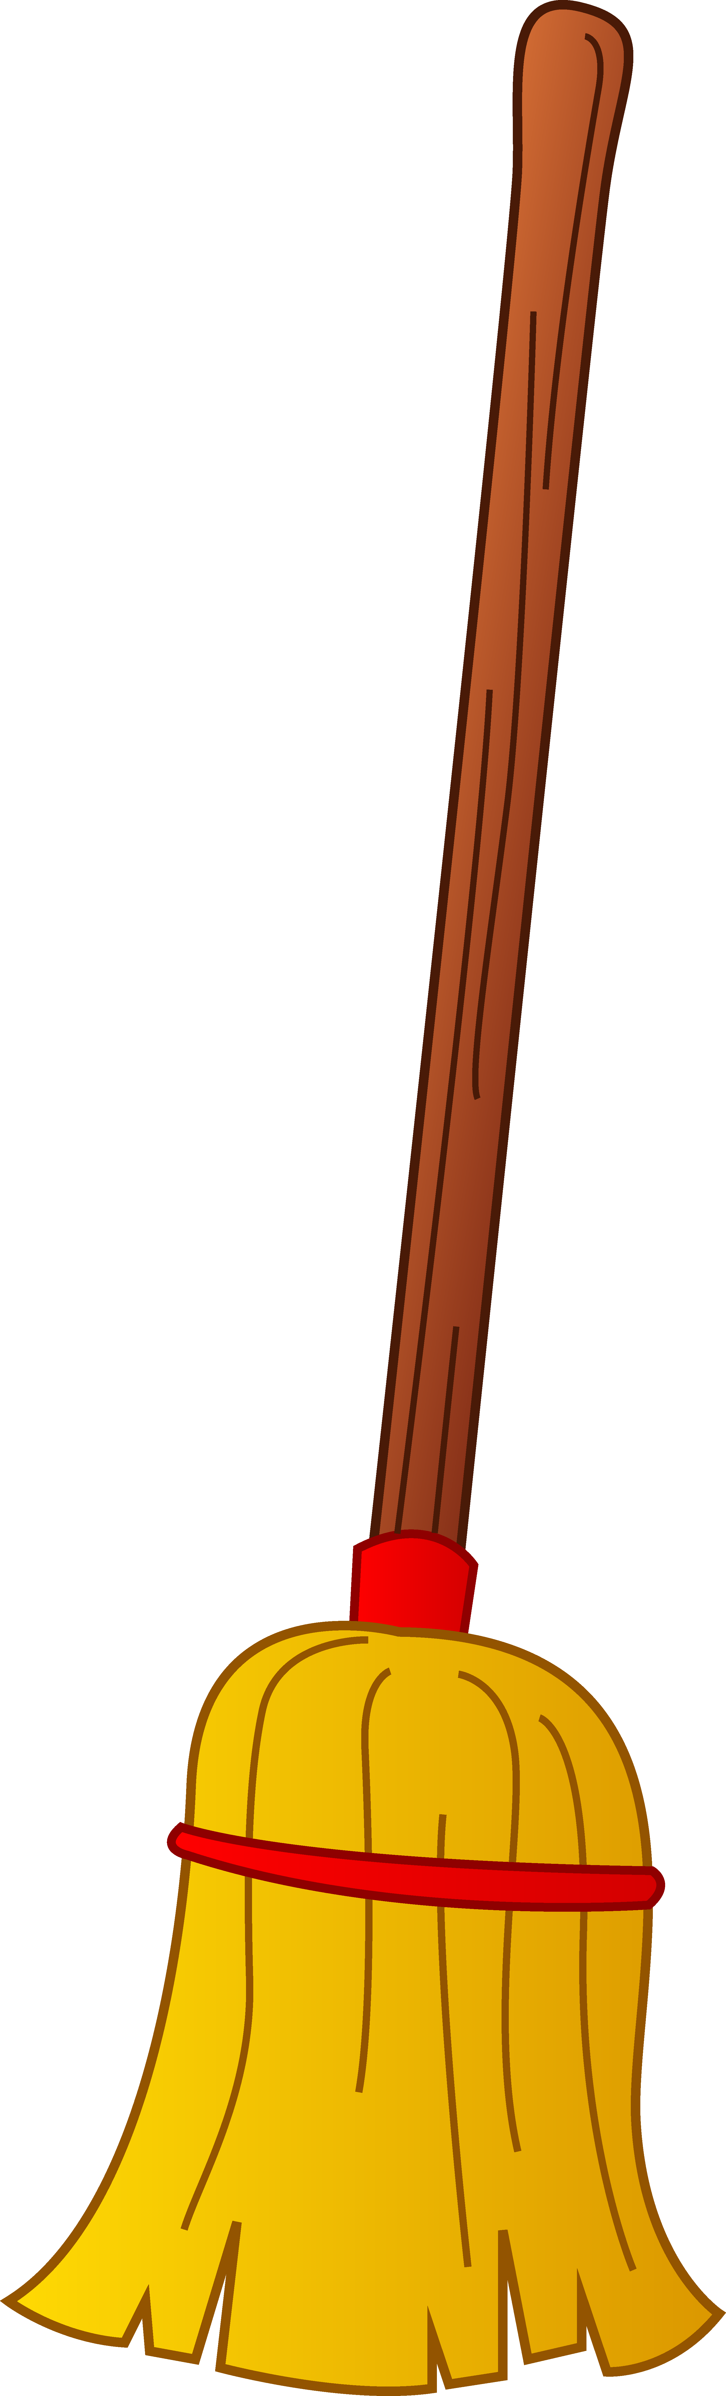
_ o _ | _ a _
_ u _ | _ i _
_ e _ | _ o _

