**Book Review**

Title:

Author:

Star Rating

Favourite character (write and draw)

Why?

Would you recommend this book to a friend? Why not post a photo of your review on Seesaw.

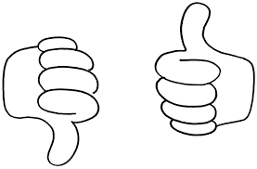

Favourite part (write and draw)

Why?