Woodburn Primary School

Self-Evaluation Policy

**Rationale**

In Woodburn Primary School self-evaluation is integral to how we work with our community and is an on-going feature of school life to ensure we are making positive improvements for our learners. Our approach takes account of best practice, current curriculum advice and a framework of indicators to guide the process.

**“Self- Evaluation is forward looking. It is about change and improvement, whether gradual or transformational, and is based on professional reflection, challenge and support. It involves taking decisions about actions which result in clear benefits for young people.”** *The Journey to Excellence Part 3 HMIe**(2007)*

Effective self-evaluation in Woodburn Primary supports the school team to:

* ensure educational outcomes for all learners are improving;
* address the impact of inequity on wellbeing, learning and achievement;
* consistently deliver high-quality learning experiences;
* embed progression in skills for learning, life and work from 3-18;
* further strengthen school leadership at all levels;
* improve the quality and impact of career-long professional learning;
* extend and deepen partnerships to improve outcomes for all learners;
* increase learning for sustainability; and
* tackle unnecessary bureaucracy.

**Aim**

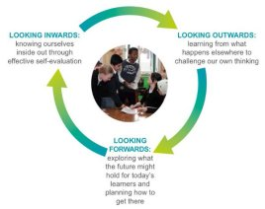The main aim of this policy is to ensure a consistent approach is used by the Senior Leadership Team, Staff Team and partners when reflecting together on the quality of education provided within our school. We recognise the importance of ensuring that all staff are aware and agree upon how self-evaluation is carried out and that a calendar of activities is agreed upon annually. We aim to ensure that over a period of time all aspects of the school’s work is evaluated. The main tools we use are: **HGIOS 4, HGIOELC and HGIOURS.**

In accordance with HGIOS 4 we use the ‘inwards, outwards, forwards’ approach to reflect the significant relationship between effective self-evaluation and school improvement. This enables us to answer the questions that lie at the heart of self-evaluation:

* How are we doing?
* How do we know?
* What are we going to do now?

In Woodburn our self-evaluation involves reflection and critical enquiry through a blend of internal and external analysis. Central to our self-evaluation is making sound judgements about the impact on learners. We ensure that our self-evaluation provides a valuable picture of what is having most and least impact upon learners. This enables us to create our plans for improvement to ensure that Woodburn Primary is the best it can be.

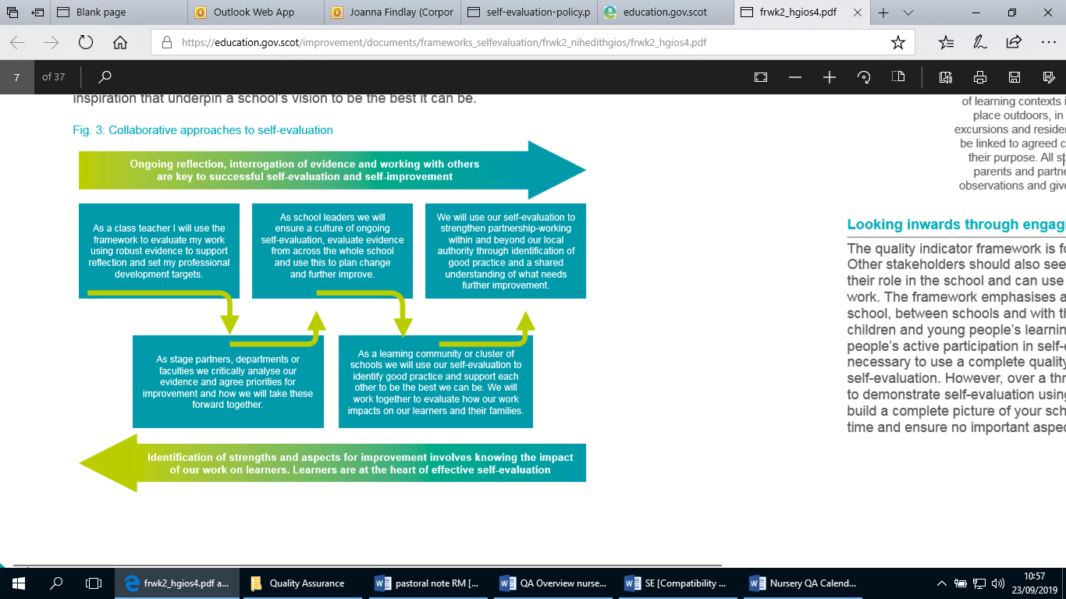

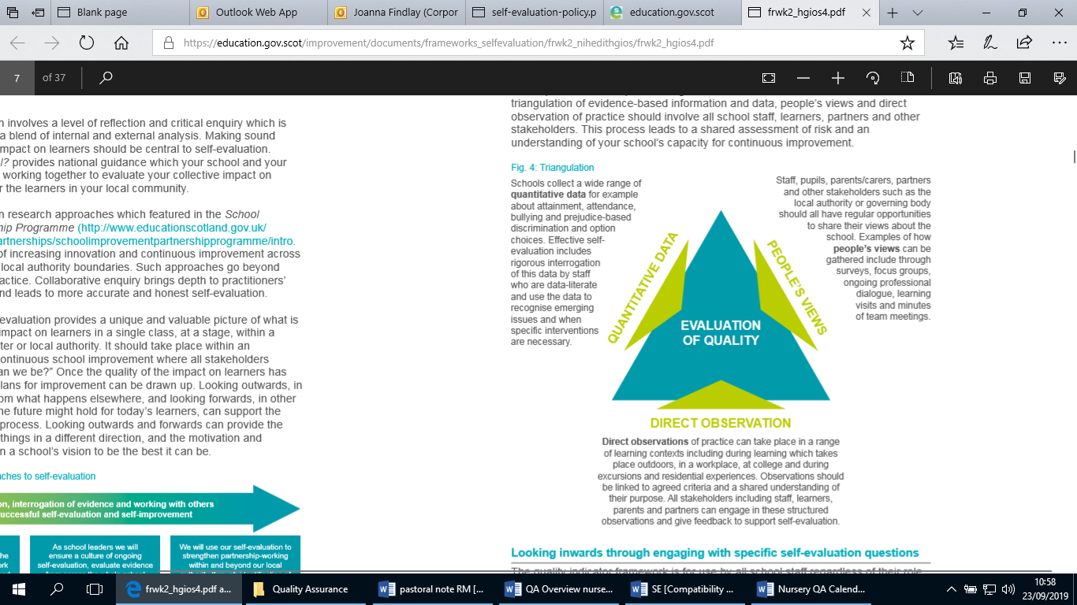

We use triangulation to ensure that evaluative statements about our strengths and areas for development are grounded in a robust evidence base. We strive to ensure that the triangulation of evidence-based information and data, people’s views and direct observation of practice, involves all school staff, learners, partners and other stakeholders. This process will lead us to a shared assessment of risk and an understanding of our school’s capacity for continuous improvement.

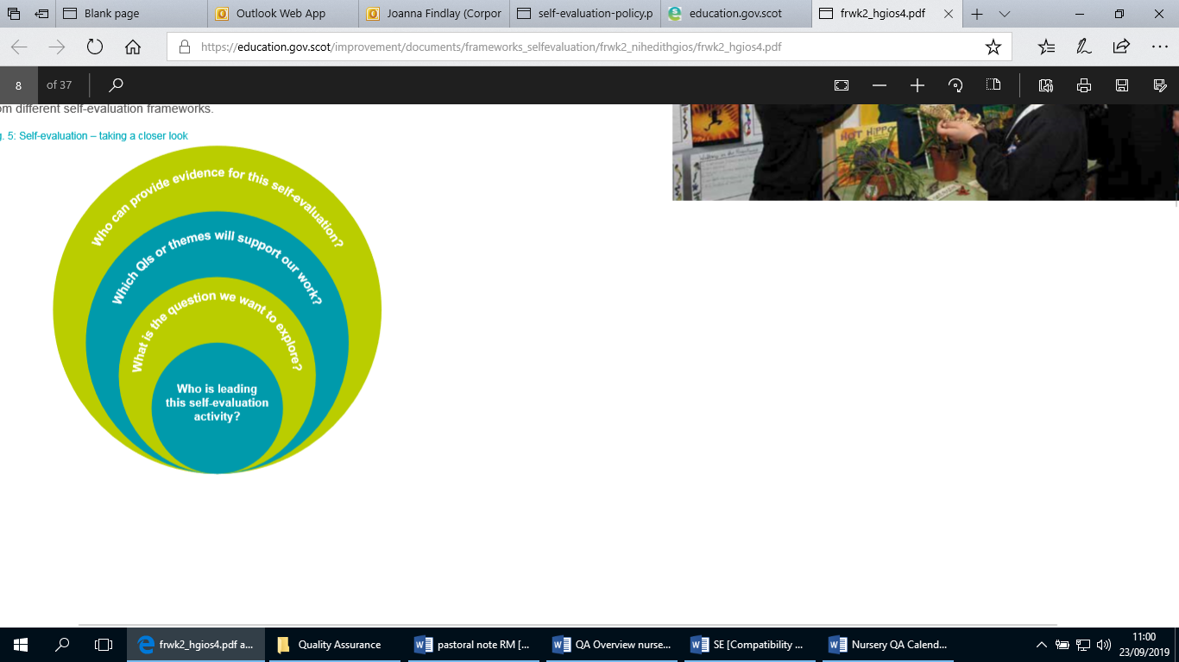**HGIOS 4, HGIOELC and HGIOURS** support our analysis of the impact of our work upon learners. We use quality indicators or themes from different quality indicators bundled together to enable a focus on a particular area of work such as family learning, employability skills or ensuring equity. We recognise that developing more specific self-evaluation questions and identifying relevant partners can create a focused context for this type of self-evaluation. We bundle together quality indicators or themes to enable us to focus upon a particular area of work in the school. This enables us to identify aspects of school life which require a greater focus.

**Woodburn Primary School (Nursery) Quality Monitoring and Tracking Overview**

| **Monitoring activity/process** | **QI** | **Responsibility** | **Aug** | **Sep** | **Oct** | **Nov** | **Dec** | **Jan** | **Feb** | **Mar** | **Apr** | **May** | **June** |
| --- | --- | --- | --- | --- | --- | --- | --- | --- | --- | --- | --- | --- | --- |
| Nursery Monitoring Visit | 1.1 1.2 1.3 | DHT, NM, SCDW, EEL |  | x | x |  |  | x | x |  |  | x | x |
| Nursery Environment Audit | 1.1 1.2 1.3 | NM, EEL, SCDW, CDW |  |  | x |  |  | x |  |  | x |  |  |
| Planning Meetings | 1.1 1.2 1.3 | NM, ELL, SCDW, CDW | x | x | x | x | x | x | x | x | x | x | x |
| Monitor Attendance, Lates and Behaviour | 2.1 2.4 3.1 | NM, EEL, SCDW |  |  |  |  |  |  |  |  |  |  |  |
| Monitoring of Wellbeing Folders | 2.1 3.1 2.4 3.2 | DHT, NM, SCDW |  | x |  | x |  | x |  | x |  | x |  |
| Reviewing Care Plans | 2.1 2.4 | DHT, NM, SCDW |  |  |  |  |  |  |  |  |  |  |  |
| Children’s Planning Meetings | 2.1 2.4 3.1 | DHT, NM |  |  |  |  |  |  |  |  |  |  |  |
| ASN/Wellbeing Meetings | 2.1 2.4 3.1 | SLT, NM | x | x | x | x | x | x | x | x | x | x | x |
| Updating/Reviewing of Pastoral Notes | 2.1 2.4 3.1 | DHT, NM | x | x | x | x | x | x | x | x | x | x | x |
| Learning Journal Monitoring | 2.3 3.2 | SCDW |  |  |  |  |  |  |  |  |  |  |  |
| Observation Monitoring | 2.3 3.2 | NM, SCDW, EEL |  |  |  |  |  |  |  |  |  |  |  |
| Seesaw Monitoring | 2.3 3.2 | DHT |  |  | x | x | x | x | x | x | x | x | x |
| Parent Drops to gather feedback to determine next steps for parental groups | 2.5 | NM, EEL |  |  | x | x | x | x | x | x | x | x | x |
| Gathering of children’s views – 5 a Day | 2.3 3.1 3.2 | NM, SCDW |  |  | x | x | x | x | x | x | x | x | x |
| Parental Consultations | 2.5 2.7 3.2 | SCDW, CDW |  |  |  |  |  |  |  |  |  |  |  |
| Making Performance Matter | 1.2 | DHT, NM, SCDW, CDW |  |  | x |  |  |  |  | x |  |  |  |

**Woodburn Primary School Nursery**

**Quality Assurance Calendar 2019-2020**

|  |  |  |  |  |  |  |
| --- | --- | --- | --- | --- | --- | --- |
| **Term 1** | | | | | | |
| **General:**  SLT, Nursery Manager and EEL audits  SLT, Nursery Manager and peer walkthroughs  On-going evaluation of SIP  Safeguarding and Wellbeing  Attendance, Lates and Behaviour  Wellbeing Meetings  5 A Day with learners  Seesaw Monitoring  Child’s Planning Meetings | | | | | | |
| **August** | **September** | | **October** | **November** | | **December** |
| * Home Visits * Health Care Reviews | * SQIP (Published to Parents) * Parent Consultations - Gather Stakeholder Views * Review Wellbeing Folders * Journey to Gold Baseline questionnaire * Observation Monitoring | | * School Authority Review (3 day) * MPM Interim Meetings SCDW/CDWs * Environment Audit * Parent Drop Ins - gathering parental views * Learning Journal Monitoring | * Review Wellbeing Folders * Observation Monitoring | | * Learning Journal Monitoring |
| **Term 2** | | | | | | |
| **General:**  SLT, Nursery Manager and peer walkthroughs  On-going evaluation of SIP  Safeguarding and Wellbeing  Attendance, Lates and Behaviour  Wellbeing Meetings  5 A Day with learners  Seesaw Monitoring  Child’s Planning Meetings | | | | | | |
| **January** | | **February** | | | **March** | |
| * Review Wellbeing Folders * Nursery Environment Audit * Parent Consultations - Gather Stakeholder Views * Observation Monitoring | | * Parent Drop Ins - gathering parental views * Learning Journal Monitoring | | | * MPM Meetings SCDW/CDWs * Review Wellbeing Folders * Observation Monitoring | |
| **Term 3** | | | | | | |
| **General:**  SLT, Nursery Manager and EEL audits  SLT, Nursery Manager and peer walkthroughs  On-going evaluation of SIP  Safeguarding and Wellbeing  Attendance, Lates and Behaviour  Wellbeing Meetings  5 A Day with learners  Seesaw Monitoring  Child’s Planning Meetings | | | | | | |
| **April** | | **May** | | | **June** | |
| * Nursery Environment Audit * Parent Drop Ins - gathering parental views * Learning Journal Monitoring | | * Review Wellbeing Folders * Transition Arrangements * Self-evaluation of Nursery Improvement Priorities * Observation Monitoring | | | * Parent Consultations - Gather Stakeholder Views * Complete and Return SQIP (DRAFT) * Parent/Carer and Pupil Questionnaire * Transition Arrangements * Learning Journal Monitoring | |

**Woodburn Primary School (Primary 1-7) Quality Monitoring and Tracking Overview**

| **Monitoring activity/process** | **QI** | **Responsibility** | **Aug** | **Sep** | **Oct** | **Nov** | **Dec** | **Jan** | **Feb** | **Mar** | **Apr** | **May** | **June** |
| --- | --- | --- | --- | --- | --- | --- | --- | --- | --- | --- | --- | --- | --- |
| Phonological Awareness Assessment P1 Baseline and follow-up | 1.1 2.3 3.2 | HT, DHT (JF), SfL (LL) | X |  |  |  |  |  |  |  |  |  | X |
| Health Care Reviews  *Reviewed for all pupils in August. When required through the year.* | 2.1 2.4 2.7 | DHT (SW) | X |  |  |  |  |  |  |  |  |  |  |
| Forward Plan Reviews  *Checked by SLT X3 in year. Also used to support dialogue linked to other monitoring activities e.g. tracking and monitoring, classroom observations.* | 1.1 2.2 2.3 | SLT |  | X |  | X |  |  |  | X |  |  |  |
| Tracking and Monitoring Meetings  *Analysis of traffic lighted groups and identification of lowest and highest achievers. Link to SfL Liaison meetings.* | 1.1 2.3 2.4 3.2 | HT, DHTs, SfL, CTs |  | X |  |  |  |  | X |  | X |  |  |
| CfE Data SEEMIS (P1, 4 and 7 data)  *Analysis of traffic lighted groups and identification of lowest and highest achievers.* | 1.1 2.3 2.4 3.2 | SLT, SfL, CTs |  | X |  |  |  |  | X |  | X |  |  |
| SWST P2-7 | 1.1 2.3 3.2 | SfL, CTs |  | X |  |  |  |  |  |  |  |  |  |
| SfL Liaison focussing on ASN and attainment (traffic lighted)  *Links to tracking and monitoring exemplified.* | 1.1 2.3 2.4 3.1 3.2 | HTs, DHTs, SfL |  | X |  |  |  | X |  |  |  | X |  |
| SQIP (Published to Parents) | 1.1 | HT |  | X |  |  |  |  |  |  |  |  |  |
| Parent Consultations - Gather Stakeholder Views | 1.1 | SLT, Parent Partnership |  | X |  |  |  | X |  |  |  |  | X |
| CIRCLE baselines and follow-ups  *CIRCLE Inclusive Classroom Scale (CICS) baseline, CIRCLE Inclusive Classroom Scale (CICS) Evaluation -> Case Study using CIRCLE Participation Scale (CPS)* | 1.1 1.5 2.4 2.7 3.1 | SfL, CTs |  | X |  |  |  | X |  |  |  | X |  |
| Journey to Gold Baseline Questionnaire and follow-up | 1.1 1.2 2.7 3.1 | DHT (SW), RRSA Working Group |  | X |  |  |  |  |  |  | X |  |  |
| School Authority Review (3 day) | Agreed QIs | Authority, SLT & All Staff Team |  |  | X |  |  |  |  |  |  |  |  |
| Midlothian Returns | 2.2 2.3 1.5 3.2 | SLT, Key Staff dependent on QI |  |  | X |  | X |  | X |  |  | X |  |
| Dalkeith Learning Community Walkthrough | 1.2 1.3 2.3 2.7 | DHT (SW&JF), QL&T Group |  |  | X |  |  | X |  | X |  |  |  |
| School Moderation  *Writing, Listening and Talking, Reading, Numeracy. Links made to DLC moderation, authority moderation, SEIC and QUAMSO activities.* | 1.2 2.2 2.3 3.2 | SLT, SfL, Literacy Champions, Numeracy Co-ordinators, CTs |  |  | X | X |  |  | X |  | X |  |  |
| Targeted Intervention Review (IEP) | 2.4 3.1 3.2 | SLT, SfL |  |  |  | X |  |  |  | X |  |  |  |
| Professional Review and Development | 1.4 | HT, DHTs, All GTCS Registered Staff |  |  |  | X |  |  |  |  |  |  |  |
| SLT Classroom Observations  *Triangulated (Learners’ Experience, Pupil Focus Group & monitoring jotters/learning)* | 1.1 1.2 1.3 2.3 3.2 | SLT, SfL, CTs |  |  |  |  |  |  | X |  |  | X |  |
| MPM Meetings  *Learning Assistants and Office Team* | 1.4 | HT, DHTs |  |  |  |  |  |  |  | X |  |  |  |
| Scottish National Standardised Assessment (SNSA) | 1.1 2.3 3.2 | HT, DHTs, SfL, CTs |  |  |  |  |  |  |  | X |  |  |  |
| Reports to Parents/Carers | 2.7 | HT, DHTs, CTs |  |  |  |  |  |  |  |  |  | X |  |
| Complete and Return SQIP (DRAFT) | 1.1 | HT |  |  |  |  |  |  |  |  |  |  | X |
| Transition Arrangements | 2.6 2.7 3.1 | SLT, SfL, CTs |  |  |  |  |  |  |  |  |  |  | X |
| Parent/Carer and Pupil Questionnaire | 1.1 2.5 2.7 | SLT |  |  |  |  |  |  |  |  |  |  | X |
| Peer Observations (Impact Coaching) | 1.1 1.2 1.3 2.3 3.2 | L&T Working Group, CTs |  | X | X | X |  | X | X | X | X | X |  |
| Pupil Walkthroughs | 1.1 1.2 | SLT |  | X | X | X | X | X | X | X | X | X | X |
| Snap Jotter Sampling | 1.1 2.3 3.2 | All Staff Team |  | X | X | X | X | X | X | X | X | X | X |
| SLT and Staff Walkthroughs | 1.2 1.3 2.3 2.7 | All Staff Team |  | X | X | X | X | X | X | X | X | X | X |
| On-going evaluation of SIP | Various QIs dependent on focus | All Staff Team | X | X | X | X | X | X | X | X | X | X | X |
| QI (Quality Indicator) Elves (pupil voice) | Various QIs dependent on focus | SLT |  | X | X | X | X | X | X | X | X | X | X |
| 5 A Day (focus changed through each term) | Various QIs dependent on focus | SLT |  | X | X | X | X | X | X | X | X | X | X |
| Safeguarding and Wellbeing | 2.1 | HT, DHTs, SfL (LG), NT | X | X | X | X | X | X | X | X | X | X | X |
| Attendance, Lates and Behaviour | 2.1 2.4 3.1 | HT, DHTs, YW, EY Homelink | X | X | X | X | X | X | X | X | X | X | X |
| Woodburn Learning Council (Pupil Voice) | 1.2 2.3 2.7 3.3 | DHT (SW&JF) | X | X | X | X | X | X | X | X | X | X | X |
| Dalkeith Learning Council (monthly) Pupil Voice | 1.2 2.3 2.7 3.3 | DHT (SW) | X | X | X | X | X | X | X | X | X | X | X |
| RRSA Steering Group | 3.3 | DHT (SW), RRSA Working Group | X | X | X | X | X | X | X | X | X | X | X |
| Wellbeing Meetings | 2.1 3.1 | HT, DHTs, SfL (LG), NT, YW, EY Homelink | X | X | X | X | X | X | X | X | X | X | X |
| OTI Cohort 4 | 1.1 1.2 1.3 2.3 | SLT, OTI Cohort |  | x | X | X | X | X | X | X | X | X |  |
| RWI Coaching Model | 1.2 1.3 1.4 2.3 2.4 | SfL |  |  | X | X | X | X | X | X | X |  |  |

**Woodburn Primary School Quality Assurance Calendar 2019-2020**

|  |  |  |  |  |  |  |
| --- | --- | --- | --- | --- | --- | --- |
| **Term 1** | | | | | | |
| **General:**  Peer Observations (Impact Coaching)  Pupil Walkthroughs  Snap Jotter Sampling  SLT and Staff Walkthroughs  On-going evaluation of SIP  QI (Quality Indicator) Elves (pupil voice)  5 A Day (focus changed through each term)  Safeguarding and Wellbeing  Attendance, Lates and Behaviour  Woodburn Learning Council (Pupil Voice)  Dalkeith Learning Council (monthly) Pupil Voice  RRSA Steering Group  Wellbeing Meetings  OTI Cohort 4  RWI Coaching Model | | | | | | |
| **August** | **September** | | **October** | **November** | | **December** |
| * Phonological Awareness Assessment P1 Baseline * Health Care Reviews | * Forward Plan Reviews * Tracking and Monitoring Meetings * CfE Data SEEMIS * SWST P2-7 * SfL Liaison focussing on ASN and attainment (traffic lighted) * SQIP (Published to Parents) * Parent Consultations - Gather Stakeholder Views * CIRCLE Inclusive Classroom Scale (CICS) baseline * Journey to Gold Baseline Questionnaire | | * School Authority Review (3 day) * 2.2 (Curriculum) Return * Dalkeith Learning Community Walkthrough * School Moderation (Writing) | * Forward Plan Reviews * Targeted Intervention Review (IEP) * Moderation (Numeracy) * PRD | | * 2.3 (Learning, Teaching & Assessment) Return |
| **Term 2** | | | | | | |
| **General:**  Peer Observations (Impact Coaching)  Pupil Walkthroughs  Snap Jotter Sampling  SLT and Staff Walkthroughs  On-going evaluation of SIP  QI (Quality Indicator) Elves (pupil voice)  5 A Day (focus changed through each term)  Safeguarding and Wellbeing  Attendance, Lates and Behaviour  Woodburn Learning Council (Pupil Voice)  Dalkeith Learning Council (monthly) Pupil Voice  RRSA Steering Group  Wellbeing Meetings  OTI Cohort 4  RWI Coaching Model | | | | | | |
| **January** | | **February** | | | **March** | |
| * SfL Liaison focussing on ASN and attainment (traffic lighted) * Parent Consultations - Gather Stakeholder Views * Dalkeith Learning Community Walkthrough * CIRCLE Inclusive Classroom Scale (CICS) Evaluation -> Case Study using CIRCLE Participation Scale (CPS) | | * SLT Classroom Observations – Triangulated (Learners’ Experience, Pupil Focus Group & monitoring jotters/learning) * Moderation (Listening and Talking) * Tracking and Monitoring Meetings * CfE SEEMIS * 1.5 (Management of Resources to Promote Equity) Return | | | * Forward Plan Reviews * Targeted Intervention Review (IEP) * MPM Meetings LAs/SCDW/CDWs * Scottish National Standardised Assessment (SNSA) * Dalkeith Learning Community Walkthrough | |
| **Term 3** | | | | | | |
| **General:**  Peer Observations  Pupil Walkthroughs (Impact Coaching)  Snap Jotter Sampling  SLT and Staff Walkthroughs  On-going evaluation of SIP  QI (Quality Indicator) Elves (pupil voice)  5 A Day (focus changed through each term)  Safeguarding and Wellbeing  Attendance, Lates and Behaviour  Woodburn Learning Council (Pupil Voice)  Dalkeith Learning Council (monthly) Pupil Voice  RRSA Steering Group  Wellbeing Meetings  OTI Cohort 4  RWI Coaching Model | | | | | | |
| **April** | | **May** | | | **June** | |
| * SLT Classroom Observations – Triangulated (Learners’ Experience, Pupil Focus Group & monitoring jotters/learning) * Moderation (Reading) * Tracking and Monitoring Meetings * CfE SEEMIS * Journey to Gold Follow-up | | * SfL Liaison focussing on ASN and attainment (traffic lighted) * Reports to Parents/Carers * 3.2 (Raising Attainment and Achievement) Return * Self-evaluation of School Improvement Priorities * CIRCLE Participation Scale (CPC) Evaluation | | | * Phonological Awareness Assessment P1 Follow-up * Parent Consultations - Gather Stakeholder Views * Complete and Return SQIP (DRAFT) * Transition Arrangements * Parent/Carer and Pupil Questionnaire | |