Rationale

As a Rights Respecting School we respect children’s right to play as affirmed by the UN Convention on the Rights of the Child (1990). Article 31 of the convention states that we;

*Shall respect and promote the right of the child to participate fully in cultural and artistic life and shall encourage the provision of appropriate and equal opportunities for cultural, artistic, recreational and leisure activity.*

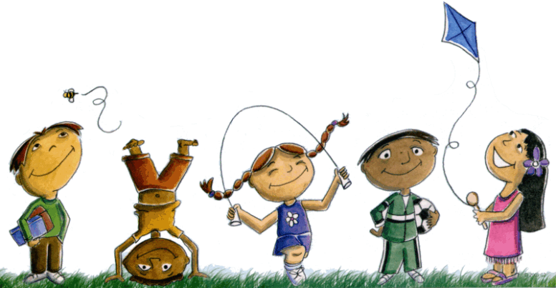

Play is integral to children’s learning and is defined by the Scottish Government as

*...children’s behaviour which is freely chosen, personally directed and intrinsically motivated. It is performed for no external goal or reward and is a fundamental and integral part of healthy development.*

*National Strategy for Play (2013)*

The benefits of learning through play are numerous and well-documented.

*Some theorists emphasise that when playing, children try out ideas and come to a better understanding of thoughts and concepts as they play; others see play as a means of children coping with reality through using their imagination; and, others see play as a means to practise new skills. All of which are valid.*

*Building the Ambition (2014)*

Midlothian has committed to establishing learning through play in schools and understands this as necessary for the effective delivery of Curriculum for Excellence.

*When play is valued, respected and promoted in schools, children will have opportunities to achieve the aims of the Curriculum for Excellence, becoming*

*successful learners, confident individuals, responsible citizens and effective contributors. Schools should recognise play’s importance for both mental and*

*physical well-being.*

*Playful learner-led approaches that will be embedded within the delivery of the*

*Curriculum for Excellence in nursery, primary, secondary and special schools.*

*Midlothian Play Strategy (2017)*

Friedrich Froebel made clear the importance of play for children’s learning and development.

*Play is the highest expression of human development in childhood.*

At Woodburn we continue to take inspiration from the work of Froebel, as we develop our approach to learning through play.

Statement of Intent

Play is valued by staff at Woodburn and we are committed to ensuring that all pupils experience the benefits of free flow child-led play. Pupils will have regular opportunities to manage their own learning, make choices and follow their interests through play. Literacy and numeracy activities will also be provided to allow children to consolidate their class learning. This might include activities to develop and practise;

* Letter and number formation
* Writing common words
* Recognising sounds
* Reading, writing and ordering numerals
* Adding and subtracting

Staff will offer high quality support to pupils through timely and appropriate interactions and documentation of learning. Pupils will be fully involved in planning, developing and evaluating the play environment. This will be visible in our floorbooks and displays. Learning will link with Literacy , Numeracy and across the curriculum

C:\Program Files\Microsoft Office\MEDIA\CAGCAT10\j0293844.wmf

Aims

The aims of this policy are;

* To ensure consistency in the high quality play opportunities offered at Woodburn.
* To ensure pupils have access to a wide variety of types of play to meet their physical, emotional and academic needs.
* For pupils to understand and value how we learn through play.
* For pupils to engage productively with play resources.
* For pupils to develop social skills and have the opportunity to play both independently and with others.
* For pupils to develop their language skills and to close the ‘vocabulary gap’.
* For pupils to develop their ‘learning skills’.
* For pupils to make links between their lessons and learning through play, applying skills.

Planning for Play

High quality play needs to be planned for and given adequate time within the class timetable. Planning dedicated time for play demonstrates to pupils that it is valued. Planning for play and responding to the learning we observe does not mean planning *outcomes* to be *achieved* by pupils. This is in fact a feature of free flow play that distinguishes it from other playful approaches such as active learning. Teachers will plan responsively based on observations and children’s ideas, linking these to the Experiences and Outcomes within CfE. They will also provide resources and stimuli linked to the seasons and festivals. This will allow responsive learning to be interwoven with the backdrop of seasonal planning.

It is important that time is set aside where teachers can be with the pupils during play, allowing them to intervene appropriately to support learning and observe key learning taking place.



The Adult’s Role

The adults’ role in supporting children to learn through free flow play differs from the role played by teachers in other types of learning but is of equal importance. Adults’ careful observations and sensitivity to developing learning is central to this role. Adults will support learning through play in a variety of ways;

* Providing a warm, safe and supportive environment for play.
* Providing appropriate resources, responding to children’s developing interests and needs.
* Supporting pupils to maintain a ‘looked after’ and valued play environment.
* Supporting pupils in making choices about what they want to learn and how.
* Observing learning, where appropriate recording this, and planning for possible next steps.
* When invited, joining in with play. This can be a good opportunity to model social skills.
* Using effective questioning to promote thinking skills and encourage pupils to believe they have answers to their own questions.
* Drawing attention to links between pupils’ play and class learning.
* Engaging in sustained shared thinking with pupils. This is;

*... when two or more individuals 'work together' in an intellectual way to solve a problem, clarify a concept, evaluate an activity, extend a narrative etc. Both parties must contribute to the*thinking*and it must develop and extend the understanding.*

Documentation of Learning 

Early Years pedagogy has long championed the importance of recording the learning process children engage in through play. This recording, also known as ‘documentation’, involves capturing the learning that is taking place, as it is happening. Practitioners then display this process in order to promote discussion and reflection on key learning.

*Documentation is only useful to children, teachers and parents if it is constantly revisited and time is given to reflection and discussion of it. Documenting is much more than showing and displaying children’s work on the wall. It must create a greater understanding of children’s learning and of the experiences of all involved. Documentation should add something to the learning experience and inform planning for future learning.*

*The Reggio Emilia Approach to Early Years Education, Learning and Teaching Scotland (2006)*

Photographs are an effective way of recording learning through play, although it is essential that photographs include annotations, captions or comments to highlight the learning. Other examples may include the use of post its, children’s writing or drawing, speech bubbles, adult’s observations and plans/maps/diagrams/lists created jointly with children. All of these may be found in our floorbooks and displays.

It is helpful for us to consider the following questions as we continue to develop our approach to documentation;

How effectively do our learning spaces, displays and floor books document the learning process?

How involved are pupils in recording their learning?

How do we share our documentation of learning with parents/carers?

Does our documentation of learning lead to discussion and reflection with pupils?

Does our documentation inform planning and new learning?

Resources and the Play Environment

At Woodburn we provide a rich environment for play that facilitates learning across all curricular areas, promotes independence and encourages children to develop the necessary skills and qualities to be good learners.

The quality of the play environment we offer directly impacts on our pupils’ development of the four capacities that underpin Curriculum for Excellence. It is therefore the responsibility of all staff to continually plan for, manage and develop the environment for learning through play, responding to developing needs and interests of children.

Research has shown that open-ended materials are particularly effective in promoting productive play. These materials encourage more imaginative and creative use of the resources to create a wider range of possible play scenarios.

Open ended materials may include;

* Shells
* Pinecones
* Leaves
* String or wool
* Pipe cleaners
* Feathers
* Pebbles or stones
* Sticks, bark and twigs
* Wood cuts (round)
* Corks
* Rattan
* Buttons
* Scraps of material or ribbons
* Junk
* Cardboard boxes

As promoted by Froebel, where possible open-ended materials should be used to maximise creativity for example; using these instead of plastic food in the home corner and using cloaks, lengths of materials and scarves instead of fixed dressing up outfits.

While there are benefits of providing specific small world sets linked to children’s interests or learning in lessons, we should also consider using more open-ended small world where appropriate. This might include providing pieces of fabric instead of commercially designed play mats, providing blocks instead of a farm building or providing a variety of boxes instead of a doll’s house.

It is important that resources replicate real world experience, for example, crockery in the home corner should be the same size, and made of the same materials, as they would be in a real home.

Our play resources must be representative of human diversity and should include people of different ethnicities and cultures. Men, women and families should also be represented in diverse ways. It is the responsibility of all staff to encourage children to play free from pre-conceived ideas about who they should be and to sensitively challenge any stereotypes or prejudices that arise through play.

Core Provision

The following are considered ‘core provision’ and children have access to them daily.

* Painting
* Variety of paper and card
* Junk
* Gluing
* Non-fiction and fiction texts
* Dough or equivalent
* Small construction (e.g., lego)
* Sand or water
* Role play

The ‘Quality Learning Environments’ document authored by the Midlothian Early Years and Childcare team will guide us in developing our core provision.

Fun 31

Every Friday all pupils in school will experience the benefits of play or self-selected activities through our ‘Fun 31’ time. Named after the 31st article of the United Nations Convention on the Rights of the Child (UNCRC), pupils can play and engage with their peers freely for thirty one minutes, developing their social skills, mental wellbeing and relationships with others.

**How could you make it better?**

**What do you think would happen if...?**

**What have you learnt?**

**How did you do that?**

**How did you work it out/learn how to do that?**

**Can you show me...?**

**Could you teach ...... how to do that?**

**What did you have to do for it to work?**

**What will you need to practise?**

Appendix 1

Appendix 2

Examples of Documentation

