Woodburn Nursery Class



GIRFEC Policy

Getting it Right for Every Child (GIRFEC) is relevant to all staff working with children and young people, including practitioners working in adult services and with parents and carers. Everyone working with children, young people and families needs to be aware of the GIRFEC approach and how it can positively impact on the lives of children and young people.

This approach helps practitioners to focus on what makes a positive difference for children and young people and how they can act to deliver these improvements. Getting it Right for Every Child permeates through all existing policy, practice, strategy and legislation affecting children, young people and their families.

**Building a Network of Support**

* GIRFEC aims to create a network of support at the right time.
* A network involves a child’s family, health and education services working together to meet the needs of the child.
* GIRFEC supports immediate action to ensure all children and young people are safe.

**What ‘Getting it Right’ Means:**

**For Children and Families**

**They will:**

* Feel confident about the help they are receiving
* Develop an understanding of what is happening and why
* Feel listened to and that their opinions are valued
* Feel involved in discussions and decisions affecting their lives
* Benefit from appropriate help being accessed as soon as possible
* Experience an integrated approach from practitioners

**For Practitioners:**

**They will:**

• Put the child or young person at the centre and developing a shared understanding within and across agencies.

• Use common tools, language and processes, considering the child or young person as a whole, and promoting closer working where necessary with other practitioners.

**For managers in children’s and adult services:**

**They will:**

• Provide leadership and strategic support to implement the changes in culture, systems and practice required within and across agencies to implement Getting it Right for Every Child.

• Plan for transitions, as staff in agencies move from the current working processes to the new child-centred process.

The wellbeing of children and young people is at the heart of Getting it Right for Every Child. We want all our children and young people to be fully supported as they grow and develop. There are eight areas of wellbeing in which they need to thrive to ultimately reach their full potential, now and in the future: ***safe, healthy, achieving, nurtured, active, respected, responsible and included***. These eight areas – often referred to as the ‘wellbeing indicators’ – are set in the context of the ‘four capacities’, which are at the heart of Curriculum for Excellence. The four capacities aim to enable every child and young person to be a successful learner, a confident individual, a responsible citizen and an effective contributor. The Wellbeing Wheel shows how they interconnect.

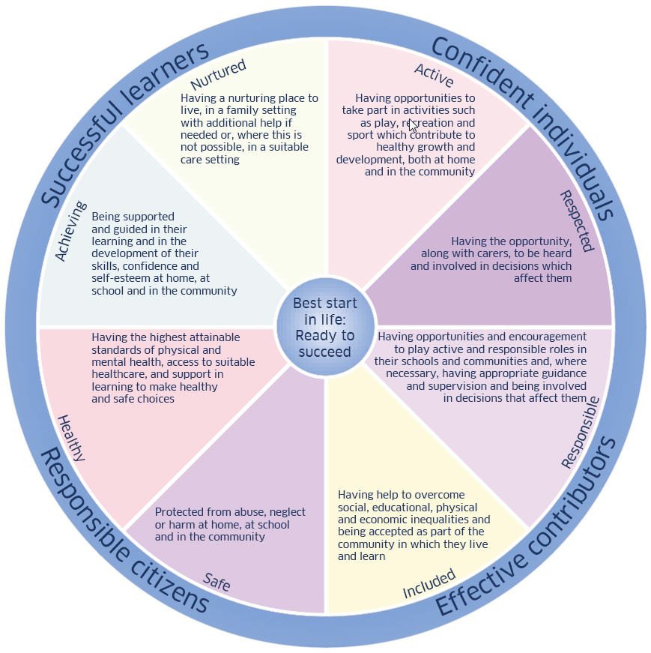

To ensure children and young people achieve their potential, Getting it Right for Every Child is supported by 10 core components. These can be applied in any setting and circumstance where individuals are working with children and young people. These 10 core components can be applied in any setting and in any circumstance. They are at the heart of the Getting it Right for Every Child approach (in practice) and provide a benchmark from which practitioners may apply the approach to their areas of work:

1. A focus on improving outcomes for children, young people and their families based on a shared understanding of well-being.

2. A common approach to gaining consent and to sharing information where appropriate.

3. An integral role for children, young people and families in assessment, planning and intervention.

4. A co-ordinated and unified approach to identifying concerns, assessing needs, agreeing actions and outcomes, based on the Well-Being Indicators.

5. Streamlined planning, assessment and decision-making processes that lead to the right help at the right time.

6. Consistent high standards of co-operation, joint working and communication where more than one agency needs to be involved, locally and across Scotland.

7. A Lead Professional to co-ordinate and monitor multi-agency activity where necessary.

8. Maximising the skilled workforce within universal services to address needs and risks at the earliest possible time.

9. A confident and competent workforce across all services for children, young people and their families.

10. The capacity to share demographic, assessment, and planning information electronically, within and across agency boundaries, through the national eCare programme where appropriate.

**National Practice Model**

Practitioners can use the national practice model for assessment, planning and action when required.

* Provides a framework for practitioners and agencies to structure and analyse information consistently so as to understand a child or young person’s needs, the strengths and pressures upon them, and consider what support they might need.
* Defines needs and risks as two sides of the same coin. It promotes the participation of children, young people and their families in gathering information and making decisions as central to assessing, planning and taking action.
* Provides a shared understanding of a child or young person’s needs by identifying concerns that may need to be addressed.

The National Practice Model is a dynamic and evolving process of assessment, analysis, action and review and a way to identify outcomes and solutions for individual children or young people. It allows practitioners to meet the Getting it Right for Every Child core values and principles in an **appropriate**, **proportionate** and **timely** way.

It contains the key elements of a single planning process that should in turn lead to a single child’s plan - if one is needed.

It is a way for all agencies and workers who support children, young people and their families to begin to develop a common language within a single framework, enabling more effective inter- and intra -agency working.

Using the National Practice Model in this consistent way allows practitioners in any agency or organisation to construct a plan and take appropriate action. It also allows for regular and consistent reviewing of the plan.

