**Welcome to**

**Woodburn Primary School**

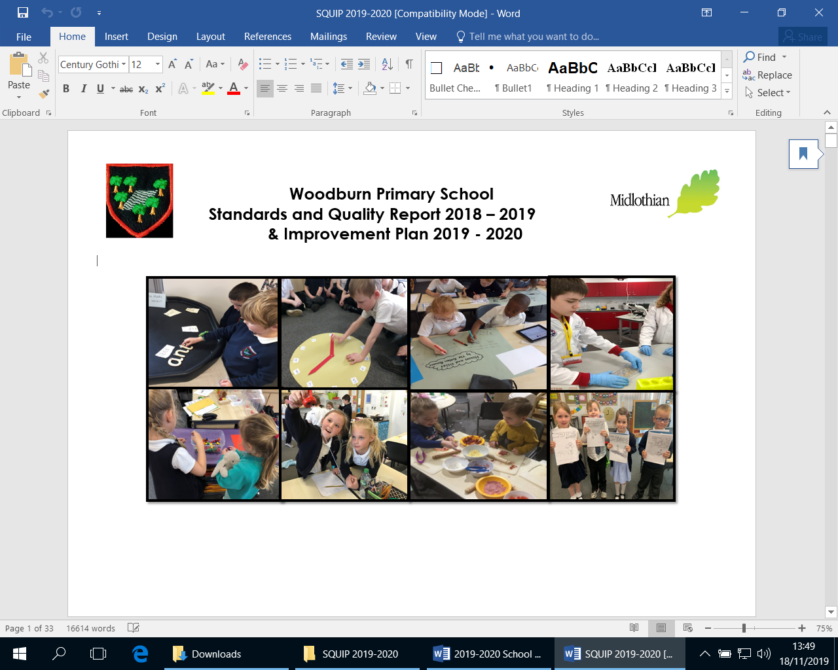

**School Handbook**

**2019-2020**

**We hope you find the information in this booklet interesting and helpful. Please contact the school for further information**

Growing Community Creating Success

**SCHOOL HANDBOOK**

|  |
| --- |
| **Contents** |
| 1. Introduction |
| 1. Information about the School |
| 1. Enrolment and Transfers |
| 1. Our Vision and Values |
| 1. Parent/Carer Involvement 2. Complaints Procedures |
| 1. The School Curriculum 2. Assessment and Reporting on Pupil Progress |
| 1. Pupils with Additional Support Needs 2. School Policies and Practical Information 3. Complaints Procedure 4. Useful Addresses |
|  |
| Appendix 1.  2018-2019 Session Dates  Appendix 2.  Child Protection Policy  Appendix 3.  Preventing Bullying and Prejudice Policy  Appendix 4.  Ready to Learn Policy |

**1.**

**Introduction**

Woodburn Primary School is a non-denominational primary school. Woodburn moved to its current site on the Dalkeith Campus in August 2009.

The school has two wings. The first wing comprises of the school office, our Nursery, service rooms and the dining and activity halls. The second wing has our classrooms and some community facilities. This wing is split into three sections with all classrooms opening out on to atria. In total we have 22 classrooms. In addition we have an Expressive Arts Hall, a Library and ICT suite. Members of the community can apply for a let to use any of the school facilities. The school has multi-sport facilities including basketball, badminton and athletics. Beside the school is a small Multi Use Games Area (MUGA) used by the children for P.E and for recreation during intervals.

There are a variety of opportunities for parents and families to be involved in their child’s learning journey including open events, drop-ins, shared starts, class assemblies, classroom visits and special concerts/events. We acknowledge the importance of working with and engaging the local community and utilise links effectively.

In addition to our teaching and Learning Assistant Team, we have two new roles in school to support children and families. Mrs Angela Welsh, our Early Years Homelink Worker and Miss Dawn McKimmie, Youth Worker.

We have an active Parent Partnership whose role is to participate in policy developments and support the school in its drive towards continuous improvement. They also organise many fundraising events during the school year. We are always looking for new members and welcome your attendance at various events through the school year.

Woodburn Primary continues to be committed to providing a safe, nurturing and supportive learning environment for all. In this fast changing world we strive to equip our children with the skills they will require to become Successful learners, Confident Individuals, Independent Learners and Responsible Citizens. We place considerable value on trust, respect and integrity. We believe that by actively seeking to work in partnership with all involved in the care of a child, that we will maximise the opportunity for every child to realise their full potential.

It is hoped that, by reading this booklet, you will learn all about Woodburn Primary School so that we may have the pleasure of welcoming your children into our midst.

Joanna Findlay

Head Teacher

November 2019

# 2.

# Information about the School

|  |  |
| --- | --- |
| School Address | Woodburn Primary School  5 Cousland Road  DALKEITH  EH22 2PS |
|  | Telephone No. 0131 271 4715  Email woodburn\_ps@midlothian.gov.uk  Web: <http://woodburn.mgfl.net> |
| Head Teacher | Mrs Joanna Findlay |
| Depute Head Teacher | Mrs Susan Welsh  Mrs Jennifer Faulds (Acting) |
| Principal Teachers | Mr Scott Borthwick  Miss Helen Gordon  Mrs Sarah Corrieri  Mrs Vicky Ormiston  Miss Lynne Gilles (SfL) |
| Admin Assistant | Miss Susan Shanks |
| **Office Support Assistant**  **Office Support Assistant** | Miss Pamela Whitehead  Ms Debra Lang |
| **School Janitor** | Mr Paul Roe |

**Teaching Team**

Mrs Kirsty Haig

Miss Linzi Slymand

Miss Emma Murdie

Ms Eleanor Ferguson

Miss Sophie Taylor

Miss Sharon Balfour

Mrs Nadine Cosgrove

Mrs Diane Pratt

Mrs Pam Chada

Mrs Fin Gallagher

Miss Martha Menzies

Miss Chloe Gilmour

Miss Cheryl Hannah

Mrs Jenny Melvin

Mrs Lucia Poves de la Rosa

Mrs Vicky Ormiston

Mrs Alex Glennon

Mrs Lynne Kelly

Mrs Emma Stewart

Mrs Leigh Andrews

Mr Luke Naismith

Mrs Eleanor Garwood

Miss Laura Ingram

Miss Emma Reeves

Mrs Irene Macdonald

**Support for Learning Teachers**

Miss Lynne Gilles (Principal Teacher)

Miss Sarah Corcoran

Mrs Lynne Lawrie

**Specialist Teaching Team**

Mrs Lisa Power (P.E.)

Miss Kirsten Welsh (Art)

Mrs Mary McIlroy (Music)

Mrs Elaine Callaghan (Music)

Mrs Dorothy Smith (Dance)

Mrs Lucia Poves de la Rosa (Spanish)

**Learning Assistants**

Mrs Rae Howie

Mrs Jennifer Thomas

Mrs Louise Berry

Mrs Helen Cackette

Mrs Catherine Woodward

Mrs Jackie Scott

Mrs Joyce Costello

Mrs Nicola Sibley

Mrs Pauline Veal

Mrs Priscilla Smail

Mrs Laura Watson

Mrs Laura Gillespie

Mr Kevin Marr

Mrs Janet Hanley

Mr Aaron Waugh

Mrs Sandra Lewandowska

**Early Years Community Manager**

Mrs Audrey Lenaghen

**Excellence & Equity Lead**

Mrs Janine Stewart

**Senior Child Care Development Workers (SCDW)**

Ms Kirsty Murdoch

Mrs Liz Doig

**Child Care Development Workers (CDW)**

Mrs Denise Dickson

Mrs Linette Stevenson

Miss Louisa Fallon

Mrs Angela Murphy

Mrs Ruth Morrison

Mrs Emma Aitchison

Miss Lauren Smith

Mrs Caroline Ramsay

Mrs Rosanne Sloan

Miss Kimberly Torrance

Ms Janine Goodall

Mrs Adele Steven

**Nursery Learning Assistants**

Miss Julie Eddleston

Mrs Sheree McArthur

Mrs Donna Thayne

**Modern Apprentices – Nursery**

Mrs Sandra Winning

Mrs Lisa Findlay

Mr Andrew Thompson

**Dining Room Supervisors**

Miss Lynn Hutchison

Mrs Joanne Laidlaw

*Staffing information is subject to change as personnel and complement may vary from year to year.*

**Playground Supervision**

We have playground supervisors on duty during morning breaks and lunchtime. We also have Primary 7 prefects in the playground who assist younger children at breaks. Parents are requested not to visit their children in the playground at break times for security reasons.

**After School Club**

For all information regarding the After School Club (including their Breakfast Club) please call 0795 0852 098.

**Our School Hours**

**Monday – Thursday**

***School Begins***

8.50am

***Break***

10.30 – 10.45am

**Lunch**

12.00 – 13.25 (staggered)

**Friday**

***All Finish***

12.10pm

Total Number of Hours:

Primary 1-7: 25 hours

**Nursery**

Nursery: Nursery children have a total of 600 hours over a year, we are currently piloting fulltime (1140) hours for some of our families.

For further information about our Nursery please see our Nursery Handbook.

**Term Dates and Holidays**

Each session these are sent out to parents as soon as they are known. Dates for session 2019-2020 are given in Appendix 1.

### School Dress Code

It is expected that all children will wear school uniform.

This will consist of - **Sweatshirt (Navy)**

**Trousers/Skirt/Culottes (Dark)**

**Polo shirt/Shirt/Blouse (White or Navy)**

**Dark Shoes (Not trainers)**

Sweatshirts and polo shirts are available to order - details from the office. The school blazer is navy and the school tie is navy/white. Both are optional items of dress.

Children in P7 wear a red sweatshirt to distinguish them from the other children.

As part of our school dress code, football colours are not allowed in school.

For Physical Education (PE), pupils will require gym shoes, shorts and a suitable top. Please note that for medical reasons, pupils are not allowed to go barefoot, nor may soft-soled shoes be worn if they have been worn outside. For safety reasons, items of jewellery should be removed, especially hoop earrings. For hygiene reasons it is important that children have a change of clothes for P.E. and do not wear the same set of clothes all day. House PE T-Shirts are available to order from the school office.

**3.**

**Enrolment and Transfers**

The school has a nursery class which can accommodate **80** part-time and **40** fulltime children. The nursery is regularly inspected by the Care Inspectorate. A Nursery handbook is available at the school office.

##### Enrolment to Primary 1

In the case of children starting school for the first time Midlothian Council will contact parents by letter in November with advice on how to enrol their child. Children outwith the school catchment area are required to apply directly to Midlothian Council for a placing request for the school.

During the summer term there will be a variety of transition activities involving children and parents. At the end of May parents will receive a letter explaining arrangements for starting school in August. The children attend school for mornings only for the first week.

Before starting school full time all parents and Primary 1 pupils are given the opportunity to familiarise themselves with lunchtime arrangements and to meet the catering staff.

**Enrolment to Primary 2 - Primary 7**

Enrolment to P2 - P7 stage simply involves coming to the school office, asking for and completing the enrolment forms. If pupil numbers in the class allow, a place will be offered. We encourage pre-visits before enrolling, to view the school and discuss the enrolment with key members of staff. An opportunity to visit the school can be arranged by phoning the school on 0131 271 4715.

**Placement Requests**

Parents of non-catchment pupils wishing to enrol at a preferred primary or secondary school are required to complete an out-of-catchment placement request\*. Details are available from the authority or school. Confirmation of places is normally advised by the authority in April.

\*Please note that a registration form still requires to be completed for the catchment school in order to secure a place for your child in Primary 1, as placement requests are not guaranteed.

**Transfer to Secondary School**

The majority of children from Woodburn Primary School transfer to:

Dalkeith High School

2 Cousland Road

Dalkeith

Tel No: 0131 654 4701

However parental choice now allows parents to select other secondary schools and a few do exercise this option. Pupils will normally transfer to secondary school on completion of the seven year course of primary education or on attaining the age of 12 years 6 months at the date of transfer. To prepare the pupils for the transition from primary to secondary education Dalkeith High School, in consultation with the primary school, makes the following provisions during the pupil's P7 year:-

* There are a variety of opportunities through the year where Primary 7 children visit Dalkeith High School and teaching staff from Dalkeith High School visit and teach within Woodburn. There are 2 full days in June where the children follow a typical timetable.
* Parents of P7 pupils are invited to attend a meeting, held in the High School, at which senior management and guidance staff from Dalkeith High School give short talks and answer questions.
* There increasing opportunities for the Primary 6 children to also familiarise themselves with Dalkeith High School and their staff.
* Children in P7 attend school camp at Whithaugh in May with pupils from other primary schools associated with Dalkeith High School. Staff from Dalkeith High School help organise and run the camp.

**4.**

**Our Vision and Values**

**Vision and Values**

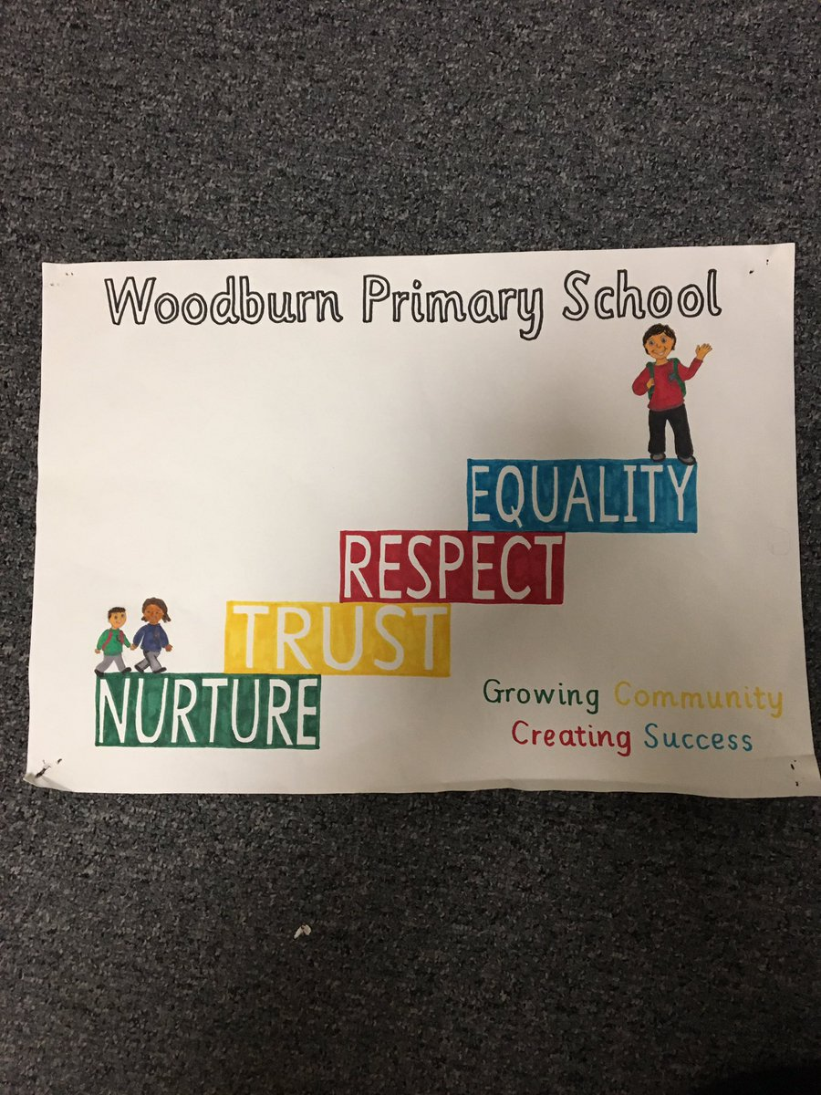

**Aims:**

**With our Vision and Values at the centre of our work and in partnership with our children, families and wider community we aim for our learners to:**

## Enjoy learning and strive to achieve more than they have before.

1. *Acquire knowledge and skills to apply learning in school and beyond.*
2. *Be responsible global citizens**who take responsibility for themselves, their actions and their behaviour.*

### 5.

**Parent/Carer Involvement**

Everyone at Woodburn firmly believes that in order for children to reach their potential, parents/carers and school need to work closely together. We place considerable value on building partnerships through effective communication. Parents are always welcome at our school, and are kept informed through our website, school app phone calls, newsletters, etc. All concerns will be dealt with promptly.

**Parent Partnership**

The Scottish Schools (Parental Involvement) Act 2006 requires the Education Authority to support the establishment of a Parent Council for every primary, secondary and special school.

The Act aims to help all parents to be:

* involved in their child’s education and learning;
* welcomed as active participants in the life of the school; and
* encouraged to express their views on school education generally and work in partnership with the school.

At Woodburn our Parent Council is known as The Parent Partnership. Parent Partnership members are selected from the members of the Parent Forum which is made up of all the parents with children in attendance at the school. Midlothian Council has developed guidance for Parent Councils including a support pack to assist with the establishment of a Parent Council.

We have a very supportive Parent Partnership, who always welcome and actively encourage new members to join. They assist in fund raising, activities and are involved in our school’s decision making processes.

**6.**

**Complaints Procedure**

## How we will respond to your complaint

### Stage 1 - Frontline resolution

When you contact us we will aim to resolve your complaint. If we can't resolve it at this stage, we will explain why and tell you what you can do next.

We will give you our decision in 5 working days or less, unless there are exceptional circumstances.

### Stage 2 - Investigation

Unresolved complaints at stage 1, or complex complaints requiring a detailed investigation are called stage 2 complaints.

We will:

* acknowledge receipt of your complaint within 3 working days
* discuss your complaint with you to understand why you remain dissatisfied and what outcome you are looking for
* give you a full response to the complaint as soon as possible and within 20 working days

We will tell you if our investigation is going to take longer than 20 working days and will agree a revised date with you.

## Confidentiality

Your complaint will be kept confidential.  Details will only be given to those people who need to know in order to investigate your complaint.

## 6 month time limit

You must make your complaint within 6 months of:

* the event you want to complain about, or
* finding out that you have a reason to complain

If you feel that the time limit should not apply to your complaint, please tell us why.

### If you are still not satisfied

If you are unhappy with the way we dealt with your complaint, [contact the Scottish Public Services Ombudsman](http://www.spso.org.uk/contact-us).

***7.***

### Curriculum

### Learning in School

Woodburn Primary School strives to provide a stimulating, safe, secure and caring atmosphere through which children can derive a sound solid education. Each child is to be valued as an individual and work is provided which extends the child to the best of its ability. The curriculum is designed to provide learners with opportunities to help them become:-

Successful Learners

Confident Individuals

Responsible Citizens

Effective Contributors

To help us achieve this we are working to ensure that we provide opportunities for Active Learning. Within this, our programmes of work are designed to allow the children to take an active part in their learning. This is achieved through investigation, enquiry, questioning and practical involvement both teacher led and independently by the children.

Each child is assessed on an on-going basis to determine his or her strengths and next steps. Children are fully involved in discussions about their learning and progress.

Intrinsic to the education on offer within the school is the need to build on the partnership between home, school, and community. Links, which allow the child to take an active part in and understand the community/environment in which he/she lives, are encouraged. As such the school is seen as belonging to the community, and parents and others interested in the school are encouraged to visit and use the facilities within the school.

Through the Curriculum for Excellence, young people will be given the best possible chance to realise their potential for a successful future. Excellence in education means putting the learner first and equipping every young person with the knowledge and skills most suited to their particular talents and aspirations. A strong emphasis is placed on literacy, numeracy, citizenship, enterprise, health and wellbeing and the essential skills for life and work.

The curricular areas included within our 3-18 curriculum are:

**Literacy and English**

Learning and teaching within Literacy and English promotes the development of critical and creative thinking as well as competence in listening and talking, reading and writing.

Pupils have the opportunity to spend time with stories, literature and other texts which enrich their learning, develop their language skills and enable them to find enjoyment. Spoken language has particular importance in the early years. Teachers balance play-based learning with more systematic development and learning of skills and techniques for reading, including phonics.

Links to relevant, real-life and enjoyable contexts which build upon children’s own experiences are fully utilised.

***Reading***

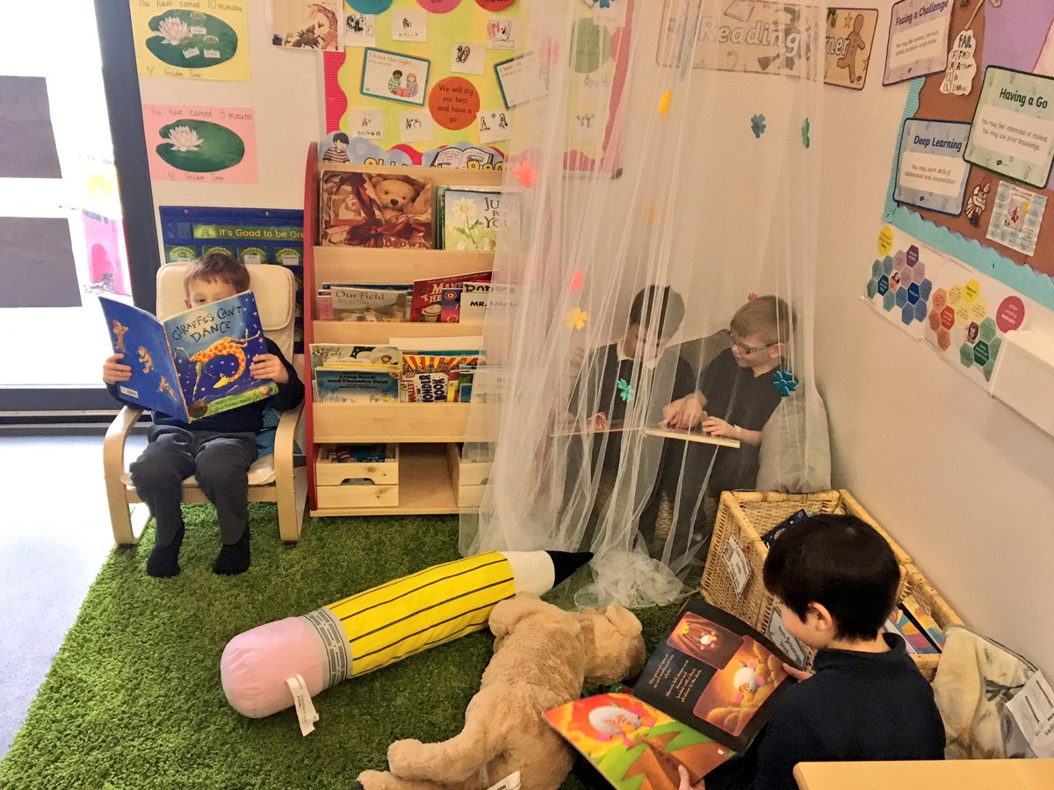From the earliest years children will have been used to looking at pictures, listening to stories and talking to adults about what is happening in the story. They should see books as a source of pleasure and enjoyment. Children should have regular opportunities to hear stories, look at pictures and discuss books. Research has shown that a variety of approaches should be used to teach reading.

Children are provided with colourful high quality reading materials, which stimulate them to want to read, and which offer them success at an early stage. Parents can best help their children by showing an interest in the books the children bring home from school, doing reading homework regularly and by sharing stories and books as often as possible.

***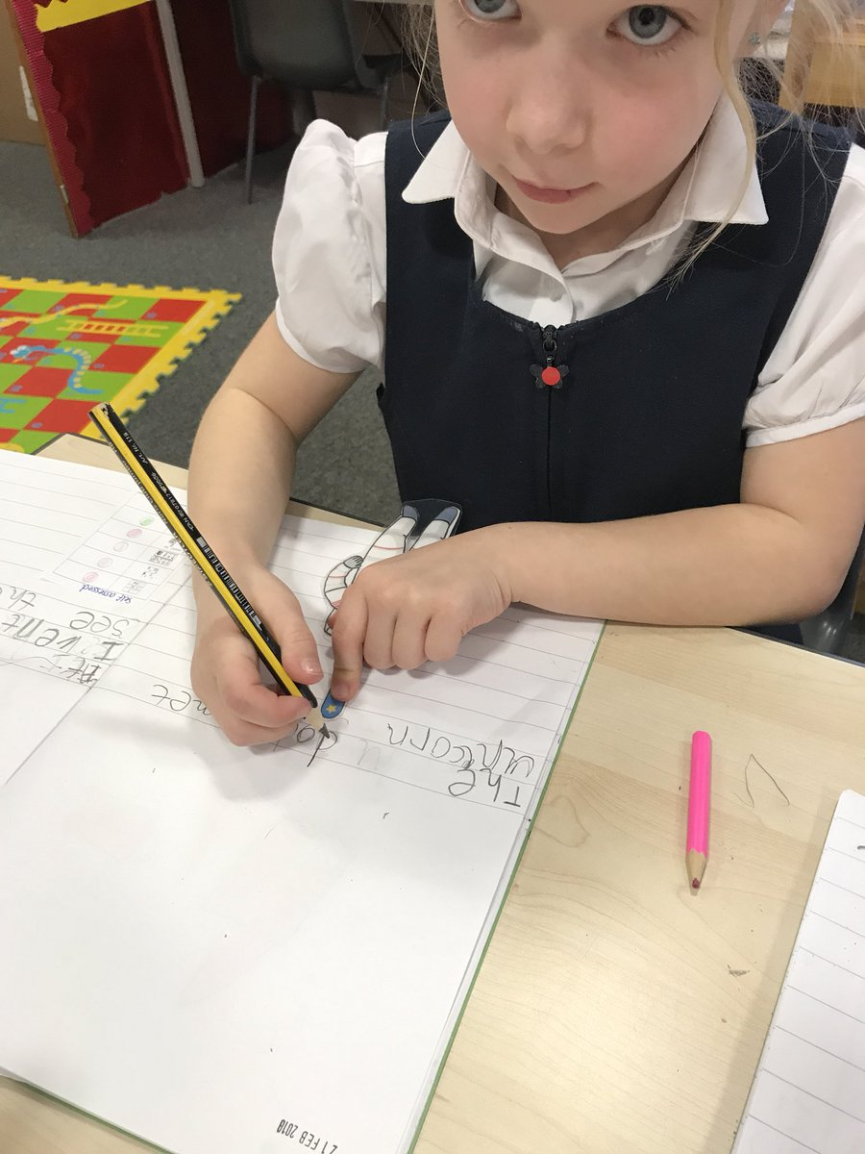Writing***

There are many activities involved in writing including thinking, planning, using imagination, spelling, grammar, punctuation and handwriting. In school we try to develop all of these areas and build children’s confidence in their abilities. Children are encouraged to work together, to share their writing with others, to display their efforts, and to publish their writing to a wider audience.

***Listening and Talking***

These areas are very much linked. In school we help children to develop listening skills - listening to the teacher, listening to each other or listening for a specific piece of information. Children are encouraged to talk in order to build up their communication skills, to develop their ability to explain themselves orally, and to learn and use new vocabulary.

**Modern Languages**

Children from Primary 1 are taught French. Our main emphasis is to teach in an enjoyable, active and motivating way through the provision of a wide range of activities, including games, songs, role play and story telling as well as direct teaching of vocabulary and language structures. There are also opportunities for children to access Spanish.

**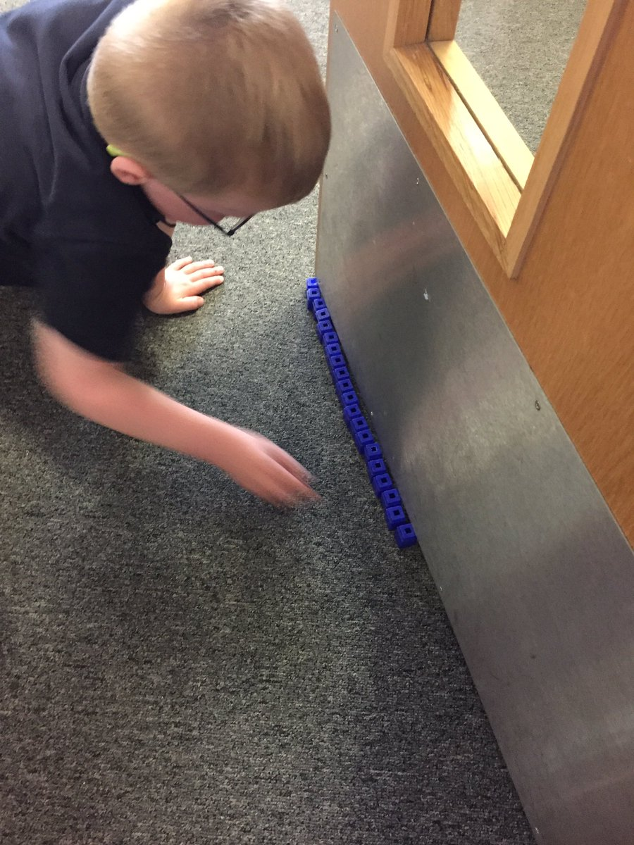**

***Mathematics - Numeracy***

Mathematics consists of four aspects:-

* Number, Money and Measure
* Shape, Position and Movement e.g. turning left or right, angles
* Information Handling e.g. collecting information, tallying, making graphs
* Problem Solving and Enquiry

From the early stages onwards children experience a range of active, fun and collaborative approaches where they explore and apply mathematical concepts. This allows them to develop the confidence to take risks, ask questions and explore alternative solutions. Learning takes place through other curricular areas, particularly Social Studies, Technologies and Science.

***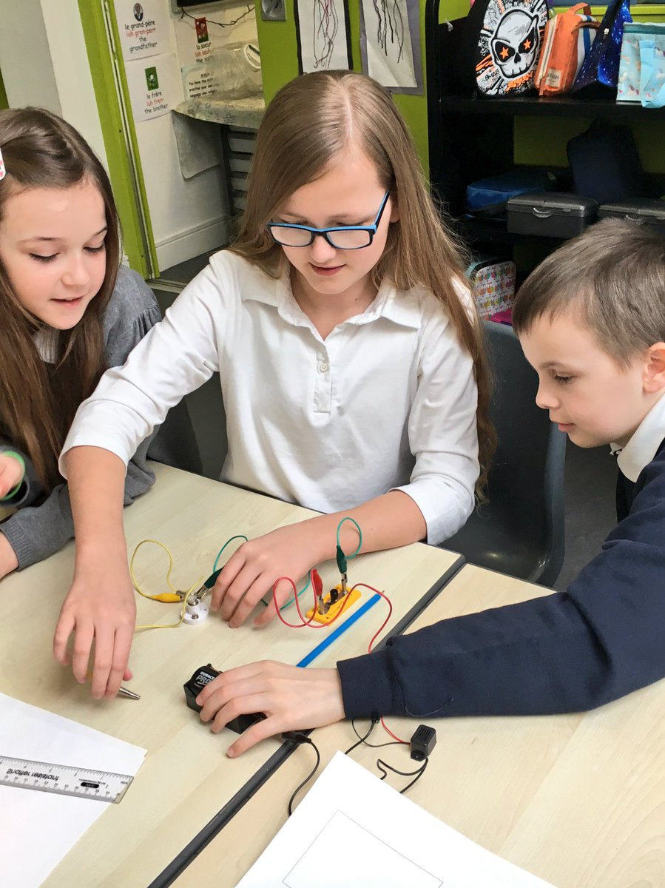***

**Social Studies and Science**

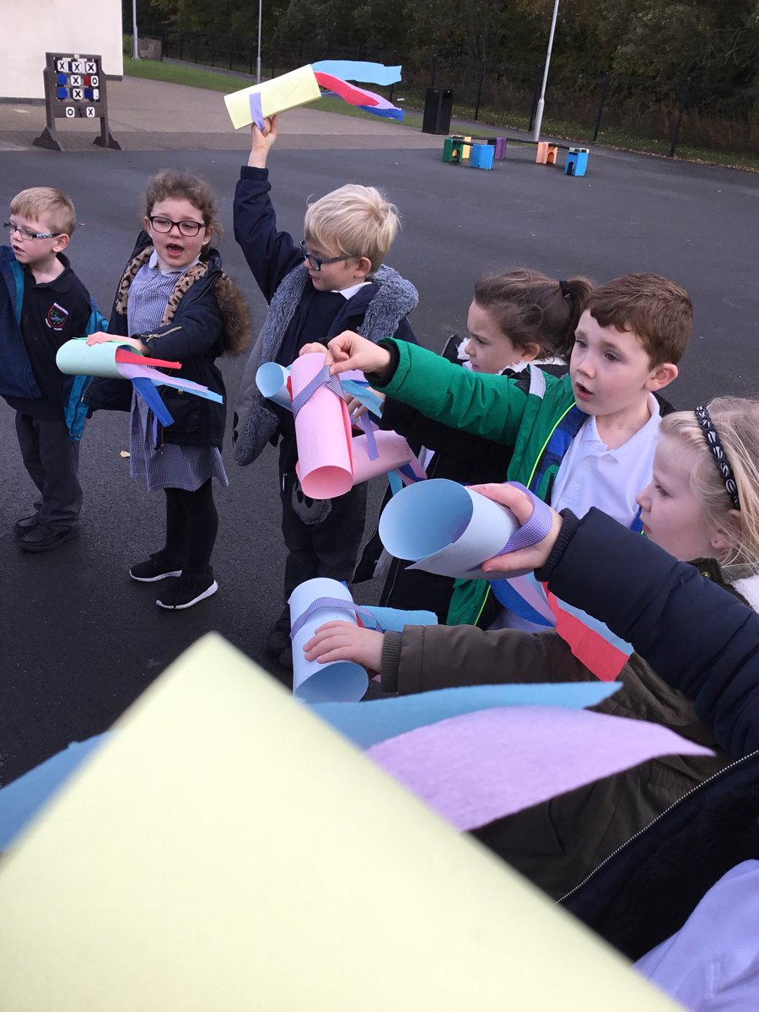Our curriculum provides for the study of Social Studies and Science within interesting and stimulating topics or themes. They are planned creatively to provide for the development of knowledge and understanding of scientific technological principles. They encourage the children to adopt informed values and attitudes to the environment and towards their own health and wellbeing. Local and global citizenship education including Eco-Schools, Rights respecting Schools and understanding the importance of Fairtrade all form a crucial part of the school curriculum.

Links to other areas of the curriculum are made where possible and educational visits to enhance children’s’ learning experiences are carefully planned. Within topic work the contribution of parents, families and the wider community is welcomed.

**Technologies**

Technologies include:

* Digital Literacy

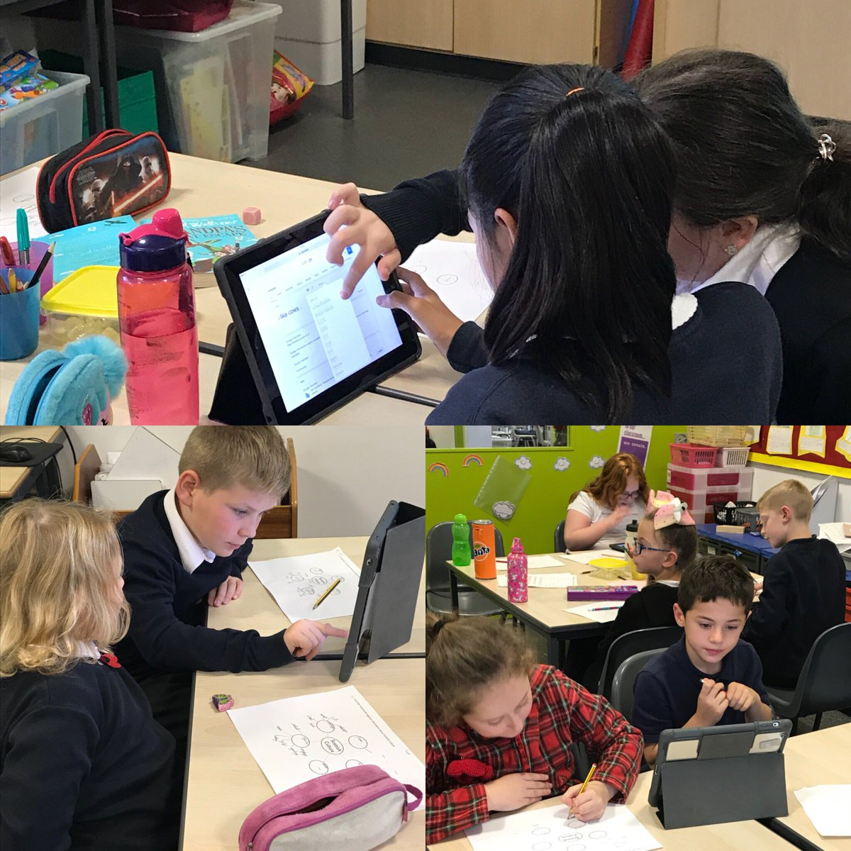Technological Developments in Society and Business

* Computing Science
* Food and Textiles Technologies
* Craft, Design, Engineering and Graphics.

Well-designed and practical activities in the technologies offer children the opportunity to develop a range of skills in using tools, equipment, software and materials and to become critical thinkers through exploration and discovery in a range of learning contexts.

Use of the technologies are integrated into many curricular areas to ensure they are taught in a meaningful context. We encourage our children to become independent in their use of the technologies and we have a well-equipped computer suite and atrium to support their learning.

**Health & Wellbeing**

Health education includes physical, emotional and social health. We aim to promote the importance of developing a healthy lifestyle.

There are Personal Safety Programmes in operation throughout the school. The importance of road safety is stressed at all the appropriate stages and the Police pay regular visits to the school to talk to the children about road and personal safety. Personal and Social Development permeates the whole school curriculum and is taught specifically through programmes such as Creating Confident Kids and Emotion Talks.

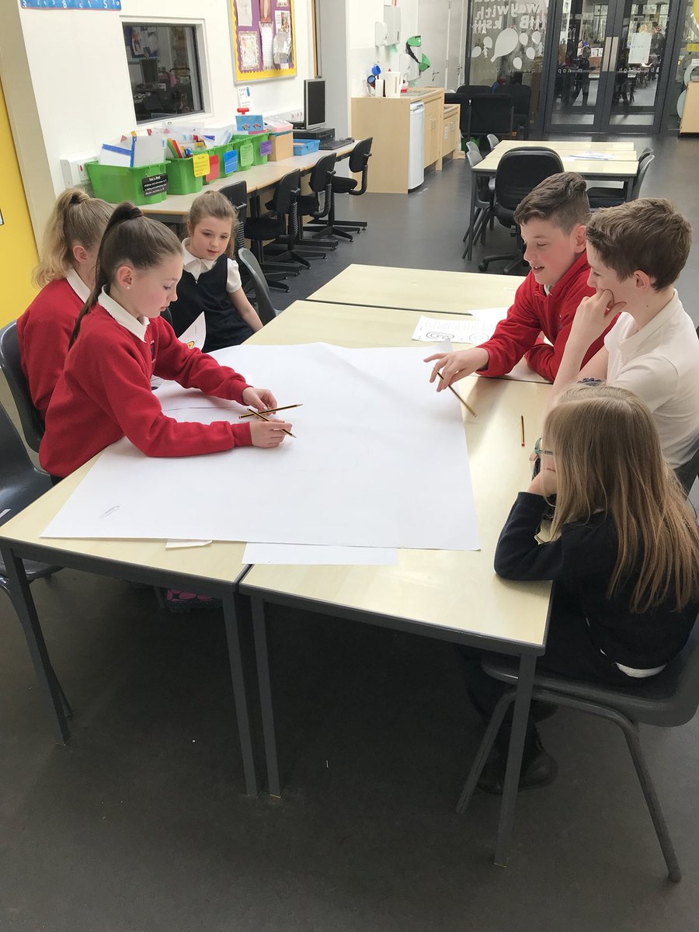Through the learning and teaching opportunities we provide, we aim to help pupils to take increasing responsibility for their lives and to develop a positive regard for others and their needs. There are meaningful opportunities for pupil participation; Primary 7 Prefects, House Captains, Shared Reading Buddies, Pupil Learning Council, Eco Group, Rights Respecting Schools Steering Group and Junior Road Safety Officers.

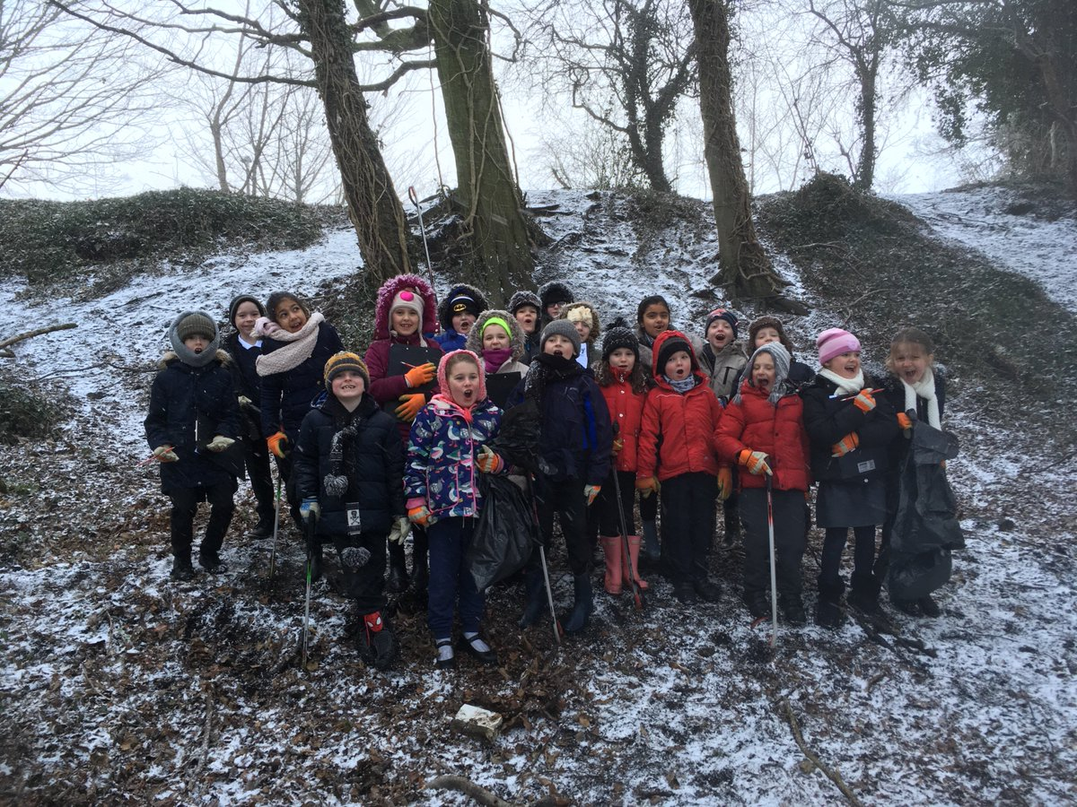Outdoor education supports the health and wellbeing of pupils and links to learning in other curricular areas.

Physical Education includes gymnastics, games and athletics. We have a PE specialist who takes classes in school. Children have the opportunity to take part in a range of competitions including football, rugby, cross country and athletics. Primary 4 pupils have swimming lessons for part of the year. The children are encouraged to see PE as part of a whole school health and fitness programme. Parents can support the school by ensuring that children bring their PE kit for lessons.

**Expressive Arts**

Art, Music, Drama and Dance play an important part of our pupils’ development. Through this area of the curriculum, pupils are encouraged to shape, make sense of and express their personal experience, to develop their aesthetic awareness and their communication skills and to appreciate the importance of wellbeing; physical, mental and emotional.

***Art and Design***

Pupilsat all stages will have opportunities to draw, paint, make models, use clay and look at the work of artists. Pupils will be encouraged to use their imagination and their own ideas. We aim to develop a visual awareness of colour, tone, line, shape, form and pattern.

***Drama***

Drama has links with Language work. Pupils will develop their understanding of the world, by talking and exploring ideas through acting out different situations. They will be involved in role play and may make up their own sketches or plays.

***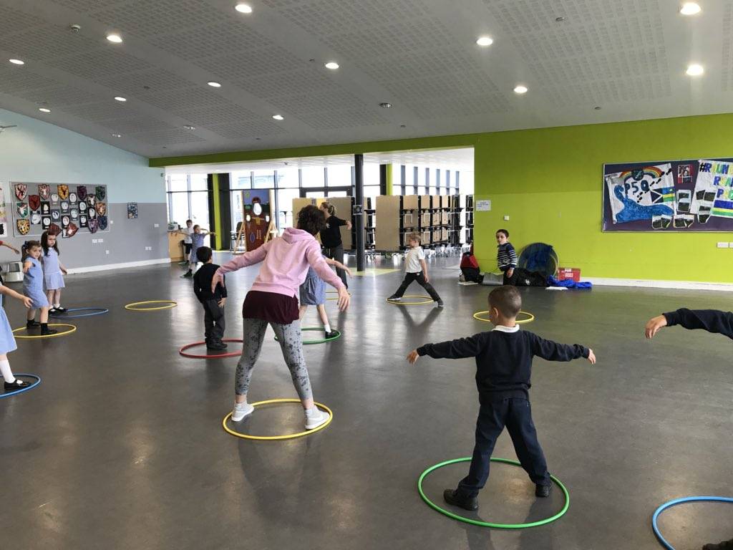***

***Dance***

Through dance, pupils have rich opportunities to be creative and to experience inspiration and enjoyment. Creating and performing are the core activities for all learners, and taking part in dance contributes to their physical education.

***Music***

Pupils will be involved in a number of activities; singing, playing instruments and composing their own pieces of music. We have a Music specialist and there are instructors of brass, violin and cello.

**Religious and Moral Education**

Children learn about a number of world religions including Christianity. The ideas of caring for others, sharing and tolerance are developed in this area of the curriculum. Children attend regular assemblies and Citizenship Gatherings. There is often a focus on learning in its broadest sense and pupils’ achievements are celebrated.

The law allows parents the right to withdraw without detriment, a child from any religious observance or religious education, and parents are encouraged to discuss their wishes with the Head Teacher.

#### **https://pbs.twimg.com/media/Dedwe0zX4AEwc-3.jpgHome Learning**

It is school policy to give the children work to do at home which practises, and reinforces work being carried out in class. Home Learning helps develop good study skills as children progress through their primary stages and on to High School. Home Learning also provides opportunities for parents to work with their child and to be included and involved in what he/she is doing in school. Information from each class teacher is sent out near the start of each session, identifying the forms of learning parents can expect to see throughout the session, together with suggestions on ways of supporting their child.

If your child experiences difficulties with Home Learning at any time please contact the class teacher so we can resolve the matter as quickly as possible. We do run a Home Learning Club in school, this is supported by ‘Storehouse’.

Home learning is not normally allocated at weekends or for holiday absence during term time.

**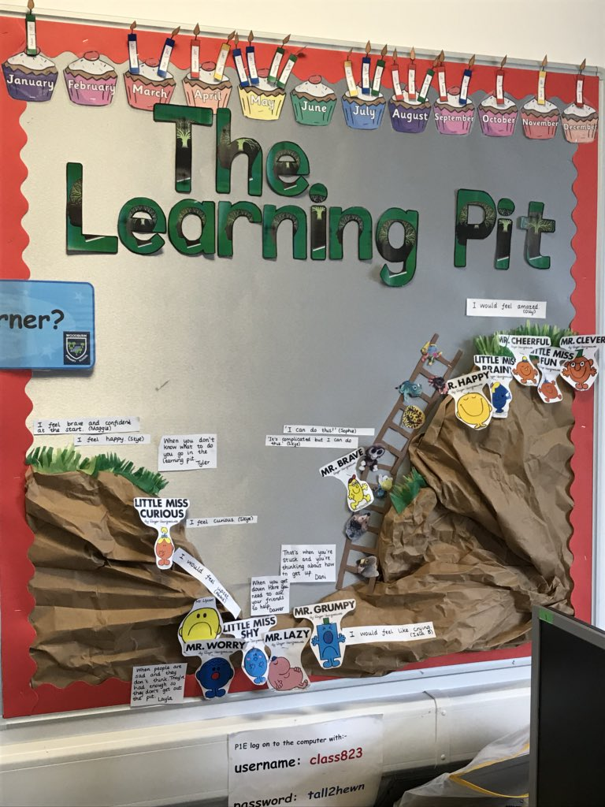Woodburn Learning Skills**

At Woodburn we focus on different learning dispositions that encourage children to develop a growth mindset where they know that learning from mistakes is good, what to do when faced with different challenges and how to work together as a team.



**8.**

**Assessment and Reporting on Pupil Progress**

Reflecting the principles of *Curriculum for Excellence*, progress is now defined in terms of ‘how well’ and ‘how much’ as well as learners’ rate of progress. This approach promotes breadth and depth of learning, including a greater focus on the secure development of skills knowledge and understanding, attributes and capabilities across the full range of the curriculum.

In *Curriculum for Excellence*, the standards expected for progression are indicated within a series of Experiences and Outcomes at each level. The levels represent the breadth and depth of learning to be experienced by young people, typically over a three-year period.

***Attainment Levels***

Within the Curriculum for Excellence stages of attainment are set out in levels of increasing demand.

|  |  |
| --- | --- |
| **Level** | **Stage** |
| **Early** | The pre-school years and P1, or later for some. |
| **First** | To the end of P4, but earlier or later for some. |
| **Second** | To the end of P7, but earlier or later for some. |
| **Third and Fourth** | S1 to S3, but earlier for some. The fourth level broadly equates to SCQF level 4. |
| **Senior phase** | S4 to S6, and college or other means of study. |

Teachers assess in a range of ways as part of the normal learning and teaching process; for example through observing learners carrying out tasks and in their making and doing; by monitoring their writing and in evaluating their responses. Teachers get to know children’s strengths and needs and involve them in planning their learning. Pupil peer and self-assessments are used throughout the school to encourage pupils to identify their own targets and next steps. Effective ongoing assessment establishes where children and young people are in their learning, where they are going and how best to get there. Our teachers use the evidence about learning to provide useful feedback to learners, to adapt learning and teaching approaches to meet their needs and to revisit areas where learning is not yet secure.

**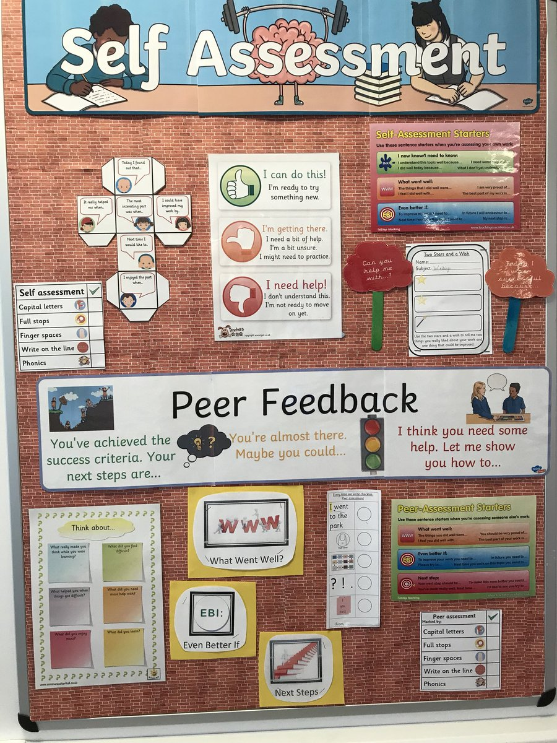Sources of evidence** can include:

* observations of learners carrying out tasks and activities , including practical investigations,
* performances, oral presentations and discussions
* records (oral, written, audio-visual) created by children and young people
* self-assessment and/or peer assessment or may be assessed by the teacher
* information obtained through questioning in high quality interactions and dialogue
* written responses
* a product, for example, piece of artwork, report, project
* accounts provided by others (parents, other children or young people, or other staff) about what learners have done

We use a range of strategies to assist teachers in assessing initial stages of learning.

We have individual tracking of pupil progress and attainment in place throughout the school. We also carry out Standardised Assessments a different stages across the school.

We have three formal parental consultation sessions each year, in addition to Shared Learning Events. During the 2019-2020 we are also implementing SeeSaw, an online platform to share and celebrate a child’s learning with home.

In respect of any Additional Support Needs, arrangements to meet are agreed in discussion between home and school. It is our school approach to contact parents/carers at an early stage to support a pupil’s learning and /or pastoral needs, should there be a concern over any aspect of a child’s progress and wellbeing.

**9.**

**Support for Pupils**

**Pupils with Additional Support Needs – An Inclusive School**

When a pupil requires additional support in order to access learning, their needs will be identified and addressed using Midlothian’s Assessment and Planning Staged System (MAPSS). Some interventions may be short term; others will last longer and may be long term. Pupils may be referred for support from services external to the school, including through a multi-agency forum. Some children with additional support needs will require an Individual Education Plan, Child and Young Person’s Plan or a Co-ordinated Support Plan. Reviews are held three times a year for these children and may involve other professionals and agencies. All parents and children will be involved in setting and reviewing targets. The views of parents and children are gathered annually and the feedback is used to improve our services.

We have a fulltime and two part-time Support for Learning Teachers who provide support and advice for staff and parents. We have a skilled team of Learning Assistants who provide support for children across the school.

We work well with a range of other professionals to ensure that children and families are effectively supported. These include; the Education Psychology Service, Speech and Language, Occupational Therapists, the Child and Adolescent Mental Health Service and Community Child Health. We also have effective links with Children and Families and Life Long Learning and Employability.

Parents are entitled to request additional assessment by contacting the school in the first instance, a request can also be made in writing to the ASN Officer, Education and Children’s Services Division, Fairfield House, 8 Lothian Road, Dalkeith EH22 3ZG.

The Council’s policy “Education for All” provides a framework for full and effective inclusion of pupils who have additional support needs. Further information is set out in ‘Education for All: a guide for parents, carers and young people’, and is available from school. The authority keeps the additional support needs of each such child and young person under consideration through the Midlothian Assessment and Planning Staged System (MAPSS) process. The additional support needs of these identified children and young people are recorded on Seemis, the authority’s secure management of informationsystem*.*

Organisations specified by Scottish Ministers which provide advice, further information and support to parents of children and young people with ASN are identified under ‘The Additional Support for Learning (Sources of Information) (Scotland) Amendment Order 2011’ as:

* + 1. Children in Scotland: Working for Children and Their Families, trading as “Enquire – the Scottish advice and information service for additional support for learning”, a charitable body registered in Scotland under registration number SC003527;
    2. Scottish Independent Advocacy Alliance, a charitable body registered in Scotland under registration number SC033576; and
    3. Scottish Child Law Centre, a charitable body registered in Scotland under registration number SCO12741.

**10.**

**School Policies and Practical Information**

### Assistance with Provision of Clothing and Footwear

The Authority operates a scheme for clothing grants to assist parents in ensuring that a pupil is sufficiently and suitably clothed to take full advantage of the education provided. Families in receipt of Income-based Job Seekers allowance, on Income Support or Child Tax Credit but not Working Tax Credit (subject to a maximum annual income), both maximum Child Tax Credit and maximum Working Tax Credit (subject to a maximum annual income) or support under Part V1 or the Immigration and Asylum Act 1999 will automatically qualify for such a scheme. Other cases will be determined according to the personal circumstances of the family. Parents who wish to apply for the scheme should complete an application which is available from the school or the Education and Children’s Services Division, Fairfield House, 8 Lothian Road, Dalkeith, EH22 3ZG.

### Arrangements for School Meals and Milk

Milk is provided for all children at a current cost of £32.30 per year and this money is collected termly or if preferred a payment for the full school session can be made in August. Free milk is available to all children in nursery class and to children whose parents are entitled to free school meals.



Woodburn is a Health Promoting School and lunches on offer are nutritiously balanced. The school has a tray system in operation offering a choice of hot meals and snacks. Children not eligible for free meals are able to buy lunch for £2.10. There is also space set aside in our dining hall for any child who brings a packed lunch.

Our popular Breakfast Club, provides a nutritious breakfast free for children in receipt of free school meals, or at a cost of 70p for all others.

Please note, while the Breakfast Club may support childcare, the main purpose is to ensure that children have access to a nutritious breakfast. It is therefore expected that all children attending will eat breakfast.

**Parent Pay**

A system for electronic payment of dinner money, school trips etc. is now in place. Please ask at the office for further information and guidance

**School Medical Services - Roles and Responsibilities**

bd00038_Throughout their time at school a team of specialist Health Service and Education staff will see children as part of a planned programme to make sure that they benefit as much as possible from all that school has to offer, and to help prepare them for life after leaving school. The school health service is part of Midlothian’s Community Child Health Service and has direct links with those who carry out health checks on children before they start school.

Many different services are provided. The issue of maintaining confidentiality is taken seriously by the School Health team at all times. The staff involved make every effort to work closely with parents and with others who are caring for your child, both at school and in other branches of the Health Service. Some of the services, e.g. testing of vision in Primary 1, are normally provided to all children on a routine basis to discover which children may need further tests or treatment. Parents are not necessarily notified at the time of these screening tests and any parent who does not want a child to be included should notify the school at the beginning of the session. Naturally, if treatment is thought to be required, parents will be informed and consent requested. If you have any concerns about your child’s vision please contact the school nurse who will arrange to test vision or alternatively you can take your child to a local optician (optometrist).

**Some of the staff concerned and the parts they play are as follows:-**

**The school nurse** is the lead professional in mainstream schools in Midlothian. School nurses are involved with health promotion and education, prevention of ill health, immunisation, health surveillance and screening. The school nurse may be helped by a health assistant and have close working links with Community Paediatricians.

The school nurse reviews the notes of all children in Primary 1 as well as those of all new entrants. A member of the school health team measures their growth and tests vision. The school nurse will assess these measurements and results. In addition she may review children who are referred either by parents, teachers of other health professionals at any stage in their school life.

Every opportunity is taken to provide pupils with access to confidential support and advice from the school health team throughout their school career.

Parents are also asked to complete a health questionnaire about their child at Primary 1 and Primary 7. Any specific conditions can be raised at that point.

If you have concerns about your child’s hearing the school can refer him or her to the appropriate specialist directly.

**The Speech and Language Therapist** can provide assessment and, if necessary support if you, a teacher, your GP or the school doctor feels that your child may need help with communication. Appointments are normally arranged at the local Speech and Language Therapy clinic with follow-up at school if required. Speech and Language Therapists work closely with school staff and support is often provided as part of a Learning Support programme.

In conjunction with the class teacher and Support for Learning Teacher, referrals to other agencies such as Occupational Therapy, Physiotherapy, Child Community Health, Midlothian Educational Psychology Service or Child and Adolescent Mental Health may be made.

Any enquiries concerning the provision of dental services should be made to the Director of the Community Dental Service, 16 Duncan Street, Edinburgh, EH9 1SR (Tel. 0131 667-7114).

We hope that the School Health Service can, together with yourselves, contribute to your child’s overall well-being and development. Please do not hesitate to arrange through the Head Teacher to see the school doctor, school nurse or the health visitor if you want any information.

**Illnesses and Accidents**

When a child falls ill or has an accident during the school day, a parent or the emergency contact is notified and should make arrangements for the child to be collected. In the case of minor accidents, First Aid will be administered and contact will be made with a parent or emergency contact for a bump to the head.

Where a child has a contagious condition which may lead to others being affected, parents should notify the school. The school follows NHS guidance for periods of absence related to a contagious illness.

It is necessary for parents to inform the school of any special medical conditions or requirements, particularly conditions which may require essential or emergency administration of medication. Where a child has a particular medical need, the School Nurse will meet with the family and a member of the Senior Leadership Team to put a Care Plan in place.

If your child requires medication during the school day, parents are required to sign a consent form (held in the school office) giving permission for a member of staff to administer the medication.

**Health and Safety**

Midlothian Education Division requires School Handbooks to include the following statement:

***“The Education and Communities Division has prepared policy statements on Health and Safety for all areas of its responsibility in accordance with the Health and Safety at Work Act 1974. Schools staff are fully instructed in their responsibilities in this respect, and safety regulations apply to all aspects of school life, both on and off the premises. It is expected that pupils will behave responsibly and comply with all safety requirements. The support of parents in promoting good practice in health and safety matters is of great importance to the school.”***

All Midlothian schools have ‘controlled access’ systems. During periods when pupils are in class, visitor access to school and nursery is only available via the reception point in the main building. Visitors are asked to register and are issued with identification badges.

**In addition, with regard to children’s safety, the following points are reinforced:-**

* Pupils must stay within the school grounds at interval and lunchtime, unless they are going home for lunch.
* The school should be informed if a child will be leaving school for lunch.
* If a child has an appointment during school time then someone **must pick the child up from school**. We do not permit children to leave school during school hours by themselves.

**Employment of Children**

Children under the statutory school leaving age can only be employed within the terms of the Council’s bye-laws on the part time Employment of Children. These regulations do not permit the employment of children under 14 years of age, except in specific categories, and for those over that age there are limits on the hours and type of employment which are allowed. Parents and employers must both complete an application form for an employment permit before the employment begins.

Further details can be obtained from the Education Office at Fairfield House.

**Attendance**

Parents/carers are responsible for ensuring that their child attends school regularly. Parents are requested to inform the school if their child is absent or to send a note giving details of any absences. Parents are encouraged to ensure that their child arrives at school on time.

**When pupils are taken out of school during term time, this can have a significant effect on their progress and we strongly encourage parents to take holidays whenever possible during the school holiday periods.**

Attendance is monitored by School staff on a regular basis. In cases of unsatisfactory attendance, parents/carers will normally be contacted by the school in the first instance. Our Youth Worker and Early Years Homelink Worker support children and families to improve attendance.

**Children who are late in the morning should enter the school by the main entrance.**

We realise, however, that there will be occasions when your child is unable to attend school. The following information tells you what to do on such occasions.It also tells you how the school may respond when your child is absent. By following the guidelines below, you will help us to make sure that your child is safe.

***What do I do if I know my child is going to be absent from school, for example to see a doctor or dentist?***

You should tell the school the date(s) and the reason, as soon as you know. That way, the school will know not to expect your child on that date. You can tell them by phone call, letter or e-mail.

***What do I do if my child is going to be absent today, for example, because he/she is unwell?***

You should tell the school before 8.45am. Then the school will know not to expect your child to arrive. You can tell them by phone (0131 271 4715 message service) or e-mail (woodburn\_ps@midlothian.gov.uk).

**We would emphasise that in this situation it is up to you to contact the school. The school will try to contact you if the Head Teacher has reason to believe that you might not know that your child is not at school, but you should not rely on the school phoning as a matter of course. If there is an unexplained absence for your child then the main contact will receive an automated text message advising of this. Someone should then call the school to inform us that you are aware of the absence.**

***What if my child goes missing from school in the course of a day?***

This is unlikely, but if it happens, the school will phone you or the emergency contact whose name and contact numbers you have supplied to the school.

***Can I be sure that the school knows how to contact me if it has to?***

Only if you have given the school your up-to-date contact details. For example, if your contact number is a mobile, and you change your mobile number, you must tell the school. Please do not just assume that the school will find you somehow.

We have tried to make this as clear as possible, but if there is anything you do not understand, or if you want to discuss any issues to do with your child’s attendance at school, please contact the Head Teacher. Please remember that these arrangements are to keep your child safe. We thank you for your help in this.

**Transport**

The travelling expenses of those pupils attending the district school who live more than two miles from the school is met by the authority. Bus passes are issued where public transport exists and contract transport is arranged where there is no suitable public transport. Where there are vacant seats on contract buses, these may be made available to pupils who are attending the district school and who are not normally entitled to free transport. A charge may be made for this.

Travelling expenses are also met in the case of any pupil whom the Authority requires to attend a school other than the district school, if the pupil meets the distance qualification. Where appropriate, free travel is provided for pupils receiving special education. Consideration may also be given to requests for assistance with travel in exceptional circumstances, e.g. where the road between home and school is deemed dangerous by the Authority, and where there is no public transport available.

Parents who choose to send their children to a school other than the district school will not receive assistance in relation to travel to and from school.

##### Child Protection

### The Council has a range of duties and responsibilities in relation to the child protection procedures for all pupils which includes having regard for their right to be protected from harm and abuse. The school’s duties and responsibilities for this are set out in the Edinburgh and Lothians Child Protection Committee’s ‘Child Protection Guidelines’ which are used by all Midlothian schools and our partner agencies. Please find Woodburn’s Child Protection Policy in Appendix 2.

**In circumstances where a school has a significant concern that a child or young person has, or is at risk of being harmed or abused, the school is required to pass information to the Police, Social Work Department and Health colleagues who have a legal duty to investigate further. While we always endeavour to work in an open manner with parents and guardians, there are some circumstances when it may not be appropriate to inform the parent or guardian that a Child Protection referral has been made or that information has been passed on to these agencies. Under these circumstances, the decision as to when and how parents and guardians will be informed is the responsibility of the Police, Social Work and Health Services as part of their investigation and the school will be informed by these services of the action that they have taken.**

Should you wish to discuss this or any associated matter further, please contact the Head Teacher, the school’s designated Child Protection Co-ordinator or the Education Officer, Pupil Support Services.

**Data Policy**

At the time this handbook was updated, General Data Protection Regulation (GDPR) was coming into force and authority policy and guidelines being aligned with this. Please see updated Data and Privacy Policy on the school website or request a copy from the school office.

***The information in this booklet is accurate at the time of compilation, but parents/carers appreciate that changes may take place. Every effort will be made to keep you informed of any changes via our school app, the school website, twitter, and newsletters.***

***Appendix 1.***

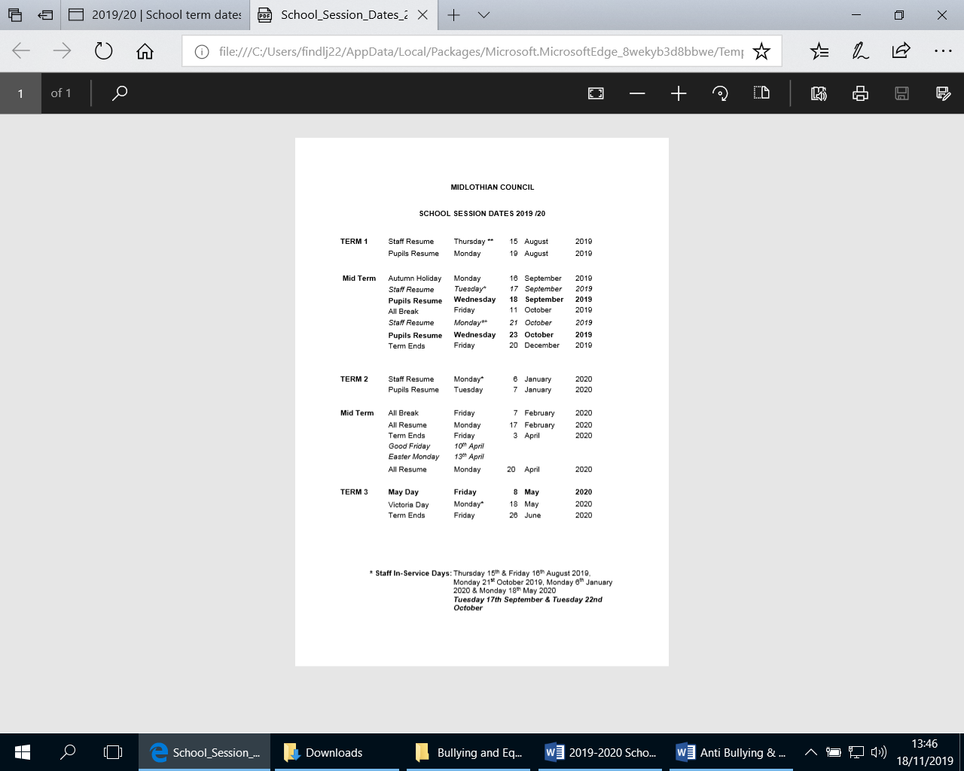

***Appendix 2.***

**Woodburn Primary School**

**Child Protection, Safeguarding and Wellbeing Policy**

This policy applies to all staff and volunteers.

We are committed to practice in a way that protects all children and young people and fully adhere to the processes and procedures contained within Edinburgh and Lothian’s Inter-Agency Child Protection Procedures 2015 <http://emppc.org.uk/file/Child_Protection/Inter-agency_Child_Protection_Procedures_-_Edinburgh__the_Lothians_Oct_2015.pdf>

The purpose of this policy is;

* to protect children and young people attending Woodburn Primary School Nursery .
* to provide staff and volunteers with the overarching principles that guide our approach to safeguarding and child protection;

Staff at Woodburn Primary School believe that a child or young person should never experience abuse of any kind. We have a responsibility to promote the welfare and wellbeing of all children and young people and to keep them safe.

**Legal Framework**

This policy has been drawn up on the basis of law and guidance that seeks to protect children, namely:

* National Guidance for Child Protection (2014) <http://emppc.org.uk/file/Child_Protection/Scottish_Government_-_National_guidance_for_CP_in_Scotland_2014.pdf>
* Inter-agency Child Protection Procedures – Edinburgh and the Lothian’s (2015)

<http://emppc.org.uk/file/Child_Protection/Inter-agency_Child_Protection_Procedures_-_Edinburgh__the_Lothians_Oct_2015.pdf>

* Getting it Right for Every Child Policy

<http://www.gov.scot/Topics/People/Young-People/gettingitright>

* Children and Young People (Scotland) Act 2014

<http://www.legislation.gov.uk/asp/2014/8/contents/enacted>

* National Framework for Child Protection Learning and Development in Scotland (2012)

<http://www.gov.scot/Topics/People/Young-People/protecting/child-protection/national-framework-cp-learning-2012>

* Protection of Vulnerable Groups (Scotland) Act 2007

<http://www.gov.scot/Publications/2011/08/04111811/1>

* United Nations Convention on the Rights of the Child

<http://www.unicef.org.uk/UNICEFs-Work/Our-mission/UN-Convention/>

This policy should be read alongside our policies and procedures on:

* Equalities, Administration of Medication, Attendance, Whistle Blowing and Managing Allegations against staff.

We recognise that:

* The welfare of the child is paramount, as enshrined in The Children (Scotland) Act 1995
* All children, regardless of age, disability, gender, racial heritage, religious belief, sexual orientation or identity, have a right to equal protection from all types of harm and abuse.
* Some children are additionally vulnerable because of the impact of previous experiences, their level of dependency, communication needs or other issues.
* Working in partnership with children, young people, their parents, carers and other agencies is essential in promoting young people’s welfare and wellbeing.

We will seek to keep children and young people safe by:

* Valuing them, listening to and respecting them
* Appointing a Designated Member of Staff for Safeguarding and Child Protection for the school and also a deputy
* Adopting the processes and procedures contained within Edinburgh and Lothian’s Inter-Agency Child Protection Procedures
* Developing and implementing an effective e-safety policy and related procedures
* Providing effective management for staff and volunteers through training, support and quality assurance measures
* Recruiting staff and volunteers safely, ensuring all necessary checks are made
* Recording and storing information professionally and securely
* Using our procedures to share concerns and relevant information with agency’s who need to know, and involving children, young people, parents, families and carers appropriately.
* Using our procedures to manage any allegations against staff and volunteers appropriately
* Creating and maintaining an anti-bullying environment and ensuring that we have a policy and procedure to help us deal effectively with any bullying that does arise
* Ensuring that we have effective complaints and whistle blowing measures in place
* Ensuring that we provide a safe physical environment for our children, young people, staff and volunteers, by applying health and safety measures in accordance with the law and regulatory guidance
* Sharing information about safeguarding and good practice with children, their families, staff and volunteers via leaflets, posters, one to one discussions

Contact details

The Designated Member of staff for Safeguarding and Child Protection at

Woodburn Primary School is:

Name: Joanna Findlay (Head Teacher)

Phone/email: 0131 271 4715 / woodburn\_ps@midlothian.gov.uk

The Deputy Designated Members of Staff for Safeguarding and Child Protection are:

Name(s): Susan Welsh (Depute Head Teacher)

Phone/email: 0131 271 4715 / [woodburn\_ps@midlothian.gov.uk](mailto:woodburn_ps@midlothian.gov.uk)

We are committed to reviewing our policy and good practice annually.

This policy was last reviewed: August 2019

Signed: Joanna Findlay

***Appendix 3.***

****

**PREVENTING BULLYING AND PREJUDICE POLICY**

**What Is bullying?**

Bullying is an abuse of power that is defined by its effects. People who are bullied are seriously upset by something someone else has done or said to them or about them. They are likely to fear that this will happen again and feel powerless to stop it.

Woodburn Primary has adopted the definition of the national anti-bullying organisation, ‘Respect Me’ which states that bullying might include one-off or unintentional incidents. Bullying is also a breach of children’s rights under several articles of the Convention on the Rights of the Child.

“Bullying behaviour” is a more useful term than ‘bully’ to avoid labelling individuals as this tends to become fixed. “Person being bullied/picked on/isolated” or “person on the receiving end of bullying behaviour” is used as an alternative to “victim” for the same reason.

Bullying can be:

* Emotional being unfriendly, excluding, tormenting, intimidating (e.g. hiding books, threatening gestures)
* Physical pushing, kicking, hitting, punching or any use of violence
* Racial taunts, graffiti, gestures or exclusion
* Sexual unwanted physical contact or sexually abusive comments
* Homophobic because of, or focussing on the issue of sexuality
* Verbal name-calling, sarcasm, spreading rumours, teasing
* Cyber All areas of internet ,such as email & internet chat room misuse Mobile threats by text messaging & calls Misuse of associated technology , i.e. camera &video facilities
* Sport bullying during sports activities can take the all of the above forms
* Gangs groups carrying out the above forms of bullying.

**Prejudice**

People with particular characteristics are protected from discrimination by the Equalities Act 2010. They are:

* Disability
* Gender Reassignment (people at any stage in the process of gender change)
* Race
* Religion or Belief
* Sex
* Sexual Orientation

**Why is it important to respond to bullying or prejudice?**

Bullying and prejudice hurts. No one deserves to be a person on the receiving end of bullying or prejudicial behaviour. Everybody has the right to be treated with respect. Pupils who are bullying or being prejudiced need to learn different ways of behaving. Schools have a responsibility to respond promptly and effectively to issues of bullying and prejudice.

**Bullying, prejudice and the law**

* UN Convention on the Rights of the Child
* Offences (Aggravation by Prejudice) (Scotland) Act 2009
* Schools (Consultation) (Scotland) Act 2010
* Equality Act 2010
* In on the Act (Supporting children and young people with additional support needs)When a bullying incident could have serious consequences for the victim

When bullying or prejudice happens out of school, it will inevitably affect relationships within school and the progress of children in school. It is vital for teachers and parents to work in cooperation to stop out of school hours bullying and prejudice.

**What are the signs and symptoms of bullying and prejudice?**

A child may indicate by signs or behaviour that he or she is being affected by bullying behaviour or prejudice. Adults should be aware of these possible signs and that they should investigate if a child:

* is frightened of going to or from school or truants
* changes their usual routine
* becomes withdrawn, anxious or lacking in confidence
* starts stammering
* attempts or threatens suicide or runs away
* cries themselves to sleep at night or has nightmares
* feels ill in the morning
* begins to do poorly in school work
* comes home with clothes torn or books damaged
* has possessions which are damaged or " go missing"
* asks for money or starts stealing money (to pay bully)
* has dinner or other monies continually "lost"
* has unexplained cuts or bruises
* comes home hungry (money / lunch has been stolen)
* becomes aggressive, disruptive or unreasonable
* is bullying other children or siblings
* stops eating
* is frightened to say what's wrong
* gives improbable excuses for any of the above
* is afraid to use the internet or mobile phone
* is nervous & jumpy when a cyber message is received.

These signs and behaviours could indicate other problems, but bullying or prejudice should be considered a possibility and should be investigated.

**Reporting allegations of bullying behaviour or prejudice. What will happen next?**

* Report incidents to the teacher in the first instance. If this does not improve the situation, report the bullying to the head teacher
* The teacher in the first instance will investigate and record the bullying concern. This will involve:
* Asking the person on the receiving end of this behaviour about what has happened
* Asking the person showing bullying behaviour about what has happened
* Asking other children/ adults who may have seen what happened
* Keeping notes on concern form
* Agreeing if this is bullying or not
* Agreeing action to stop the bullying with the person on the receiving end of this behaviour and the person showing bullying behaviour such as checking in each day with both the person on the receiving end of this behaviour and the person showing bullying behaviour, setting limits on the bully’s movements around school for an agreed period, contacting parents and informing them of the bullying and asking for their help in stopping the bullying.
* In cases of bullying, parents of the person showing bullying behaviour and the person on the receiving end of this behaviour will always be informed and/or will be asked to come to a meeting to discuss and agree next steps
* If necessary and appropriate, our professional partners will be consulted (educational psychologist, social work service, police service, health service etc.)

**What will happen to the person showing bullying behaviour?**

* The person showing bullying behaviour will be asked to genuinely apologise. Other consequences may take place.
* In serious cases, exclusion will be considered
* If possible, the pupils will be reconciled
* After the incident / incidents have been investigated and dealt with, each case will be monitored to ensure repeated bullying does not take place. Usually this will be a member of staff checking each day for a period of time with both the person showing bullying behaviour and the person on the receiving end of this behaviour.

**How will we try to stop bullying in the first place? What will we do when it happens?**

School will provide an environment where everyone is safe, respected and included. This will be achieved through the following 3 areas of action.

**1. Ensuring a safe and supportive school where children know we will prevent bullying.**

* ‘Ready to Learn’ Framework
* Class teaching and learning experiences that promote positive peer relations, social skills and resilience
* Health & Wellbeing Education lessons
* Anti-bullying week/ survey every year in October/ November
* Assemblies focussing on anti-bullying during the year
* Circle Time dealing with bullying as appropriate
* Annual monitoring of the anti-bullying policy (including bullying reports) by the school leadership team
* Staff and children will view the playground as an important part of children’s learning where social skills should be developed and alertness for bullying maintained
* Develop play and games in the playground which promote social skills
* Provide safe places for pupils to be when they fear bullying.

**2. Knowing what bullying is and recognising when it is happening. Supporting those involved and stopping the bullying as quickly as possible.**

* Teaching children how to challenge bullying and support victims and bullies
* Adult and peer mediation as a way of resolving bullying
* Restorative Practices training for staff and pupils
* Pupils should always feel they can have incidents listened to/dealt with on a 1 to 1 basis with a trusted member of staff.

3. **Managing incidents that have serious impact on individuals or the school.**

* Staff handling bullying incidents consistently according to school policy
* Staff reporting incidents to the school leadership team using the welfare concern form
* Parents being informed of further incidents of bullying
* Records kept of bullying allegations by the head teacher
* Monitoring of bullying
* Referral to specialist staff of persistent bullying (e.g. behaviour support service).

**Suggested Resources**

|  |  |
| --- | --- |
| Personal, Social and Emotional Education resources | In Health & Wellbeing resources area |
| KIDSCAPE Parents Helpline (Mon-Fri, 10-4) | 0845 1 205 204 |
| Parentline Plus | 0808 800 2222 |
| Bullying Online | http://bullying.co.uk |
| Kidscape | www.kidscape.org.uk |
| Anti-bullying network | www.antibullying.net |

|  |  |
| --- | --- |
| Anti-bullying alliance | www.anti-bullyingalliance.org.uk/Page.asp |
| Anti-bullying week class lessons | www.bratz-toolkit.co.uk/ |
| Anti-bullying week class lessons | http://bullying.co.uk |
| Anti-bullying week activities | www.antibullyingweek.co.uk/ |
| Powerpoint for older children; how to recognize bullying behaviour. Bullying and the law. | www.bullyfreezone.co.uk/downloads.php?s=3&p=1276 |
| Bullying advert movie explaining “Tell someone” (P3-7) | www.dfes.gov.uk/bullying/video.shtml |
| Bullying playscript (bullying and drugs) (P6-7) | www.actionwork.com/freescripts.html |
| Movies where famous actors talk about being bullied at school | www.dfes.gov.uk/bullying/teachersindex.shtml#a |
| Advice on homophobic bullying | www.schools-out.org.uk/ |
| Professional development videos on dealing with bullies | www.teachers.tv/video/browser/1290 |
| Anti-bullying week film (P4-7) www.teachernet.gov.uk/wholeschool/behaviour/tacklingbullying/makingthedifferencefilm/ | |
| Bullying cartoons (USA)  http://stopbullyingnow.hrsa.gov/index.asp?Area=webisodes&webisodes | |
| Professional development for staff on dealing with bullies | www.teachers.tv/bullying/link |

***Appendix 4.***

**Woodburn ‘Ready to Learn’ Positive Behaviour Policy**

**Rationale**

The procedures we have in place to support children at Woodburn in making good behaviour choices and to ensure everyone in our school has the right to be safe and to learn.

**Supporting Readiness to Learn**

Our school ethos and culture ensures we support children’s learning and social & emotional needs. While we recognise that the vast majority of children behave well, like all schools we experience low level inappropriate behaviour and on occasion more challenging behaviours from children experiencing particular difficulties. Within the procedures described below, when a child is experiencing difficulties, the school aims to work together with parents/carers and other professionals where appropriate.

This policy also links with our school’s ‘Preventing Bullying and Prejudice Policy’ which is available on our school website.

Our expectations for everyone in our school are to:

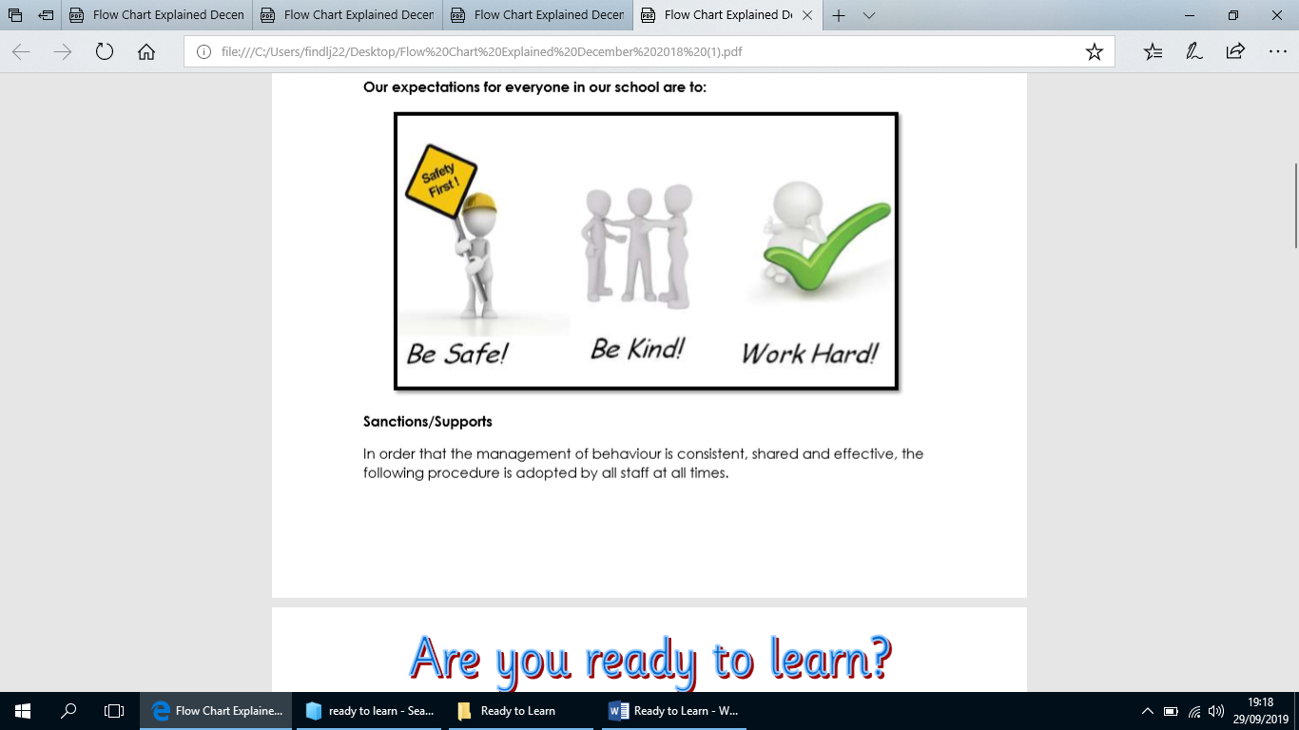

**Sanctions/Supports**

In order that the management of behaviour is consistent, shared and effective, the following procedure is adopted by all staff at all times.

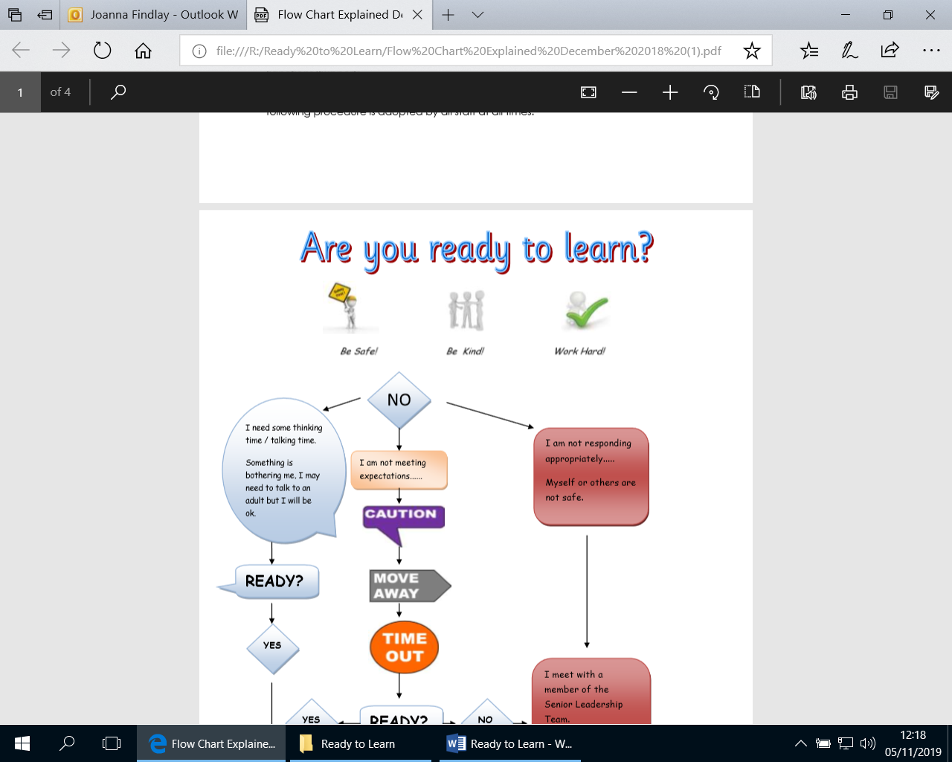

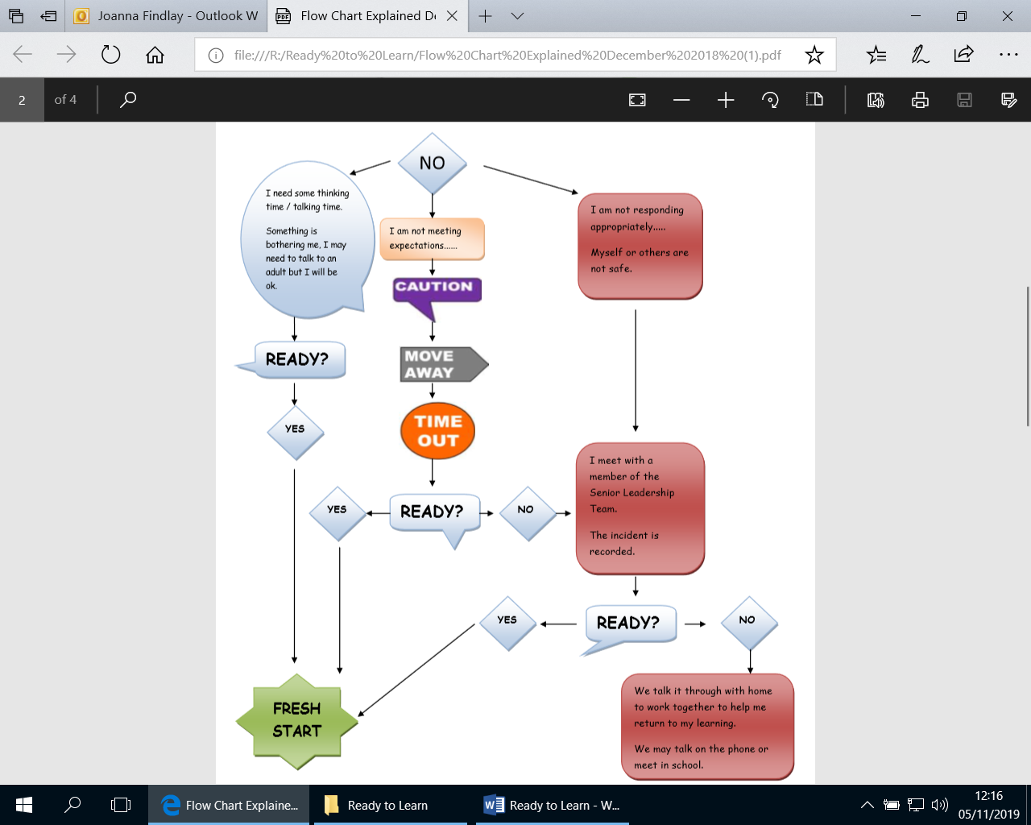

**Flow**

**Chart Explained**

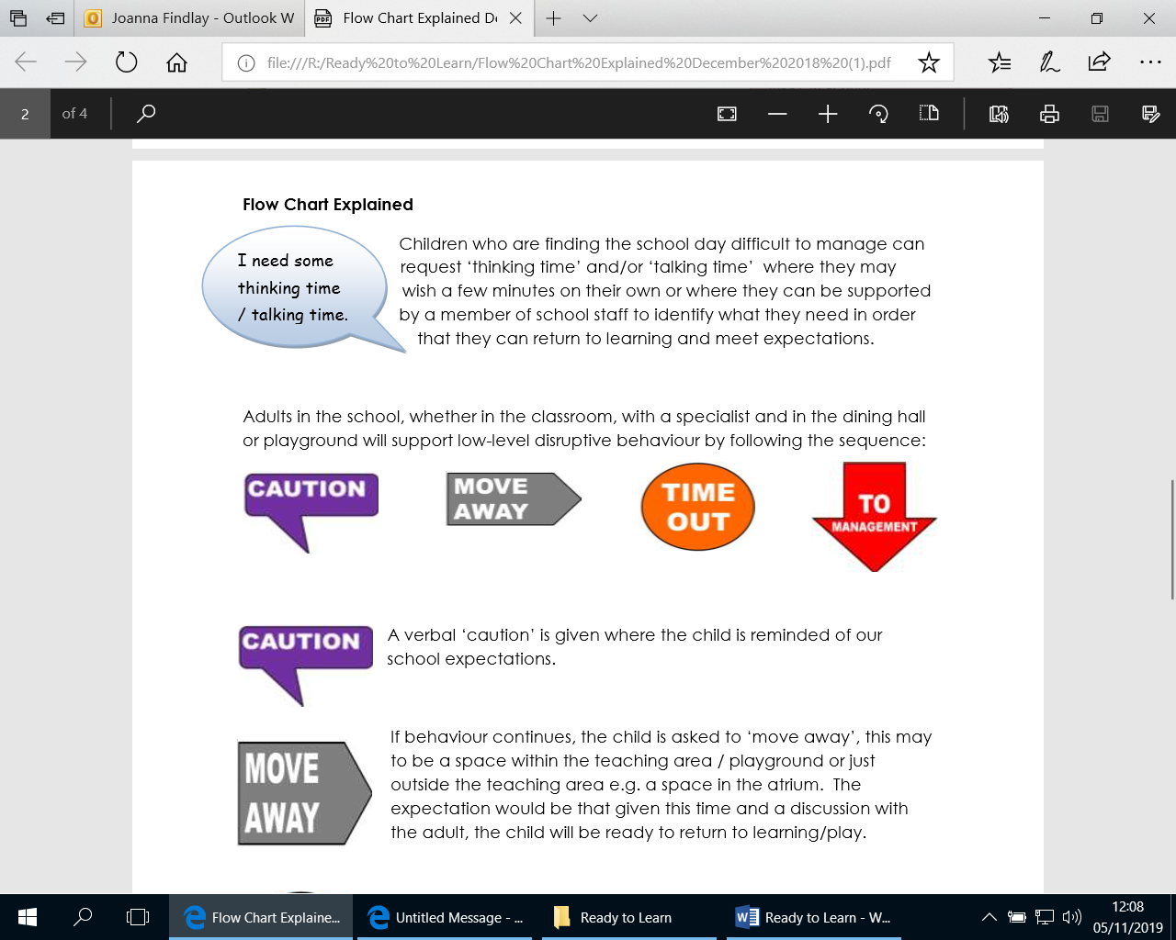Children who are finding the school day difficult to manage can request ‘thinking time’ and/or ‘talking time’ where they may wish a few minutes on their own or where they can be supported by a member of school staff to identify what they need in order that they can return to learning and meet expectations.

Adults in the school, whether in the classroom, with a specialist and in the dining hall or playground will support low-level disruptive behaviour by following the sequence:

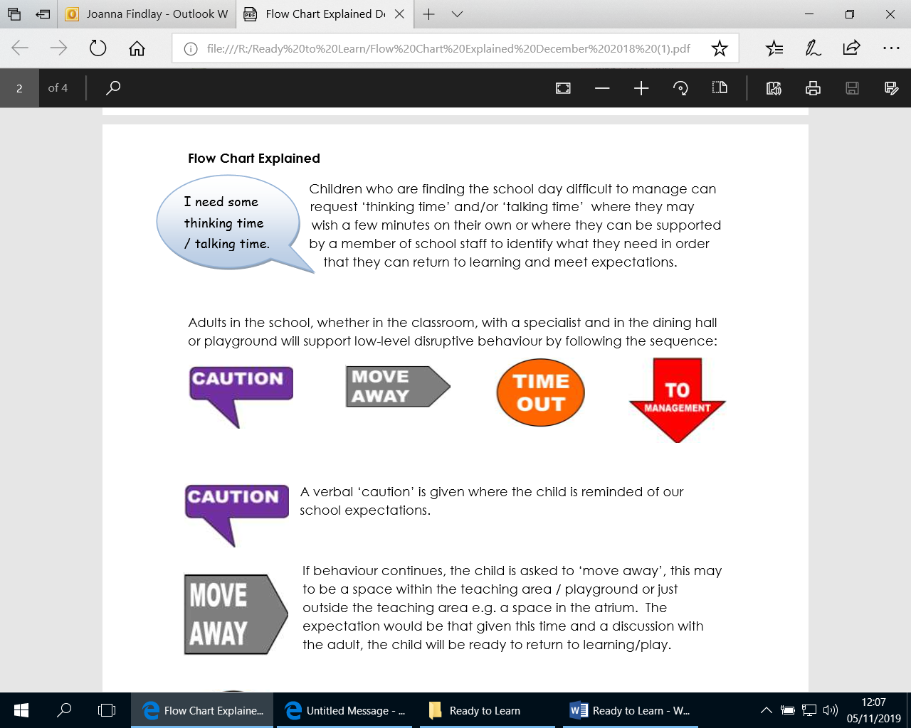

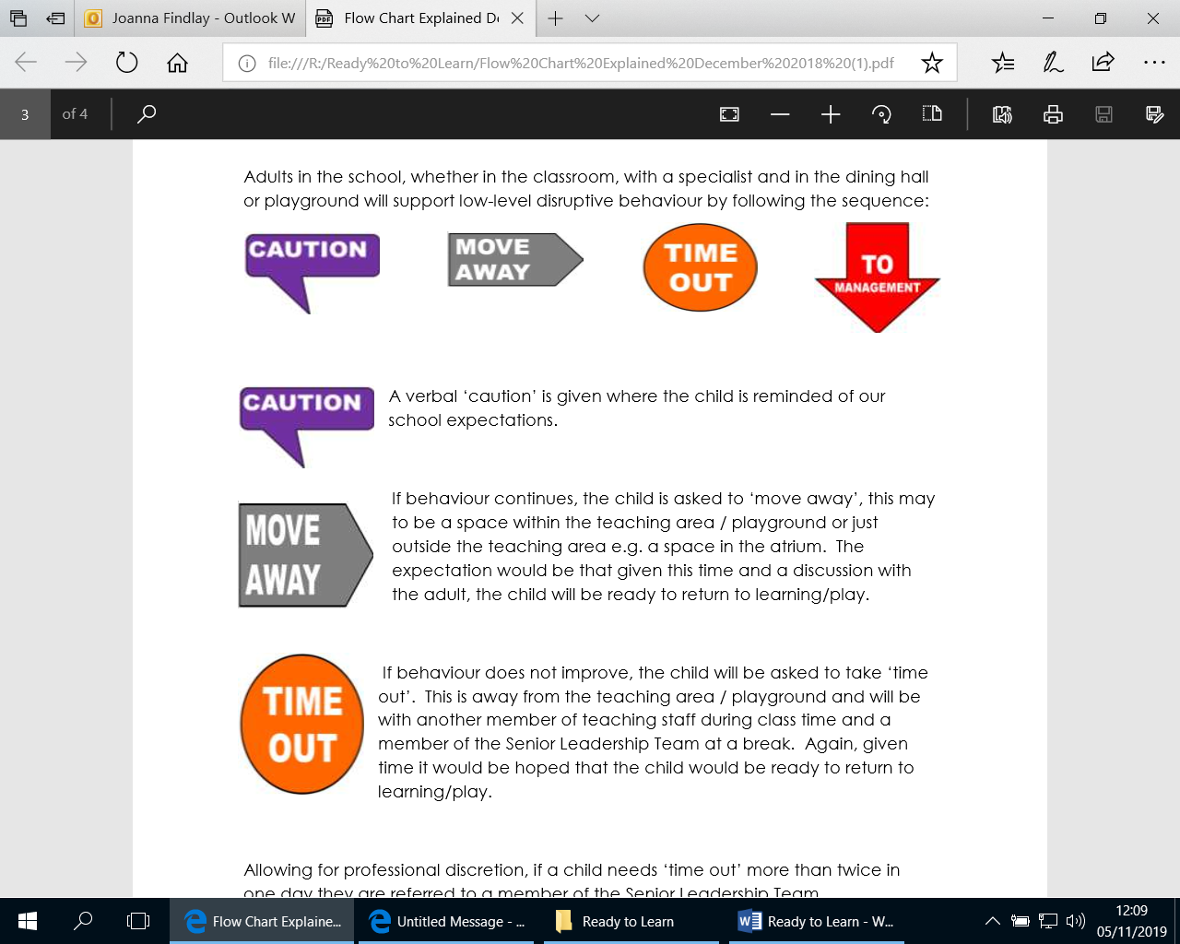

A verbal ‘caution’ is given where the child is reminded of our school expectations.

If behaviour continues, the child is asked to ‘move away’, this may to be a space within the teaching area / playground or just outside the teaching area e.g. a space in the atrium. The expectation would be that given this time and a discussion with the adult, the child will be ready to return to learning/play.

If behaviour does not improve, the child will be asked to take ‘time out’. This is away from the teaching area / playground and will be with another member of teaching staff during class time and a member of the Senior Leadership Team at a break. Again, given time it would be hoped that the child would be ready to return to learning/play.

Allowing for professional discretion, if a child needs ‘time out’ more than twice in one day they are referred to a member of the Senior Leadership Team.

**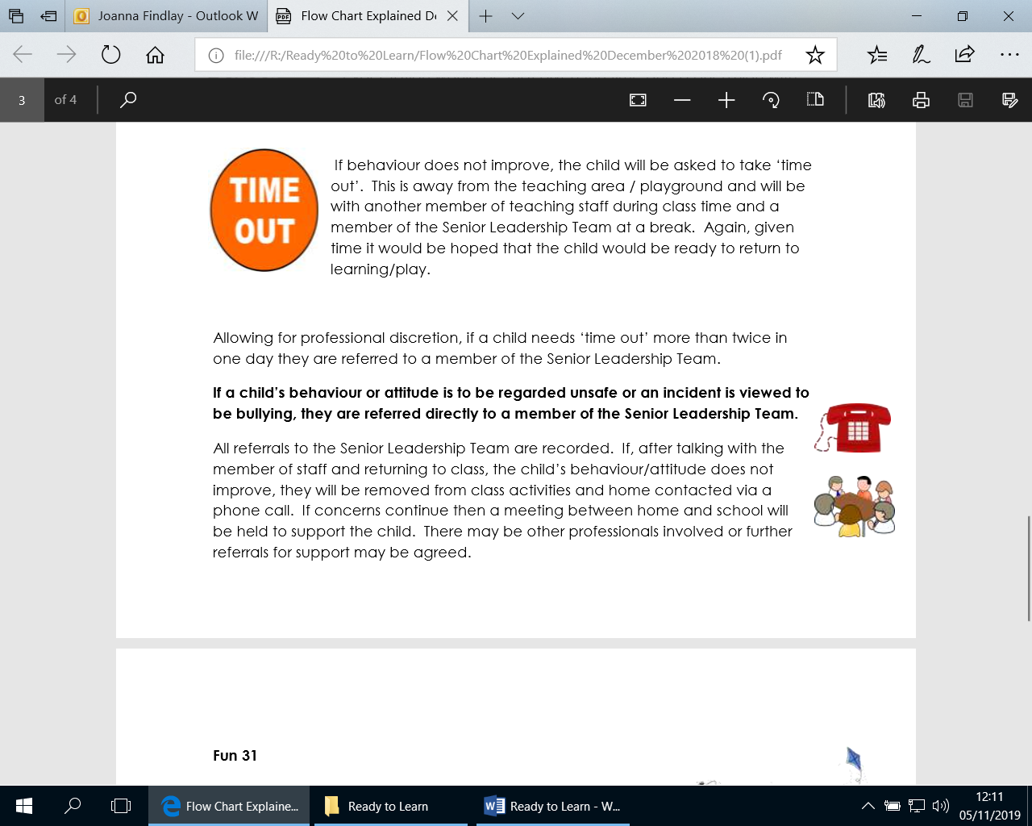If a child’s behaviour or attitude is to be regarded unsafe or an incident is viewed to be bullying, they are referred directly to a member of the Senior Leadership Team.**

All referrals to the Senior Leadership Team are recorded. If, after talking with the member of staff and returning to class, the child’s behaviour/attitude does not improve, they will be removed from class activities and home contacted via a phone call. If concerns continue then a meeting between home and school will be held to support the child. There may be other professionals involved or further referrals for support may be agreed.

**Fun 31**

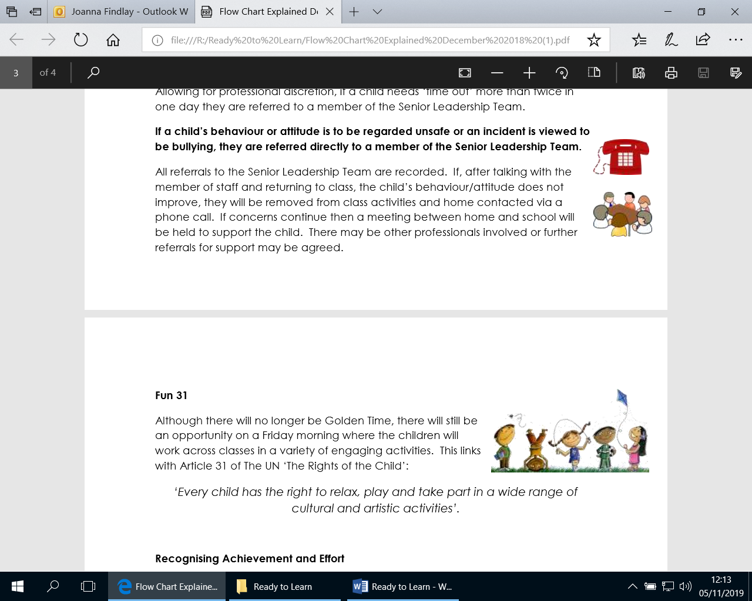Although there is no longer be Golden Time, there is still be an opportunity on a Friday morning where the children work across classes in a variety of engaging activities. This links with Article 31 of The UN ‘The Rights of the Child’:

‘Every child has the right to relax, play and take part in a wide range of cultural and artistic activities’.

**Recognising Achievement and Effort**

Alongside these procedures, it is important that we recognise and celebrate our children’s achievements.

There are individual strategies used by classes and adults across school. There are also several whole school strategies which include; recognising success with our ‘Woodburn WOW’, the earning of house points for good behaviour which goes above and beyond, and the celebration of wider achievements.