What to Wear

At Strathesk, we take pride in our vibrant and identifiable school uniform.

Our learners are encouraged to wear:

White or purple polo shirt

Purple or black school jumper/cardigan

Black skirt/trousers

Purple gigham dress

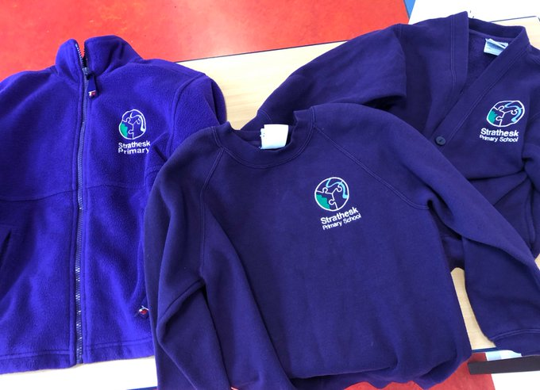

Examples of polo shirts, sweatshirts, fleeces and gym bags can be seen at the school office where they can be purchased. Purchases can also now be made online at strathesk.imagescotland.com/

We have a ‘nearly new’ box of clothing which can also be taken for a small donation towards school funds. Please contact the school office if interested.

For PE children should have shorts, t shirt and gym shoes which can be kept at school.

It can be difficult to distinguish between school uniforms so it is very important to label all belongings with your child’s name.

