Stem is an approach to learning that integrates the areas of science, technology, engineering and mathematics. Through STEM, children develop key skills including problem solving and creativity.
 | Sensory Bags  - Zip Lock Bag  - Hair Gel  - Food Colouring | 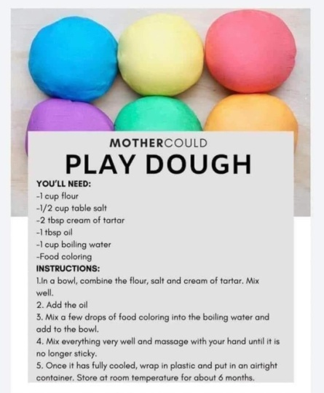
Float or Sink  Gather up items around your house and the garden and place them in water to discuss with your child if they sink or float. Ask them to predict what different items will do | Bridge Building  Use household objects to construct a bridge. Plastic cups, lollypop sticks, egg carton, cardboard. Talk about what material is stronger to make a better bridge. Try to balance different items on the bridge to test the strength. | Magnets  Using some fridge magnets, talk to your child about what a magnet is and the type of materials that they will stick to. Get your child to explore your house and see how many things they can find that the magnet sticks to.
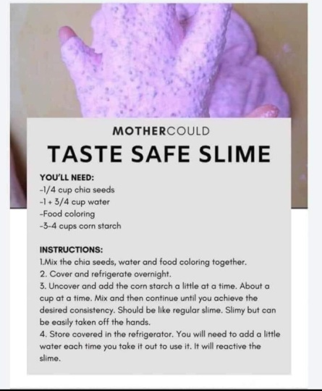 | 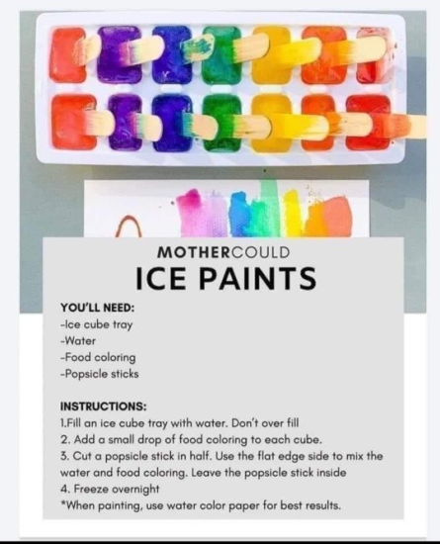 | 