

#### Midlothian

**Stobhill Primary School**

**Improvement Plan 2019-2020**

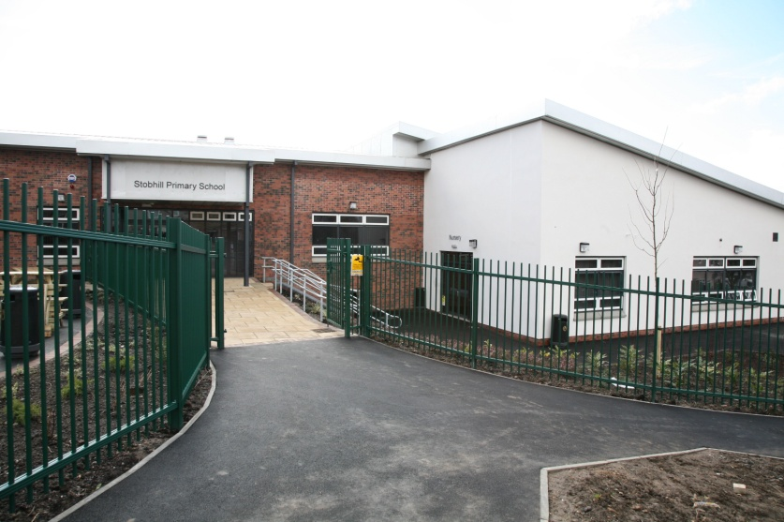



**Priority 1 - Improvement in attainment – literacy and Numeracy**

* Reduce anxiety in numeracy and literacy
* Share the learning journey
* Mediated learning
* Planning, teaching, assessing, moderation cycle
* Tracking and monitoring data

**Priority 2 - Closing the Gap**

* Family engagement
* Learning through play
* Timetabling of support
* See priority 1

**Priority 4 - Improvement in employability skills**

* Planning, teaching, assessing, moderation cycle
* Tracking and monitoring data
* SSERC and STEM
* Family engagement
* SDG’s
* See other priorities

**Priority 3 – Improvement in Health and Well Being for all**

* Timeous support and intervention
* Visual school
* Building resilience year 2
* Rights respecting School
* Recognising achievements
* Play

Newbattle Learning Community joint plan

PEF Funding plan