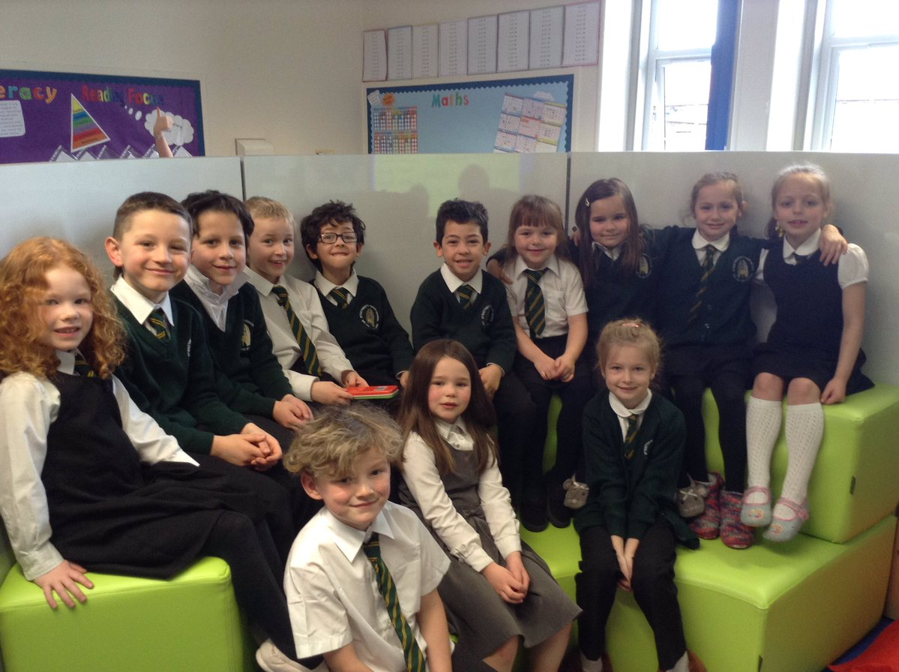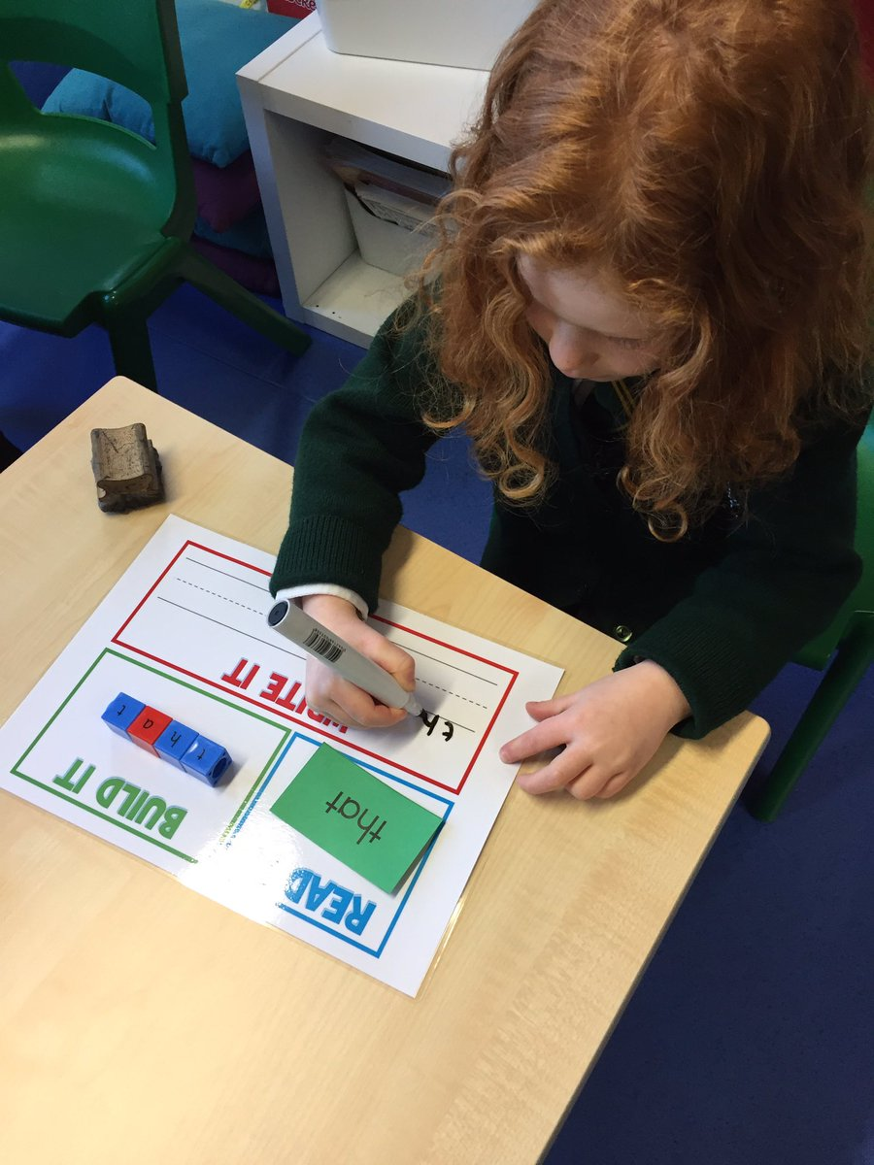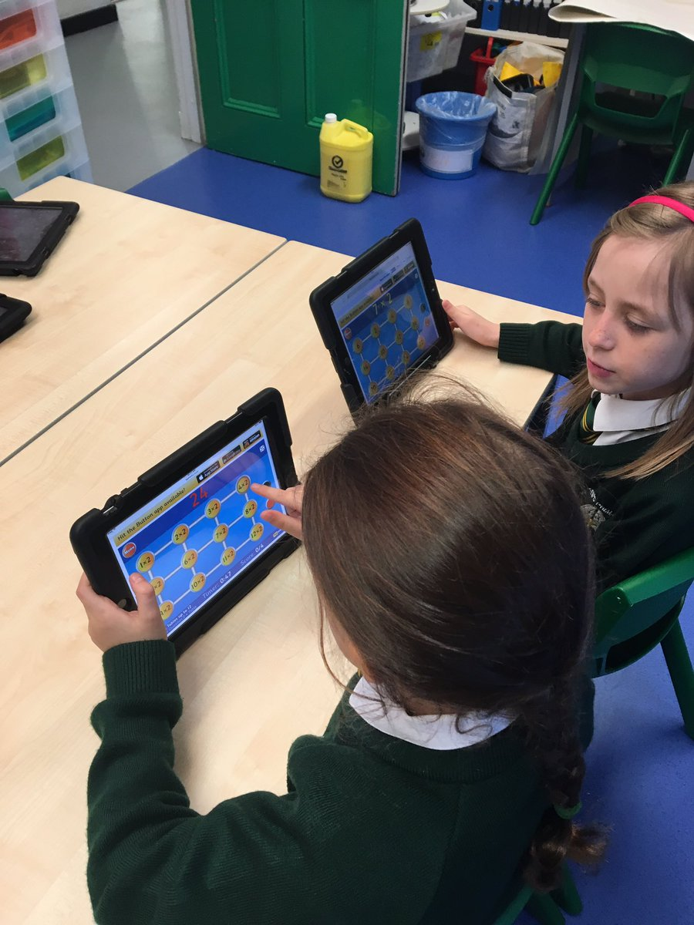

St Matthew’s RC Primary



2019-2020

School Handbook

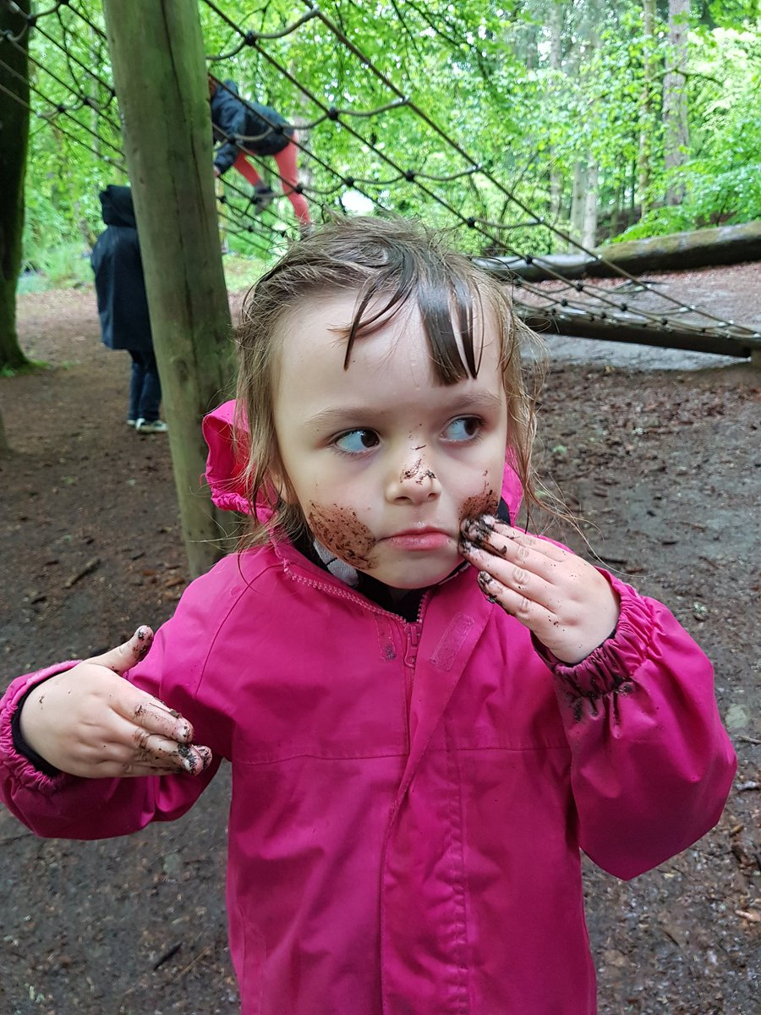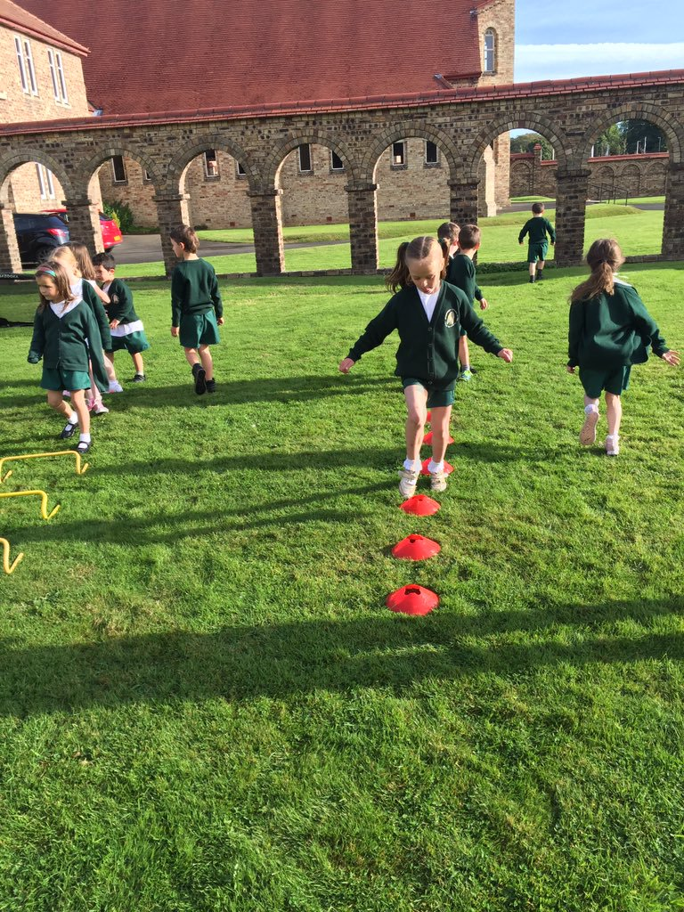



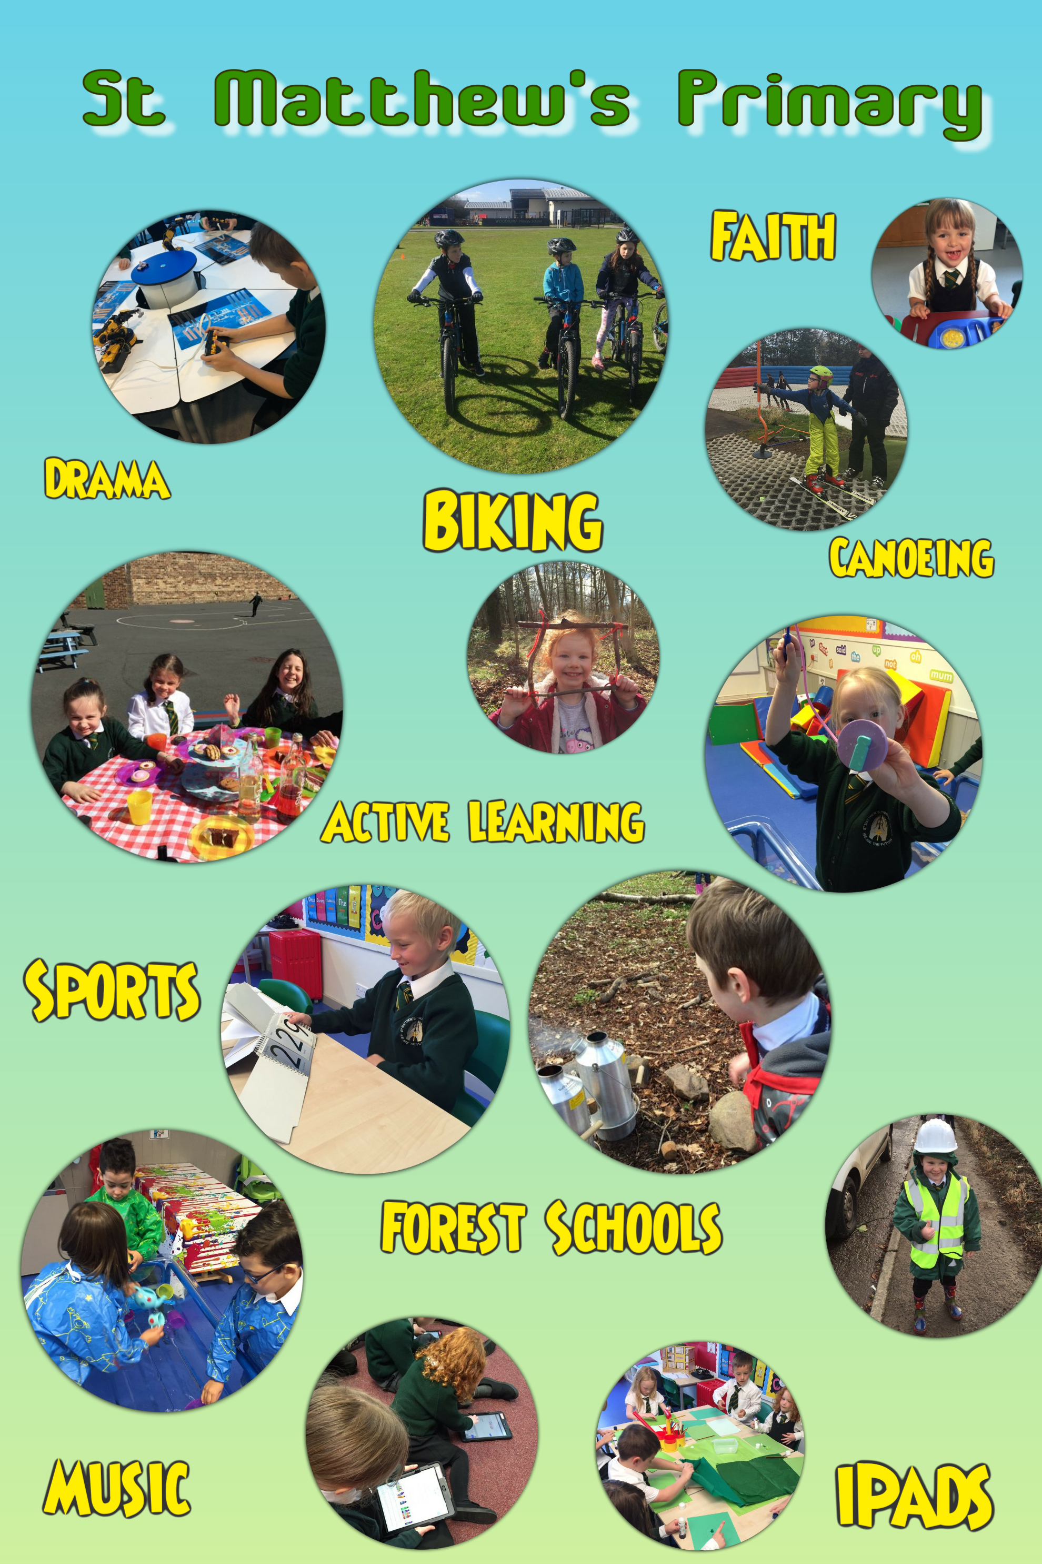

**Contents**

|  |  |
| --- | --- |
| 3 &4 | Contents Pages |
| 5 | Introduction & Welcome |
| 6 & 7 | Ethos, Values & Aims |
| 8 | Community it Serves, Pupil Responsibilities & Extra Curricular Activities |
| 9 & 10 | Educational Visits, School Contact Details & School Staff |
| 11 | Enrolling your child for P1/ Enrolling your child for P2-P7 |
| 12 | Attendance & Punctuality |
| 13 | Parental Involvement / Engagement |
| 14 | Engaging Parents/Carers in their Child’s Learning – Weekly/Termly/Annually |
| 15 | Homework |
| 16 – 24 | School Improvementengaging parents in the improvement process/School Curriculum including Religious Education in Catholic Schools |
| 25 - 28 | Assessment, Reporting, Achievement and Profiling |
| 29 | Transitions – Transfer to Secondary School |
| 30 & 31 | Education Maintenance Allowance/ Support for Pupils |
| 32 | School Improvement |
| 32 & 33 | School Uniform |
| 34 | Standards of Behaviour, School Rules and Discipline /Rights Respecting School Children’s Rights and Responsibilities |
| 35 | The School Day/Out of School Childcare service (also called After School Clubs) |
| 36 | Meals and Milk /School Transport |
| 37 | The School Health Service |
| 38 | Child Protection / Health and Safety**/**Employment of Children |
| 39 | The School and its Community /Parent Forum (all parents with children at the school) and establishing a new Parent Council |
| 39 & 40 | Inclement Weather / Occasional and Emergency Arrangements |
| 40 & 41 | Playground Supervision / Letting Procedures / Complaints Procedures |
| 42 & 43 | Transferring Educational Data About Pupils |
| 44 | Useful Addresses |
| 45 | Session Dates 2019/2020 |
|  |  |

**Introduction and Welcome to St. Matthew’s R.C. Primary School**

**WORKING TOWARDS EXCELLENCE**

Dear Parent/Carer

Firstly, may I welcome you to the Rosewell area and to St. Matthew’s Primary School. You are now an integral part of our school community and, together, it is our responsibility to provide the best possible learning experiences for our children and to enhance the excellent ethos of our school community; to set a high standard for learning and achievement, behaviour and manners and have a high expectation of our children, our staff team and our school community as a whole.

This booklet has been produced for parents/carers. If your child is about to start school for the first time or you have moved into the area, the booklet will give you some initial information about St. Matthew’s Primary School.

It is designed to give you information on day-to-day organisation, curriculum and assessment, the role of the Education and Communities Division and the involvement of partner agencies. It provides details of the responsibilities of parents/carers in relation to their child’s attendance, punctuality and behaviour.

However, we begin by highlighting the schools‟ vision, values and aims, created through the input of our children, parents and staff. We will be revising our vision, values and aims with our new school community and partners next session. This sets out to present clear and concise statements on the aspirations of our school and equally to give a starting point for dialogue with parents/carers.

By selecting St. Matthew’s as your preferred school of choice you have already identified with these aims and we are already well on the way to building the co-operation and partnership between home, school, local and parish community which will be of crucial importance throughout our children’s education.

Once again, welcome to the school community of St. Matthew’s. I’m sure that this will be the beginning of a long and happy partnership as we endeavour to provide the highest quality learning experiences for your child.

Yours faithfully



Miss Anna Chidgey   
Head Teacher

School Motto: *We are the Future*

**St. Matthew’s Primary School – Ethos of Excellence**

St. Matthew’s Primary School has a strong ethos, where all children and families are included, where religion, culture and diversity are celebrated in an atmosphere of challenge and support.

We have very high expectations of all children in their learning, presentation, behaviour, attitude politeness and manners. We create the conditions for learning to take place but also for your child to grow in confidence and develop respect and tolerance for others and their opinions. We challenge children within the curriculum and with wider learning experiences, we use mistakes as an opportunity for new learning.

Throughout your first experience of our school prior to enrolment, you are asked to see if this is an environment whereby your child will thrive in their primary school years, a school community that will present them with the opportunity to become a successful learner, a confident individual, an effective contributor and a responsible citizen. But also, a school community whereby your child will be prepared fully for the challenges of Secondary education and beyond and providing the basis of skills for learning, life and work!

**St. Matthew’s Primary School – Vision, Values and Aims (2016)**

**Our Vision**

We are the future.  
At St Matthew’s we aspire to create an outstanding positive ethos based on the Gospel Values and respect for all. We will provide a safe learning environment that encourages learners to discover and challenge their thinking. Through high quality learning and teaching we will promote curiosity and ignite a passion for life-long learning, developing independent learners who embrace challenge enthusiastically. We endeavour to ensure our learners develop their skills and confidence and reach their full potential in preparation for the future.

**Values**  
Faith  
Honesty  
Integrity  
Respect  
Responsibility  
Forgiveness  
Friendship

**Aims**A school environment, where all members of the school community feel valued and respected, where the health and wellbeing of all are nurtured, fostering a sense of high self esteem and motivation within a secure and positive ethos.

Providing the highest quality teaching and learning environment, where both staff and children set high expectations for themselves and become successful, reflective learners across the curriculum.

Offering our children a wide range of learning experiences, which give opportunities to learn about issues such as sustainable development, citizenship, enterprise, the arts, which develops a greater understanding of the world around them and a sense of their place in the world.

Encouraging staff and children to be creative thinkers to enable them to meet new challenges and situations with confidence.

To work closely with the parish of St. Matthew’s, supporting one another in nurturing the Gospel values and embracing the Christian ethos as well as preparing our children to receive the sacraments.

To plan, monitor and evaluate each aspect of school life on a regular basis to ensure our children are being offered the very best teaching and learning experience.

To promote healthy and active living and embrace the principles of a health promoting school.

**St. Matthew’s Primary School and the Community it Serves**

St. Matthew’s Primary School is located on the main street in Rosewell. The school opened in its existing building and campus in September 1894. The building was originally used also as the local parish church until 1926 when the present church opened.

Today the building houses four class bases, a library, an ICT and Support for Learning base and a dining area. The church hall is used for PE.

There is, at present, four teachers, including: Head Teacher, Miss Chidgey; Acting Principal Teacher, Mrs Syme, Class Teacher, Miss Forbes, Class Teacher Mrs McCready and Class Teacher, Miss Duncan. A visiting Teacher of Brass and a visiting Music Teacher. We also have a Homelink Teacher Mrs Bowman. The school also employs the support of an Administrative Assistant, Mrs Golder, and three Learning Assistants, Mrs Lawson, Ms Gow and Ms Anderson.

We have an excellent working partnership with St. David’s High School, St. Matthew’s Parish, Rosewell, and the Archdiocese of St. Andrew’s and Edinburgh and often work alongside other local religious organisations and other major world faiths in the Midlothian and Edinburgh areas. Respect and tolerance and the celebration of diversity are integral to our schools’ visions, values and aims.

Our projected classes for 2019/2020 is as follows:

P1-3

P3-5

P5-7

**Pupil Responsibilities – Promoting Leaders of learning at Every Level**

**In School Groups**   
Pupil Council  
House Captains  
Eco Committee  
Rights Respecting Schools’ Team of UNICEF Ambassadors  
Junior Road Safety Officers  
Website Club  
  
**Extra Curricular Activities**  
P1-7 Residential experiences Tai Kwan Do  
Brass Scottish Country Dancing  
Orienteering Homework Club  
Mountain Biking Educational excursions  
Rock Climbing Digital Technology  
Canoeing Various Active School Clubs  
Forest Schools’   
Dance and School Shows  
Outdoor Education Workshops   
**Educational Visits and Outings –**over the past few years these have included:

National Museum of Scotland, Edinburgh   
Edinburgh Castle  
Our Dynamic Earth   
Edinburgh Risk Factory, Edinburgh  
Edinburgh Zoo  
National Gallery, Edinburgh  
Lady Haig Poppy Factory, Edinburgh   
Vogrie Park   
National Museum of Mining, Newtongrange   
Whole School Camp to Dalguise, Perthshire

…..to name but a few

*It should be noted that some activities currently available cannot be guaranteed in future years since the pattern of activities depends on the changing expertise and interests of school staff, children and parents/carers.*

**School Contact Details**

In this section you will find all the main school contact information and procedures for contacting the school. If you are unsure of anything please contact our Administrative Assistant, Mrs Golder, at the school office in the first instance.

Class teachers welcome discussion of learning and teaching and how you can support and challenge your child’s learning at home. Appointments can be made via the school office. All teaching staff are unavailable during class contact hours.

If you would rather discuss your child’s learning and development with the Head Teacher, again, please make an appointment at the school office.

Please note that all information contained in the Handbook is correct at the time of print, however, it is subject to change.

## School Address 32 Carnethie Street

Rosewell

Midlothian

EH24 9AT

Telephone 0131 271 4695

E-mail [stmatthews_ps@midlothian.gov.uk](mailto:stmatthews_ps@midlothian.gov.uk)

Website <http://stmatthews.mgfl.net>

Twitter @stmatthewsps1

School Roll 57

Classes: P 1-2, 3-5 & P5-7

**St. Matthew’s Primary School Staff (2019/2020)**

Staffing for each area is as follows:   
Headteacher Miss A Chidgey

Acting Principal Teacher Mrs S Syme

Teaching Staff: Miss Forbes Mrs Y McCready

Miss L Duncan

Support for Learning: Mrs Y McCready

Specialist Teachers: Mr A Fernie (Brass)

Homelink Teacher Mrs R Bowman

Learning Assistant: Ms C Gow

Mrs I Lawson

Ms L Anderson

School Support Staff: Mrs D Golder

Catering Supervisor: Ms L Anderson

Cleaner: Miss S Tait

Janitor: Mr P Finlayson

Caretaker: Vacancy

*Please note that staffing, as with all parts of the handbook is correct at the time of print, however, it is subject to change.*

**Enrolment at St. Matthew’s Primary**

**Enrolling your child for Primary 1**

We are presently enrolling for entry to our Primary 1 class in August 2020 and taking notes of interest for August 2021. If your child is aged at least 4 years old by the end of February 2020, please contact the school office at your earliest convenience.

In November each year, information will be issued direct from Midlothian Council to all families with children in their pre-school year attending nursery classes or establishments in the Midlothian area. Notices will also appear in the press and announcements will be made over the pulpit in your local parish church advising you to enroll your child.

The information issued by Midlothian Council will detail your catchment area schools. All parents/carers are responsible for contacting their preferred catchment area school and registering their child/children.

Deciding on a school for your child is a very important one. We always advise that you make a point of visiting your catchment areas schools before deciding on your preferred choice. You are welcome to visit St. Matthew’s Primary School at any point – we promote an open door policy at all times.

School placements are then finalised by Midlothian Council between December 2019 and March 2020 before parents/carers are informed of their child’s school. In late March 2020 enrolments will be confirmed with the school. The school will then send invitations for you and your child to visit the school in May 2020 and again in June 2020 to meet with their classmates and their Primary 1 teacher.

We operate an enhanced transition programme between these two dates also for children with additional support needs and all children who will benefit from additional visits to the school.

Between April and May, school staff will visit your child at their nursery establishment to observe them in nursery and to discuss their strengths and next steps with nursery staff.

**Enrolling your child for Primary 2 to Primary 7 classes**

If you wish to transfer your child from another school to St. Matthew’s Primary please inform your child’s present school of your intention.

Then contact St. Matthew’s school office with your child’s name, date of birth, present school and class.

Our school office will inform you of availability and arrange for you to visit the school to meet with the Head Teacher and plan the transfer of your child to the school.

The Head Teacher will then contact your child’s school to discuss your child’s next steps in learning and to arrange the transfer of information.

Your child will then start St. Matthew’s as quickly as possible thereafter where they will be supported in their transition to our school by school staff and children.

**Attendance and Punctuality**

When your child is unable to attend school because of illness, please phone or contact the school as quickly as possible. On your child’s return to school we ask that you send a letter detailing the circumstances of the absence.

The school office will contact all families of children who are absent from school and without notice by 9:15am to ensure that all children are accounted for.

A note to the class teacher is also required when a child needs to leave school, for example, to attend a dental or doctor’s appointment. Please try to arrange these out-with school hours.

A child will not be allowed to leave his or her classroom unaccompanied unless the Head Teacher/teacher has received a note giving the time of appointment and the arrangement a parent/carer wishes to make for accompanying the child. You will appreciate that these steps are taken with the safety of your children in mind.

Where possible, you are asked to arrange holidays out-with term times. Following guidance from the Scottish Government Education Department in June 2003, I must inform you that most family holidays are categorised as unauthorised absence and this will be reflected in your child’s attendance figures.

Irregular attendance, late coming, appointments during school time and holidays during term time may, on occasion, be unavoidable. However, there is no doubt that these do have an effect not only on your child, but also on every other child in his or her class. When a child returns after a period of absence he/she tends to take up a disproportionate amount of the Teacher’s time, to the detriment of other children in that class.

Parents/Carers are responsible for ensuring that their child attends school regularly. In cases of unsatisfactory attendance, the Head Teacher will ask the Education Welfare Officer (EWO) to visit the home and discuss the problem with parents. If such unsatisfactory attendance persists, the Head Teacher, following discussions with the Education Welfare Officer and other agencies will decide whether the case should be referred to the local Area Attendance Advisory Group. This Group has been formed to make recommendation to the Director on the statutory responsibilities of the Authority with regard to defaulting parents.

Regular attendance is an important element in a child’s educational progress; even an occasional half-day absence can be harmful. Similarly punctuality, as well as being important in school, is a habit that needs to be developed throughout a working life. Cases of repeated late coming will be referred to the Education Welfare Officer.

School staff monitor children’s punctuality and attendance and make every effort to promote its importance.

We are delighted that at St. Matthew’s Primary almost all children and families have excellent attendance.

**Parental Involvement and Engagement**

At St. Matthew’s we pride ourselves in engaging parents and carers in their children’s learning and wider school experiences.

From the initial meeting at enrolment whereby parents/carers are engaging with the schools visions and aims and matching these to their own aspirations for their child, this sets the expectation of a shared partnership aimed at challenging and improving your child’s learning and development throughout the primary school experience.

The school encourages an open door policy and parents/carers are welcome to visit the school at any time. Discussions with class teacher or the Head Teacher regarding the children’s learning and development should be made in advance as much as possible in order to ensure you get the most from the meetings.

Class teachers welcome discussion of learning and teaching and how you can support and challenge your child’s learning at home. Appointments can be made via the school office. All teaching staff are unavailable during class contact hours.

If you would rather discuss your child’s learning and development with the Head Teacher, again, please make an appointment at the school office.

Communication is of paramount importance. The school prides itself in communicating in a variety of methods and to suit the needs of the individual family circumstance. For example, through monthly newsletters, the playground notice board and regular updates via the school website, class blogs and the school Twitter account.

We also communicate via telephone and SMS text messaging services, celebrating success and achievement through Assembly, Parents’ meetings, school events and performances, workshops, the Parent Council and through ‘Sharing the Learning’ days each term.

Below are some of the examples of how we engage parents/carers in their child’s learning and development:

**Engaging Parents/Carers in their Child’s Learning and Development Weekly**

* Profiles – strengths and next steps shared
* Learning updates via school website, class blogs and Twitter account
* Homework activities and diaries; leading after-school clubs
* iPads
* Welcome to attend Friday Assembly

**Termly**

* Class Assemblies on other aspects of learning
* Individualised Education Programmes (IEP) updates
* Invitations to other school events to share in the wider school life and work of school

**Tri-annually September, February and May/June each year**

• Parent-Teacher-Child conferences (Parents’ evening) – strengths and next steps in learning shared with child meeting with Teacher and Parent/Carer

**Annually**

• August – welcome new P1 children  
• August – Learning and Teaching Workshop  
• September – P1-7 invitations to lunch with child  
• October – school staff engage with Pre-school establishments  
• November – P1 Enrolment Month for following school year  
• November – St. Andrew’s Day celebrations  
• November – P5-7 St. David’s High School Open Evening  
• December – P1-7 Nativity Performance   
• December – Advent preparations and celebrations with St. Matthew’s Parish  
• January – Burns’ and other Scottish literature celebrations  
• February/March – Notification of P1 placing for August  
• March/April – Lent and Easter celebrations  
• April/May – school staff visit new P1s in Nursery establishments  
• May – Whole School Camp to Dalguise, Perthshire  
• May – P4 Sacrament of Confirmation and Eucharist with St. Matthew’s Parish  
• May/June – P6 and P7 transition visits to St. David’s High School  
• May – P1 induction meeting 1 and enhanced transition visits begin  
• June – P1 induction meeting 2  
• June – Pupil Progress Report – strengths and next steps in learning shared  
• June – Sports Day  
• June – P7 Leavers’ Assembly and Celebration  
• June – Annual School Awards Ceremony

**Homework**

**Rationale**

At St. Matthew’s homework is seen as an important extension to classroom learning. It can reinforce class learning and can provide opportunities for pupils to extend their individual learning. It is also an important channel for engaging parents/carers in their child’s learning and development and to promote partnership working between the home and school.

**The Purpose of Homework is:**

* To allow practice and consolidation of class activities.
* To develop good habits in pupils planning and organisation of their time.
* To create channels for home/school co-operation, partnership and support.
* To help parents engage more in their child’s learning and development.

**Homework should:**

* Be clearly understood by children and be within their capabilities
* Be manageable by teachers and pupils
* Be given high priority by pupils and parents
* Be related to the ongoing activities and linked to the experiences and outcomes of *‘Curriculum for Excellence’*
* Be relevant and varied according to interests and stages
* Be monitored so that high standards are maintained
* Be part of the home/school dialogue and partnership

**How Much and How Often?**   
This may be differentiated according to the needs of the child.   
As a guide, however, and in accordance with national advice, current research and parent consultation at St. Matthew’s Primary:

* P1 & 2 will be expected to do up to 15 minutes Reading per night.
* P3, 4 & 5 will be expected to do up to 20 minutes Reading per night.
* P6 & 7 will be expected to do up to 30 minutes Reading per night.

Homework will be set for 4 nights each week with occasional homework for weekends, particularly in the senior classes where aspects of research will require an extra time commitment, normally extending beyond one week – timescales for personal projects are provided in advance also.

**School Improvement – engaging parents in the improvement process**

We regularly engage with all parents in seeking their views and opinion on how we can work together to improve children’s learning experiences further. This is undertaken via questionnaires, focus group meetings, Parent Council and through paper and online surveys.

**The School Curriculum**

**Areas of the Curriculum: Working Towards ‘*A Curriculum for Excellence’***

Scotland’s *‘Curriculum for Excellence’* (CfE) is made up of the following curriculum areas:

Languages  
  
Mathematics  
  
Technologies   
  
Health and Wellbeing

Expressive Arts

Sciences

Religious Education

Social Subjects

We now have a single curriculum framework from age 3 – 18. We equip young people with a high level of literacy and numeracy skills. We promote learning across a wide range of contexts and well planned experiences through:

* *Curriculum areas and subjects*
* *the Ethos and life of the school*
* *Interdisciplinary projects and studies*
* *Opportunities for personal achievement*

Please click on the image above to take you to the Parentzonesection of Education Scotland’s website. Here, you will find out all you need to know about Curriculum for Excellence

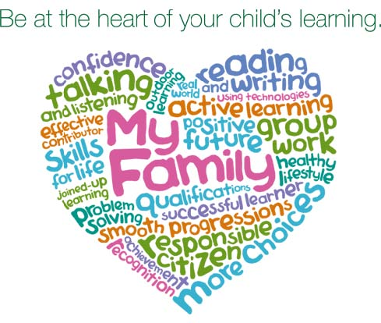

**Languages: Literacy and English and Modern Languages**

There are two aspects of the languages area of the curriculum. The first covers experiences and outcomes in the language a young person needs in order to engage fully in society and in learning - whether that is English, Gaelic or, for young people who need additional support, the means of communication which enables them to communicate most effectively. The second covers experiences and outcomes in additional languages.

Language is at the core of thinking. We reflect, communicate and develop our ideas through language. Literacy offers an essential passport to learning, helping children and young people to achieve to the full and be ready for active involvement in society and work. Literature opens up new horizons, and a love of reading can be an important starting point for lifelong learning. As we communicate increasingly through digital technologies, we need to be able to interpret and convey information in new ways and to apply discernment.

Scotland has a rich diversity of language which offers rich opportunities for learning. Learning other languages enables children and young people to make connections with different people and their cultures and to play a fuller part as global citizens. At St. Matthew’s we offer French as an additional language from P1-P7 – this is then continued at St. David’s High School.

Learning through the languages area of the curriculum enables children and young people to:

* develop their ability to communicate their thoughts and feelings and respond to those of other people
* develop the high level of skills in listening, talking, reading and writing which are essential for learning, work and life
* use different media effectively for learning and communication
* develop a secure understanding of how language works, and use language well to communicate ideas and information in English and other languages
* exercise their intellectual curiosity by questioning and developing their understanding, and use creative and critical thinking to synthesise ideas and arguments
* enhance their enjoyment and their understanding of their own and other cultures though literature and other forms of language
* develop competence in different languages so that they can understand and communicate.

**Numeracy and Mathematics**

Mathematics includes specific aspects of numeracy which will be developed both in mathematics and through activities in other areas of the curriculum.

Putting mathematical knowledge and understanding to constructive use has been one of the decisive factors in shaping societies. Engineering, science, technology and business rely upon mathematics and continue to find new applications for mathematics. Cultural development and artistic endeavour are influenced by mathematics. Each of us uses mathematical skills and concepts in everyday life.

To face the challenges of the 21st century, each young person needs to have confidence in using mathematical skills, and Scotland needs both specialist mathematicians and a highly numerate population.

Learning through mathematics enables children and young people to:

* develop essential numeracy skills, including arithmetical skills which allow them to participate fully in society
* develop a secure understanding of the concepts, principles and processes of mathematics and apply these in different contexts
* have an understanding of the application of mathematics, its impact on our society past and present, and its potential for the future
* establish firm foundations for further learning.

**Religious Education in Roman Catholic Schools**

Religious Education in Roman Catholic schools takes place within the context of the Catholic faith community. Religious education in Catholic schools is designed to nurture faith and assist children and young people to be able to make an informed response to God in faith. Children and young people in Catholic schools will be at different places in the spectrum of faith development. While some young people will be of the Catholic tradition, some will be of other denominations and faiths, or have different stances for living – this culture and diversity is something which is integral to the inclusive ethos of a Catholic school in Scotland and celebrated throughout the whole St. Matthew’s school community.

Religious education should support all children and young people, irrespective of religious affiliation, in their personal search for truth and meaning in life, and so it is central to their educational development. For those who demonstrate active faith participation, however, it also contributes to the development of their personal response to God in faith.

The religious education curriculum offers a valuable contribution to the whole school approach to the development of faith, attitudes and values. Learning through religious education enables children and young people to:

* prepare for the reception of the Sacraments of Reconciliation, Confirmation and Holy Eucharist
* develop their knowledge and understanding of significant aspects of Catholic Christian faith and an understanding of other Christian traditions and world religions
* investigate and understand the responses which faith offers to questions about truth and the meaning of life
* highlight and foster the values, attitudes and practices which are compatible with a positive response to the invitation to faith
* develop their beliefs, attitudes, moral values and practices through personal search, discovery and critical evaluation, and make a positive difference to the world by putting their beliefs and values into action.

Opportunities for parental workshops and information evenings are provided in preparation for learning about Relationships Education.

**RELIGIOUS OBSERVANCE IN THE CATHOLIC SCHOOL**

The Education (Scotland) Act 1980 imposes a statutory duty on local authorities to provide “Religious Observance” in Scottish schools. This is defined in a national R.O. Review Group report published in 2004 as comprising: *"community acts which aim to promote the spiritual development of all members* of *the school's community and express and celebrate the shared values* of *the school community".*

In a letter of guidance issued by the Scottish Government in February 2011, it is acknowledged that Catholic schools take a distinctive approach to the provision of Religious Observance:

*Scottish Government Ministers welcome the tradition that, in Roman Catholic denominational schools, Catholic Liturgy will largely shape the nature and frequency of religious observance activities in the classroom and in the wider school community. So, at times, children and young people will be invited to participate in, and sometimes to lead, prayer and reflection in classrooms and at assemblies. At other times, to honour particular occasions or feasts, chaplains will lead school communities in the celebration of Mass and other forms of liturgical celebration.*

Catholic schools follow the customs and practices of the Church in order to nourish the spirituality and faith of pupils and staff. Our Catholic tradition is enriched by ancient rites, prayers and devotions which help young people to become aware of, and show reverence to, the sacred presence of the living God, Father, Son and Holy Spirit. Guided by this tradition, we celebrate various seasons and special feast days to honour God, Mary his Mother and the Saints.

Pupils are invited to pray with their teachers at times in classrooms and assemblies, as well as in liturgical services. Usually a classroom will display a Crucifix on the wall; in some classrooms and other areas of the school, a sacred space will feature a copy of the Bible and will be decorated with signs and symbols that reflect the changing seasons of the Church Calendar Year i.e., Advent, Christmas, Lent, Easter and Pentecost.

This regular practice of Prayer is complemented by religious services conducted, sometimes as part of an Assembly, to mark special occasions - e.g. the distribution of Ashes on Ash Wednesday, the seasons of Advent or Lent. To mark special Feast Days and Holy Days of Obligation, Holy Mass will be celebrated by the school chaplain, with the school community, in school buildings or in local parishes. Some pupils, at certain stages, may be able to participate in retreats and pilgrimages to places of special significance within the Catholic tradition.

While Religious Education is governed by separate Church guidance, it is complemented by Religious Observance practices and, together, these experiences help pupils to develop their understanding of the Catholic faith, to experience opportunities for spiritual growth and to commit to beliefs, values and actions in a positive response to God’s invitation to faith.

In terms of pupil participation in R.O. Scottish Government guidance makes it clear that it makes an important contribution to pupils' development and that it promotes the ethos of a school by bringing pupils together and creating a sense of community. However, it also makes clear that parents have the right to withdraw children from participation in religious observance and that this right should always be made known to parents and their wishes respected. The Scottish Government also recognises that:

*Where a parent chooses a denominational school for their child's education, they choose to opt in to the school's ethos and practice which is imbued with religious faith and religious observance. In denominational schools, it is therefore more difficult to extricate a pupil from all experiences which are influenced by the school's faith character.*

Curriculum For Excellence - Provision of Religious Observance in Schools, Scottish Government, 17 February 2011

**Science**

The most important goal for science education is to stimulate, nurture and sustain the curiosity, wonder and questioning of children and young people.

Young children have a natural sense of wonder and curiosity and are active and eager learners endeavouring to make sense of the world. They develop ideas through play, investigation, first-hand experience and discussion. As they grow older children ask searching questions based on their everyday observations and experiences of living things, the environment and the materials, objects and devices they interact with. Young people are fascinated by new discoveries and technologies and become increasingly aware of, and passionate about, the impact of science on their own health and wellbeing, the health of society and of the environment.

Learning through the sciences enables children and young people to:

* investigate their environment by observing, exploring, investigating and recording
* demonstrate a secure understanding of the big ideas and concepts of science
* make sense of evidence collected and presented in a scientific manner
* recognise the impact science makes on their lives, on the lives of others, on the environment and on culture
* express opinions and make decisions on social, moral, ethical, economic and environmental issues informed by their knowledge and understanding of science
* establish the foundation where appropriate, for more advanced learning and future careers in the sciences and technologies.

**Social Studies**

Social studies include experiences and outcomes in historical and geographical, social, political, economic and business contexts.

It is important for children and young people to understand the place where they live and the heritage of their family and community. Through social studies, children and young people develop their understanding of the world by learning about other people and their values, in different times, places and circumstances, and how their environment has been shaped. They learn about human achievements and to make sense of changes in society, conflicts and environmental issues. With greater understanding comes the opportunity to influence events by exercising informed and responsible citizenship.

* Learning through social studies enables children and young people to:
* broaden their understanding of the world by learning about human activities and achievements in the past and present, political, social and environmental issues, and the values underpinning their own society and other societies
* develop the capacity for critical thinking, through accessing, analysing and using information
* form their own beliefs and view of the world and develop their understanding of different values, beliefs and cultures
* establish firm foundations for lifelong learning.

**Expressive Arts**

The expressive arts include experiences and outcomes in art and design, drama, dance and music.

Through the expressive arts, children can have rich opportunities to be creative and imaginative and to experience inspiration and enjoyment. They can come to understand the important roles of the arts in describing and changing society. The arts have a growing significance in the life and prosperity of Scotland. Through their experience of the expressive arts, children can appreciate the contributions of the arts in the lives of individuals and communities.

Learning through the expressive arts enables children to:

* express themselves in different ways and be creative
* experience enjoyment (and contribute to other people’s enjoyment) through creative and expressive performance and presentation
* develop important skills specific to expressive arts and also transferable skills
* develop an appreciation of aesthetic and cultural values and ideas.

**Health and Wellbeing**

Health and wellbeing includes experiences and outcomes for personal and social development, understanding of health, physical education and physical activity. It also includes approaches and activities such as physical activity and nutrition, planned by the school to promote the health and wellbeing of their learners and the wider community.

Children and young people need to experience what it feels like to develop, enjoy and live a healthy lifestyle. They also need to learn ways of dealing with the many new and challenging situations they will experience throughout their lives.

A healthy lifestyle supports physical, social and emotional wellbeing, and underpins successful learning. Concerns about the health, diet and activity levels of Scotland’s children and young people, social inclusion and inequalities in health emphasise the importance of a focus on health and wellbeing throughout education, starting in the early years.

Learning through health and wellbeing enables children and young people to:

* experience positive aspects of healthy living and activity for themselves
* develop the knowledge and understanding, skills, abilities and attitudes necessary for their physical, emotional and social wellbeing now and in their future lives
* make informed decisions in order to improve their physical, emotional and social wellbeing
* apply their physical, emotional and social skills to pursue a healthy lifestyle
* successful move to the next stage of education.

Opportunities for parental workshops and information evenings are provided in preparation for learning about Relationships Education.

At St. Matthew’s our Health and Wellbeing approach is a whole school community approach working alongside our children, parents, staff, parish and local community and other partners who support our children’s learning experiences. It involves extra-curricular activities as well as the curricular experiences. It encourages leadership at all levels through pupil responsibilities such as Eco-Committee, JRSOs, Pupil Council and House Captains and our Rights Respecting School Team, to name a few. We celebrate our achievements at regular school Assemblies throughout the week and endeavour to engage all parents as key partners in their child’s learning and development.

**Technologies**   
  
This curriculum area includes creative, practical and work-related experiences and outcomes in craft, design, engineering, graphics, food, textile, and information technologies. To participate fully in modern life, children and young people need to be skilled and knowledgeable users of technologies and be ready to embrace further developments in the future. The technologies consider how knowledge can be applied for practical purposes. They provide exciting opportunities to develop children’s creativity and the enterprising attitudes which Scotland needs, not least to compete in a global economy. Technologies are developing at an unprecedented rate. Such dramatic change brings risks as well as benefits, and children and young people need to be able to assess the impact of technologies so that they can take action in an informed way.

Learning through technologies enables children and young people to:

* develop an understanding of technologies and their impact on society - in the past, present and future
* apply knowledge, understanding and practical skills to design and create products, processes and solutions that meet needs in play, work and daily life
* gain the confidence and skills to embrace and use technologies now and in the future.

Opportunities for parental workshops and information evenings are provided in preparation for learning about Internet Safety. The school has invested heavily in promoting learning through technologies in recent years, we have a designated computer lab and every child has their own iPad to enhance their learning.

**Assessment, Reporting, Achievement and Profiling**

**How are pupils assessed through Curriculum for Excellence?**

The curriculum is no longer only defined by what goes on in the classroom but is now defined by everything that is planned in school and out of school to allow young people to learn. Some of the ways that children’s learning is being assessed is different. This aims to raise standards of achievement, improve learning experiences and develop skills for learning, life and work.

**Methods of Assessment**

Children are continually assessed to determine the level of work appropriate to their needs. Assessment is for Learning (AifL) is embedded in practice throughout the school. The strategies recommended by AifL i.e. learning intentions, success criteria, high-order questioning, thinking time and feedback, strengths and next steps in learning will inform practice in the classroom.

Teachers use a variety of sources to evidence the strengths and next steps in learning of our children. This is commonly evidence of what our children:

***say, write, make and do***

Class teachers use both informal and formal methods of assessment to ascertain individual levels of attainment. In this way the programme of work for individuals and groups is set at an appropriate level in order to provide appropriate pace, challenge and support to groups of children and individuals. Where appropriate, Class Teachers may select assessment materials from the National Assessment Resource (NAR) also and, as with all continuous assessment undertaken, the information gathered is used to inform the child’s next steps in learning.

**Moderation of Assessment**

Class teachers will regularly moderate their assessments of children with other school staff, including the senior management team and with colleagues in associated primary and secondary schools to share good practice, ensure a consistency of approach and to maintain high expectations of all children.

These methods as far as possible are designed to fit the needs of individual children. Materials and strategies used are open-ended allowing children increasing independence within their own learning under the overall direction of the class teacher.

When a child requires support, this will be discussed with parent/carers and assessments designed to diagnose specific needs will be adopted and results used to re-examine the curricular programme and make any necessary adjustments. If additional support is still required, this will be discussed with parents/carers and where appropriate the help of specialist partner advisers sought.

**From Nursery to P7 and beyond...**

Following the transition in Scottish schools in session 2010/2011 towards Curriculum for Excellence, staff and children now engage in assessment and evidence gathering and moderation linked with the Experiences and Outcomes of Curriculum for Excellence.

From Nursery to P7 most children will progress from Early Level (Nursery – P1), through First Level (P2-P4) and Second Level (P5-P7) towards Third and Fourth Level before reaching their Senior Phase at St. David’s High School and the new National Qualifications.

Further information on the New National Qualifications will be shared via the Primary 6 and Primary 7 Open Evening at St. David’s High School in November each year as well as being accessible via Education Scotland’s Website and the Parentzone section.

Nursery profiles received through our transition programme with the nursery school, centre or class your child attended help inform initial steps in primary education. Class teachers meet regularly to discuss children’s attainment and meet to discuss individuals at the key transition period from June to August each year.

Formal Assessments – Primary 1 are assessed at the beginning and end of Primary 1 using the PIPS programme (Performance Indicators in the Primary School). This allows us to see the progress of individual pupils throughout the year in Reading and Mathematics.

Children in P2 – P7 are assessed in Numeracy and Mathematics and Reading using Standardised Assessments (GL Assessments Resources) and these results allow us to track progress against comparator information but most importantly to inform next steps in our children’s learning and development.

**Recognising Reporting, Achievement and Profiling**

**Reporting and Profiling**

“Reporting has two main purposes. Firstly, it provides clear, positive and constructive feedback about children’s and young people’s learning and progress, looking back on what has been achieved against standards and expectations. Secondly, it creates an agenda for discussions between learners and those teaching and supporting them about their next steps in learning.”

Building the Curriculum 5: A Framework for Assessment: Recognising Achievement, Profiling and Reporting

At St. Matthew’s we start the child’s profiling journey from P1. These are updated throughout the year with your child’s strengths and next steps. These form your child’s end of year school report.

Reporting allows information to be shared and exchanged among children and young people, parents/carers and staff. At the centre of reporting are informed discussions between teachers and parents/carers on their child’s learning. It focuses on what information is needed to ensure that parents/carers know what their child has achieved and how well he/she is doing against expectations. It provides a summary of what the learner has aimed for; describes progress in terms of what the learner has achieved so far; and sets out for the learner, parents/carers and staff what needs to be done to ensure continued progress and improved standards of achievement.

Reporting makes the child’s or young person’s learning and achievement explicit to all and helps engage parents/carers actively in their child’s learning. It encourages active parental/carer involvement as well as providing information and feedback to them on their child’s progress and achievements.

**Achievement**

Learners' achievement relates to all aspects of their planned learning. It includes their achievement in relation to national standards and expectations in the broad general education and in the senior phase, including in National Qualifications and their progress in becoming successful learners, confident individuals, responsible citizens and effective contributors.

Gaining recognition for a range of achievements and for the skills for learning, skills for life and skills for work that are developed through these achievements benefits all young people. The process of planning, assessing, recording and recognising achievements can help learners to understand the skills and attributes they have developed through their planned learning and enable them to build on these.

Examples of ways of recognising learners' achievements include using profiling, such as online profiles, as well as through formal qualifications and awards. Others include celebrating success through school certificates and awards, school notice boards and awards ceremonies.

**Reporting to Parents – Annual Calendar**   
  
September P1-7 Parent-Teacher-Child Conferences with Profiles

February P1-7 Parent-Teacher-Child Conferences with Profiles

May/June P1-7 Parent-Teacher-Child Conferences with Profiles sent home

We present many opportunities throughout the school year for you to engage actively in your child’s learning and development as mentioned earlier in the Handbook.

Also, as mentioned earlier, school staff are always open to engagement in your child’s learning and are happy to discuss your child’s progress and next steps – similarly, there may be times throughout the school year that school staff or the Head Teacher may contact you to discuss your child’s learning and development. It is important that we all work together in partnership to improve our children’s learning.

**Transitions – Transfer to Secondary School**

Children normally transfer to secondary education at the end of Primary 7. Our associated secondary school is Saint David’s RC High School, Dalkeith.

**St David’s RC High School**

1 Cousland Road, Dalkeith, EH22 2PS

Telephone: 0131 654 4702   
Fax: 0131 663 1826

Email: [StDavids.hs@midlothian.gov.uk](mailto:StDavids.hs@midlothian.gov.uk)

School Website: stdavids.mgfl.net  
Twitter: @StDavidsHS  
  
Headteacher: Mr Donny MacDonald

In November of your child’s last year at primary school you will be informed of transfer arrangements together with details you should follow if you wish to apply for a place at a non- district school.

Within Midlothian and parts of East Lothian, pupils living in the catchment area designated for St David’s will have priority for admission in accordance with Council policy. Parents of pupils from other areas should contact the Director of Education at their earliest convenience. They will be advised if a place is available.

In the summer term, our associated primaries are visited by a member of the Senior Management Team, Head of House and representatives of some departments. In June there is a programme of induction events, which includes a visit to St David’s High to experience part of the S1 timetable. Any other pupils who have been allocated a place at the school are also invited to come along. We, at the primary school, also work very closely with the High School for supporting the transition of children with additional needs through enhanced transition from P6 – S1.

There are two members of the Pupil Support team at the High School with specific responsibility for transition from Primary School and from High School. Ms Oliver has responsibility for Primary 7 transition and Ms Craig has responsibility for pupils leaving St David’s High School for employment, training or Further Education.

The Primary 7 class teacher, Support for Learning teacher and the Head Teacher work with our colleagues at St. David’s High to ensure that our children’s needs are being met at this key point of transition.

**Education Maintenance Allowance (EMA)**

Education Maintenance Allowance (EMA) is available to students who will have reached their sixteenth birthday after 1 March and have decided to stay on at school from August in the next academic session. The EMA is a means tested weekly allowance, paid fortnightly into the student‟ s bank account; payment is dependent on the student attaining 100% attendance in each week of the payment period. Application packs can be obtained from the school or from the Education and Children’s Services Division, Fairfield House, 8 Lothian Road, Dalkeith EH22 3ZG.

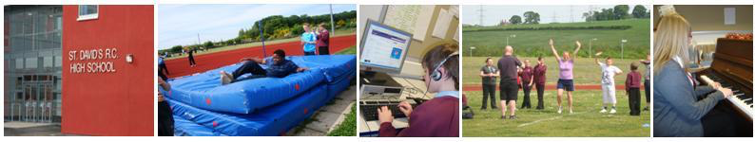

**Support for Pupils Children with Additional Support Needs Communication**

Children with Additional Support Needs (ASN) are supported in school in line with Midlothian Council’s “*Education for All*” policy, Education (Additional Support for Learning) (Scotland) Act 2009. Information on this policy is issued to parents/carers and children via Midlothian Council’s publication “Education for All: a guide for parents, carers and young people”, which is also available in school.

Information is also available in alternative formats and in community languages – please contact Midlothian Council for further details. For school based information the contact person is the Head Teacher.

“The authority keeps the additional support needs of each such child and young person under consideration through the Midlothian Assessment and Planning Staged System (MAPSS) process.

The additional support needs of these identified children and young people are recorded on Seemis, the authority’s secure management of information system.”

**Enrolment**

Children with Additional Support Needs will commence their partnership with the school as early as possible before transition to the school, especially from Nursery to Primary 1. Children’s additional support needs will be identified and addressed using Midlothian’s Assessment and Planning Staged System (MAPSS).

The Head Teacher and school staff will work in partnership with the parents/carers, professionals and other partners and the child to ensure that their needs can be best met prior to their official start date.

**Assessment**

Regular meetings take place in school with Support staff and partner agencies to discuss pupils who have Additional Support Needs and to plan appropriate supports. This is part of The Under-12 Forum process and parents/carers are consulted during this process.

Parents and carers may request an additional needs assessment by contacting the school in the first instance. A request can also be made in writing to the ASN Officer asnofficer@midlothian.gov.uk Education and Children’s Services Division, Fairfield House, 8 Lothian Road, Dalkeith EH22 3ZG.

**Support**

Within the school the support system for children consists of the Head Teacher, Class Teacher, Support for Learning (SfL) and Support Staff and partner agencies. The principle behind this being, that all pupils with ASN should receive appropriate levels of support from one or all of the systems available to them.

All school staff and partner agencies in partnership with parents/carer have an important role to play in a whole-school approach to teaching and learning of all children with a particular emphasis on those children with additional needs of short or long term nature.

A multi-agency approach is employed to support young people and their families where necessary. Regular internal reviews (with appropriate agencies) and annual multi agency reviews take place to reflect, inform and update on the young person’s progress and daily support. This takes place in liaison with school staff to ensure that appropriate levels and working strategies are in place.

Individual Education Plans are written and reviewed with the child and parents/carers regularly. At the annual review parents/carers and the pupil are given a stakeholder’s questionnaire to complete. The Class teacher and SfL teacher work in partnership with parents/carers who are kept informed of the child’s progress at every stage.

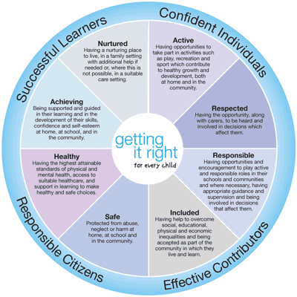At St. Matthew’s Primary we take great pride in our approach to inclusion and value all children. We ensure we provide the highest possible learning experience for all children.

**School Improvement**

Our recent visit from Her Majesty’s Inspectors of Education (HMIe) October 2012 highlighted the strengths of our school some of which are detailed below:

* Children are highly motivated, keen to learn and proud of their school.
* Staff provide a very nurturing environment and support children’s learning and development very well.
* Staff feel valued and form a strong cohesive team which shows strong commitment to school and the children.

Our improvements in communicating the life and work of the school and children’s learning experiences has received extremely positive feedback from parents/carers who enjoy a multi-media approach through text messaging, website and our school email as well as conversations about learning, workshops and classroom observation

Please click on the link to our school website to review our most recent Standards and Quality Report and our present School Improvement Plan. <http://stmatthews.mgfl.net>

These documents will provide you with:

* information on the main achievements of the school over the last 12 months
* information on how the school has improved standards in relation to literacy, numeracy and  health and wellbeing
* plans for improvement of the school’s performance over the next three years

**10 School Policies and Practical Information**

**School Uniform**

It is the policy of the school to encourage school uniform and it is expected that parents will endorse this. Establishing and maintaining a school dress code has many benefits. These include improvements in safety, security, discipline and community spirit and a decrease in bullying and expense for parents/carers. For your guidance, the dress code for St. Matthew’s is:

A bottled green V necked jumper with school logo, with black trousers/skirt, a white shirt and school tie. Order forms for the uniform can be obtained from the School Office.

Children are asked to change into black indoor shoes when entering the school building.

**P.E. Kit**

White St Matthew’s T-Shirt  
Green Gym shorts  
Trainers  
Tracksuit bottoms and a St Matthew’s Hoodie or Jumper will be required all year round

No clothing associated with football clubs should be worn to school, during PE or when representing the school in the locality.

All items of clothing should be clearly labelled with your child’s name in case of loss. For indoor school wear, all children are asked to have a change of footwear. This protects and keeps the floors in school safe and clean.

**Interval**

We have a large concrete playground and encourage the children to interact and make best creative and imaginative use of this. In partnership with the parent council we provide materials and equipment for the children to play and interact with. Please ensure your child is appropriately dressed for Scotland’s ever-changing weather conditions.

Our playground project has started. Have a look at our playground project display for more information.

**Assistance with the provision of Clothing and Footwear**

The Authority operates a scheme of clothing grants to assist parents in ensuring that a pupil is sufficiently and suitably clad to take full advantage of the education provided. Families in receipt of Income-based Job Seekers allowance, on Income Support or Child Tax Credit but not Working Tax Credit (subject to a maximum annual income), both maximum Child Tax Credit and maximum Working Tax Credit (subject to a maximum annual income) or support under Part VI or the Immigration and Asylum Act 1999 will automatically qualify for such a scheme. Other cases will be determined according to the personal circumstances of the family.

Parents who wish to apply for the scheme should complete an application form which is available from this school or the Education and Children’s Services, Fairfield House, 8 Lothian Road, Dalkeith EH22 3ZG.

**Standards of Behaviour, School Rules and Discipline**

The excellent behaviour of children is essential in the maintenance of excellent classroom management and in the promotion of sound learning habits. It is the policy of the school to encourage high standards of behaviour, attitudes and manners since this ensures the security of the individual child, the morale and cohesion of the class group and the atmosphere and ethos of the whole school. Excellent behaviour from children creates a favourable impression on visitors and the local community also. At all times children are expected to stay within the school boundaries.

When these rules are infringed the matter will be dealt with by the playground supervisor and class teacher who will employ certain minor sanctions. When a child persistently commits minor misdemeanours or is involved in a more serious breach of discipline the matter will be reported to the Head Teacher. If necessary, second stage sanctions will be employed. These include withdrawal of privileges and detention (within school hours). Should these measures prove inadequate, you - the parent/carer - will be informed and invited to discuss the use of further sanctions with the Head Teacher to work towards a resolution and to move the situation forward.

**Rights Respecting School Children’s Rights and Responsibilities**

Each classroom also has its own class charter that have been agreed by both adults and children after class discussion and based on children’s rights and responsibilities. The children, along with the class teacher have agreed a system of awards and sanctions which complement the whole school promoting positive behaviour policy.

A Promoting Positive Behaviour/Behaviour Management Statement is held by every member of staff and is shared and agreed with parents/carers and children.

The Education Committee has extended the Youth Strategy Policy to primary pupils with social and emotional needs.

**The School Day**

Primary 1-7 spend a total of 25 hours per week in class.

Primary 1 pupils will spend the whole day at school from their first day.

The regular school times are as follows:

**The School Day**

j0232735 8:50am The school day begins

10.30am Morning interval

10.45am End of morning interval

12.30pm Lunch break

1.15pm Afternoon session begins

3:15pm (Mon – Thurs) School day finishes

(12.25pm on Fri)

**Out of School Childcare service (also called After School Clubs)**

All Primary Schools in Midlothian are served by one of the Out of School Childcare services (also called After School Clubs) that operate in Midlothian. The Out of School Childcare service will either operate in or close to this Primary School or provide a pick up and drop off service.

For further information on Childcare (including After School clubs, Childminders, Wrap Around Care, Day Nurseries and Playgroups) and pre-school education in your area contact the Midlothian Childcare Information Service on:

Telephone: 0131 271 3754  
Email: childcare@midlothian.gov.uk or Visit: www.scottishchildcare.gov.uk

**Meals and Milk**

School meals are provided by the authority at the current price of £2.00 daily (this will increase from August to £2.10 per day).

Menus are shared with children and they indicate their choice of meals for the coming week. A choice of main courses including baked potatoes, soup and pizza is available along with a selection of fresh fruit, home baking and yogurt. Packed lunches are eaten in the dining area. Please note that drinks should not be brought in glass containers.

Milk is available to all children in primary school at reasonable prices. Payment is spread across the year. Details of the 5 payments are included in the school newsletter.

Free milk will also be available to all children in nursery education. Free milk will also be available to children in primary schools and to children of primary school age in special schools if their parents are in receipt of Income Support or Job Seekers Allowance.

“Under the Education Committee’s Policy, children in attendance at schools under the management of the Authority are entitled to free school meals if their parents are in receipt of Income Support or Income Based Job Seekers Allowance and Child Tax Credit from the Department of Social Security. Children attending certain special schools where eating skills and the midday meal are part of the educational programme also receive free meals. No other children are eligible for free meals.”

Further information and an application form can be obtained from the school or from the Free School Meals and Clothing Section, Fairfield House, 8 Lothian Road, DALKEITH, Midlothian, EH22 3ZG.

**School Transport**

The Authority currently pays the travelling expenses of those children attending the district school who live more than two miles from that school.

Bus passes are issued where public transport exists and contract transport is arranged where there is no suitable public transport. Where there are vacant seats on contract buses, these may be made available to children who are attending the district school and who are not normally entitled to free transport; however a charge may be made for this service.

Transport costs are also met in the case of any child whom the Authority requires to attend a school other than the district school, if the child meets the distance qualification - where appropriate, free travel is provided for such children.

Consideration may also be given to requests for assistance with travel in exceptional circumstances, e.g. where the road between home and school is deemed dangerous by the Authority, and where there is no public transport available.

Parents who choose to send their children to a school other than the district school will not receive assistance in relation to travel to and from school.

**The School Health Service**

Throughout their time at school a team of specialist Health Service and Education staff will be seeing children as part of a planned programme to make sure that they benefit as much as possible from all that school has to offer, and to help prepare them for life after leaving school. The school health service is part of Midlothian’s Community Child Health Service and also has direct links with those who carry out health checks on children before they start school.

Many different services are provided. The School Health team takes the issue of maintaining confidentiality seriously at all times. The staff involved make every effort to work closely with parents/carers and with others who are caring for your child, both at school and in other branches of the Health Service. Some of the services, e.g. testing of vision in Primary 1, are normally provided to all children on a routine basis to discover which children may need further tests or treatment. Parents/Carers are not necessarily notified of screening tests (vision, hearing, speech) and any parent/carer who does not want a child to be included should notify the school in writing at the beginning of the session. Naturally, if treatment is thought to be required, parents/carers will be informed and consent requested. If you have any concerns about your child’s vision please contact the school nurse who will arrange to test vision or alternatively you can take your child to a local optician (optometrist).

**Some of the staff concerned and the part they play are as follows:**

The school nurse is a lead professional in mainstream schools in Midlothian. School nurses are involved within health promotion and education, prevention of ill health, immunisation, health surveillance and screening. The school nurse may be helped by a health assistant and have a close working links with Community Paediatricians.

The school nurse reviews the notes of all children in Primary 1 as well as those of all new entrants. A member of the school health team measures their growth and tests vision. The school nurse will assess these measurements and results. In addition she may review children who are referred either by parents, teachers or other health professionals at any stage in their school life.

If you have concerns about your child’s hearing the school can refer him or her to the appropriate specialist directly.

Speech and Language Therapist - can provide assessment and, if necessary, support if you, a teacher, your GP or the school doctor feels that your child may need help with communication.

Any enquiries concerning the provision of dental services should be made to the Director of the Community Dental Service, 16 Duncan Street, Edinburgh EH9 1SR (Telephone: 0131 667 7114).

We hope that the School Health Service can, together with parents/carers, contribute to your child’s overall well-being and development. Please do not hesitate to arrange through the Head Teacher to see the school doctor, school nurse or the health visitor if you want any information.

**Child Protection**

The Council has a range of duties and responsibilities in relation to the child protection procedures for all children which includes having regard for their right to be protected from harm and abuse. The school’s duties and responsibilities for this are set out in the Edinburgh and Lothians Child Protection Committee’s “Child Protection Guidelines” which are used by all Midlothian schools and our partner agencies.

In circumstances where a school has a significant concern that a child or young person has, or is at risk of being harmed or abused, the school is required to pass information to the Police, Social Work Department and Health colleagues who have a legal duty to investigate further. While we always endeavour to work in an open manner with parents and guardians, there are some circumstances when it may not be appropriate to inform the parent or guardian that a Child Protection referral has been made or that information has been passed on to these agencies. Under these circumstances, the decision as to when and how parents and guardians will be informed is the responsibility of the Police, Social Work and Health Services as part of their investigation and the school will be informed by these services of the action that they have taken.

Should you wish to discuss this or any associated matter further, please contact the Head Teacher, the school’s designated Child Protection Co-ordinator or the Information Officer, Co-ordinated Services for Children and Young People.

**Health and Safety**

The Education and Children’s Services Division has prepared policy statements on Health and Safety for all areas of its responsibility in accordance with the Health and Safety at Work Act 1974.

Schools staff are fully instructed in their responsibilities in this respect, and safety regulations apply to all aspects of school life, both on and off the premises.

It is expected that pupils will behave responsibly and comply with all safety requirements. The support of parents in promoting good practice in health and safety matters is of great importance to the school.

**Employment of Children**

Please note that children under the statutory school leaving age can be employed only within the terms of the bye-laws on the Employment of Children. These regulations do not permit the employment of children less than 13 years of age, and for those over that age there are limits on the hours and type of employment which are allowed. Parents and employers must both complete an application form for an employment permit before the employment begins. Further details can be obtained from the Education Office.

**Parent Forum (all parents with children at the school) and establishing a new Parent Council**

The Scottish Schools (Parental Involvement) Act 2006 requires the Authority to support the establishment of a Parent Council for every primary, secondary and special school. The act aims to help all parents to be:

* involvement in their child’s education and learning
* welcomed as active participants in the life of the school
* encouraged to express their views on school education and work in partnership with the school

Midlothian Council has produced guidance for Parent Councils including a support pack to assist with the establishment of a Parent Council.

All parents/carers of children attending St Matthew’s Primary School are members of the Parent Forum and as such may attend all meetings of the Council. The Council comprises of parents/carers who have volunteered.

Please feel free to contact the members if you wish. Should you have a concern it is helpful to contact the head teacher or school office to discuss the matter in the usual manner.

j0174351

St Matthew’s Parent Council Representatives:

Chair Person – Wendy Park

Vice Chair Person – Jodie McCabe

Secretary – Michelle Courtney

Treasurer – Sarah Clarke

Co-opted Members – Father Allan Ocdenaria

Teacher Rep – Miss Chidgey

*St. Matthew’s Parent Council are always looking to recruit members and supporters to help in all aspects of supporting the school, school improvement, raising school profile and fundraising*

**Inclement Weather**

It is advisable during inclement weather that you do not send your child to school early in the morning or before 8.45am or 1:10pm following lunch at home. On such days children will normally be brought inside but you will appreciate that this does cause problems in providing adequate supervision.

During morning and lunch interval we encourage all children to go outside – please ensure your child is dressed for Scotland’s ever-changing weather conditions. Please see Midlothian’s winter safety advice by clicking:

http://www.midlothian.gov.uk/info/1608/severe_weather

**Occasional and Emergency Arrangements**

In winter, even when conditions in Rosewell may not be severe, the contract buses may run early if the weather in outlying areas is bad. You are asked to make arrangements for the early reception of your child in these circumstances. Otherwise, we will ensure that your child is retained in school until arrangements are made for the journey home.

If unsure of arrangements please use refer to the school’s communication systems for up to date information via telephone, school and Council website or Twitter as well as local radio stations.

**Playground Supervision**

When children are at school, the responsibility for their safety rests with the Authority, the Head Teacher and staff undertaking this responsibility on behalf of the Authority.

This means that reasonable steps should be taken to prevent any children suffering injury and to ensure that accidents or difficulties can be reported to a responsible adult and appropriate action taken. The school has playground supervisors both at morning interval and lunchtime in the school playground areas as well as in the dining room area over lunch and the school corridors during both interval and lunch.

**Letting Procedures**

Information on making use of school premises can be obtained from the Education and Children’s Services Division.



**Complaints Procedures**

“The Education Committee has approved the following statement of principles and procedures:

**If you are concerned about...**

...a particular aspect of our work, please arrange an appointment to discuss the matter with the Head Teacher in the first instance. Where appropriate, the Head Teacher may nominate another senior member of staff to act on her/his behalf.

The Head Teacher will listen carefully to what you have to say, establishing clearly the issue(s) of concern and, if appropriate, providing you with any relevant information.

In some cases, your concerns can be dealt with immediately; other matters may require more extended investigation.

In any event, the Head Teacher will notify you, normally within five working days, of the school’s response.

It is anticipated that, in most cases, the above steps will result in a satisfactory solution for all concerned.

**If you are dissatisfied with the school’s response...**

...please notify the Head Teacher that you wish to pursue the matter further.

He/she will either review the proposed action or notify you of the appropriate officer of the Education Authority whom you should contact (see “Useful Addresses”).

Contact the named manager by telephone or by letter at Education and Children’s Services Division headquarters.

The Parental Liaison Officer will investigate the matter and endeavour to resolve any difficulties. He/she will report the outcome to you, normally within five working days of being contacted.

Nearly all matters of concerns are resolved through the above procedures. If you remain dissatisfied, please contact again the officer involved at stage 2; he/she will review the situation and/or indicate what other avenues are open to you.

In all cases, final appeal can be sought through the Chief Executive’s office.”

#### Transferring Educational Data About Pupils

Education authorities and Scottish Government have collected data about pupils on paper forms for many years. We now work together with schools to transfer data electronically through the ScotXed programme. Thus Scottish Government has two functions: acting as a ‘hub’ for supporting data exchange within the education system in Scotland and the analysis of data for statistical purposes within Scottish Government itself.

Why do we need your data?  
  
*In order to make the best decisions about how to improve our education service, Scottish Government, education authorities and other partners such as the SQA and Careers Scotland need accurate, up-to-date data about our pupils. We are keen to help all our pupils do well in all aspects of school life and achieve better examination results. Accurate and up-to-date data allows us to:*

* plan and deliver better policies for the benefit of all pupils,
* plan and deliver better policies for the benefit of specific groups of pupils,
* better understand some of the factors which influence pupil attainment and achievement,
* share good practice,
* target resources better.

Data policy

The ScotXed programme aims to support schools and Local Authorities by supporting the collection, processing and dissemination of statistical information required for planning, management and monitoring of Scottish education services.

A subset of this information is passed to Scottish Government for research and National Statistics publications. Education data within Scottish Government is managed effectively by secure systems and is exploited as a valuable corporate resource, subject to confidentiality restraints. As part of its data policy, Scottish Government will not publish or make publicly available any information that allows individual pupils to be identified, nor will data be used by Scottish Government to take any actions in respect of individuals. Data is held securely and no information on individual pupils can or would be published by Scottish Government.

The individual data collected by Scottish Government is used for statistical and research purposes only. We hope that the explanations contained on the ScotXed website will help you understand the importance of providing the information.

Your data protection rights

The collection, transfer, processing and sharing of ScotXed data is done in accordance with the Data Protection Act (1998). We also comply with the National Statistics Code of Practice requirements and other legislation related to safeguarding the confidentiality of data. The Data Protection Act gives you the right to know how we will use your data. This message can give only a brief description of how we use data. Fuller details of the uses of pupil data can be found on the ScotXed website (www.scotxed.net).

Scottish Government works with a range of partners including HM Inspectorate of Education and the SQA. On occasion, we will make individual data available to partners and also academic institutions and organisations to carry out research and statistical analysis. In addition, we will provide our partners with information they need in order to fulfil their official responsibilities. Any sharing of data will be done under the strict control of Scottish Government, which will ensure that no individual level data will be made public as a result of the data sharing and that these data will not be used to take any actions in respect of an individual. Decisions on the sharing of data will be taken in consultation with relevant colleagues and individuals within and outwith Scottish Government.

Concerns

If you have any concerns about the ScotXed data collections you can email the Senior Statistician, Peter Whitehouse, at **Peter.Whitehouse@scotland.gsi.gov.uk** or write to The ScotXed Support Office, Area 1B, Victoria Quay, Leith, EH6 6QQ. Alternative versions of this page are available, on request from the ScotXed Support Office, in other languages, audio tape, braille and large print.

Want more information?

Further details about ScotXed are available on the ScotXed website, [**www.scot****xed.net**](http://www.scotxed.net/)., which contains a section on ‘frequently asked questions’ at <https://www.scotxed.net/jahia/Jahia/lang/en/pid/220>.