Contents

2 Introduction by Head Teacher
3 School Aims
4 Catholic Schools’ Charter
5 Basic Information about the School
6 Staff
7 The School Day / Timekeeping / Attendance
8 Communication with Parents
9 Complaints Procedure
10 Parental Involvement
11 Homework Policy
12 Parent Council
13 Community Involvement
13 The Curriculum
19 Assessment, Recording and Reporting
20 Wider Curriculum
20 Support for Pupils
23 School Improvement
23 Standards of behaviour
25 Employment of Children
25 Health and Safety
26 School Uniform
27 Provision of school meals and milk
28 Transport
28 Medical Care
29 School Health Service
31 Child protection
32 Useful addresses
33 Dates for next session

Dear Parents and Carers

Welcome to St Mary’s RC Primary School, Bonnyrigg

St Mary’s is situated in a central position in Bonnyrigg. As a denominational, co-educational school our catchment area is fairly wide, taking in Bonnyrigg, Lasswade and Poltonhall. We also attract children from outside the area, as well as a number of children of other, or no, faith background and several children from mixed ethnic backgrounds. We currently accommodate 160 children in seven classes from P1-P7. We also have a nursery class, which can cater for the needs of forty 3 and 4 year old children on full time basis. We moved into our impressive new school building in August 2020. Key features of our new building are fantastic outdoor spaces, dedicated expressive arts room, digital connectivity, all with complete disabled access. Burnbrae Early (Nursery) and Complex Needs Provision share the campus with us.

Specialist teaching is provided in Support for Learning, Music and Drama. Pupils in the upper school have the opportunity to learn to play brass and stringed instruments.. St Mary’s also has the services of a Home Link teacher one-day a week.

St Mary’s is an associated primary of St David’s RC High School, 1 Cousland Rd, Dalkeith, EH22 2PS Tel No: 0131 654 4702 to which most of our pupils transfer after completing P7. We also have very good links with Lasswade High School Centre.

The school has an established Parent Council and we welcome parent volunteers who could help in a variety of ways in the school.

At St Mary’s we aim to provide a caring environment in which each child can feel happy, secure and respected as an individual and thus develop educationally and socially to the best of his/her ability. We offer a broad curriculum with the emphasis on active learning through interdisciplinary topics and real life situations as far as is possible.

As you read through this introduction to the school I hope you will appreciate our joint responsibility in achieving the above. I look forward to working in partnership with you and your family within the school community of St Mary’s.

Yours sincerely

Liz Laird (Headteacher)

The information in this booklet is accurate at the time of compilation but is subject to changes in roll, staffing and resources in future years. (November 2021).

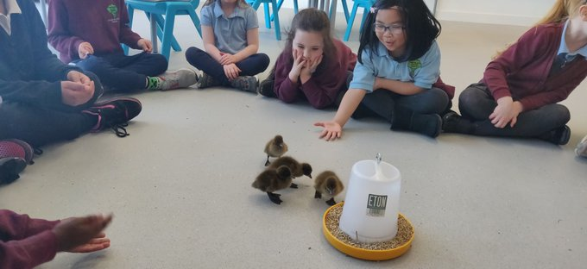

AIMS

St Mary’s exists to serve the families and children who are in the school community. We want it to be a school where every child receives an education best suited to his or her needs, abilities and interests. We aim to assist pupils to become successful learners, confident individuals, responsible citizens and effective contributors.

The school aims are to:
St Matthew said
“treat one another as you would like to be treated”

Put your child at the centre of everything we do

Have high aspirations and expectations of everyone

Provide high quality leadership

Provide innovative and inspiring learning opportunities

Meet all learners’ needs

Work in collaboration and partnership

Work together to develop our children holistically within a culture and ethos of mutual trust and respect



Promote a secure and happy Catholic Christian environment, which extends into a close partnership between school, home, parish and the wider community

Show consideration for individuality, promote and celebrate diversity, inclusion and tolerance based on Gospel values

Our school vision, values and aims have been created in joint consultation with staff, pupils and parents and are regularly revisited and reviewed alongside national and local priorities.

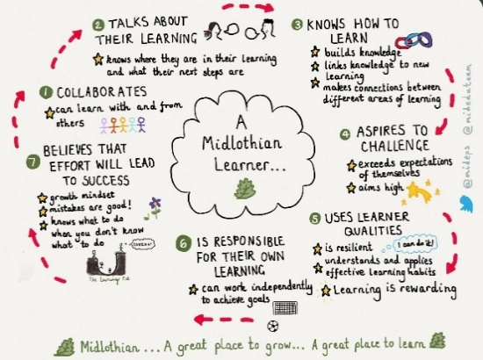
We place our school vision, values and aims at the heart of our collaborative work both with pupils and parents.
- I can CARE for myself, other people and our school.
- I show COURTESY and good manners.
- I show CONCERN by respecting people’s rights and feelings.
- COOPERATION is important to me when I work with others
- I use my COMMUNICATION skills to work things out and build friendships.

All of our rewards and certificates in school are based on the attributes of the Midlothian Learner in tandem with developing the four capacities of Curriculum for Excellence. The attributes of a Midlothian Learner are included in our final report to parents.
A CHARTER FOR CATHOLIC SCHOOLS IN SCOTLAND

The mission of the Catholic school is to develop as a community of faith and learning, providing the highest quality of education, and offering formation through the promotion of Gospel values, through celebration and worship, and through service to the common good.

All Catholic schools in Scotland, in honouring Jesus Christ as the Way, the Truth and the Life, will feature the following characteristics:

- a commitment to the integrated education and formation of the whole person, in close partnership with parents as the first educators of their children;
- an inclusive ethos which aims to honour the life, dignity and voice of each person, made in the image of God;
- a commitment to the search for wisdom in life and to the pursuit of excellence, through the development of each person’s unique God-given talents;
- a commitment to the spiritual formation of the school community, through the shared experience of prayer and liturgy, and in partnership with local parishes;
- the provision of religious education programmes which will enable young people to develop their understanding of Gospel values and of how to apply them to life;
- a commitment to uphold the moral teaching, faith tradition and sacramental life of the Catholic Church;
- a commitment to communicate Catholic social teaching and thereby to promote social justice and opportunity for all;
- a commitment to ecumenical action and the unity of Christians;
- the promotion of respect for different beliefs and cultures and for inter-faith dialogue;
- a commitment to support the continuing professional and spiritual development of staff.

All staff appointed to a Catholic school are expected to support and promote the aims, mission, values and ethos of the school, as illustrated in this Charter.



BASIC INFORMATION ABOUT THE SCHOOL
Mrs Liz Laird – Headteacher
Mrs Fiona Macaulay – Depute Head Teacher
St Mary’s RC Primary School Tel: 0131 271 4690
Rosewell Road
Bonnyrigg
Midlothian
EH19 3HL
e-mail: stmarys_ps@midlothian.gov.uk
School website: stmarys.mgfl.net
follow us on twitter@stmarysrcps

Mrs Caron Hogg – Admin Assistant
Mrs Kirsty MacArthur – Office Support Assistant
School website: stmarys.mgfl.net

Schools Group Manager – Mrs Jennifer Allison – Fairfield House,
Dalkeith – 0131 271 3726

Please visit our school website to find out more about our school. Why not include our website address in your “favourites” option on your computer?

Registration

Each year, around November, the authority will publicise registration timetable details for parents of prospective P1 pupils in Midlothian schools. This information will be displayed on the nursery notice board, the school website and sent to all other local nurseries. If parents have any queries about registration please contact Mrs Hogg, Admin Assistant in the first instance. Parents of pupils, who are non-district, i.e. not living in the catchment area for the school, must register their child at their catchment school and then make a written placing request. Please contact Pupil Placement - pupil.placement@midlothian.gov.uk at Fairfield House on 0131 271 3733. Placing request forms are also available from the school office.

The authority will provide written communication to parents of pupils moving from P7 to S1. Should you have any queries regarding this procedure please contact the above department at Fairfield House. During the school year, if parents wish to enrol a pupil in St Mary’s, then please contact Mrs Hogg, Admin Assistant, who will arrange an appointment with the Headteacher or Depute Head Teacher.

TEACHING STAFF

Mrs L Laird Headteacher
Mrs F Macaulay Depute Head Teacher
Mrs C Nisbet Support for Learning Teacher
Mrs A MacKerron Teacher
Mrs S Stewart Teacher
Ms F Scola Teacher
Ms Kydd Teacher
Ms I Lopez Teacher
Ms A Liddle Teacher
Mrs M Richardson Teacher
Mrs M Brolly Teacher (part time – RERC and pastoral care
Mr R Collins Teacher (Maths and Outdoor Learning – Pastoral Care)
Ms R Bowman Home Link Teacher (part time)

VISITING SPECIALISTS

Mrs Aird Drama

INSTRUMENTAL TUTORS

Miss Fiona Gray Woodwind

SUPPORT STAFF

Mrs S Henderson Senior Early Years Practitioner
Miss S Munro EYP (Maternity Leave)
Mrs H Ewart EYP
Mrs A Wilson EYP
Mrs F Lavery EYP
Mrs M Fiegel EYP
Vacancy EYP
Ms D Allan Modern Apprentice EYP
Mrs Caron Hogg Administrative Assistant
Mrs K MacArthur Office Support Assistant
Mrs J Halliday Learning Assistant
Mrs A Grigg Learning Assistant
Mrs M Kozlowska Learning Assistant
Mrs S Wilson Learning Assistant
Ms A Kane Learning Assistant
Ms E Paxton Learning Assistant
Mr J Kay Caretaker
Mr K Duraj Janitor

Please note that information about staff is subject to change since personnel and complements may vary from year to year.

THE SCHOOL DAY

P1-7

Monday - Thursday 9.00 am-3.30pm
Morning break 10.30-10.45am
Lunchtime 12.30-1.15pm
Friday 9.00am – 12.15pm

NURSERY
Monday to Thursday 8.30 am – 3.30pm
Friday 8.30 – 12.15pm

OFFICE HOURS: 8.30 am – 4.00 pm Answer machine available to report pupil absences outwith these hours

TIMEKEEPING  and  ATTENDANCE | 

We would appreciate your co-operation in ensuring that your child arrives at school on time and, in the case of P1 and P2, is picked up by an adult (i.e. someone who is at least 16 years) promptly at the end of the day. Pupils who frequently arrive late may miss the teaching input, which is required for learning tasks. They may also disturb the rest of the class. It can be very distressing for a child to be left when everyone else has gone home at the end of the school day. There are times when unforeseen circumstances occur to keep you late and in this situation a telephone call to school allows us to reassure your child that you are on your way.

It is also important that pupils do not arrive in the playground too long before the start of the school day – 8.45am would give pupils a chance to chat with friends before the bell rings! Please note that most school staff do not start until 9.00am and cannot be responsible for pupils before that time. On a very wet morning the children will be permitted to gather in the gym hall (not possible during Covid Restrictions).

If your child is absent from school for any reason please inform us by telephone on the first day of absence so that accurate records of attendance can be kept. It is important that family holidays are taken during designated holiday periods out with term time as pupils’ progress may be affected by term time absences. Please state name of child, class and reason for absence when leaving a message.

Should your child remain at home after a lunch break please contact the school so that the Headteacher knows the exact whereabouts of the child.

Parents are responsible for ensuring that their child attends school regularly. In cases of low attendance the Headteacher will contact families and, if necessary ask Children & Families Services to get involved, to assess why a child is not attending school and to offer family support if necessary.

EARLY CLOSURES AND EMERGENCY ARRANGEMENTS

Dates and times of any planned early closures will be indicated in good time in the school newsletter. However there are occasions when the school has to be closed unexpectedly because of some domestic failure. In any such circumstance every effort will be made to contact parents or a designated adult to pick up or receive the child. In this respect it is essential that we have a current mobile phone number through which we can make this contact using GROUPCALL.

COMMUNICATION WITH PARENTS

Throughout the school session there are many opportunities, both formal and informal, for communication between parents and the school. In the first term there will be the first of three opportunities for Parental Consultations offered in the year. The second is in term three in March, and a third in the summer term in June. Additionally teachers organise “Learning Showcases” to which parents and carers are invited. (Covid restrictions permitting)

A number of meetings involving representatives of the Parish as well as teachers and parents are normally held each year in connection with the preparations for the sacraments of Reconciliation, the Eucharist and Confirmation. Sacramental Preparation has changed and pupils are presented for Reconciliation in P3, First Holy Communion in P4 and Confirmation in P7. For P5, P6 & P7 parents, there is also the opportunity to participate in an information evening related to the Growth and Development: Sex and Relationships Education and Personal Safety topics taught in these years. (Covid restrictions permitting)

In addition to these formal occasions parents may contact the school to make an appointment to meet the Headteacher, or class teacher, in order to discuss any problems which have arisen. Please do not hesitate to raise any issue which causes you concern.

During the school day when parents find it necessary to call at the school they must in the first instance report to the staff in the school office. Parents who wish an urgent meeting with the Headteacher should, if possible, telephone in advance to ensure that she is free. (Covid restrictions mean that no-one is permitted in the school without a prior appointment)

In addition to a monthly newsletter, there are regular letters home from the school sent via the children’s book bags. All letters sent home are also posted on the school website. Stakeholder views are gathered via questionnaires and surveys and comments from school reports and parents’ evenings. Welfare concerns are communicated to parents by telephone and we also use a text messaging service.

COMPLAINTS PROCEDURE

“The Education Committee has approved the following statement of principles and procedures:
Parents and schools separately can do a great deal to assist children’s educational development: together they can achieve even more. We will keep you informed of your child’s progress and we will deal confidentially with any information, which will help us in planning his/her education. We will keep you informed of our policies and procedures and will consult with you whenever a significant change is contemplated.
We rely on your support and we welcome your comments on the school.

If you are concerned about…

- a particular aspect of our work please arrange an appointment to discuss the matter with the Headteacher in the first instance. Where appropriate, the Headteacher may nominate another senior member of staff to act on her/his behalf.

- The Headteacher will listen carefully to what you have to say, establishing clearly the issue(s) of concern and, if appropriate, providing you with any relevant information. In some cases your concerns can be dealt with immediately, other matters may require more extended investigation.

- In any event, the Headteacher will notify you, normally within five working days of the school’s response.

- It is anticipated that, in most cases, the above steps will result in a satisfactory solution for all concerned.

If you are dissatisfied with the school’s response:

- Please notify the Headteacher that you wish to pursue the matter further. She/he will either review the proposed action or notify you of the appropriate officer of the authority whom you should contact: (see Useful Addresses)

- Contact the named officer by telephone or by letter at Education Division headquarters. The officer will investigate the matter and endeavour to resolve any difficulties. He/she will report the outcome to you, normally within five working days of being contacted.

- Nearly all matters of concern are resolved through the above procedures. If you remain dissatisfied, please contact again the officer involved in stage 2; he/she will review the situation and /or indicate what other avenues are open to you.

- In all cases, final appeal can be sought through the Chief Executive’s office.

PARENTAL INVOLVEMENT

All staff value effective partnership with parents in order to support the education of all our pupils. The basis of this partnership is effective communication and respect. Please support the school’s efforts to communicate its work through curriculum evenings, parental consultation evenings and other school events. Parents are heavily involved in the school and in the nursery - escorting swimmers, helping with outings, making teaching materials and generally being available to us when the need arises. If you are able to help in any way, please contact Mrs Hogg, Admin Assistant.

Our Support for Learning teacher has an overview of the management of Individual Education Plan review meetings which are held termly in September, January and May. A letter of invitation will be sent out to all involved in supporting a pupil. For pupils with Additional Support Needs, who have Individual Education Plans (IEPs), there will be regular discussion with their class teachers to set appropriate targets for their learning. Pupils will usually ‘traffic light’ their progress on meeting these targets and if in P5 – P7 will be invited to attend their IEP review meeting with their parents, staff members and representatives from outside agencies. Arrangements for further meetings are usually agreed at the first meeting of the year and a reminder letter is sent out 2 weeks prior to the next meeting.

ASN stakeholder’s questionnaires for parents/carers with a separate questionnaire for pupils are also issued. These are sent out annually and returns collated in school and copies sent to the ASN officer in Fairfield House. The feedback given is used to review and improve current practice.

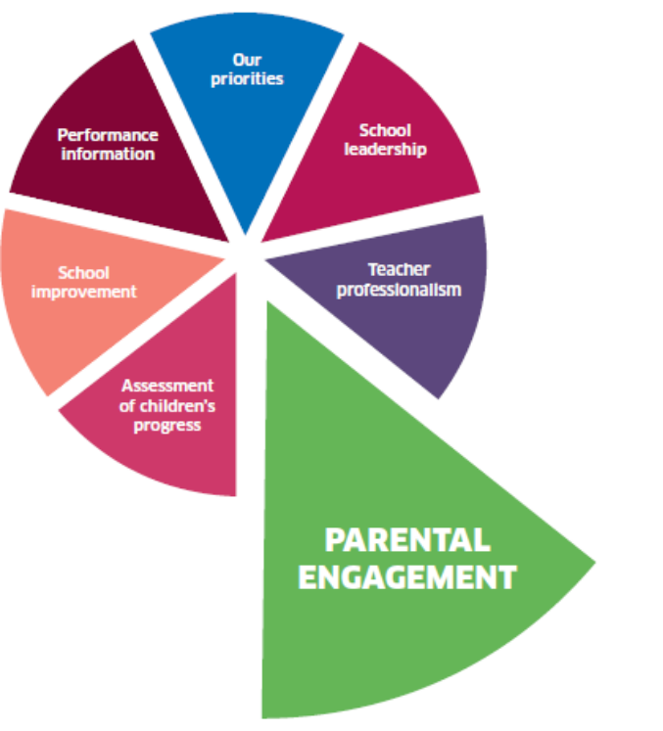
What is this?
Parental engagement focuses
on ways in which parents,
families and professionals work
together to support children’s
learning.

HOMEWORK POLICY
Rationale
Homework is seen as an invaluable contact with home providing an opportunity for parents to be involved in their child’s learning. Learning out of school should complement, strengthen and support the process of learning within the school.

Learning out of school is appropriate at all stages and can take a variety of forms eg:
- Parents/carers reading to and with their children and discussing the reading materials
- Parents/carers listening to their children read the text of a book.
- Parents/carers and children watching television/listening to radio for a purpose and discussing the programme contents
- Parents/carers and children working on developing research skills e.g. visiting the library to gather information on the class topic/exploring a particular website
- Parents/carers and children working together on practising number bonds/facts and spelling
- Parents/carers and children visiting places of interest together
- Visiting the local library together

At St Mary’s children will be given a book to read at home for enjoyment. In P1 and P2 phonics practise is encouraged as is basic letter formation. All learners are encouraged to practise their Basic Maths Facts.

From time to time homework may be given in RE eg Sacramental Preparation, competitions and challenges.

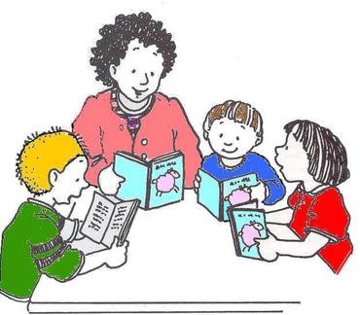

PARENT COUNCIL

The Scottish Schools (Parental Involvement) Act 2006 requires the Education Authority to support the establishment of a Parent Council for every primary, secondary and special school.

The Act aims to help all parents to be:
- involved in their child’s education and learning;
- welcomed as active participants in the life of the school; and
- encouraged to express their views on school education generally and work in partnership with the school.
Parent Council members are selected from the members of the Parent Forum which is made up of all the parents with children in attendance at the School. Midlothian Council has developed guidance for Parent Councils including a support pack to assist with the establishment of a Parent Council.

Parent Councils consist of elected parent members, elected staff members and co-opted members chosen from the local community. Parent members must always form the majority. Parent Council members normally hold office for three years. There are certain conditions relating to membership qualification.

The appointment committee for senior school staff must include nominees from the Parent Council. The Parent Council must be consulted with regard to the drafting of the short leet of candidates in the case of a Headteacher appointment. The Parent Council and the Headteacher have a duty to promote contact between the school, parents and the wider community.

The Parent Council may raise funds and spend the money for the benefit of the school. The Parent Council must keep proper accounts for these monies. The Parent Council is however prohibited from levying fees and charges for school education and from owning heritable property.

PLEASE SEE THE PARENT COUNCIL NOTICE BOARD FOR CURRENT MEMBERSHIP INFORMATION. PARENT COUNCIL MEMBERS
Chair— Annette Egan
Vice Chair— Suzie Fegen
Secretary—Kelly Stewart
Treasurer—Joanna Shields

Church Representative Annette Egan
Staff Members Mrs F Macaulay, Mrs J Halliday
Clerk Vacancy
Both the Chairperson and Clerk can be contacted at: c/o St Mary’s RC Primary School, Rosewell Road, Bonnyrigg, Midlothian EH19 3HL.

COMMUNITY INVOLVEMENT

As a Catholic school we have a significant involvement in the parish of Our Lady, St Matthew’s and St Margaret’s. Father Allan Ocdenaria is our school chaplain, and leads Mass with the children around three times a year. We have an active and mutually supportive relationship with St Matthew’s, Rosewell and St Andrew’s Primary Schools and value the joint activities, which we often plan together.

We take part in the local Bonnyrigg Lights ceremony each year and on the sports side we participate in Football, Swimming, Rugby, Hockey and Athletics organised by the Active Schools Coordinators and local Community Groups, the emphasis being on participation and good sportsmanship rather than competition. We support a number of Community and fund raising events throughout the year such as Bonnyrigg Lights, Children in Need, Kilts for Kids Day and supporting Marie Curie Cancer Care with our Easter daffodils. Missio Scotland is our global charity supported throughout the year.

The Road Safety Officer supports the work of the school in Road Safety matters, including supporting our Junior Road Safety Officers’ Group.

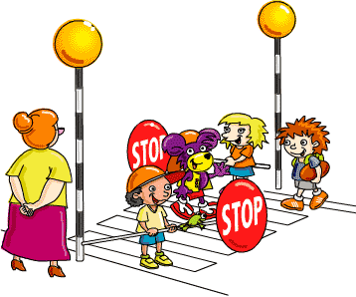

THE CURRICULUM

At St Mary's we are committed to implementing Curriculum for Excellence which aims to provide a coherent, more flexible and enriched curriculum from 3 -18, firmly focused on the four capacities – successful learners, confident individuals, effective contributors and responsible citizens. Important themes such as enterprise, citizenship, sustainable development, international education and creativity are developed in a range of contexts. Learning related to these themes is built in to experiences and outcomes across the curriculum areas.

LANGUAGE AND LITERACY

At St Mary’s we aim to develop in each child a positive attitude to language through the provision of structured and stimulating learning experiences from which can be developed skills of communication and knowledge, understanding and appreciation of their own and other languages, using a variety of contexts. The foundation for this lies in good oral skills and developing a wide vocabulary is a priority in our Nursery class.
In the Nursery and P1, reading is approached on an individual basis with the child selecting, with guidance, a book to read with you and with the teacher - a system known as “shared reading” progressing thereafter through graded reading. A synthetic phonics programme Read, Write, Inc is used to teach pupils their initial sounds and blends and to word build in P1, P2 and P3. Use is also made of the Oxford Reading Tree as a core text, with additional support material for those children who need more support in this area being used e.g. by the Support for Learning teacher.

As children progress through the school the range of reading materials increases and group studies of novels develop further understanding of text. At all stages children are introduced to non-fiction material at an appropriate level. Critical Literacy strategies are used to help children gain meaning from a range of texts.

At all stages children are encouraged to discuss the content of their reading material thus developing associated skills of TALKING and LISTENING.
Further skills in talking and listening are learned using audio visual aids and from early stages discussion skills are developed from children’s own experiences, topical issues and current affairs. Children are encouraged to take part in assemblies, productions etc developing the confidence to speak publicly.
In the Nursery and P1, WRITING is developed alongside the reading within the structure of the synthetic phonics programme and using Foundations Of Writing. As part of the synthetic phonics programme P1 pupils learn to write known words as the teacher dictates them from an early stage.


Further development of writing finds children engaged in producing varied written work for many different purposes linked, where possible, to real life situations, and the class topic. Language structure, spelling and punctuation are taught at appropriate levels again where possible in the context of reading material and using a variety of resources such as the Nelson Spelling Programme, and the Pelican Guided Writing Scheme. Star Writers from each class are awarded certificates at Assembly.

Children use digital devices from Nursery and throughout their learning in the school. Significant use is made of digital devices in the classrooms by groups of pupils and individuals.



MATHEMATICS AND NUMERACY

At St Mary’s it is our aim to develop in each child a positive attitude to mathematics through a balanced, progressive series of stimulating learning experiences. These in turn can develop knowledge and understanding of numeracy and mathematical thinking and the capacity for independent thought through enquiry, problem solving, information handling and reasoning, using a variety of contexts. At St Mary’s we follow the progression of the Midlothian Understanding Maths Programme (MUMP).



In the Nursery and early stages, Maths and Numeracy is developed through active learning, through play, sorting, matching, counting games etc progressing to more formal work based on the ‘Midlothian Understanding Maths Programme’. Mathematics is also taught through topic work and related to every day situations whenever possible. Emphasis is placed on understanding of mathematical concepts and their relevance to real life. In developing this understanding great use is made of concrete materials and practical activity.

Digital devices are introduced at an early stage as we prepare children for life skills for their future. Logical thinking and problem solving skills are developed through carefully chosen games, topic work and real life experiences.

HEALTH AND WELLBEING/PERSONAL AND SOCIAL DEVELOPMENT

A variety of resources and initiatives, are used to provide a systematic, structured approach to learning in this curricular area throughout the school. As a Nurturing School we support pupils in understanding their learning is developmental, that the classroom is a safe base, that nurture is important for their wellbeing, that language is a vital means of communication, that all behaviour is communication and the importance of transitions in their lives.

In the teaching of Relationships and Moral Education, staff will follow the ‘Guidelines for Teaching Relationships and Moral Education to Catholic Children’ published by the Catholic Education Commission. The main resource for this is “God’s Loving Plan”. Staff are trained in Emotion Works, a programme which supports pupils to self-regulate their behaviour in class and in the playground through discussion, intervention and celebration of emotions and a Growth Mindset.

At all stages in nursery and primary, pupils are encouraged to develop self-confidence, independence, a sense of interdependence and citizenship. All learners are helped to develop an emotional literacy and are encouraged to recognise the different emotions they experience. Personal safety including cyber safety, is taught progressively through the school with P5, 6 & 7 working with partner agencies to learn more about the dangers of drugs and alcohol. The school has an anti bullying policy in place and children are taught what to do if they are being bullied or if they see someone else being bullied. Pupils are encouraged to take on responsibilities in the classroom and for older pupils within the school and local community. Pupils from P3-P7 represent their classes on a range of Pupil Voice Committees. P6 pupils act as ‘Buddies’ for P1 pupils and P7 for P2 pupils. All pupils experience the use of ‘Circle Time’. Class teachers use a variety of teaching resources to plan and teach this area of the curriculum.

Physical Education

Our PE programme is taught by our class teachers. At St Mary’s, all pupils receive 2 hours of quality PE each week. Included in the programme are gymnastics, dance, games and athletics, our aim being to develop skills of co-ordination and balance and foster co-operation and sportsmanship so that all pupils may enjoy active participation in sporting activities. Swimming lessons for P4 pupils and skiing for P5 pupils are planned during the year. (Covid restrictions permitting).

Where possible, we offer a residential experience to our senior pupils in P7, this being an ideal situation in which to develop social studies as well as personal and social skills. Pupils are encouraged to participate in all activities under the guidance of trained staff. This is a Learning Community Camp and children are given the opportunity to meet and learn alongside pupils from the Associated schools for St David’s High School who will be in their S1 class. For safety reasons and depending on a pupil’s skill level, activities may be altered. Some activities currently on offer cannot be guaranteed in future years, since the pattern of activities depends on the changing expertise and interests of staff and pupils.

RELIGIOUS EDUCATION AND OBSERVANCE

St Mary’s is a Catholic school and as such specifically gives instruction in the Catholic faith following Pope Francis’ Laudato Si Programme and This Is Our Faith Religious Education Programme in common with all Catholic schools in the Archdiocese. The curriculum is based on the theme of following God’s way by leading a life of love and respect for all people. There are three areas of school life where our faith is especially important. They are our Religious Education programme, our prayers and religious observance and our pastoral care. Regular themed assemblies are held in school. Mass is celebrated in school or we join with the parish on Holydays of Obligation. We have a close relationship with the parish of Our Lady, St Matthew’s and St Margaret’s and Father Allan supports pupils and staff as our chaplaincy team.

Children in P3, P4 and P7 being prepared for the Sacraments of Reconciliation, Holy Communion and Confirmation join with their parents at celebrations in the Church and are encouraged to play an active role in parish life.

We have a large number of children of other or no faith background on the roll and, while no special arrangements are made for these children, no serious difficulties have been encountered in their religious education and observance. Parents have a statutory right to withdraw their children from religious and moral education and from religious observance. At all times we expect that the appropriate respect be afforded to our beliefs and those of the other denominations represented in the school. Pupils are educated to respect the spiritual, moral, social and cultural values of others. As a registered LAUDATO SI school we are commited to protecting the World in which we live.


SOCIAL STUDIES


Our aim in Social Studies is to stimulate children’s awareness and understanding of their environment and their place within it, to enable them to learn about the factors, which have shaped it and develop their knowledge of other people, places and times. Social Studies is organised as follows:

- People, past events and societies
- People, place and environment
- People in society, economy and business

Knowledge and understanding of Social Subjects is developed through Interdisciplinary topics integrating some or all curriculum areas. Social Studies also gives children the opportunity to use and further develop their skills in language and maths, to develop investigative and practical skills and powers of expression and to acquire positive attitudes and values. When appropriate this work is enhanced by external resources of people, experiences and places of interest.

EXPRESSIVE ARTS
 |  |  | 

Music, Drama, Dance, Art and Design are important parts of the curriculum offered in St Mary’s. Specialist teachers complement and extend the work done by the class teachers generally integrated with the topics being studied.

Music
We aim to give our pupils a great variety of musical experiences including singing, musical games, dance, playing of recorders, percussion as well as the production of plays etc. With the support of instrumental tutors in cello, violin, viola and cornet, pupils display a wide knowledge and interest in music.

Drama
Drama is developed in many different ways; through themes, as part of a language exercise, through music, and in a more structured way through the various productions, which are put on by the children. All pupils are encouraged to express themselves through this medium thus coming to a deeper understanding of situations etc.

Dance
Through dance pupils have rich opportunities to be creative and to experience inspiration and enjoyment. Creating and performing will be core activities for all learners and taking part in dance contributes to pupils’ physical education and physical activity.

Art and Design
From the earliest stages children are encouraged to express their ideas through drawing, painting and model making frequently linked to topics being studied. Many different techniques are introduced using a variety of materials and strategies from the Borders Art Pack. Pupils’ work is displayed regularly within the classroom and corridor areas.

TECHNOLOGIES and Digital Learning

This aspect of the curriculum offers pupils the opportunity to learn new skills, which can then be used in all other areas of the curriculum. Smartboards are installed in classes. The school’s Digital Learning coordinator supports staff in accessing this area of the curriculum.

In P1, P2 and P3 Seesaw is used for learning, remote learning and communication with parents and carers. Beginning in P3 to P7, G Suite for Education (Google Classroom, Google Drive) is used for learning and remote learning. Pupils have regular opportunities to use digital devices and equipment such as IPads, Chromebooks and green screen technology.

SCIENCES
Key concepts in sciences have been clearly identified using five headings:

- Planet Earth
- Forces, electricity and waves
- Biological systems
- Materials
- Topical science

NURSERY CLASS

The aim of the nursery class is to develop each individual child both socially and intellectually, to encourage independence and to foster an enquiring mind. This is achieved through the provision of a meaningful child centred curriculum. Being aware of the individual needs and interests of the children, staff provide learning opportunities in a variety of contexts with reference to guidelines on nursery education entitled “Building the Ambition”, “How Good is our Early Learning and Childcare”, Care Inspectorate Care Standards and the Early Level Experiences and Outcomes of Curriculum for Excellence for 3-5 year olds. This is all planned within the overarching framework of GIRFEC and the well being indicators which we use to endure your child is Safe, Healthy, Active, Nurtured, Achieving, Respected, Responsible and Included.

More detailed information is offered to parents of nursery children in our Nursery Booklet, available from the nursery. Parents are encouraged to be involved in the nursery in many ways thus enriching the children’s experiences.

It is important to note that the granting of a place in our Nursery class does not automatically guarantee a place in P1 at St Mary’s as criteria for enrolment in a Catholic school is used.

MODERN LANGUAGES IN THE PRIMARY SCHOOL

St Mary’s along with the other Catholic schools in Midlothian are leading the way with the Scottish Government initiative 1+2 languages, which aims to teach a second language to every pupil from Nursery to P7. All classes will be taught French with an emphasis on conversational skills, and in the early years, songs and rhymes.

LEARNING AND TEACHING APPROACHES

In all areas of the curriculum a variety of methods is employed in order that the needs of each child are addressed taking account of pupils’ learning styles and staff teaching styles. These include class, group and individual direct teaching. Staff use active learning and develop co-operative learning strategies to give pupils ownership of their learning. Pupils are increasingly involved in selecting methods of learning and setting their own targets as they progress through the school. Formative feedback is used regularly to help pupils progress in learning and pupils regularly self and peer assess work in a range of subjects. This makes learning VISIBLE for the children and is a key strategy in all schools in Midlothian. Our aspiration is for all learners to develop the attributes of a Midlothian Learner.
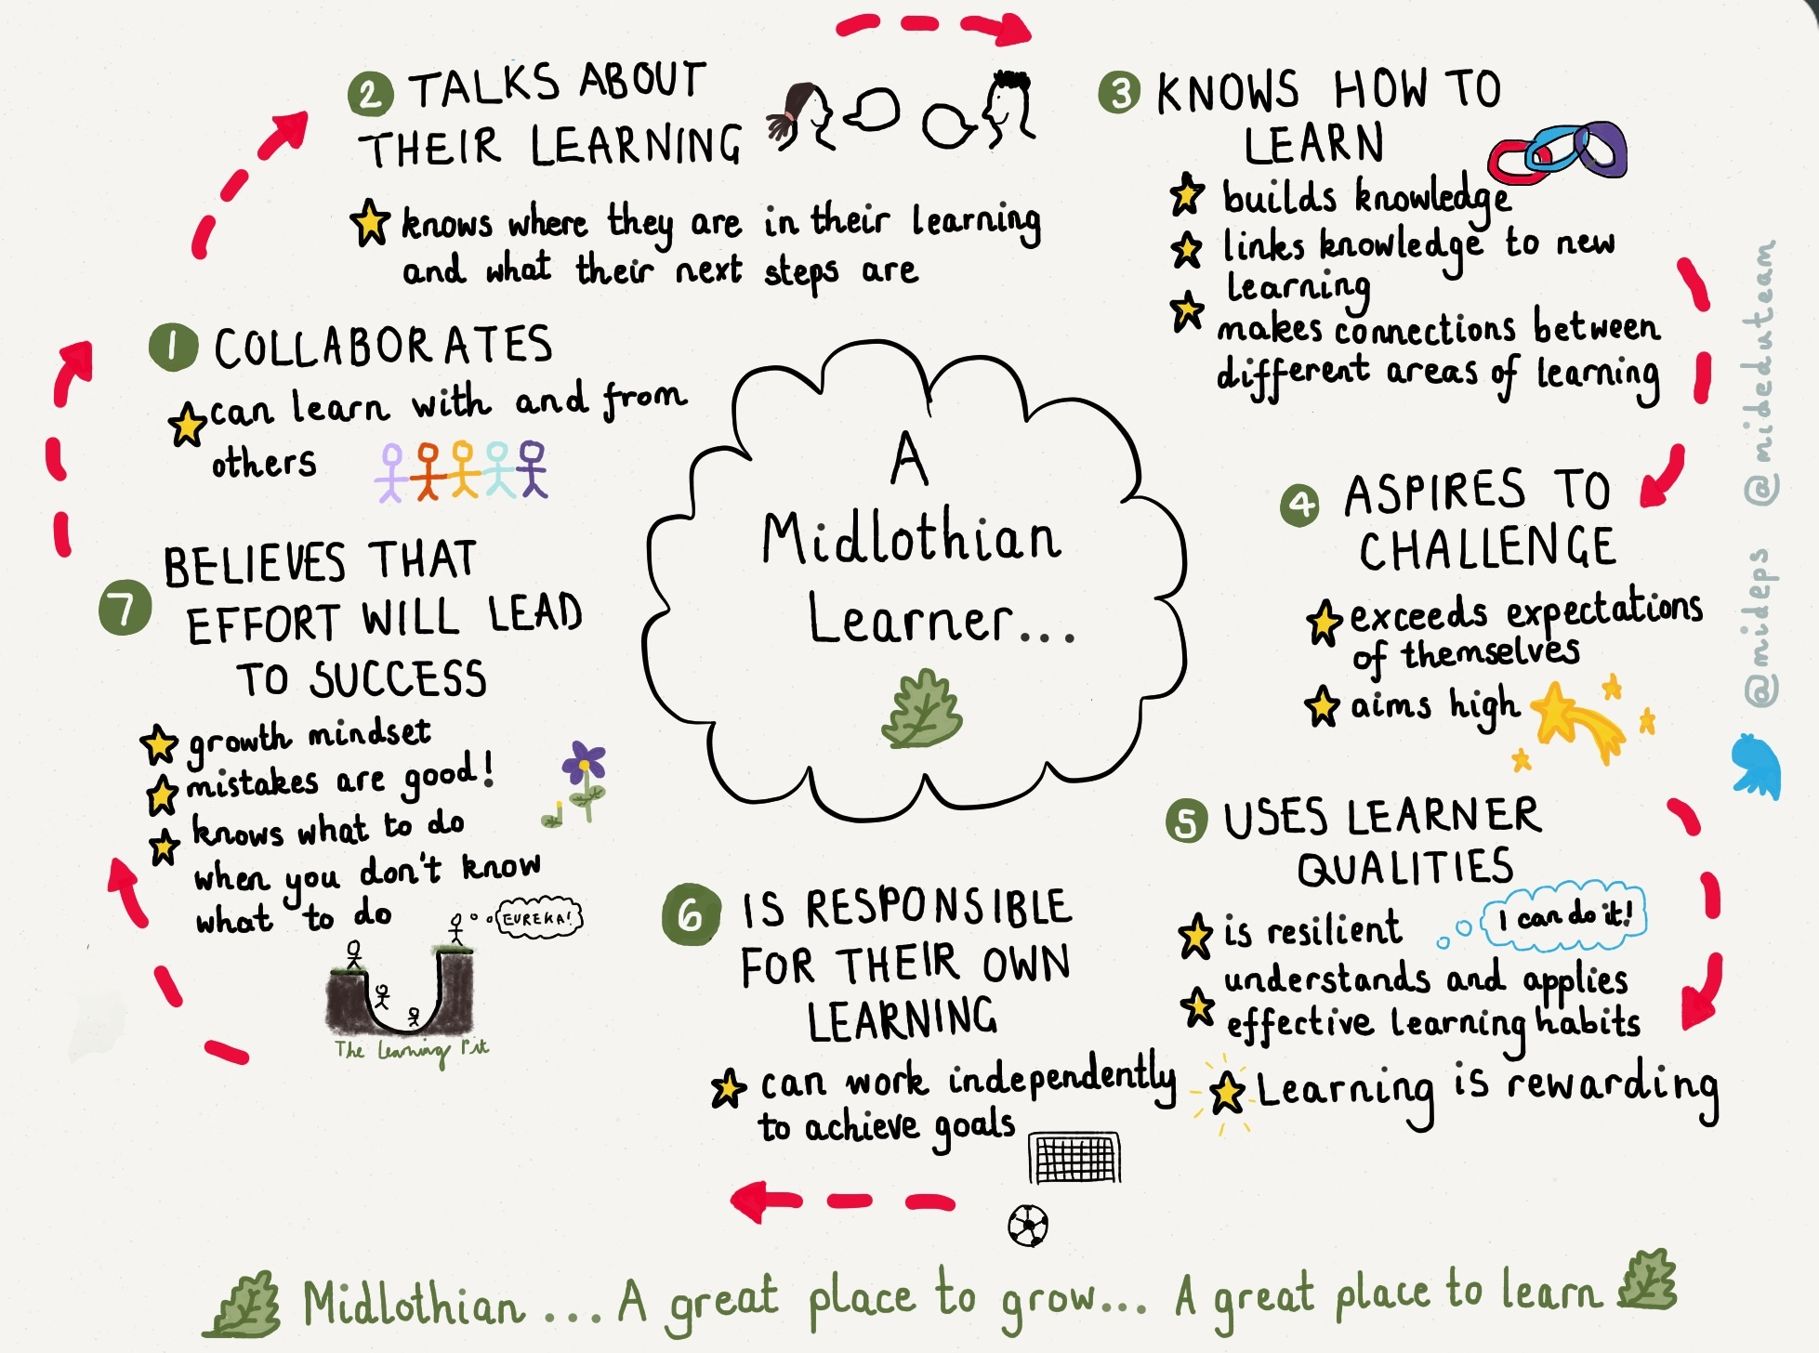

ASSESSMENT, RECORDING AND REPORTING

All teaching staff use continuous assessment to monitor pupil’s progress, evidence being taken from all areas of the curriculum. Assessment is also used to plan the next steps of a pupil’s learning and pupils are active partners in the process through planning in class or through individual education plan reviews etc. From time to time small tests will be administered to assess specific aspects of learning. All assessment matches the aims of the teaching/learning process within ‘Assessment is for Learning’. Parents will be consulted if there are concerns about a pupil’s progress and support may be given by the Support for Learning teacher or authority staff. Each pupil has a learning journal which includes samples of work across the Curriculum. This folder continues with a pupil throughout their school career, being updated in subsequent years.

Prior to the start of the session nursery profiles are forwarded to the P1 teacher and nursery staff and P1 teacher will meet to discuss pupils. The Scottish Government has introduced National Standardised Assessments to be used in schools alongside teacher judgements to assess pupil attainment.

Three formal opportunities are given for individual parental consultation throughout the year and we are currently reviewing how we report on progress to parents. In addition to this, open meetings are held for parents of P5, P6 and P7 pupils in relation to the Growth and Development (Sex Education) and Personal Safety topics taught in the summer term. Further information meetings are held, as appropriate, prior to residential trips. Prior to transition to secondary school, assessment information and pupil progress report files are forwarded to the designated secondary school. Should you be concerned about any aspects of your child’s education please do not hesitate to make an appointment to see the Headteacher or the class teacher. Similarly, if we have concerns we will ask to see you to discuss these.

Nursery Pupils create a Learning Journal. P7 pupils work on producing a digital Profile of achievement throughout their final year. We intend to extend the use of profiles to P5 as training and 1:1 digital devices become available. Children can access their profile at home and will be encouraged to discuss it with their parents. The Profile is an important document supporting transition to High School.

THE WIDER CURRICULUM

During the school year pupils have the opportunity to participate in Nativity Plays, Concerts, assemblies and various workshops e.g. science, dance. Currently pupils have experience of swimming, skiing, rugby, football and musical instruction in cello, violin, viola and brass. P7 pupils participate in St David’s High Cluster Camp. All activity will be risk assessed by the lead professionals to ensure the safety and well-being of all participants. Please note that activities currently available cannot be guaranteed in future years, since the pattern of activities depends on the changing expertise and interests of staff and pupils.

SUPPORT FOR PUPILS
At St Mary’s we work hard to Get It Right For Every Child (GIRFEC) and support children socially, emotionally, physically as well as academically. We use the well being indicators to ensure your child is Safe, Healthy, Active, Nurtured, Achieving, Respected, Responsible and Included. Welfare concerns are raised promptly and the health and well being of pupils is regarded as the responsibility of everyone working at St Mary’s RC Primary.

Our Support for Learning Teacher takes on a variety of differing roles. She can work with individuals or groups, within or outwith the class setting, and can act in a consultancy role, advising teachers regarding strategies and resources most suitable for children who need extra support. She may offer general support in class to pupils in a particular area of the curriculum e.g. Maths or writing. She also liaises with outside agencies and orders and manages appropriate resources. Part of her remit is to ensure, in partnership with the class teacher, that the educational needs of the most able pupils are met. She can support individuals and groups on a short or long term basis. If it is in a child’s best interests she will work elsewhere either individually or with a small group. This will generally be seen, as part of the differentiation required within the class situation, however if long-term regular support is deemed necessary parents will be informed and offered the opportunity to discuss the support.

The Support for Learning teacher has overall responsibility for managing individual educational programmes and reviews. Reviews are held each term and parents and children will be invited to attend. Agreed targets and evaluations will be noted by the pupil in conjunction with school staff and parent /carer. In supporting the needs of each child the school values the work of its learning assistants who will work in a variety of supporting contexts with children e.g. ‘Toe by Toe’ literacy programme, keyboard skills groups, theraputty. In consultation with class teachers, parents and the SfL teacher, a programme of work can be set in place for pupils with special aptitudes to ensure appropriate pace and challenge.

PUPILS WITH ADDITIONAL SUPPORT NEEDS

Midlothian Council values inclusion and promotes the placement into primary and secondary schools of pupils with additional support needs. Information available to parents may be given in a variety of formats, including community languages. Should you wish to enquire further about this service please contact the Head Teacher, in the first instance.

Additional support needs are identified and assessed using Midlothian’s Assessment and Planning Staged System (MAPSS). The process of referral for support may be made through the Team Around the Child Forum and parents and children over 12 are always consulted before any referral. Parents may request additional assessment by contacting the school in the first instance and that a request may also be made by writing to the ASN Officer (asnofficer@midlothian.gov.uk), Education Division, Fairfield House, 8 Lothian Road, Dalkeith, EH22 3ZG. The additional support needs of these identified children and young people are recorded on SEEMIS, the authority’s secure management of information system.

If your child has any kind of additional support need you should discuss this with the Head Teacher at enrolment in order to ensure that staff are able to provide appropriate support for your child.

TRANSITIONS

We organise a planned programme of transition visits for pupils transferring from Nursery into our P1 class in May and June each year. These visits include the opportunity to meet the P1 teachers but also to meet with buddies and key personnel within the school such as the Learning Assistants, Office staff, Kitchen staff, and Janitor.

Close links exist between St Mary’s and St David’s High School. Opportunities to visit the High School are offered to our pupils and to parents and we have a transition programme planned from P6. Good links have also been made with Lasswade High to support the transition process for those pupils who enrol there for their secondary education.

Should you wish to exercise your choice of secondary school then appropriate information will be made available to the high school concerned. During the final weeks of the summer term all high schools offer the opportunity for children to visit their new school to meet the staff and their future classmates and to familiarise themselves with the surroundings.

All of these experiences serve to make the transfer from Nursery to primary to secondary as smooth and as enjoyable as possible. Mrs Bowman, Home Link Teacher, has a particular remit to support families at times of transition from nursery to P1 and from P7 to S1.

PLAYGROUND SUPERVISION

When pupils are at school the responsibility for their safety lies with the Authority. The Headteacher and staff undertake this responsibility as the Authority’s representatives. This means that reasonable steps should be taken to prevent any pupils suffering injury and to ensure that accidents or difficulties can be reported to a responsible adult and appropriate action taken.

At St Mary’s we have playground supervisors at lunchtime and at morning interval. There is no supervision before the start of the school day however, in severe weather and, at the Headteacher’s discretion, pupils will be taken into the school hall, 10 minutes before the start of the school day. In cases of inclement weather pupils are accommodated in their classrooms with supervision by classroom assistants. It is important that all pupils are adequately dressed for inclement weather as they will go outside in light rain.


SCHOOL IMPROVEMENT

The main achievements of the school are summarised in our Standards and Quality and Improvement Plan which is available on the school website or from the school office.
stmarys@mgfl.net

Our School Improvement Plan details the action plans in place this session to improve the learning experiences for our pupils. The improvement plan is created in collaboration with staff and input from parents via the Parent Council and Pupils via the Pupil Council and stakeholder questionnaires. Our School Improvement Plan forms part of the St David’s Learning Community Improvement Plan and we work closely with all the Catholic Primary Schools in Midlothian and St David’s High School to create this.

School Inspection information can be found at:

www.educationscotland.gov.uk/inspectionandreview/index.asp

Our most recent School Inspection Report and Care Inspection Report are on the school website or available from the School Office on request.

Information and copies of School Policies will be included on the School Website.

STANDARDS OF BEHAVIOUR
RATIONALE
Recognising individual achievement and attainment is at the core of Curriculum for Excellence. A consistent whole school approach to rewarding individual achievements sets high and consistent expectations for every learner in the school. Where everybody is expected to work hard and achieve their best, a “can do” approach to learning can be fostered and children can be included in measuring their successes.

At St Mary’s RC Primary this approach to rewarding progress in work goes hand in hand with rewarding good behaviour and developing positive behaviour strategies. There are three key strategies adopted which work together to produce consistent, easy to administer approach to monitoring and rewarding work and behaviour.

REWARD CARDS
- Each term every child will be issued with a reward card with spaces for stickers
- Stickers will be awarded by staff members to recognise progress in learning, good effort, collaborative working and reaching individual targets
- Each card is linked to one of the four capacities of excellence and each term, children will have the opportunity to complete 5/6 specific tasks under these headings.
- When a card is completed a special certificate will be issued in Assembly and pupils will have their photograph added to the achievement board.
- In the summer term every child will have the opportunity to work towards completing their gold award card which will be linked to a special Gold Reward Treat Day at the end of term.
- Any member of staff can award a pupil a sticker.

GOOD TO BE GREEN – BEHAVIOUR MANAGEMENT
- Every class in the school has a Good to be Green chart.
- Every day every child starts of with a green card and the target to stay on green.
- The Good to be Green chart is linked to Golden Time on a Friday where children can sign up for a 30 minute fun activity.
- If a child stays on green all week, they will receive an extra sticker for their reward card and have 30 minutes of Golden Time.
- If children are misbehaving or not following class rules then they will be given a warning or have their card turned to yellow.
- If behaviour improves the card can be turned back to green.
- If behaviour does not improve then the card will be turned to red resulting in loss of 5 minutes Golden Time.
- If a child loses 15 minutes golden time they are then sent to the HT who will set a specific behaviour target. They will also lose a playtime and stay in with the HT and complete a task which is usually a reflection on their behaviour in class.
- A record of Time Out is kept by the HT and if a child has three Time Outs with the HT, a letter will be sent home inviting Parents and Carers in to school to meet with HT and/or class teacher to discuss specific behaviour and agree a strategy for improvement..
- Individual behaviour charts will be used where children are not able to follow the Good to Be Green chart.

CLASS OF THE WEEK
- Each class has a chart on their classroom door with 25 spaces in which to draw smiley faces.
- Classes can earn smiles for their class by demonstrating the 5 Cs
- Care
- Concern
- Cooperation
- Courtesy
- Communication
- The 5Cs reinforce good manners and the message to treat others fairly and as you would like to be treated.
- The class with the most smiley faces each week are awarded the Golden Toast Award in Assembly on a Friday.
- A smile can be awarded to a class by any member of staff in the school and is used to encourage quiet walking around the school, good manners, good behaviour in the dining hall, quality play at playtime etc.

HOUSE POINTS
- Every child in the school will be allocated to either St Margaret’s or St Andrew’s
- A boy and girl in P7 will be House Captain for each house.
- House points can be used to support good classroom organisation and management of resources e.g. everyone who still has their pencil at the end of each day, tidiest tables, tidy trays, homework handed in on time, letters returned etc.
- A visual record of House points will be kept in each class and collated each week by the house captains and announced at Assembly
- House points should be allocated in multiples of 5 for ease of tallying and counting


St Mary’s adopts a zero tolerance approach to bullying and uses a range of restorative approaches to tackle bullying behaviour. St Mary’s Anti bullying Policy has been updated with input from staff, pupils and parents and is available on the school website.

EMPLOYMENT OF CHILDREN

“Children under the statutory school leaving age can only be employed within the terms of the bye-laws on the part-time Employment of Children. These regulations do not permit the employment of children under 14 years of age, except in specific categories; for those over that age there are limits on the hours and type of employment, which are allowed. Parents and employers must both complete an application form for an employment permit before the employment begins.”

Further details can be obtained from the Education Division, Fairfield House, 8 Lothian Road, and Dalkeith EH22 3ZG

HEALTH AND SAFETY

The Education Division has prepared policy statements on Health and Safety for all areas of its responsibility in accordance with the Health and Safety at Work Act (1974). School staffs are fully instructed in their responsibility in this respect and safety regulations apply to all aspects of school life both on and off the premises. It is expected that pupils will behave responsibly and comply with all safety requirements. The support of parents in promoting good practice in health and safety matters is of great importance to the school.

When pupils are in class all external doors will be secured. To gain entry please ring the entry phone system either at the nursery entrance or main school entrance, as appropriate. This will be answered by a staff member. Please note that pupils have been instructed not to open external doors to visitors.

St Mary’s staff are trained in Emergency Aid and Child Protection and adhere to the revised Child Protection Procedures

All children are given instruction and practice on emergency procedures and fire alarms and appliances are tested regularly.

All children should bring suitable clothing for PE on those days specified by the class teacher. Suitable clothing is defined as shorts, T-shirt and rubbers or trainers and for some activities a track suit. In order to facilitate a degree of flexibility of timetable we suggest that gym kit is kept in school in a suitable bag being taken home occasionally for washing. A protective overall should be provided for painting, gluing etc - recent experience shows that an old adult T-shirt is ideal for this purpose.

“The Authority operates a scheme of clothing grants to assist parents in ensuring that a pupil is sufficiently and suitably clad to take full advantage of the education provided. Families in receipt of Income-based Jobseeker’s Allowance, on Income Support or Child Tax Credit (within the limit of an annual income), both maximum Child Tax Credit and maximum Working Tax Credit (subject to a maximum annual income) or support under Part V1 of the Immigration and Asylum Act 1999 will automatically qualify for such a scheme. Other cases will be determined according to the personal circumstances of the family. Parents who wish to apply for the scheme should complete an application form, which is available from the school or from the Education Division, Fairfield House, 8 Lothian Road, Dalkeith, EH22 3 ZG.”

SCHOOL UNIFORM

It is the policy of the school and the wishes of the parents that school uniform should be worn by all pupils at all times. As well as showing pride in belonging to the school the uniform is an equalling factor in these days of designer clothing. If school uniform is not available then clothing of similar colours to those of the uniform should be worn.

The school colours are maroon and sky blue. Basic school uniform consists of:

GIRLS BOYS
white blouse or white or sky-blue shirt
sky-blue polo shirt sky-blue polo shirt
grey/black skirt/trousers grey/black trousers
maroon sweatshirt maroon sweatshirt or jumper
maroon cardigan dark shoes
dark shoes
red/white school dress

As well as the traditional school uniform our own embroidered sweatshirts/polo shirts are a less formal, comfortable alternative and especially convenient on gym or swimming days, details of these are available from Mrs Hogg, Admin Assistant. A waterproof maroon reversible fleece top with full zip and embroidered school badge is also on offer for winter wear or as an alternative to a blazer. School sweatshirts, polo shirts, shorts and T-shirts are ordered once a year through the school. There is also a link on the school website for orders outwith the school bulk order. A comprehensive price list is available on request via the school website or the following link.
http://www.border-embroideries.co.uk/

Please ensure that all items of clothing and equipment have the pupil’s name on them. All lost property is handed in to the school office and then placed in the lost property box at the P4 –P7 entrance. School staff take appropriate measures to maintain the safety of pupils and their property but pupils and parents are responsible for complying with school rules in this regard. The school will not be held liable where this is not the case.

The wearing of jeans, designer clothing, fashion shoes or designer trainers is discouraged as is the wearing of any item of clothing or accessory which may be deemed to be unsafe for pupils. Girls must not wear shoes with high heels as these do not constitute safe playground wear and create too much noise in the corridors and classrooms. Jewellery should not be worn to school and certainly not for PE.

PROVISION OF SCHOOL MEALS AND MILK

Pupils in P1, P2, P3 and P4 are entitled to free school meals. Parent Pay is the system used for school meals. A user name and password for this will be issued when your child enrols at the school. Weekly menus are shown to all children to indicate their choice of meal and choices are made daily. A choice of 3 main courses including soup is on offer each day and a variety of fresh fruit, home baking and yoghurts are available. A rota operates so that each class gets the opportunity to be first in to school lunches at various times. Packed lunches are eaten in the dining hall and are supervised by an adult. Please note that drinks should not be brought in glass containers. (Covid restrictions permitting)

“Under the Education Committee’s policy, children in attendance at schools under the management of the Authority are entitled to free school meals if their parents are in receipt of Income Support or Income-based Jobseeker’s Allowance and Child Tax Credit but not working tax credit (within the limit of an annual income) both maximum Child Tax Credit and maximum Working Tax Credit (subject to a maximum annual income) or support under Part VI of the Immigration and asylum Act 1999. Children attending certain special schools where eating skills and the midday meal are part of the educational programme also receive free meals. No other children are eligible for free meals.”

Further information and an application from can be obtained from the school or from the Free Meals and Free Clothing Section, Education Division, Fairfield House, 8 Lothian Road, Dalkeith, EH22 3ZG

Milk is available to all children in primary school at favourable prices. The collection of this money is roughly 5 times per year and covers a specific period of time. Intimation of the dates for payment is made in the school newsletter and timely payment is required so that an accurate order can be placed with the supplier.

Free milk will be available to all children in nursery education. Free milk will also be available to children in primary schools and to children of primary school age in special schools if their parents are in receipt of the Income Support or Jobseeker’s Allowance or the new Universal Credit.

Under the Education Committee’s policy children in attendance at schools under the management of the authority are entitled to free school meals and milk if their parents are in receipt of Income Support from the Department of Social Security.

TRANSPORT

It is the policy of the Education Division to pay the travelling expenses of those pupils attending their district school from within the catchment area who travel more than two miles to that school. Bus passes are issued where public transport exists and contract transport is arranged where there is no public transport. Where there are vacant seats on contract buses, these may be made available to pupils who are attending the district school and who are normally entitled to free transport: however a charge may be made for this service.

Travelling expenses are also met in the case of any pupil whom the Authority requires to attend a school other than the district school if that pupil meets the distance qualification. Where appropriate, free travel is provided for pupils receiving special education. Consideration may also be given to requests for assistance with travel in exceptional circumstances e.g. where the road between home and school is deemed dangerous by the Authority, and where no transport is available.

People who choose to send their children to a school other than the district school will not normally receive assistance in relation to travel to and from school. You may contact the school or Authority for further information.

MEDICAL CARE

If a child becomes ill, or has an accident during the school day, a phone call will be made to the home requesting that the child be collected from school. If the parents cannot be contacted then the “Emergency Contact” number will be used.

Please do not send children who are unwell to school. We have neither the facilities or staff to care for sick children and there is nothing more miserable than sitting in a classroom feeling ill when all you want is to be in bed! Where a child has a contagious condition, which may lead to others being affected, the school should be notified.

If in the case of an accident it is necessary to take a child to hospital, the parent will be contacted to collect their child or to meet a member of staff at the Royal Hospital for Sick Children thus avoiding any delay in getting treatment.

The school must be made aware of any special medical condition, e.g. asthma, diabetes. If a child is required to have medicine or treatment administered by school staff then a special form (MED 1) detailing the requirements must be completed. This form is available to download from the school website.

Self-administered drugs e.g. inhalers should also be covered by a signed consent form (MED 2) also available from the office. Pupils who require inhalers must have two in school at all times. Mrs Hogg contacts parents if they need to be replaced.
All medication should be uplifted by parents at the end of each term, checked for expiry dates and appropriate medication returned at the start of the new term.

On no account should children be sent to school with aspirin, paracetamol or any other tablet or medicine in a pocket or school bag, the dangers of this are obvious.

Cuts and bruises will only be treated with water/cold compresses and covered if necessary; no creams will be applied to skin at any time.

Our Office staff, have responsibility for Emergency Aid in the first instance.



THE SCHOOL HEALTH SERVICE

Throughout their time at school a team of specialist Health Service and Education staff will be seeing children as part of a planned programme to make sure that they benefit as much as possible from all that school has to offer and to help prepare them for life after leaving school. The school health service is part of Midlothian Community Child health Service and has direct links with those who carry out health checks on children before they start school.

Many different services are provided. The issue of maintaining confidentiality is taken seriously by the School health team at all times. The staff involved make every effort to work closely with parents and with others who are caring for your child, both at school and in other branches of the Health Service. Some of the services e.g. testing of vision in Primary 1 are normally provided to all children on a routine basis to discover which children may need further tests or treatment. Parents are not necessarily notified at the time of these screening tests and any parent who does not want a child to be included should notify the school at the beginning of the session. Naturally if treatment is thought to be required parents will be informed and consent requested. If you have any concerns about your child’s vision please contact the school nurse who will arrange to test vision or alternatively you can take your child to a local optician (Optometrist).

The school nurse is the lead professional in mainstream schools in Midlothian. School nurses are involved with health promotion and education, prevention of ill health, immunisation, health surveillance and screening. The school nurse may be helped by a health assistant and have close working links with Community Paediatricians.

The school nurse acts as an important link between home and school. They visit the school regularly and liaises with the teaching staff. Where a teacher is concerned about a child’s health or development, a referral may be made to the school health team only after obtaining parental permission. Separate referrals to child and family mental health services also needs parental permission. The school nurse can link with other members of the health team, in the community or in hospital, concerned with a child’s health. The health team also work closely with colleagues from other children’s services.

The school nurse reviews the notes of all children in Primary 1 as well as those of all new entrants. A member of the school health team measures their growth and tests vision. The school nurse will assess these measurements and results. In addition she reviews all children who are referred either by parents, teachers or other health professionals at any stage in their school life.

Every opportunity is taken to provide pupils with access to confidential support and advice from the school health team throughout their school career.

Parents are also asked to complete a health questionnaire about their child at Primary 1 and Primary 7. Any specific conditions can be raised at that point.

With your consent, the school nursing staff will carry out immunisations to protect against various diseases:

Age 14 – 15 Booster immunisation against tetanus and polio.

If you have concerns about your child’s hearing the school can refer him or her to the appropriate specialist directly.

The speech and language therapist can provide assessment and, if necessary, support if you, a teacher, your GP or the school doctor feels that your child may need help with communication. Appointments are normally arranged at the local Speech and Language Therapy clinic with follow-up at school if required. Speech and Language Therapists work closely with school staff and support is often provided as part of a Learning Support programme.

Any enquiries concerning the provision of dental services should be made to the Director of the Community Dental Service
16 Duncan Street
Edinburgh EH9 1SR
(Telephone: 0131 667 7114).

We hope that the School Health Service can, together with yourselves, contribute to your child’s overall well-being and development. Please do not hesitate to arrange through the head teacher to see the school doctor, school nurse or health visitor if you want any information.

CHILD PROTECTION

The council has a range of duties and responsibilities in relation to the child protection procedures for all pupils which included having regard for their right to be protected from harm or abuse. The school’s duties and responsibilities for this are set out in the Edinburgh and Lothians Child Protection Committee’s “Child Protection Procedures” which are used by all Midlothian schools and our partner agencies.

In circumstances where a school has a significant concern that a child or young person has, or is at risk of being harmed or abused, the school is required to pass information to the Police, Social Work Department and Health colleagues who have a legal duty to investigate further. While we always endeavour to work in an open manner with parents and guardians, there are some circumstances when it may not be appropriate to inform the parent or guardian that a Child Protection referral has been made or that information has been passed on to these agencies. Under these circumstances, the decision as to when and how parents and guardians will be informed is the responsibility of the Police, Social Work and Health Services as part of their investigation and the school will be informed by these services of the action that they have taken.

Should you wish to discuss this or any associated matter further, please contact the Head Teacher, the school’s designated member of staff for Child Protection, or the Education Officer, Pupil Support Services.

