St Mary’s RC Primary
Standards and Quality Report 2018-19
Improvement Plan - Year 2019-20

At St Mary’s we aim to:
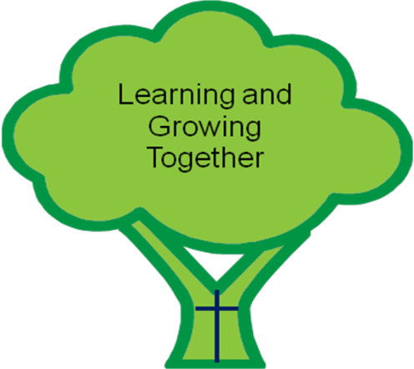
Put your child at the centre of everything we do

Have high aspirations and expectations of everyone

Provide high quality leadership

Provide innovative and inspiring learning opportunities

Meet all learners’ needs

Work in collaboration and partnership

Work together to develop our children holistically within a culture and ethos of mutual trust and respect

St Matthew said, “Treat other people the way you would like to be treated.”

Promote a secure and happy Catholic Christian environment, which extends into a close partnership between school, home, parish and the wider community
Show consideration for individuality, promote and celebrate diversity, inclusion and tolerance based on Gospel values
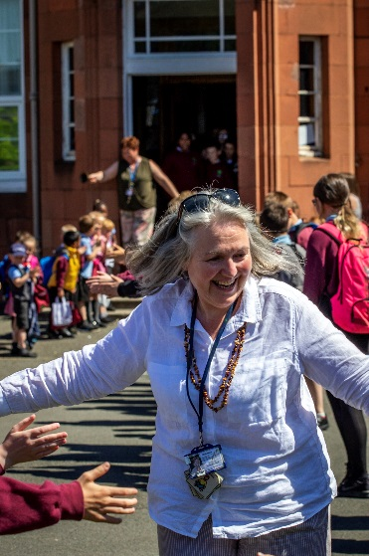
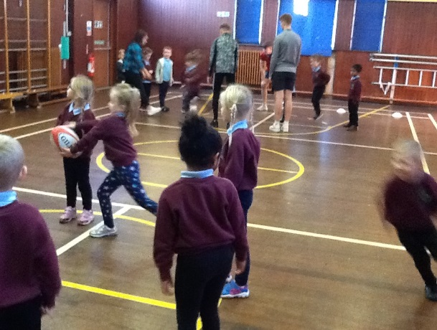
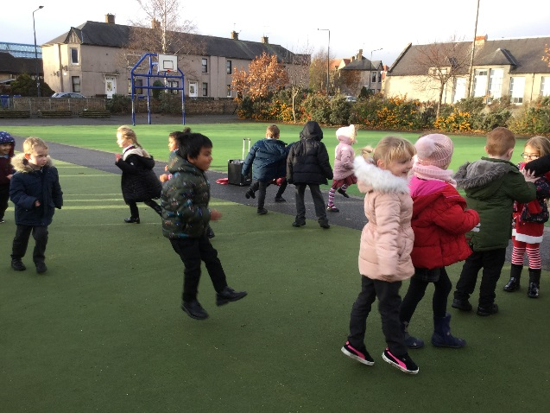

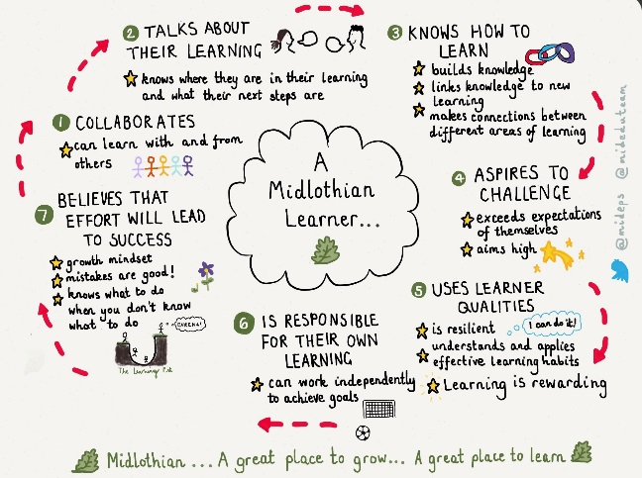
Our school vision, values and aims have been created in joint consultation with staff, pupils and parents and are regularly revisited and reviewed alongside national and local priorities.

In Session 2017-2018 we placed our school vision, values and aims at the heart of our collaborative work both with pupils and parents.
- I can CARE for myself, other people and our school.
- I show COURTESY and good manners.
- I show CONCERN by respecting people’s rights and feelings.
- COOPERATION is important to me when I work with others
- I use my COMMUNICATION skills to work things out and build friendships.

Our Pupil Voice groups used the school aims to underpin the work that they did across the school. All of our rewards and certificates in school are based on the attributes of the Midlothian Learner in tandem with developing the four capacities of Curriculum for Excellence. In session 2018 – 2019, the attributes of a Midlothian Learner were included in our final report to parents.

PROGRESS WITH PRIORITIES 2018-2019

PRIORITY | PROGRESS IN MEETING TARGET
Improvement in attainment, particularly literacy and numeracy | Good progress in maths – improving attainment in writing to be priority for next session
Closing the attainment gap between most and least disadvantaged children – removing barriers to learning | Very good progress -working in partnership with NHS
Improvement in children and young people’s health and wellbeing | Good progress – update of H&WB curriculum carried forward to next session
Improvement in employability skills and sustained, positive school leaver destinations for all young people | Good progress in developing Learning and Teaching strategy across ASG

PRIORITIES FOR SESSION 2019-2020

PRIORITY | WHAT WILL WE DO
Improvement in attainment, particularly literacy and numeracy | Update Literacy and Numeracy strategies – prioritise work on improving attainment in writing
Closing the attainment gap between most and least disadvantaged children – removing barriers to learning | Embed SALT work from last session – training in SCERTS self regulation
Improvement in children and young people’s health and wellbeing | Evaluate and re organise the H&WB Curriculum and planning frameworks
Improvement in employability skills and sustained, positive school leaver destinations for all young people | Review and update STEM and Digital Learning curriculum. Develop partnership working with external agencies
SUCCESSES AND ACHIEVEMENTS IN SESSION 2018-19
This session St Mary’s has benefitted from having a stable staff team and we were able to retain all staff as well as welcome some new ones.
STAFFING
Mrs Laird continued in the Shared Headship of St Mary’s and St Andrew’s with Mrs Macaulay continuing as Acting DHT and Miss Murphy seconded from St Andrew’s as PT. Next session Miss Murphy will return to St Andrew’s as PT and will be known as Mrs Graham following her marriage in the summer. Mrs Laird will change her management time at St Andrew’s to be more at St Mary’s from August 2020.
OFFICE
Lesley Black finished at St Mary’s as our Admin Assistant and Mrs Phillips was successful at interview to take on this role on a permanent basis. Mrs Hogg was permanently appointed as Office Support Assistant.
NURSERY
Our Nursery hours were increased to offer 24 full time spaces in January. The Nursery team were supported by the introduction of a Modern Apprentice Sara Palmer this session and she will continue with us next session. Additional CCDW were seconded from the Early Years team to support ASN in the Nursery and to cover for long term absence.
LEARNING ASSISTANTS
Mrs McAllister supported learning for a short spell between Christmas and February break, and she is now working as a CCDW in the Nursery at St Andrew’s. Miss Pilcher joined us in the school at Easter and will be continuing next session. In June, Mrs Gibson announced her retirement after 14 years at St Mary’s. She will continue to visit the school and support on a voluntary basis and we all wished her well at our final assembly of the year.
VISITING SPECIALISTS
This year all classes benefitted from specialist teaching in RE with Miss Gordon and in music with Ms Askew. They both finished with us in June. Next session specialist teaching in music will be provided by Mrs Macaulay and Chery Aird will be joining the staff one day per week to teach drama.

The new school is beginning to take shape and Mrs Laird and Mrs Macaulay have been in regular meetings with the project managers to finalise furniture options and to be kept informed about the progress of the build. The school is currently on schedule to be completed by Christmas with a plan for the school to move by Easter 2020. In session 2019 – 2020, the build of the new school will be a focus for our STEM work and along with the PC the SLT will be involved in weekly meetings with the project manager to ensure a smooth handover of the building.

Over the course of Session 2018-2019 the school offered opportunities for our learners to develop under the four contexts of CfE, for example:

ETHOS AND WIDER LIFE OF THE SCHOOL AS A COMMUNITY and OPPORTUNITIES FOR PERSONAL ACHIEVEMENT
- Pupils participated in the full range of sporting events organised by the Active Schools teams and again ran a full timetable of lunchtime activity clubs to promote health and well being and an active lifestyle.
- Our P6 and P7 pupils participated in a range of learning opportunities with staff at St David’s High School as part of our Transition planning.
- Our Nursery pupils also enjoyed a series of transition visits to P1 where our current P1 pupils led them admirably through a series of activities.
- Our P6 and P7 pupils have enjoyed buddy reading opportunities with P1 and P2 throughout the year and our P5 pupils are already in waiting to buddy up with our new P1 learners.
- P7 had a wonderful time at Lockerbie Manor at School Camp with P7 pupils from across the St David’s Learning Community.
- Targeted support for learning for pupils in P4-P7 resulted in increased attainment in reading and spelling for all learners and most importantly increased levels of confidence and fluency in reading.
- All learners in P3- P7 had the chance to participate in Pupil Voice Groups this session and all have contributed to developing the wider life and ethos of the school through charitable work, learning about poverty in the world, contributing to decisions about school improvements and social events.
- P5 enjoyed a successful block of skiing lessons in the summer term and P4 have completed a block of swimming lessons.
- We also celebrated with our P3 and P4 pupils who received the Sacraments of Reconciliation and First Holy Communion.
- Learning in and with the Community has been explored by all classes this year with a range of educational visits to contextualise learning.

DISCRETE CURRICULUM AREAS and INTER DISCIPLINARY LEARNING
- All learners have experienced a wide and varied curriculum mapped to progressive and coherent planning frameworks.
- All learners have been encouraged to make connections across curriculum areas by working on interdisciplinary projects in class and at home
- All learners have been able to share their learning with parents and peers by participating in Showcasing the Learning events
- Senior pupils have participated in transition events at St David’s High School developing their understanding of learning in Science, French and English

PARTNERSHIP WITH PARENTS

St Mary’s has a strong and active Parent Council who support the work of the school in a variety of ways. Last year they fund raised to support investment in new digital technology for our new school, supported Sacramental preparation, organised and ran social events in and out of school. Our Race Night was particularly successful and funds raised will allow all pupils to experience a quality Pantomime this Christmas.

Our BOATS events have been well attended and Parents’ Evenings had 95% turnout. Families are generally becoming more engaged in learning about the curriculum and have responded positively to showcasing the learning events and attendance at assemblies at key points in the year.

Thank you to all involved in our school for your continued support. We look forward to working closely with you as we plan our move to the new building at Easter 2020.

