Scottish Youth Parliament and Children’s Parliament: Healthy Social Media and Screen Time Toolkit

Introduction: What is the healthy social media and screen time campaign?
The Scottish Youth Parliament (SYP) and Children’s Parliament, in partnership with the Scottish Government, have co-produced a world-leading digital resource to help children and young people use social media and screens in a healthy way.
Co-created over the last year with the support of over 650 children and young people across the country, the new ‘Mind Yer Time’ resource supports mental and physical health online.
With the resource now set to launch during a time when young Scots aged 8-25 are spending an unprecedented amount of time online, the Scottish Youth Parliament and Children’s Parliament hope to provide vital support during this challenging period at MindYerTime.scot.
Backed by First Minister Nicola Sturgeon, the resource explores hard hitting issues such as online bullying, body image and reducing time wasted online while signposting official NHS and Government approved advice and support services. It features content of children and young people sharing their experiences of social media and top tips from children and young people to make the most of time spent online.
To access the resource, please visit: MindYerTime.scot
What is this toolkit for?
This toolkit has been designed to ensure key stakeholders can support the campaign if they wish, helping to maximise the communication of campaign messages directly to the target audience.
How can your organisation help?
To bolster the campaign and help us to reach as wide an audience as possible with our resource, we would appreciate any support you could provide for the campaign through social media. To aid in this, we have put together some suggested social posts below but please feel free to adjust them for your own channels. Please also feel free to interact with content on our own channels through likes, retweets and shares.

Social Media content:
Example general post to publicise the resource:
For Facebook: "@OfficialSYP have launched the new Mind Yer Time digital resource that helps children and young people learn more about healthy use of screens and social media. 📱
This world-leading resource supports mental and physical health and was co-created with @Creative_Voices through the support of over 650 children and young people from across Scotland. 💻🏴
Check out Mind Yer Time at www.MindYerTime.scot 📱

#MindYerTime "

For Twitter: "Today we launched Mind Yer Time a new resource that helps children & young people learn about healthy use of screens & social media.

The resource was created with @OfficalSYP @Creative_Voices & 600 brilliant young people in Scotland🏴

www.MindYerTime.scot 📱

#MindYerTime"

Example post on mental health:
For Facebook: "Social media has the potential to be used in a hugely positive way but it’s vital to ensure children and young people are properly informed on how social media can promote unrealistic expectations.

@OfficialSYP and @Creative_Voices have co-produced a resource to help children and young people learn about the healthy use of screens and social media.

For more advice on using social media in a healthy way visit - www.MindYerTime.scot"

For Twitter: “Social media can promote unrealistic expectations.

@OfficialSYP and @Creative_Voices have produced a resource to help children and young people learn about the healthy use of screens and social media.

For more advice visit - www.MindYerTime.scot”

Example post on bullying:
For Facebook: "When a friend or someone you know is being bullied it can be really hard to know what to do help them.

@OfficialSYP and @Creative_Voices’ new digital resource, ‘Mind Yer Time’ is here to help & can suggest a few things you could do to help someone being bullied online. 💬📱

Find more information at www.MindYerTime.scot”
For Twitter: "Cyberbullying is horrible & can be difficult to deal with. The most important thing you can do is tell someone.

Mind Yer Time offers lots of advice on how to deal with bullying. More information at www.MindYerTime.scot

@OfficialSYP @Creative_Voices #MindYerTime"

Example post on body image:
For Facebook: "Remember that what you see on social media is how people want you to see them and some of these unrealistic images you see can leave you feeling insecure about your body.

Everyone is completely unique and you have the right to feel confident in yourself and your own skin. 💃

For more information about body positivity visit www.MindYerTime.scot #MindYerTime"

For Twitter: “The images you see on social media can often be unrealistic and cause you to feel insecure about your body.

Everyone is unique and you have the right to feel confident in yourself. 💃

For more information on body-positivity visit www.MindYerTime.scot #MindYerTime”

Example post on sleep:
For Facebook: "A lack of sleep can really affect your mental health making you feel tired, grumpy and low. 😴

Although it is tempting to use screens and social media before bed, it can have a serious impact on sleep quality. 💤

For tips on getting a good night's sleep visit www.MindYerTime.scot #MindYerTime”

For Twitter: “Lack of sleep can affect your mental health making you feel tired and grumpy. 😴

Although it is tempting to use screens and social media before bed, it can have a serious impact on sleep. 💤

For tips on getting your best sleep visit www.MindYerTime.scot #MindYerTime”

Accounts to tag:

Facebook:
Scottish Youth Parliament - @OfficialSYP
Children’s Parliament - @childrensparliamentscotland

Twitter:
Scottish Youth Parliament - @OfficialSYP
Children’s Parliament - @Creative_Voices

Instagram:
Scottish Youth Parliament - @officialsyp

Social media assets for use:

We also have the following graphics available for use should you wish. Please do let us know if you require any additional file formats.

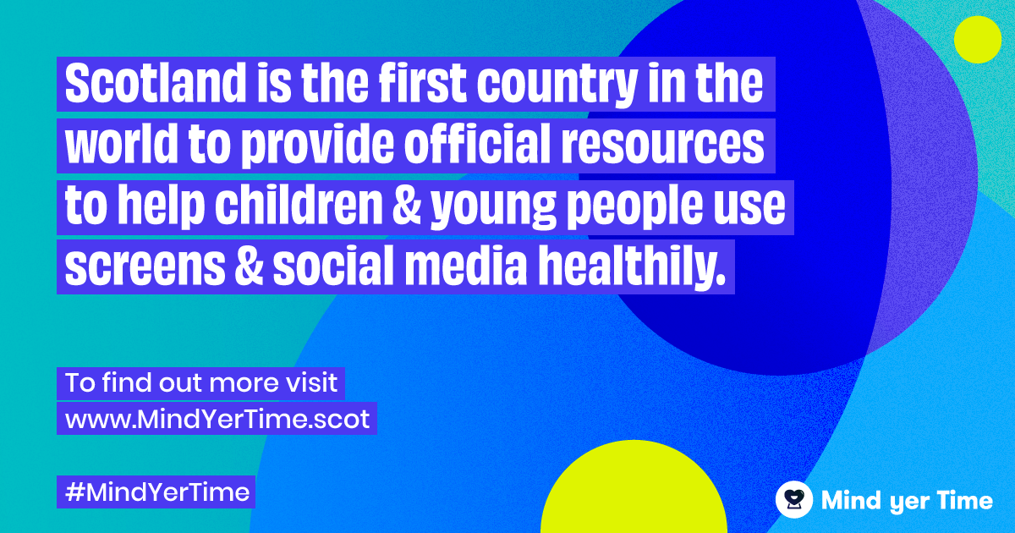

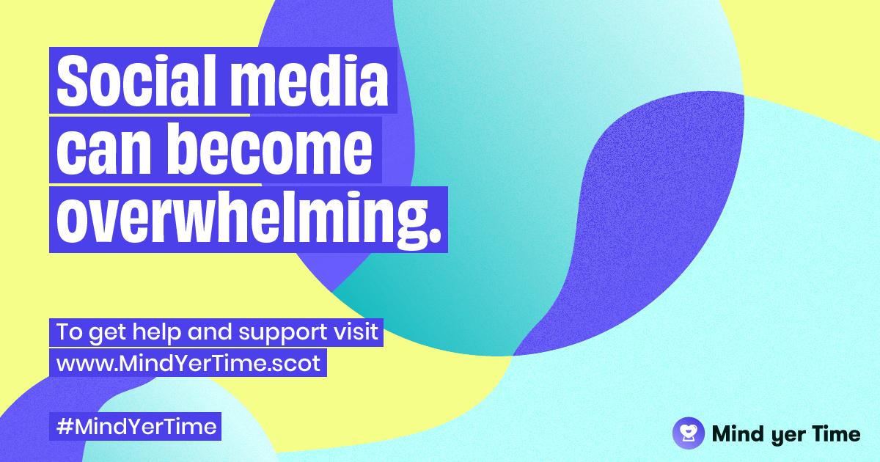

Campaign Timeline
The campaign launched officially on Friday 17 April 2020 and we will be looking to drive traffic to the resource on an ongoing basis in the coming weeks.
First Minister Nicola Sturgeon referred to the new resource as part of her ongoing COVID-19 briefings w/c 13 April. Minister for Mental Health, Clare Haughey has also provided a quote to support the campaign, available in the full press release below.

Please contact Tom Hallam or Izzy Stiven at syp@stripecommunications.com if you have any questions or would like to receive further information.

*******

Released: 17th April 2020
SCOTLAND’S CHILDREN & YOUNG PEOPLE TO ACCESS WORLD-LEADING DIGITAL RESOURCE WHICH EXPLORES A HEALTHY USE OF SCREENS AND SOCIAL MEDIA

Scotland has become the first country in the world to provide a digital resource to help children and young people learn about healthy use of screens and social media.

Co-created over the last year by the Scottish Youth Parliament and Children’s Parliament with the support of over 650 children and young people across the country, the new ‘Mind Yer Time’ resource will support mental and physical health online.

The project was originally commissioned prior to the Covid-19 outbreak by the Scottish Government to develop a world leading resource to promote healthy consumption of screens and social media.

With the resource now set to launch during a time when young Scots aged 8-25 are spending an unprecedented amount of time online, the Scottish Youth Parliament and Children’s Parliament hope to provide vital support during this challenging period at MindYerTime.scot.

The resource explores hard hitting issues such as online bullying, body image and reducing time wasted online while signposting official NHS and Government approved advice and support services. It features content of children and young people sharing their experiences of social media and top tips from children and young people to make the most of your time online.

Minister for Mental Health, Clare Haughey MSP, said: “I can’t think of a better time than now, when we are all adjusting to a new way of life and spending more time online, for this advice to publish.

“As we know, social media does have the potential to be used in a hugely positive way, but we want to ensure young people are properly informed on how social media promotes unrealistic expectations and what the healthy use of social media platforms looks like. We are also considering what further support is necessary for children and young people who may be experiencing stress, worry and anxiety around the pandemic.

“The Scottish Youth Parliament and the Children’s Parliament should be very proud of this world-leading work, and we hope it is widely used across Scotland, both during the pandemic and beyond.”

Jack Dudgeon, Chair of the Scottish Youth Parliament said: “Like all of us, young people in Scotland are adapting to physical distancing by spending more time online.

“Online tech is playing a vital role in reducing isolation during the coronavirus outbreak but at times it can be overwhelming, and research shows unhealthy amounts of screen time have a negative impact on our mental and physical health. We’re proud to be helping young people by launching the Mind Yer Time resource, so they can flourish online and off-line.”

The Children’s Parliament supported the co-creation of the resource by working with children from three schools – Banchory Primary School in Alloa, Thorntree Primary School in Glasgow and Kingussie Primary School. The pupils explore their views on social media and solutions to promote healthy screen use.

Cathy McCulloch, Co-Director of the Children’s Parliament, said: “At a time when many children will be using screens and social media more than ever, having a resource that provides them with lots of useful information, as well as opportunities to play and to participate in the wider world, is incredibly important. Children's Parliament is aware of the risks associated with screen and social media use; however, we are clear that the digital environment also offers extraordinary opportunities for promoting and protecting children's health and wellbeing, particularly at a time like this."

To access the resource visit: MindYerTime.scot

ENDS

For more information please contact Tom Hallam or Megan Cunningham at Stripe Communications on 07590 333 253 or SYP@stripecommunications.com

Notes to editors:

Scottish Youth Parliament (SYP)
The SYP is the democratic voice of Scotland’s young people. SYP’s mission is to provide a national platform for young people to discuss the issues that are important to them, and campaign for changes to the nation that they live in.
Young people aged 14-25 can stand as a candidate in SYP elections. SYP elections are held in Scotland every two years and will next take place in March 2021. For more information please visit here.

Children’s Parliament

Established in 1996, Children’s Parliament is Scotland’s centre of excellence for children’s participation and engagement.

Through rights-based, creative practice, it provides younger children aged 8 - 14 from diverse backgrounds with opportunities to share their experiences, thoughts and feelings so that they can influence positive change in their lives at home, in school and in the community. For more information please visit here.

