How to get online to Glow at home

Search Athena Midlothian or go to <https://athena.mgfl.net/>

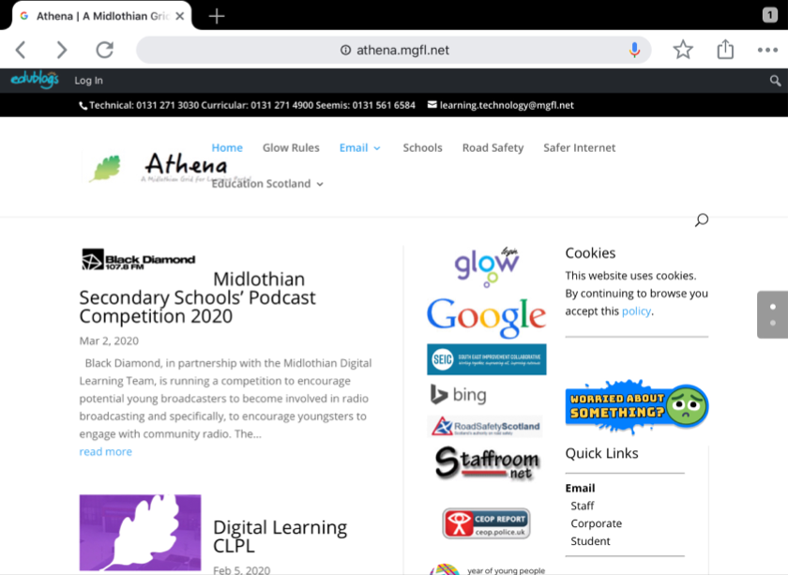

Scan for Glow log in page

