SEVERE WEATHER PLANS IN PRIMARY 2

Literacy and English

Read a story together with someone at home and discuss your favourite part.

Make some Hot Chocolate with someone at home to enjoy in the warmth and then write instructions about ‘How to make Hot Chocolate’. Include drawing/photographs for each step.

Numeracy and Mathematics

Visit http://www.readwritecount.scot/count/ and choose some of the activities and games to do at home.

Access some online games we use in class:

https://www.sumdog.com/user/sign_in

www.topmarks.co.uk

RE

Choose a Bible story and create a comic strip with 6 pictures to sequence the story you read. Add a sentence to each picture to explain what is happening.

Expressive Arts

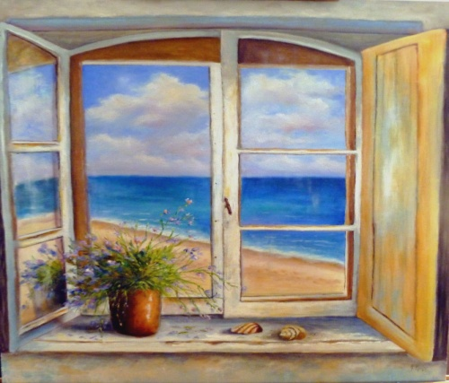
Keeping yourself warm and safe indoors, draw or paint the view from your window. Include as much detail as you can.

Social Studies

Keep a weather diary. Recording the weather in morning, afternoon and evening. Is it cloudy? Is it snowy? Maybe it’s bright and sunny! Watch the weather forecast as well as observing the weather to help you.

Health and Wellbeing

Help to prepare a meal with someone at home and take a picture of you helping.

Consider ‘Our Learning Powers’ throughout all the tasks you complete and discuss which powers you have used and why you used them.

Don’t forget to Tweet your learning throughout the day! @stdavidsprimary

