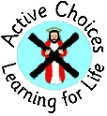
ST ANDREW’S RC PRIMARY SCHOOL
CURRICULUM OVERVIEW 2021-2022
TERM 3
PRIMARY 1 – Miss Prior

Curriculum for Excellence
All schools in Scotland use Curriculum for Excellence to provide a coherent, flexible and enriched curriculum from 3 to 18.
The purpose of Curriculum for Excellence is encapsulated in the four capacities – to enable each child or young person to achieve their full potential and to be a successful learner, a confident individual, a responsible citizen and an effective contributor. At St Andrew’s we work hard to Get It Right For Every Child – GIRFEC and work with parents and carers to ensure children are Safe, Healthy, Achieving, Nurtured, Active, Respected, Responsible and Included – using the Wellbeing Indicators.
We want pupils to:
- achieve the highest possible levels of literacy and numeracy and cognitive skills
- develop skills for learning, skills for life and skills for work
- develop knowledge and understanding of society, the world and Scotland's place in it
- experience challenge and success

Principles of Curriculum for Excellence
These are Challenge and Enjoyment, Progression, Depth, Breadth, Personalisation and Choice, Relevance and Coherence.

Learning and Teaching Approaches
A key priority for improving learning and teaching has been to embed the attributes of a Midlothian Learner with every class in the school.
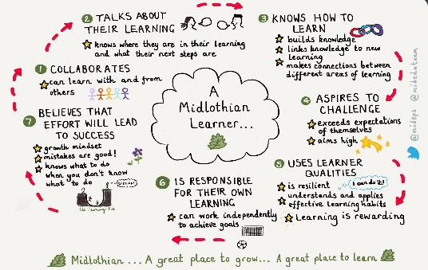

This has run hand in hand with our developing resilience work in health and wellbeing and developing a growth mindset. Pupils develop cooperative learning skills as they progress through the school and are encouraged to reflect on and self assess their work, attitudes and behaviour. They work daily, in a range of teams and groups, with opportunities for these to change and adapt throughout the year. Where possible, pupils approach topic work in an interdisciplinary way and make connections in their learning.

Active Learning
Active learning is when children are actively involved in making discoveries for themselves or in progressing their own skills and knowledge.
Methods such as group collaboration, personal projects, enterprise projects, interactive lessons and practical activities are used in school to make learning more meaningful.

Assessment
A variety of assessment methods are used to check pupil progress. Pupils are often involved in their own assessment, called ‘self-assessment’ where they indicate their own level of understanding. Teachers gather information by observation, checking written work and by listening to what pupils say. Teachers carry out both formal and informal assessments throughout the year, to check pupil’s knowledge, skills and understanding and to inform next steps in learning. It is important that children receive regular feedback on their learning.

Religious Education
We use two resources to teach the RERC Curriculum for Excellence called This is Our Faith and God’s Loving Plan. Key themes and prayers are taught, at each stage in the school, using monthly planners linked to the Liturgical Cycle

Catholic Christianity | This is Our Faith
Other world religions | Judaism and Islam

Celebrating Achievement
Learning does not just happen in the classroom and we work in partnership with other agencies to offer breadth and depth to pupils’ learning experiences at St Andrew’s. Opportunities to work in art, drama, music and sport occur throughout the year. Additionally, partner agencies such as Police, Road Safety and Fire safety Officers teach planned programmes for Health and Wellbeing, in school, during the year.

Learning at Home

Following two periods of Remote Learning and feedback from parents and carers, we have adopted a less formal approach to homework at St Andrew’s. This will be reviewed as the school year progresses.

Staff are keen to foster an enthusiasm for reading and a love of books in your child. Please encourage them to read, or read to them, daily. Join the local library. Reading is a great prompt for discussion, and the sharing of ideas, as well as being an effective way for your child to wind down at the end of a busy day.

Try to use opportunities to count and use numbers with your child, eg: noticing numbers in the supermarket, calculating costs and change, seeing sequences and patterns of numbers such as odd and even, working out scores as part of a game.

Home Learning is best done when activities are fun and relaxed. “A little and often” approach is usually the key to this – especially if activities can be made into a game or seen as part of helping around the house, eg: writing the weekly shopping list, measuring ingredients to bake a cake, helping plan a visit to the park or cinema.

From time to time staff might suggest a follow-up activity based on prior learning in class eg: “prepare a poster about your favourite rain forest animal to present to the class, or to learn a Scottish poem or song to perform.”

In addition, all classes have opportunities, throughout each term, to share items or areas of interest with their peers. Encourage your child to bring in items to support this, eg: books, leaflets or photographs.

PE

All classes have at least two PE sessions per week. While COVID guidance remains in place, pupils should come to school in sports clothing on their PE days. T shirt/ hoodies/shorts/joggers/leggings and trainers are all suitable, but no football colours please. For safety, jewellery should not be worn to school and especially not during PE lessons. We encourage long hair to be tied back.

Routines

Please support your child in ensuring that they have everything that they need for school each day. Encourage them to take responsibility for packing their own bag beforehand, and then emptying it at the end of the day.
Water bottles, containing water for throughout the day, should be taken home daily to wash and refill. Lunch bags and boxes should also be taken home at the end of the day.
Please remember to check school bags daily for letters and information coming home from school. Letters are also emailed directly to families posted on the school website.

Questions

Staff at St Andrew’s RC Primary are committed to supporting you and your child, throughout their learning journey. Should you have any questions or concerns, please contact the school office, where these can be passed on to your child’s teacher or to a member of the management team.
Thank you.
TERM 3  Jan-April 2022 | MAIN THEME/s in P1
Literacy | Phonics- revising set 1 sounds, blending to read words, beginning to read simple sentences, learning red words (words we can’t sound out).  Handwriting- Correct formation of letters, finger spaces between words.  Writing-Developing fine motor skills, writing sentences.  Grammar-Capital letters and full stops.
Numeracy | Number word sequences and numerals- forwards and backwards counting to 30, before, after and between numbers, sequencing and ordering numbers.  Number structures- using finger patterns and number frames to explore making numbers in different ways.  Addition- adding within 10  Multiplication and Division- to explore the term equal, to organise and group items in equal groupings.
Maths | Data Handling
Health & Wellbeing | Emotions Work program  Friendship, kindness, playing together, being kind.  Looking after plants and animals  Looking after a baby
PE  PE days are: Wednesday + Friday | Basic moves
Main theme or Topic | Our topic this term with be:  A step back in Time (Victorian era)
RME | The Story of Creation, God’s Love for Me, Showing Love to Others
Expressive Arts | Scottish Country Dancing, art linked to topic and seasons.

