Phonics  We are learning our letter sounds.  -Continue to practise all sounds learned so far. Use the words below to practise reading green words.  -Below is a speeds sound chart – ask an adult to point to the sounds you have learned and read them. Then an adult should say a sound; use your fastest finger to find the sound. | Reading  We are exploring texts and learning to identify letters, words and sentences.  -Choose different books and texts to read at home.  -Can you point to a word, sentence or letter on a page? Try to Fred Talk some of the words. Also see if you can split any of the words into syllables (claps). | Maths  Time  We are learning to tell the time  Look for different clocks around your house, take pictures of them. Are they analogue or digital?  Make your own analogue clock, practise making o’clock times.  Log on to Education City and play the time games in your classwork folder www.educationcity.com
Writing  We are developing our ability to write independently  -Use the word list below to practise writing your words – remember to say the word, count the sounds, pinch the sounds, write and then check.  -You could also try to ‘hold a sentence’ using the sentences below. Hold the sentence in your head and try to write it. An adult can help you remember the sentence if you get stuck. Remember finger spaces!  -Write your news | Primary 2  Home-Learning | Numeracy  We are developing our counting skills and gaining a further understanding of numbers.  -Continue to count forwards and backwards, try to count to numbers higher than 30.  -Practise writing your numbers to 30. Remember to write your numbers the correct way around.  -Practise adding and taking away different numbers – use counters to help (practise having one or both collections screened).
 | Topic – Castles  We are learning about Castles  -Draw a picture of a castle  -Look up Castles in Midlothian. Compare them with your picture. | RERC  Can you learn and memorise the Lords Prayer:  ‘Our Father, who art in heaven….

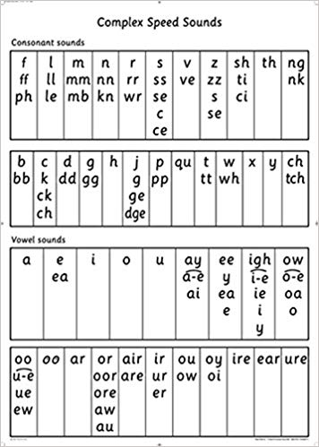

Words to Practise Writing
Cat Met Fan Lip Shop Thin
Red Run Yes Web Wish Sock
Zap Zig Chop Bang Thing Quit
Bell Best Jump Fox Flop Grin
Black Stink Hand Dress Stop Bend
Strop Stamp Kitchen Seven Rabbit Trap

Hold A Sentence
I can run and jump.
Is it a dog?
I feel sad and upset.
Will you bang the drum?
Stop! A fox is in the box.
The red hen ran up the path to the farm.

