Maths  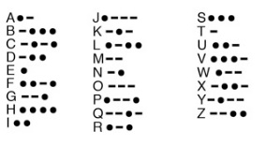  Morse Code Challenge- Write a secret message for a family member using the Morse Code. Ask them to decode it. *Challenge- use a torch or whistle to send your message- video it if you like! | Writing 2  My Wellbeing Journal-  Write a short diary entry each day about how you are feeling, what ideas you have to keep busy each day, any challenges you have had and how you have overcome them. | Numeracy 1  In your jotter, Create a multiplication grid like we use in class. Fill in all your times tables until you reach 10x10.  There is a blank grid attached below so you can copy and complete.  Ask a family member or friend to test your times tables.
Reading  Question Master  Create six questions about the book you are currently reading (either personal or class novel). Try to ask ‘Why’ questions. If you were a teacher, what questions would you ask your pupils? Could you ask inferential questions? | P7 Home Learning Activities  January 2022  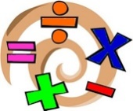  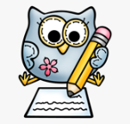  St Andrew’s RC Primary School  Share your learning on Glow & Twitter  @StAndrewsTweets, @_MissWilkinson_ | Numeracy 2  Create a poster to explain everything you have learned about fractions last term.  I have attached a copy of a fractions learning ladder so that you can see what we have learned so far and what we will be learning.  Challenge: Create your poster about the relationships between Fractions, Decimals and percentages.
Writing 1  Design a Starbucks Smoothie-  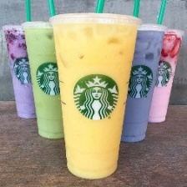  Starbucks want you to design a new smoothie for their Autumn/Winter collection. Write the recipe-  - List the ingredients  - Method- how do you  make it?  - Draw a picture of what it  Will look like. | Health and Wellbeing  Think of your new year’s resolution. How might you make a change this year? Look below for an example.  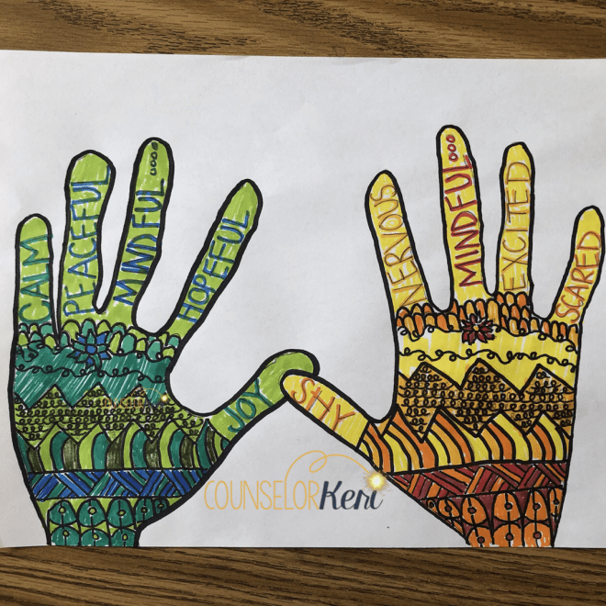  Mindfulness Hands Art- Draw around your hands and decorate inside of the hand to show your emotions. | French/ICT  Make a Google slide all about yourself in French.  Try to include a slide about your family, what you look like, along with your favourite animal and food.  You can use the internet to help you, along with Duolingo.

Numeracy 1- Fractions learning ladder

I can order and compare fractions.
I can read, write and understand mixed numbers.
I can show fractions on a number line.
I can recognise equivalent fractions in shapes.
I can find the fractions of a quantity.
e.g. 1/3 of 15?
I can show that a quantity of something can be represented as a fraction.
I can recognise fractions in shapes.
I can recognise and name the numerator and denominator.

Use this learning ladder to help you create a poster all about fractions.
Numeracy 2- Multiplication grid

 | 1 | 2 | 3 | 4 | 5 | 6 | 7 | 8 | 9 | 10
1
2
3
4
5
6
7
8
9
10

Writing

Success Criteria:
- I can punctuate my sentences properly.
- I can use adjectives throughout, to describe in detail.
- I can add clear, numbered steps.
- I can include time connectives at the start of my instructions. (First, then, next ect.)
- I can include an introduction, to encourage the reader to choose this recipe.

Health and Wellbeing Example.

Write your new year’s resolution down. Include why you want to make this change, who it might affect and what you want to have achieved by the end of the year.
Example

My new year’s resolution for 2022 is to visit my family more. Sometimes, I can get so caught up in my work that I am too busy to make time for anybody else, and I know that makes my Granny sad. This year I am going to try to take a day each week to go and visit a family member or a friend who I may not have seen in a while. This way I can make sure that they are ok and I can check in on them. Hopefully by the end of the year, I will feel that I have helped to put a smile on a few more people’s faces.

Keep it safe. Bring it back into school when you return.

