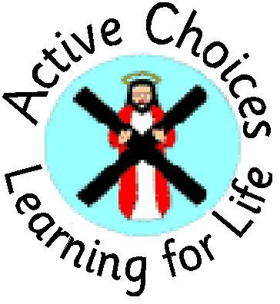

P1 REGISTRATION

Enrolment week starts Monday 22 November across Midlothian for children eligible to start school in August 2022

Apply online at www.midlothian.gov.uk or ask for an Enrolment Form at the School Office

We look forward to seeing you at one of our information meetings:

Tuesday 23 November 4.00-5.00pm
(in school maximum 10 people, one per household)
Please book a place via the school office
or
Wednesay 24th November 4.00-5.00pm
via zoom (please contact school office for the link)

