Literacy (Spelling)  Using Fry’s most common words to practice reading and spelling. Use the method of Look, Cover, Write and Check to make sure you’ve got it right! Here are some other spelling ideas for you to practice words:  -RAINBOW writing  -SDRAWKCAB (backwards) writing  -Silly sentences – write a silly sentence using your words  -Create a Wordsearch  -Hidden words – draw and colour a picture and hide your words inside it.  -p py pyr pyra pyram pyrami pyramid writing  - Bubble, squiggly, dot to dot, scrambled writing.  Fry’s first 100 most common words are below and more will be coming! A Phonics chart is also below for you to practice. | Reading  Try to read as much as possible at home. This can be stories, newspapers, signs in the street etc. Ask your adults to read to you and listen to different stories too.  There are often stories being read aloud online, try searching for books by Julia Donaldson, Dr Seuss or David Walliams.  Create a book review of each story you read or get read to you. It doesn’t matter if the books are a bit tricky, it’s all about hearing the stories and understanding them! Keep a reading diary of each story you read or hear and give it a rating out of 5 and you can show your teacher when you get back to school!  Log on to Education City and I will have given you some work to do. If your adult has access to a printer, there are also worksheets that go with each activity. | Maths  Money:  *Practise recognising and using different coins and notes to make different amounts. See if you can make the same amount in lots of different ways using different coins or notes.  **Add up the cost of different items and work out how much change you would receive from £1, £2, £5, £10 and £20  ***As well as the above look online at different items that are similar and compare the prices to see which items are the best value for money (look at different special offers as well as the weight of each item).  We are due to be moving on to learning about time – see if you can start to work out timings at home with your adult. Focus on o’clock, half past and quarter past. We have been learning to count in 5s so that will help to work out the time!
Writing  Keep a daily diary about what you have been doing. Whether it’s a detailed journal or some pictures try to include some key words that explain your day. Remember to use F-R-E-D fingers to sound out words you don’t know. You can syllable clap longer words or write the word first and ask your adult to check that its right.  When practicing our sounds we follow a program called Read, Write, Inc. Ask an adult if they can help you to practice your sounds and special friends (chart below). Each week I will attach some words for you to practice reading and writing into sentences and a hold a sentence for you to practice at home too!  Write an imaginative story about a child who gets to stay off school and go anywhere in the world? Where did they go? What did they see? What happened? | Primary 3  Home-Learning | Numeracy  Practise counting forwards and backwards, stopping and starting at different numbers and counting in different sequences (i.e. 1s, 2s, 3s, 4s, 5s, 10s, 100s, 1000s etc.). Write numbers in order from smallest-largest, put them in odd and even groups etc. Do the same with fractions! Try reciting your times tables as you walk up the stairs. Draw hopscotch and call out the numbers as you jump.  Log on to Education City and your teacher will have given you some work to do. You know the level you are on, challenge yourself with some extra activities! If your adult has access to a printer, there are also worksheets that go with each activity.
RERC

Prayer checklist: Do you by memory –
- ‘The Lord’s Prayer’,
- ‘Hail Mary’

Google them and write them down, then try and memorise.
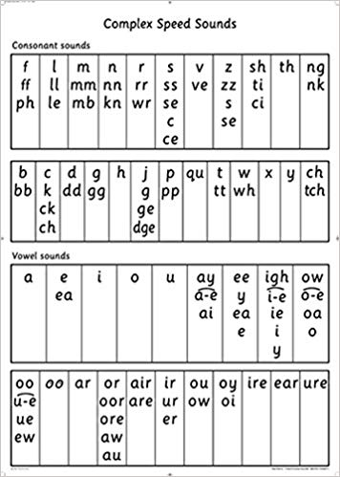
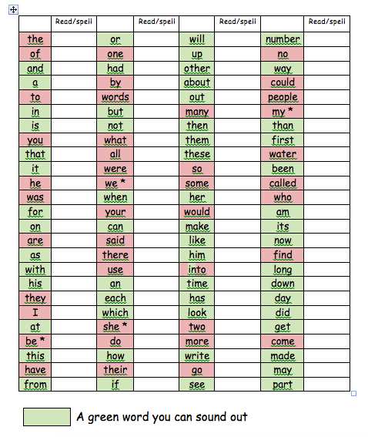

Practice your phonics here! Remember, if it is in the same box then it makes the same sound!
Can you remember its rhyme? Ask your adult to say a sound and use your finger to point to it!

