Literacy – Reading  We are exploring texts.  - Read books together at home. (Here are some pointers for the adults)  Looking at the title, cover and illustrations/pictures, what do you think will happen in this book?  What characters do you think might be in the book?  What did you like/dislike about the story?  Can you point to different characters?  Ask children to turn pages for you encouraging them to start all the beginning and hold book up the correct way. | Literacy – Name formation  We are learning to recognise and write our names  - Practise writing your name in different ways. You could use chalk, paint, pens, on a tablet etc.  - Get an adult to write your name on a piece of paper and chop it up. Can you put it in order? You could hide the letters around the house? Can you find them all and make your name? | Literacy- Fine motor skills  We are strengthening our hands for writing  - Practise your cutting skills. Maybe cut pictures of toys from a magazine? Remember, fingers on the bottom and thumb on top!  - Play with construction at home. You could play with building blocks, Lego, K’NEXS etc.  - Work with an adult to make some playdough (link below). Then use it to squash and roll to create different things.  https://www.bbcgoodfood.com/howto/guide/playdough-recipe
Numeracy  We are developing our counting skills and gaining a further understanding of numbers.  - Count forwards and backwards, try to count to 20.  - Practise writing your numbers to 5. Remember to write your numbers the correct way around.  - Count out items with an adult. This could be anything around the house.  - Have a look at these online games:  Learning to Count with these fun Counting Games (topmarks.co.uk)  https://www.bbc.co.uk/cbeebies/shows/numberblocks | Primary 1 Home Learning Wall  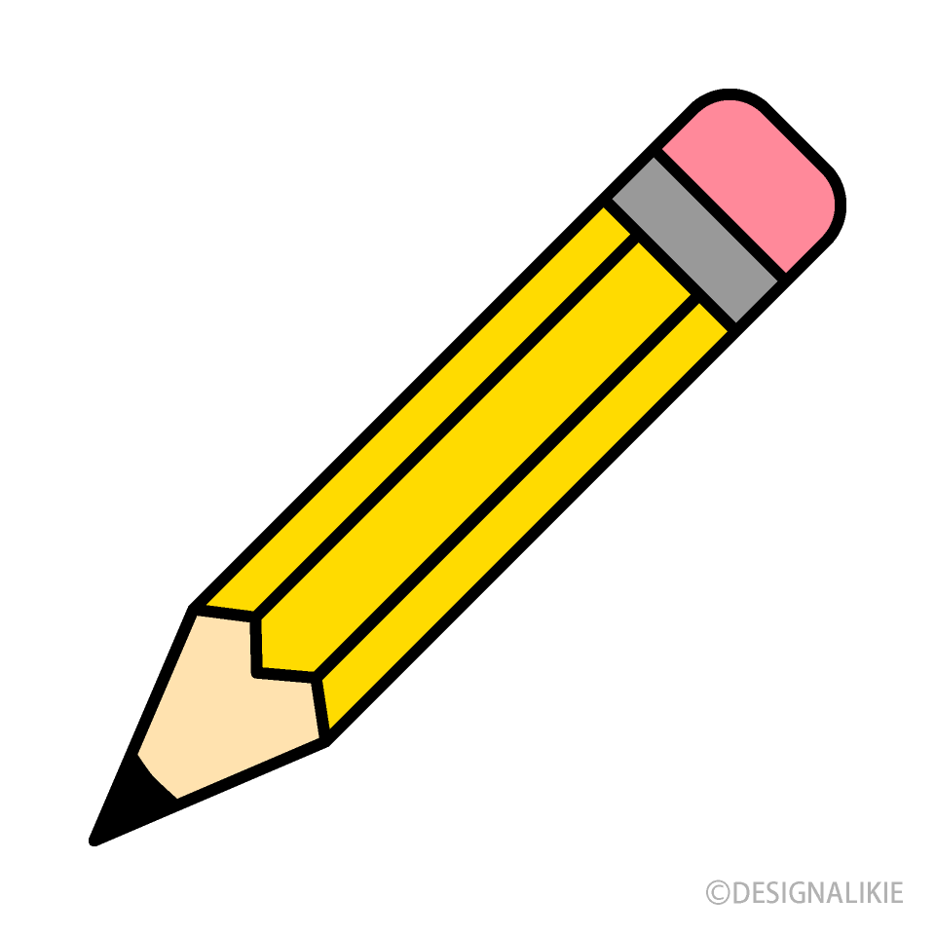 | Maths  We are learning to recognise 2D shapes.  - Look for shapes around the house (circles, squares, triangles, rectangles)  - Practise drawing these shapes.  - Have a look at these online games/videos  https://www.topmarks.co.uk/ordering-and-sequencing/shape-patterns  Shapes for Kids | 2D Shapes | Shapes Song | Shape Up| Jack Hartmann - YouTube  https://www.topmarks.co.uk/early-years/shape-monsters

