1.Literacy – Reading  -We are learning to find and use information. We are developing our reading skills.  - Choose different books and texts to read at home.  - Can you point to a word, sentence or letter on a page? Try to Fred Talk some of the words.  - Finding and using information – an adult should ask you to find something in the story, i.e. ‘how does Charlie feel when Lola eats the lollipop’ – using your fastest finger you would find the word and point to it to show you have found the information.  - On Google Classroom you will be part of a ‘Read, Write, Inc’ group – complete the weekly tasks to practise your reading. | 2.Literacy – Phonics  -We are learning our letter sounds.  - Continue to practise all sounds learned so far. Use the words below to practise reading green words.  - Below is a speeds sound chart – ask an adult to point to the sounds you have learned and read them. Then an adult should say a sound; use your fastest finger to find the sound.  - On Google Classroom you will be part of a ‘Read, Write, Inc’ group – complete the weekly tasks to practise your sounds.  - On our Google Classroom I will upload videos for you to learn your new Set 2 sounds – one sound will be uploaded each week. In this lesson you will learn a new sound, and practise your reading and writing. | 3.Literacy- Writing  -We are developing our ability to write independently  - Use the word list below to practise writing your words – remember to say the word, count the sounds, pinch the sounds, write and then check.  - You could also try to ‘hold a sentence’ using the sentences below. Hold the sentence in your head and try to write it. An adult can help you remember the sentence if you get stuck. Remember finger spaces!  - I have uploaded a video on our Google Classroom to remind you how to spell using your Fred Fingers and how to do a ‘Hold a Sentence’ activity.  - Write a personal account about one thing that you did during the Christmas Holidays. Remember to include a detailed black line drawing to illustrate your work.
4.Health and Wellbeing  We are developing our basic move and PE skills.  - On our Google Classroom, Mrs Thom (our PE Specialist) has very kindly uploaded activities for you to do to help you practise and develop your PE skills.  - Try out these different activities and see how you get on.  We are learning about relationships.  - Talk to a grown-up at home about different relationships you have with people (parents, siblings, friends, teacher, grandparents etc.).  - Think of a friend who you haven’t seen in a long time; could you draw them a picture or write them a letter? Remember to take a picture and send it to me so that I can share it with them. | January Primary 1 Home Learning Wall  Upload your completed work to our Google Classroom so that I can give you feedback. Alternatively you can tweet your work to @StAndrewsTweets and @MissEssTweets | 5.Numeracy  We are developing our counting skills and gaining a further understanding of numbers.  - Continue to count forwards and backwards, try to count to numbers up to and beyond 30.  - Practise writing your numbers to 20. Remember to write your numbers the correct way around.  - Complete the tasks that have been assigned to you in our Google Classroom.  - Practise adding and taking away different numbers – use counters to help (practise having one or both collections screened).  - I have uploaded different videos in our Google Classroom – these will help you to see how you can practise your Numeracy skills at home.
6. Religious Education  -We are learning about the Creation Story.  - Watch the story of the Creation on YouTube: https://www.youtube.com/watch?v=D9oh4YO8N7M  - Can you draw a picture of the Creation at the end? Try and add lots of detail and colour.  - Can you name the 5 senses? Correct, they are sight, hearing, taste, touch and smell. We can use our senses to enjoy and learn about the world around us. On our Google Classroom there is a 5 Sense worksheet – complete this task. | 7.Maths  -We are learning about Money.  - Recognise the symbols for ‘pound’ (£) and ‘pence’ (p) – can you find them in your environment, in books, on the TV etc.? Practise forming the pound and pence signs.  - Begin to recognise coins from 1p-£2 – can you match them, put them in order?  - Use 1p coins to make the same value as 2p, 5p, 10p and 20p.  - Use different coins to make the value of 10p.  - There are tasks for you to complete in the ‘My City’ portal of Education City – log on and complete the tasks set. | 8.Topic/Theme  -We are learning about Scotland and Robert Burns.  - This month we celebrate one of the most famous Scottish people to ever live – Robert Burns.  - Using the virtual classroom, click on the Scotland flag to learn more about Robert Burns.  - Talk to an adult about things we associate with Scotland, i.e. Highland Dancing (click on the highland dancer in our virtual classroom to see some dancing), Irn Bru, Greyfriar’s Bobby, haggis etc.  - Participate in some Scottish based activities – you could design your own tartan kilt, bake some shortbread, learn a Highland/Scottish dance, listen to Scottish music – see how creative you can be! Remember to take some pictures to show me your hard work.
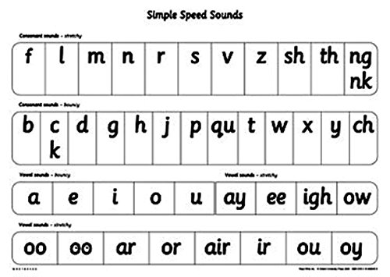
Hold A Sentence
I can run and jump.
Is it a dog?
I feel sad and upset.
Will you bang the drum?
Stop! A fox is in the box.
The red hen ran up the path to the farm.
Words to Practise Writing/Reading
Cat Met Fan Lip Shop Thin
Red Run Yes Web Wish Sock
Zap Zig Chop Bang Thing Quit
Bell Best Jump Fox Flop Grin
Black Stink Hand Dress Stop Bend
Strop Stamp Kitchen Seven Rabbit Trap

