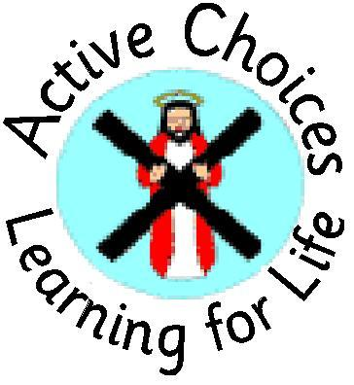

December Update
Friday 11th December 2020

Dear Parents and Carers
Well we have almost reached the end of yet another busy term at St Andrew’s Primary. Our thanks to all parents and carers for your tireless support over these unusual and tiring months. Please read on for some cheerful updates about Christmas arrangements for the days ahead.
Joanne Hunter Acting Leader of Learning

Christmas Pantomime:
Classes had a super day yesterday tuning in to the fantastic online production of the Brunton Theatre’s pantomime- Rapunzel. Pupils were thoroughly entertained by the silly songs, comical costumes and never-ending jokes and pranks. A tasty ice lolly was the perfect finishing touch for a fun afternoon.
Nativity:
After weeks of rehearsal, preparing costumes and arranging scenery, this morning saw our Primary 1 cast give their performance of this year’s Christmas Nativity. A huge THANK YOU to Miss Stewart for all of her hard work, in leading and preparing the class, and to Miss Stark for assisting her so ably. The performance was filmed by our very own Steven Spielberg - Mr Paterson, who has headed home to edit the master-piece and add the finishing touches. Information will be sent home to Primary 1 parents and carers, next week, explaining how to view this Oscar winning performance!
Sacrament of Reconciliation:
Congratulations to those members of our Primary 3 class, who will be celebrating the sacrament of Reconciliation, in school, on Tuesday 15th December. It will be lovely to welcome Father Allan into our building once more – although socially distant of course. We will be sure the take a group photograph to ensure that parents and carers have a record of this special occasion. Our love and prayers to you all.
Christmas Jumper Day:
It has been super to see so many of our pupils, parents and staff getting in the festive spirit by wearing Christmas hats, jumpers, hairbands and other festive accessories. Although national Christmas Jumper Day is Friday 16th December, pupils are welcome to wear Christmas clothing any day between now and the end of term. The brighter the better!

School Christmas Lunch:
All P1-7 pupils continue to have a packed lunch, which is eaten in their own classroom each day. On Tuesday 15th December, those pupils who receive a school packed lunch will be able to enjoy their Christmas menu choice. Christmas lunch has always been an important event at St Andrew’s and this year is no different. Classes will be provided with the usual festive table covers and decorations, along with music to add a bit of festive cheer to the proceedings. Those pupils who bring a packed lunch from home are welcome to include some festive flavours in their own lunch bag. Our school kitchen will also be providing a sweet Christmas treat for all of our pupils. Bon apetit!
Christmas Parties/Festive Fun:
Current guidance around health and safety means that our class Christmas parties will look a little bit different this year. Please be assured that although we will not be gathering in the hall, staff have planned a great variety of fun and games to be enjoyed safely within your child’s classroom. Party food will be provided and plenty of opportunities to have fun – with perhaps even a few prizes thrown in for good measure.
Cards and Gifts:
Current health and safety guidance is encouraging schools to find an alternative to the traditional exchanging of cards, between pupils, and to consider a different way of sharing Christmas Wishes with classmates. Staff have agreed that all pupils will have an opportunity to design and make a card which they can then send to the whole class. We are already very impressed by the level of imagination and creativity on display. Some true artists!
A number of enquiries have already been made around gifts for staff. Aside from current restrictions, relating to health and safety, our staff team is also mindful of the financial challenges facing many of our families, at the moment. Although very appreciative of the gesture, we want to make clear that there is no expectation of the need for families to send in gifts. Some colleagues in other schools have suggested a donation to a local food bank or charity instead, should pupils be keen to purchase a gift. This is obviously for individual families to decide.

All pupils will receive a gift-wrapped book – courtesy of our Parent Council. We would like to thank them for their generosity – not to mention wrapping skills! To complement this gift, all pupils will also receive a school bookmark, as a positive reminder of what has been a very unusual year. All gifts will have been quarantined for the required 72 hours before being given to pupils.

Thank you for your continued support.

