1.Literacy – Reading  -We are exploring texts and learning to identify letters, words and sentences.  - Choose different books and texts to read at home.  - Can you point to a word, sentence or letter on a page? Try to Fred Talk some of the words. Also see if you can listen to a word and say which sound it begins with (initial sounds only)  - Read with an adult – ask the adult to ask you questions about what you have read and try to answer them as best you can. | 2.Literacy – Phonics  -We are learning our letter sounds.  - Continue to practise all sounds learned so far. Use the words below to practise reading green words.  - Below is a speeds sound chart – ask an adult to point to the sounds you have learned and read them. Then an adult should say a sound; use your fastest finger to find the sound.  - Practise writing each of the sounds you have learned, saying the rhyme for each sound. | 3.Literacy- Writing  -We are learning to write personal accounts.  - Use the ideas below to write different personal accounts.  - Use a pen or pencil to create a detailed line drawing, showing what happened.  - Ask an adult to write a sentence about what it was that you did/were doing. Then try and copy the words underneath, or if this is too tricky write over the letters. Why not try to challenge yourself by writing some words on your own?
4.Health and Wellbeing  We are learning about different relationships.  - Talk to an adult about different people who can help you - include people at home, school and in the community.  - Talk about relationships with your friends/peer at school – discuss how you know when someone is a good friend.  - Draw a picture for a friend at school and write a little note to them (an adult can help you with this!). Tweet a picture of it to me, or share it on our Google Classroom, so that I can share it. | Primary 1 Home Learning Wall  Remember to tweet your work and tag @StAndrewsTweets and @MissEssTweets. You can also share your learning on our Google Classroom. | 5.Numeracy  We are developing our counting skills and gaining a further understanding of numbers.  - Use the Numeracy Learning Walls that I have uploaded to our Google Classroom – these will give you lots of activities to do to develop your learning in Numeracy.  - There are lots of videos to give you ideas for Numeracy on our Google Classroom – please use these to help you.
6. Religous Education  -We are learning about making good choices.  - Talk to an adult at home – what does it mean to make good choices? Can you talk about good choices you have made at school and at home? Can you talk about choices you have made that could have been better?  - Make a good choice by helping someone at home – you could help set the table, make your bed – see if the adult at home notices your good choice! | 7.Maths  -We are learning about Shape and Patten.  - Look for 2D and 3D shapes in your environment – can you draw a picture of what you find?  - Create different patterns using different shapes, can you make different patterns using different shapes, colours etc?  - https://www.topmarks.co.uk/ordering-and-sequencing/shape-patterns Play this game to help you develop your understanding of patterns. | 8.Topic/Theme  -We are learning about our emotions.  - Think about different emotions we have learned about in class – talk with an adult about the different emotions, what may be the trigger for them and what behaviours you might show when you feel this way.  - Use this link to watch one Mr Men book online. Can you draw a picture of how the Mr Man felt, what the trigger was and what behaviour they showed? https://www.youtube.com/results?search_query=mr+men+books
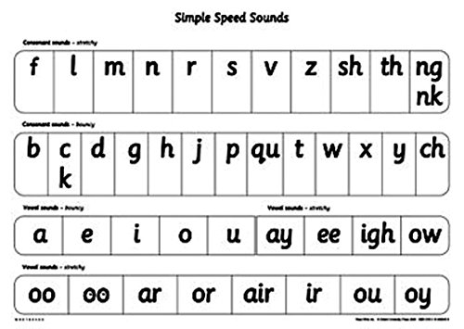
Personal Account Ideas
Write about a time you...
Watched a movie
Saw fireworks
Played in the snow
Dressed up in a costume
Went to a place with animals (farm/zoo/aquarium)
Words to Practise Writing
Cat Mat Fan Pip Dad Mum
Tin In It On An And
Tip Big Bop Bit Bat Sit
Sat Got Dog Dug Kick Can
Kit Pin Pan Sad Stop Bend
Dot Sun Man Mast Mist Tap

