Literacy  A synonym is a name given to words that have the same meaning. Look at the image of the ‘synonym roll’ below.  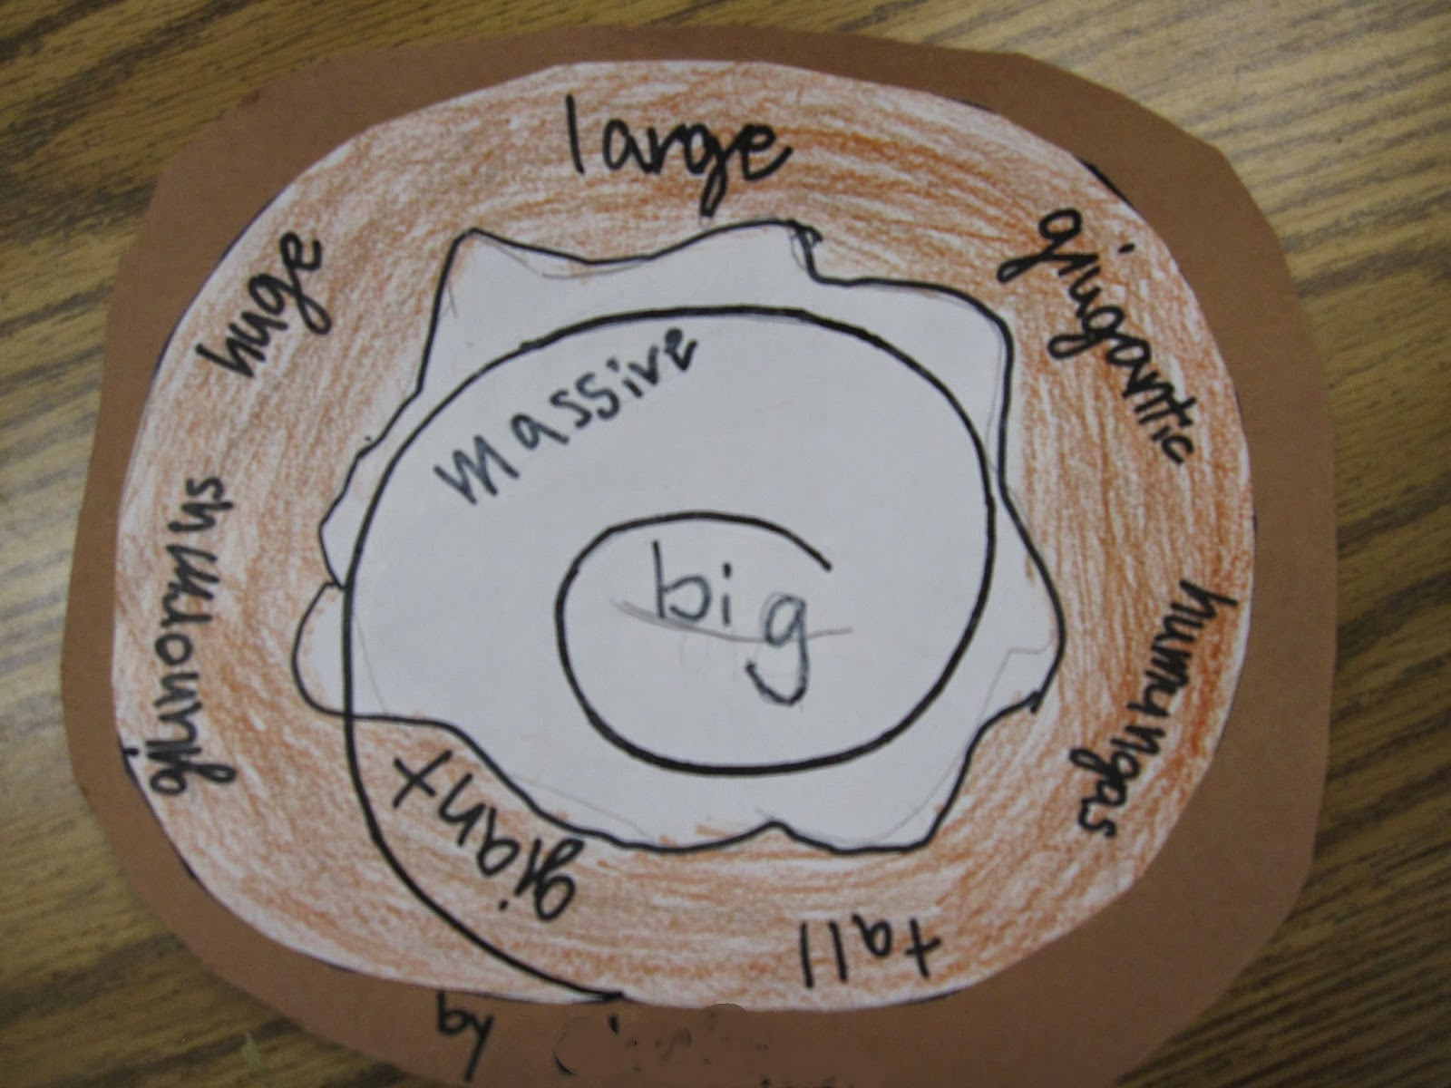  In your Home Learning jotter make a ‘synonym roll’ for each of the following words.  - Small  - Happy  - Energetic  Complete Unit 1 of your Nelson Handwriting booklet. | Reading  Try to read as much as possible at home (not just the books that you chose to take home.). This can be stories, newspapers, comics, graphic novels and signs in the street etc. You can even listen to books online.  Create a book review of each book that you read or get read to you and keep a list of everything you have read in the back of your home journal. It will be interesting to see how many books the whole class and the whole school has read by the time we return! I wonder if we can read over 100 between us? | Maths  Time:  *Practise recognising quarter past and quarter to on both analogue and digital clocks.  https://www.splashlearn.com/math-skills/second-grade/time/tell-time-to-quarter-hours  and 5 minutes  https://www.splashlearn.com/math-skills/second-grade/time/tell-time-to-5-minutes  * Continue to practise working on durations by playing these games.  https://www.topmarks.co.uk/r.aspx?sid=4572  https://www.splashlearn.com/math-skills/third-grade/time/elapsed-time  *Talk with your adult about 12 and 24 hour clock and then play this game  https://www.topmarks.co.uk/r.aspx?sid=5389  Look at clocks in real life and if you have access to a stop watch (even on a mobile phone) play some stop watch games. You could do exercises, draw a picture or have a race! Have fun and get moving.
Writing  Keep a daily diary about what you have been doing during and experiencing during this unusual time. Watch Newsround on CBBC or online and include a detail you heard on the news. You could write your diary in the style of a news report. You could even present your own daily news show for the rest of your family. | Primary 4  Home-Learning | Numeracy  Log in to education city. Your teacher has uploaded some games and worksheets that you can complete.  Practise your times tables, you can do this whilst doing skipping or another activity.
 | P.E  Joe Wicks will be doing a live P.E lesson every morning online at 9am. Why don’t you start the day by getting the whole family up and moving?  https://www.youtube.com/user/thebodycoach1 | Art  Several illustrators and artist are also offering live sessions online you could try  https://www.kennedy-center.org/education/mo-willems/  Or why not take a virtual tour of The Lourve? Some of the most famous paintings in the world are kept there.  https://www.louvre.fr/en/visites-en-ligne
 | Topic – The Rain forest.  Research people of the rainforest on the internet and then make a venn diagram to show how your lives are both different and the same. Remember we made venn diagrams on World Book Day, there are pictures of the ones we made on Twitter. | RERC  Pupils who are making sacramental preparations this year have been given booklets and worksheets to complete at home.

