How to navigate around Education City.

1. Search education city on Google and click on this link.

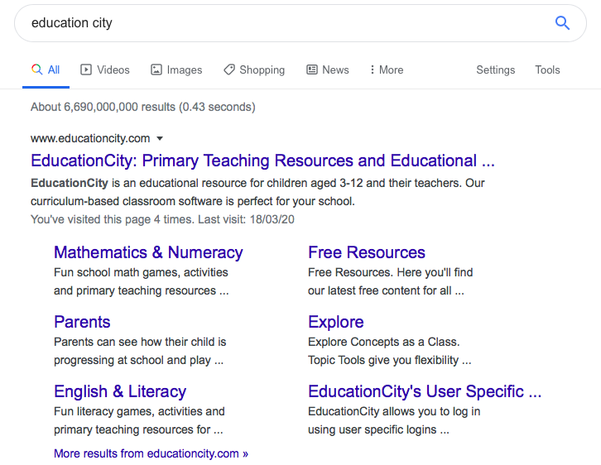

2. This will take you to a log in page. Click the blue LOG IN button in the right hand corner.

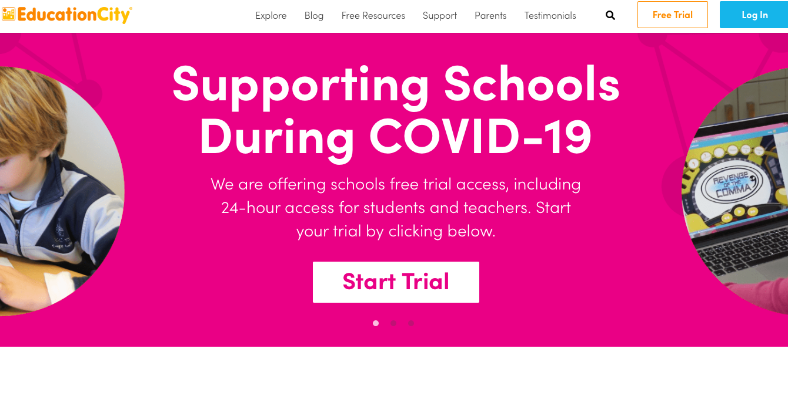

3. This will take you to a log in page. Type in your child’s username and password. Don’t forget to select Scotland as the country. Then click Log in.

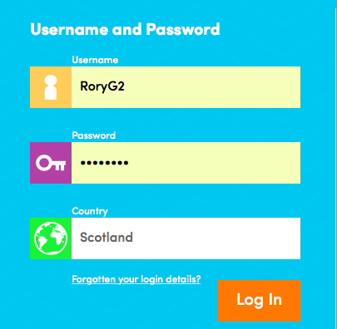

4. This is now their Education City homepage. Click on Classwork to access their assigned work.

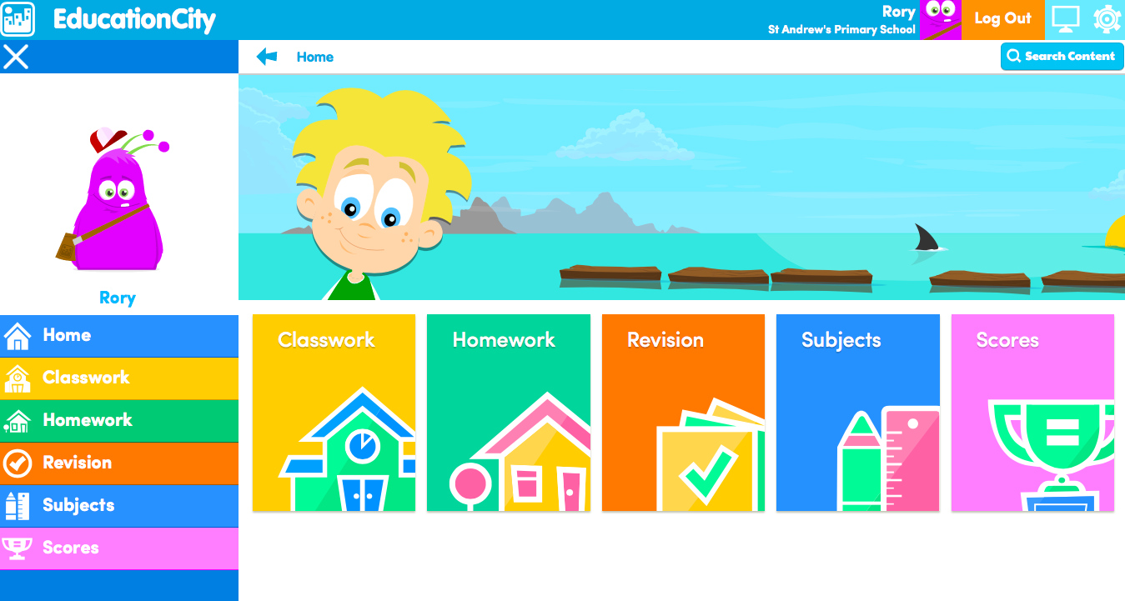

5. Here you can see the activities they have been assigned. These will be divided into literacy and numeracy folders. There will also be the phonics activities if they are part of RWI and there may be folders from their mainstream class too.

Click on the folder you would like them to work on.
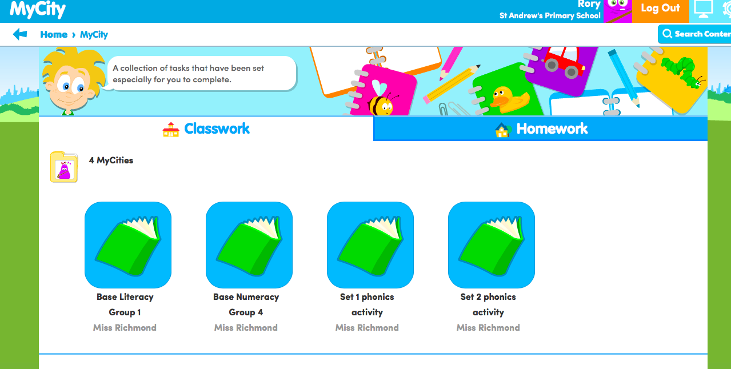

6. This will then open up the folder where you will find different activities to complete. Click on the activity you would like to play.

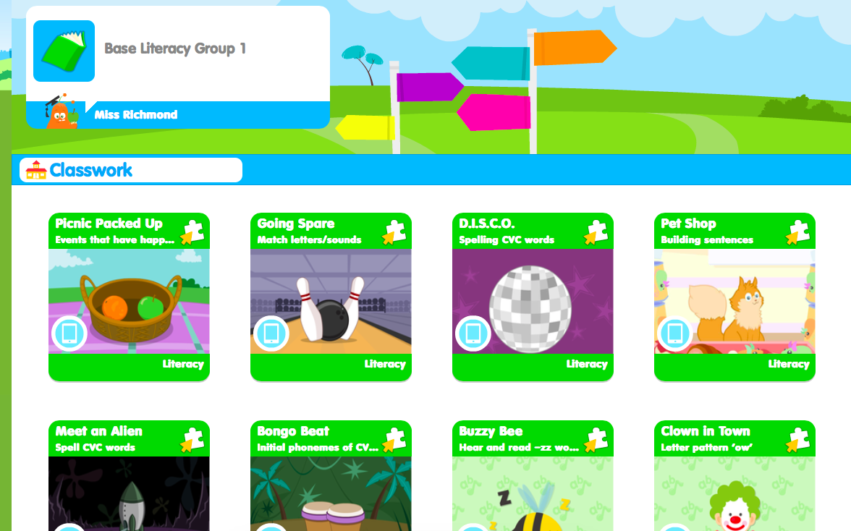

7. The activity will explain what you have to do and then you can start.

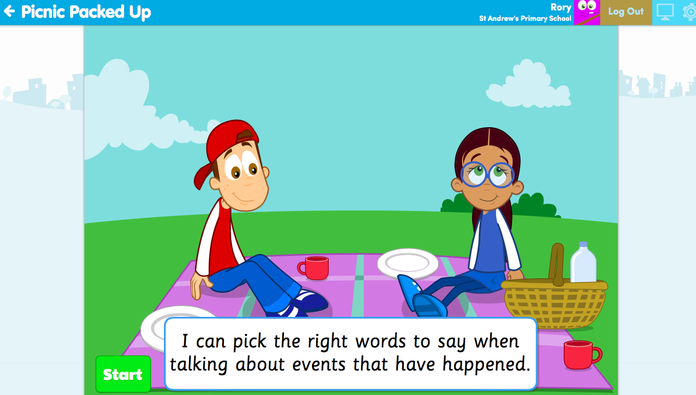

8. It will then give you a timer to complete the task and show you how many questions there are.

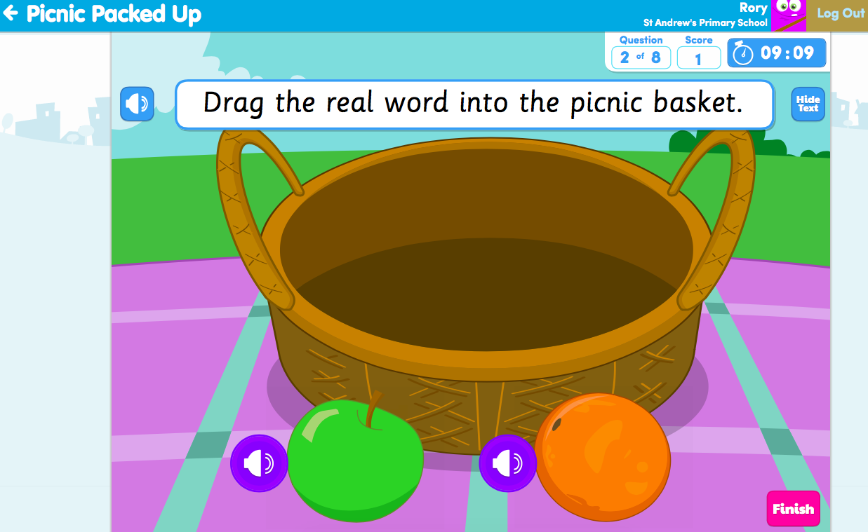

When you are done. Click Finish or the arrow in the left hand corner to return to the activities page.

9. If you need to return to the homepage at any time click on the icon in the top left hand corner next to ‘Education City’ and that will take you back.

To log out, click the orange LOG OUT button on the top right corner.

