St Andrew’s ELC Home Learning-Literacy
I can make marks using a variety of materials.  I can make marks that I identify as communication.  I make marks that represent writing.  I can make marks that relate to my play.  I can write some letters in random order.  I can write some letters from my name.  I can experiment with letters and try to write my own words.  I can write to express my ideas.  I can write in a range of contexts.  I am developing an effective pencil grip.  Mark making-can you recognise your name? Can you try to make the letters of your name? Can you try to make the letters of your family members’ name?  Write/draw a letter/card for a friend or family member.  Write a recipe book for making play dough or a meal you have made.  Write/draw your own story.  Plan a meal; write/draw a shopping list/menu.  Share your ideas with an adult.  Ask an adult to date and scribe your ideas. | I can make myself understood.  I can talk to my friends and adults about myself, my family and  my experiences.  I can make myself understood.  I can talk about what happened.  Telephone/video call a friend or a member of your family, tell them about your day. | I show an interest, take part in and engage with songs and rhymes.  I can keep the beat within songs and rhymes.  I can identify words that rhyme.  I can generate rhyming words.  I can make funny/nonsense rhymes of my own.  Practise rhymes and songs. Make up new actions or dances to go with the songs and rhymes. Make musical instruments to play along to the songs and rhymes. Look for the rhyming words and experiment by making up your own rhyming words or rhymes. Play ‘I Spy’ (recognition of simple letter sounds). | I regularly choose to look at books and other texts.  I engage with books and other texts and can share my ideas.  Choose a book you have not read before. Read a free ebook on the Oxford Owl website. Look on Words for Life website for book activities.  Share what your think about the books, whether you enjoyed it or not, share your favourite part, what you would change, what you did not like, share your thoughts and ideas with your family and friends.  Links to website on our school website page: https://standrews.mgfl.net/ | I can listen actively to a whole story.  I can retell a familiar story in different ways.  I can make and tell my own stories through a variety of medium.  I am beginning to tell real or imaginary stories in a logical order.  I can answer questions relating to a story or text.  I can ask relevant questions about a story.  I can talk about what I think will happen.  I can talk about the characters in a story.  I know the difference between: print/pictures, letters/words and numbers/letters  Read a story together, change the ending of the story.  Make up a story, make a book mark, make a paper puppet or use old socks to make a puppet. Put on a puppet show to retell the story. Answer questions using questions starters such as Who...?, What..?, Where...?, When...?, How...?, Why...?  What might happen next?  What was your favourite part of the story and why?  Create your own questions about the story.  Share your favourite character and explain why they are your favourite character.  Talk about the pictures, look for numbers, and look for letters in the book that are the same letters in your name.
 | I can use language for a variety of purposes. To: Describe/Explain/ Ask questions/Give relevant answers.  I can take turns in conversations.  Watch/read a new movie/ book and discuss. | I can find the starting point for reading and know that text is read from left to right.  I understand that the written words tell you what to say.  I can handle books with care and hold them appropriately.  Read/re-tell a well known story to your teddy bear, or family member. | I can use a variety of sources to find out information about new thing.  I engage purposefully with books and other texts on my own.  Go on the internet and find out about a different animals or different countries. Use Google maps to find where different countries are located.
 | I can share my ideas with a wider audience.  I can listen to and talk about stories and other texts.  Tweet your home learning or share your thoughts and ideas about a book/ movie your have seen. | I have a growing awareness that books have different purposes.  Go on a book hunt; find books which are different from story books. Look for nonfiction books e.g. recipe books, books about different countries etc. | I can tell a story through my drawing.  Paint or draw your favourite part of story/ movie or something that has inspired you.
I can give and follow simple instructions.

Help with a chore. Follow a recipe. Follow instructions to make a craft.

Stages of Mark Making at Early Level
Making marks  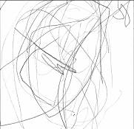  I make random marks on the page. My pencil often does not leave the paper.  (1) | Beginning to control  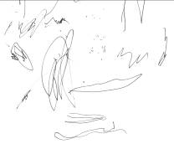  I am making marks with greater control and shapes or patterns may appear.  (2) | Shapes  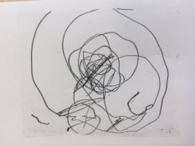  Recognisable shapes are beginning to appear in my drawings.  (3) | Beginning to represent  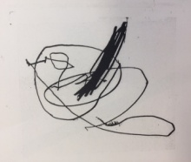  I am beginning to represent the world around me.  (4) |  | Faces  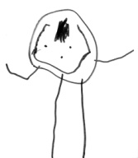  I draw faces, sometimes with arms and legs coming from them.  (5)
Bodies  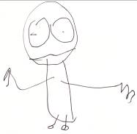  I now draw bodies, and sometimes add hands and feet.  (6) | More detail  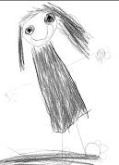  My drawings are becoming more representational of many things in my world.  (7) | Drawings are detailed  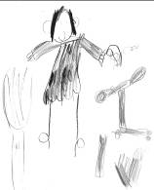  My drawings are purposeful and express my ideas.  (8) | 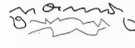  I make marks to represent writing.  (9) |  | 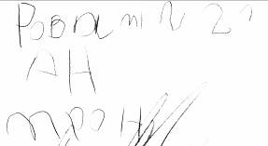  I write long strings of letters in random order.  (10)
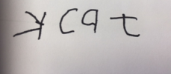  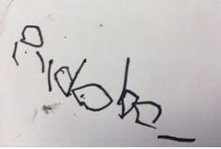  I can write my own name.  (11) | 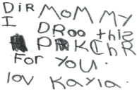  I try to write my own words by combining letters.  (12) | 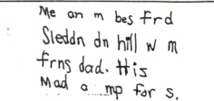  I use my knowledge of sounds and letter to write words.  (13) | 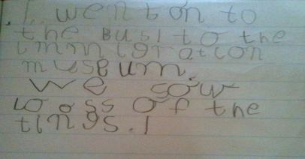  I am beginning to write common words.  I am starting to form sentences in my writing.  (14)

