St Andrew’s ELC Home Learning-Health and Wellbeing
I can explore my environment safely and I am beginning to explore my understanding of risk.  I can talk about my understanding of risk and give real life examples.  I can make safety choices as I play.  I know when to seek help for myself and others.  I am developing my spatial awareness.  -when using large equipment.  -in relation to others.  For your daily outdoor exercise go for a woodland walk. Climb some trees, jump off large stones, and balance on some logs.  Lots more ideas:  https://www.getoutwiththekids.co.uk/activities/doing/activities-walking-woods-kids/  Risk in Play  https://www.early-education.org.uk/taking-risks-play |  | I am beginning to co-operate with friends.  I am beginning to negotiate conflict situations.  I can communicate my needs.  I can express my emotions using words, not action.  I can express emotions in a variety of ways e.g. facial expressions, body language.  I respond appropriately to other children’s emotions.  I show concern for others.  4 handy steps to support children to become independent in resolving conflict:  1) Acknowledge everybody’s feelings.  2) Gather all the information giving all parties a chance to speak and say what the problem is.  3) Draw a line under the problem by saying something like ‘I’m sure we can find a way of working this out.’’  4) Ask the children for solutions to the problem, possibly offering a solution if they can’t think of any.  5) Review the solution and check if everybody is ok and is happy with the solution. |  | I can talk about keeping myself safe in a range of familiar situations.  Online Safety:  https://www.childnet.com/resources/smartie-the-penguin  Safety at Home:  Go for a Safety Walk.  Walk around the house and count how many safety items they can find. (first aid kit, fire extinguisher, etc.) On the reverse side, you could have them point out all the unsafe items (open cupboard doors where someone could bump their heads, toys on the floor where they could trip,etc.). Talk about the use of the safety items and what might happen if unsafe items are left around.
I feel safe and secure to be left with trusted adults.  Draw a picture of people who are your trusted adults.  Send them a thank you card or a letter. | I know the importance of keeping myself safe when using tools and small equipment.  Children can help with baking and cooking. Close supervision and 1:1 support can help to use some basic cooking and baking tools. | I am developing hand dominance and taking part in activities which strengthen my finger muscles.  I display reasonable control when manipulating small objects.  Arts and Crafts Activities:  Cutting, gluing, sticking, painting, threading,  Life Skills:  Zipping jackets, buttoning.  Playdough:  Playing with play dough- roll, squash, prod, flatten, squeeze, pinch, make worms, balls and make impressions with forks and knives.  Messy Play:  Messy play with shaving foam and gluck (made from cornflour and water) |  | I can make choices about what I want to do.  I can make a choice between options.  Include children in planning their activities. Time for free play is also very important but you can manage this by asking them what toys they would like to have available for their free play time.
I can give clear information to express my choice.  I can confidently give my own opinion.  Draw your feelings, share them with an adult.  Share likes/dislikes about a film/book/food etc. | I am learning to respect my environment and the wider world around me.  Make a list of chores you can help with around the house. Tidy your room and play area. Learn about recycling and help with recycling at home. | I regularly take part in  - physical activities/more challenging physical activities which help me develop control of my body and increase my agility skills.  Join in with P.E with Joe Wicks Monday-Friday. https://www.youtube.com/watch?v=Rz0go1pTda8 | I will try new things and will persevere  -with encouragement  -independently  I am becoming more self reliant and confident  -in my own environment  -with new experiences.  Try some new activities such as a morning Wake Up and Shake Up.  Take on a new chore, try making your bed.  Learn a new skill such as buttoning, zipping etc. |  | I am becoming more self reliant and independent with self help skills.  Practise putting on/taking off shoes, clothes and jackets. Tidy your room, set the table etc. | I know when to seek help for myself and others.  Set up a role play areas such as a Doctor’s Surgery/Hospital, Fire Station or Police Station.

Health and Wellbeing Activities
Gloop & Shaving Foam | Threading  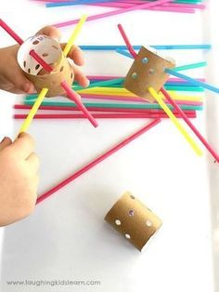  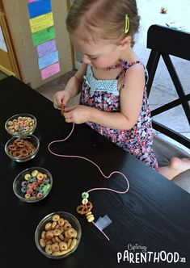 | 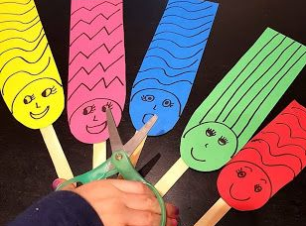  Cutting

