 St Andrew’s Nursery

Newsletter November 2019

*Welcome Back*

*We hope you all enjoyed the October break and are looking forward to the new term ahead. We would like to welcome our new families who have joined us this session. Autumn is in full swing and the team are enjoying the excitement as the children learn about and experience the changing seasons.*

**Parent Consulatations**

Parent Consultations will be within nursery hours on **Tuesday the 5th and Wednesday the 6th of November.** Please see a member of staff to choose a time slot. Parent Consultations will focus on your child’s well being and their progress in learning.

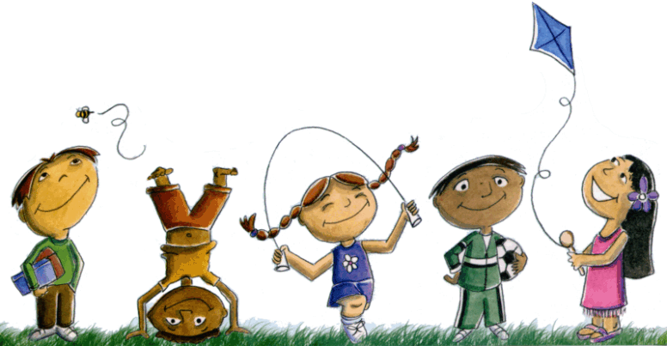

**Settling in**

Next term, we will be welcoming new children to our Nursery. We will be encouraging all our children to help in supporting our new friends in our nursery routines.

**Stay and Play Sessions**

Our first of two Stay and Play Sessions will take place during our Parent Consultation Mornings on **Tuesday the 5th and Wednesday the 6th of November**. We also look forward to welcoming you to a Christmas Stay and Play Session on **Thursday the 12th of December** from 9.00am to 10.30am.

**Spare Clothes**

**Please remember to send a full set of spare clothes.**

With the weather turning colder, please ensure that you have updated your spare clothes to include warmer items such as long sleeve t-shirts. Please ensure your child has a pair of indoor shoes.

If possible, donations of spare socks and a box of tissues would be greatly appreciated.

**Reminder**

Snack money is **£2 a week** and is payable on a **Monday.**

**Nursery Hours**

**C:\Program Files\Microsoft Office\MEDIA\CAGCAT10\j0234131.wmf**Nursery hours are:

Monday to Thursday 8.30am to 3.00pm

Friday 8.30am to 12.30pm

**DIARY DATES**

**Nov 5th and 6th** Parent Consultations

**Nov 8th** Tempest School Photos

**Nov 29th** St Andrew’s Day Celebrations

**Dec 11th** Christmas Lunch

**Dec 12th** Christmas Stay and Play

**Dec 19th** Nursery Christmas Party/ Singalong

**Dec 20th** End of Term

**Jan 7th** NewTerm Begins