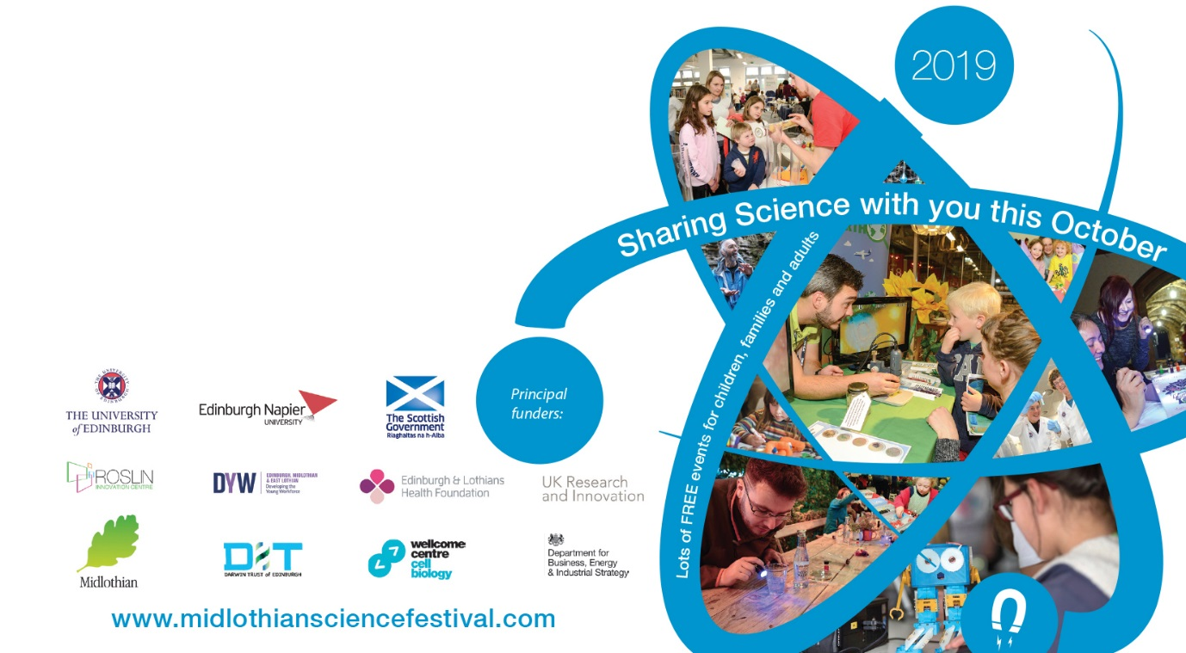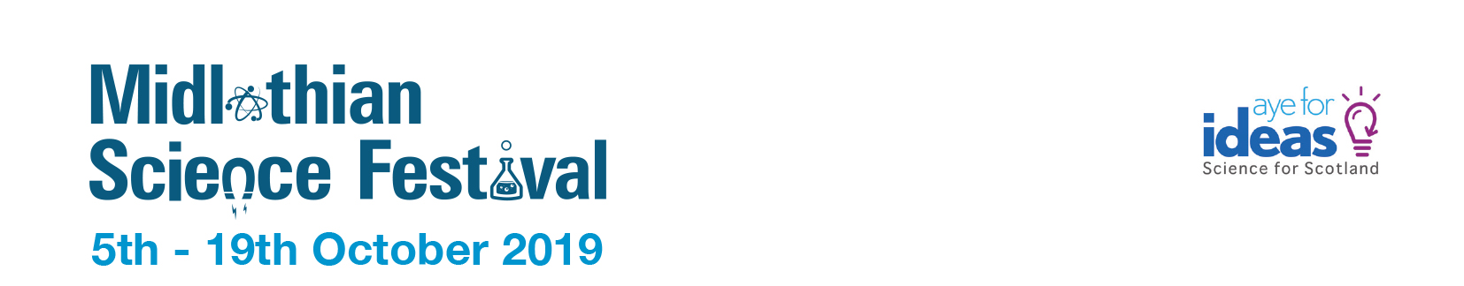

Find out about the **Hyperloop** that can travel at 700mph!

**the Future**

**Powering**

**Drop in**

**Free event**

Loads of interactive fun with the **Glasgow Science Centre** on tour

**Gorebridge Library**

**Saturday 19th Oct**

**11am – 1pm**