Skills: | Learning | What you need – a timer, bags for collecting things indoors or outdoors.  Can you collect lots of interesting things in ……. minutes ?
I am developing a sense of size and amounts.  I am exploring numbers, understanding that they represent quantities, and I can use them to count put them in order.  I can collect objects and ask questions to gather information, displaying my findings in different ways.  I can match objects, and sort using my ideas. | - Use numbers to count objects  - Recognise a ‘small’ or ‘large’ number of objects without counting.  - Estimate how many  - Check by counting  - Count on from zero  - Know that numbers represent an amount of something  - Use maths language during play  - Ask questions to help me understand  - Count objects correctly  - Display/record my findings in simple diagrams or charts  - Recognise similarities and differences in objects  - Sort objects in different ways  - Explain reasons for sorting in a specific way | 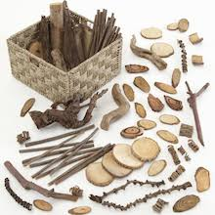  Questions for Challenge:  - How many things do you think we have?  - Can we check by counting?  - Can you put the same kinds of things together in a row?  - Which row is the biggest/smallest?  - Which row has the least number?  - Which thing did we find most of?  - How many more sticks than stones did we find?  - If we add 2 more leaves how many do we have now?  - Can we make an interesting design/picture with all the things we have collected on a large sheet of material/paper?
Wrapping Paper Challenge  You need:  A few things of different sizes to wrap e.g. empty box of chocolates, empty Pringles tube, empty toothpaste tube and a selection of different sized paper | 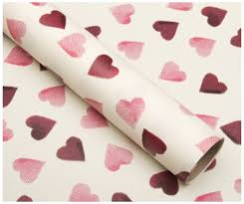 | Can you help me to wrap some birthday presents? I don’t have any wrapping paper ……..Can you help me to decorate some plain paper? I have different sizes of plain paper. Can you choose one of presents and the best size of paper to wrap it in? Can you design some wrapping paper using a pattern and wrap it up?
Experiences and outcomes  Understanding size and amount by observing.  I have experimented with everyday measure to investigate and compare sizes.  I have spotted and explored patterns and can copy and continue these and create my own patterns.  I can create images and objects using a variety of materials. | - I can use mathematical language (big, small, heavy ,light)  - I can estimate size  - I can create a simple pattern  - I can create a more detailed pattern  - I can choose materials to make a pattern  - I can choose materials to create | Questions for Challenge:  - Can you choose the best size of paper for the present?  - What shape of present have you chosen?  - Which paper will you choose and why?  - How many presents are there?  - Which is the biggest/ smallest/ heaviest/ lightest?  - How have you made your pattern?  - Can you continue the pattern?  - Is there enough paper left to wrap any more presents?  - What shapes / colours have you used?  - Can you write a label?

Counting birds in the garden
.
What do you need?
Camera or drawing materials. Pens/paper to make marks for each bird you see
Numeracy Early Level Experiences and outcomes | Context  Counting birds in the garden | Learning
Counting on and back  Collecting, organising , displaying information  Matching, sorting  I can explore digital technologies and share ideas and thoughts. | 1. How many birds can you spot at the bird feeders in the garden?  - Can you take a photograph / draw the different birds that visit?  - Can you sort the photographs in different ways?  - How have you sorted the photographs?  1.Big birds / small birds  2.Long beaks/ short beaks  3.Blackbirds/ other coloured birds | - I can point and count objects  - I can recognise similarities and differences in objects e.g. size, shape, colour’  - I can sort objects according to different criteria ( size, colour, shape )  - I can talk about how I have sorted them.  - I can ask questions to find out information.  - I can take a photograph.
 | 2. Can you count how many big birds visited the garden?  - Can you count how many small birds visited the garden?  - How many blackbirds? How many with big beaks?  - Can you make a picture / graph to show which birds were in the garden most?  - How many big birds altogether? How many small birds? How many big birds?  - How many blackbirds? How many birds with long beaks?  - Which kind of bird did we see most of?  - Which bird is your favourite?  - Can we find out more about this bird?  - Can you make a picture graph together to show the information? | - I can use tally marks to record numbers  - I can talk about my findings  - I can make a graph to show my findings.

Experiences and Outcomes | Learning | We need to hang these wet socks out to dry on the washing line. Can you help me to hang them up? (A pile of wet socks mixed up, pegs, washing line to sort and hang up )
I have explored numbers, understanding that they represent quantities, and I can use them to count;  I use practical materials and can ‘count on and back’ to help me understand addition and subtraction.  I can match objects, and sort. | - to touch and count items within 10  - to count a specific quantity from a group of items  - estimate how many in a group of objects  - to be able to say how many I have counted  - to begin to add groups of items  - to use mathematical language- more and less.  - to begin to understand that when we add we have more.  - to begin to understand that if we take some away we will have less  - to use real objects and pictures to collect information and organise by sorting (by colour, size, type and shape) | 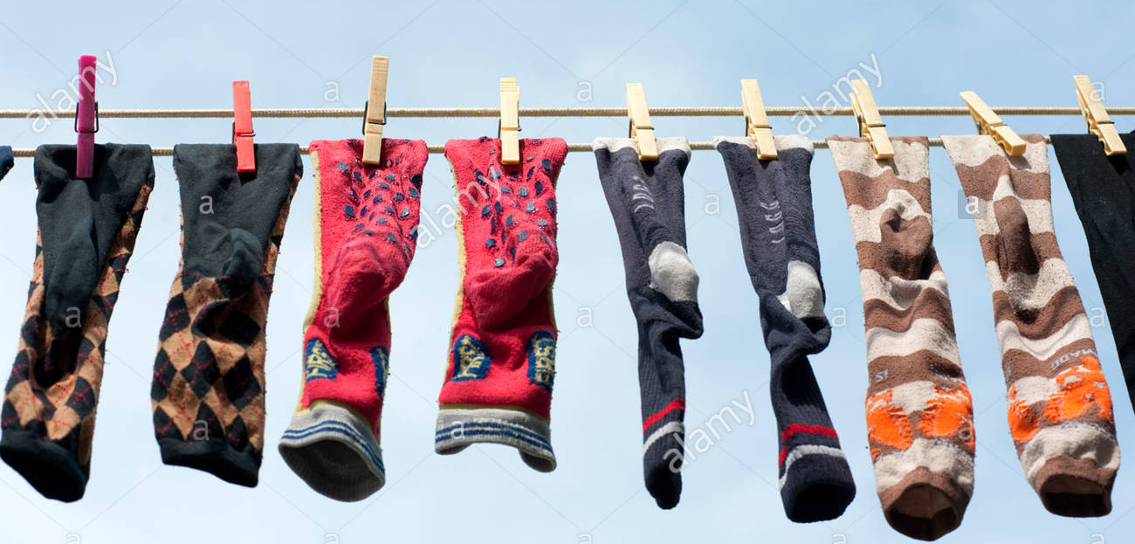  Questions for challenge  - Are there enough pegs? How many more pegs do we need?  - How many socks altogether? How many pairs of socks are there? Are there any odd socks?  - If we add another 2 pairs, how many are there now?  - If we take 5 socks away, how many now?  - Sort the socks into groups (by colour or size).  - Which colour is there most of?  - How many blue socks are there? How many more white than blue?

