Weekly Maths Tasks

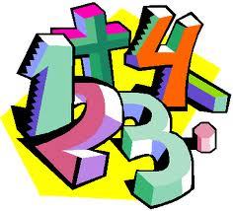
- Working on Times Table Rockstars - your child will have an individual login to access this.
- Play on Hit the Button (www.topmarks.co.uk/maths-games/hit-the-button )-
focus on their chosen times tables.
- Practise telling the time. This could be done through this game (https://mathsframe.co.uk/en/resources/resource/116/telling-the-time ) (scroll down to access the game). Read to the quarter hour and the nearest 5 minutes. Children can revise half hour and quarter hour as well
- Play a game involving counting –Snakes and ladders, Ludo etc

Weekly Literacy Tasks

- Watch Newsround and discuss what is happening in the wider world
- Write a letter/email/ text message to a member of their family that they have not seen this week.
- Fill in a page of your diary telling me what you have done, how you are feeling , who you were with etc. Be as creative as you like and don’t forget to date it.
- Read a chapter of whichever book you are reading. Discuss what is happening. What do you like/dislike about it? Who are the main characters? Can you describe them? etc
Creative/IDL
- If you have not already, why not do your rainbow picture for your window as a symbol of hope to others?
Be Active:
- Do Joe Wicks’ Five Minute Move on YouTube with the family or have a family workout. Fancy a dance? Go on BBC Super Movers for KS2 English and Maths or Just Dance on YouTube. Maybe try some Yoga. Recommendation of at least 2 hours of exercise a week.
- Help prepare a healthy lunch, remembering the work we have been doing on the food groups

