Pizza Bagel (Use bread/toast if you don’t have bagel)

Ingredients
Serves: 4
- 4 bagels, halved
- 50g grated cheddar or mozzarella
- 8 tablespoons pasta sauce
- Any toppings you like

Method
Prep:10min › Cook:10min › Ready in:20min

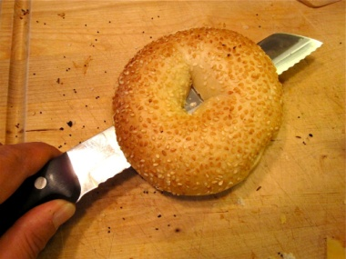

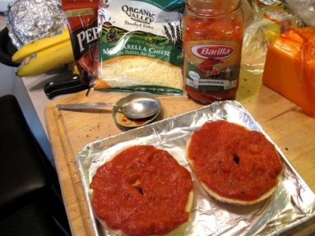

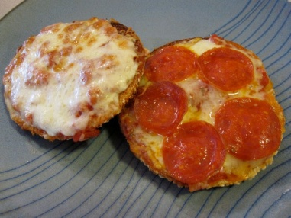

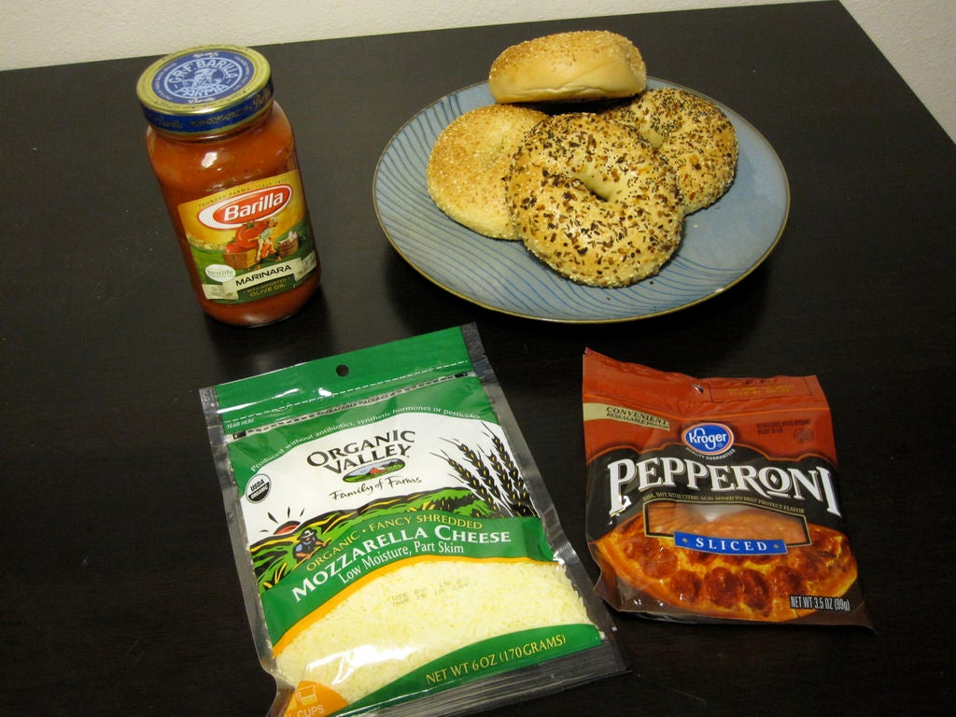

- Arrange the bagel halves on a
baking tray lined with parchment. Preheat the grill.

- Spread each bagel half with 1 tbsp of pasta sauce. Sprinkle with cheese. Then lay 2 chorizo halves on each bagel, or 2 small pepperoni slices.

- Place under the grill, about 10cm from the heat, and grill till cheese is melted and turning golden brown.

- Eat and enjoy

