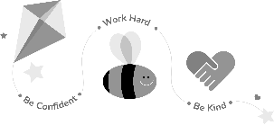
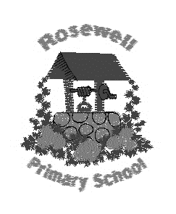
Primary P2/3 Homework
Term 3

Children should complete at least 4 tasks (or more) from the grid.
Tasks with * must be completed.

When you have completed an activity, tick it off and date it.
This grid is due back into school by Monday 30th March 2020.
*Be a researcher  We have been thinking about hot and cold climates as part of our Snail and the Whale learning. Choose an animal from a hot or cold climate. Can you research 5 (or more!) interesting facts about the animal.  Prepare a short talk to present your research to the class. You may want to use drawings or pictures to add to your presentation. | Be a mathematician  We have been thinking about time in class.  Can you create a timetable for your day.  What time do you start school? Eat lunch? Go to bed? Use what you know about o’clock, half past and quarter past to create analogue or digital clocks to label your timetable.  You can illustrate your daily timetable too!
Be a calligrapher  We have been practising cursive handwriting in class. Can you write your name in cursive handwriting?  Practise writing the names of family and friends in cursive handwriting too. | *Be a hard worker  One of our school values is to ‘work hard’. We will be completing a whole school display with examples of a time when we have worked hard.  Can you write about a time when you have worked hard? Did working hard make a difference to the outcome?  This can be an in or out of school example of working hard.
*Be resilient  Think about the talents and skills that are special about you. These talents and qualities are part of what makes you unique. Use the attached body outline to decorate and illustrate all of the skills, talents and abilities you have. Next, add words around the outline to show things that you would like to learn in the future. Finally, ask your grown up to write a positive and encouraging statement about you at the bottom of the sheet. | Be a reader  Continue the First Minister’s Reading Challenge (FMRC).  Record any texts that you have read in your FMRC booklet.  Remember a text can take many forms. It is something you can read, watch or listen to : a book, comics, novels, short stories, magazines, websites, graphic novels, poems, You Tube etc

I am working within the _____________ spelling belt in Rosewell Tricky words.

I am working within the _____________ colour on Maths Basic Facts.

Please also complete your weekly spelling homework by practising the spelling pattern in the suggested ways.

