 | PARADYKES PRIMARY SCHOOL  & FAMILY LEARNING CENTRE  MAYBURN AVENUE  LOANHEAD  MIDLOTHIAN EH20 9HB  Telephone 0131-271 4650  Ms Gillian Reid  Head Teacher

4 August 2020

Dear Parents/Carers,

We are looking forward to seeing the children all back at Paradykes on Wednesday 12th August.

I wanted to inform you that we are delighted for Mrs Louise Ward our Acting PT who has now been appointed at another school in another authority as a DHT. She has been at Paradykes Primary for six years where she has supported all of our families and children but in particular our children with additional needs. She will be sorely missed and we thank her for all her hard work! We wish her well in her career.

This post will be advertised in the following week and we hope to have it filled by the October Holidays.

Mrs J Sommerville, Mrs H Reed and myself will continue to support our additional needs children reintegrating back into the class. If you have any concerns or worries please email the school address or telephone us.

Kind regards

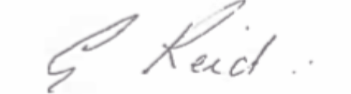

Gillian Reid
Headteacher

