Upcoming National Languages Assessments

Dear Parent/Carer,

I am writing to inform you about the upcoming formal assessments for National 5 and Higher pupils in English over the coming term.

As you know, the SQA have cancelled the formal exams for this year and have outlined an ‘Alternative Certification Model’. This allows schools to decide the best time to assess pupils and to adjust the format of assessments where appropriate to ensure the best outcomes for our pupils. For all languages, this approach allows us to split papers and assess pupils when ready in each component rather than have all the assessments in one sitting.

Evidence for our pupils will be gathered in all 4 skills:
- Talking (Only National 4 learners still have to complete this skill)
- Reading
- Listening
- Writing

While exact dates vary from class to class, the plan in languages is to conduct formal assessments across the month of April, May and into June:

For each assessment, any required support that pupils are entitled to (e.g. use if ICT, extra time etc.) will be in place.

In the run up to each session, pupils will work on the key skills required, including past paper practice. We have offered Easter Revision classes in Spanish and German and Masterclasses are also being offered to support pupils in their revision for each assessment.
In class, ongoing practice will allow us to generate a bank of additional supporting evidence for pupils should we require it.

I appreciate that this is an unusual and concerning time for you and our pupils. I hope the information above has helped ease some of the concerns you may have had.

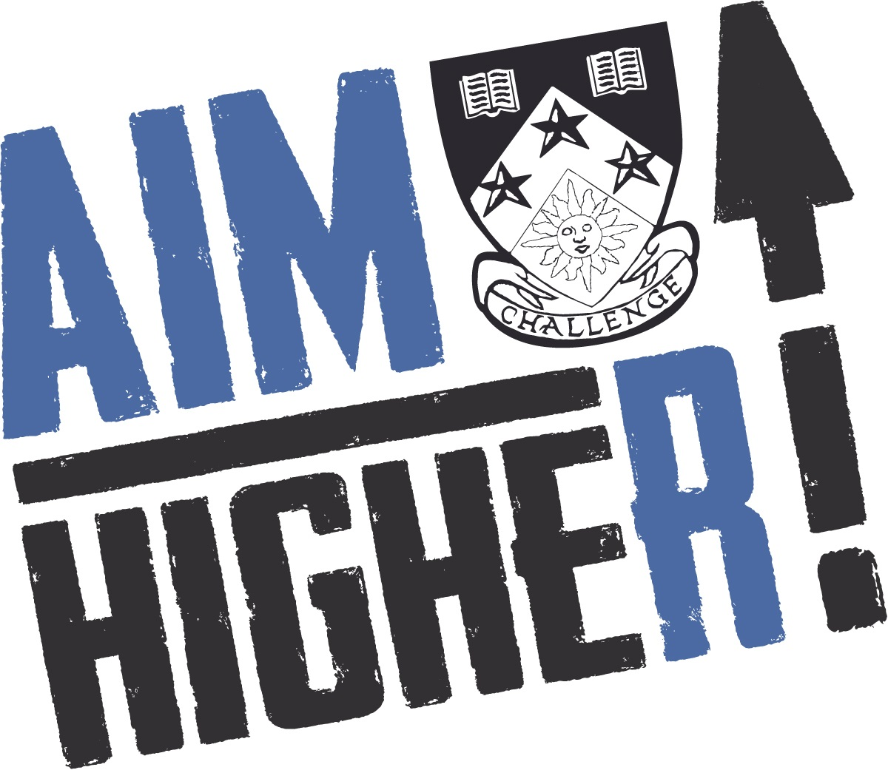
Please do not hesitate to get in touch if you have any questions or would like any of the information above explained further.

Kind regards,

Mylène Leslie
Principal Teacher of Modern Languages
m.leslie@mgfl.net

