Upcoming National 5 and Higher Media Assessments

Dear Parent/Carer,

I am writing to inform you about the upcoming formal assessments for National 5 and Higher pupils in Media over the coming term.

As you know, the SQA have cancelled the formal exams for this year and have outlined an ‘Alternative Certification Model’. This allows schools to decide the best time to assess pupils and to adjust the format of assessments where appropriate to ensure the best outcomes for our pupils. For Media, this approach allows us to split papers and assess pupils when ready in each component rather than have all the assessments in one sitting.

Evidence for our pupils will be gathered from the following key components:
- Assignment - worth 50% of the final grade. Pupils have been working on this both in class and at home since September
- Question Paper - this is a media analysis paper which makes up the other 50% of the course. This paper assesses the following elements:
  - Analysis of previously studied media texts: we have studied ‘Blade Runner’ and ‘Brooklyn Nine-Nine’
  - Analysis of previously unseen print texts: we are studying film posters
  - Role of the media: Higher pupils have focused on Christmas adverts, National 5 pupils have studied Christmas adverts, railway safety posters and ‘Dumb Ways to Die’

The dates for each assessment are outlined below:
- Thursday 29th April - Role of the Media
- Thursday 13th May - Print Analysis
- Thursday 27th May - Analysis of texts studied in class.
For each assessment, any required support that pupils are entitled to (e.g. use if ICT, extra time etc.) will be in place.

In the run up to each session, pupils will work on the key skills required, including past paper practice. We offered Easter Revision classes and Masterclasses are also being offered to support pupils in their revision for each assessment. In class, ongoing practice will allow us to generate a bank of additional supporting evidence for pupils should we require it.

The final date for submission of the assignment is Friday 4th June but please encourage your son/daughter to submit it sooner if they have completed it.

I appreciate that this is an unusual and concerning time for you and our pupils. I hope the information above has helped ease some of the concerns you may have had.

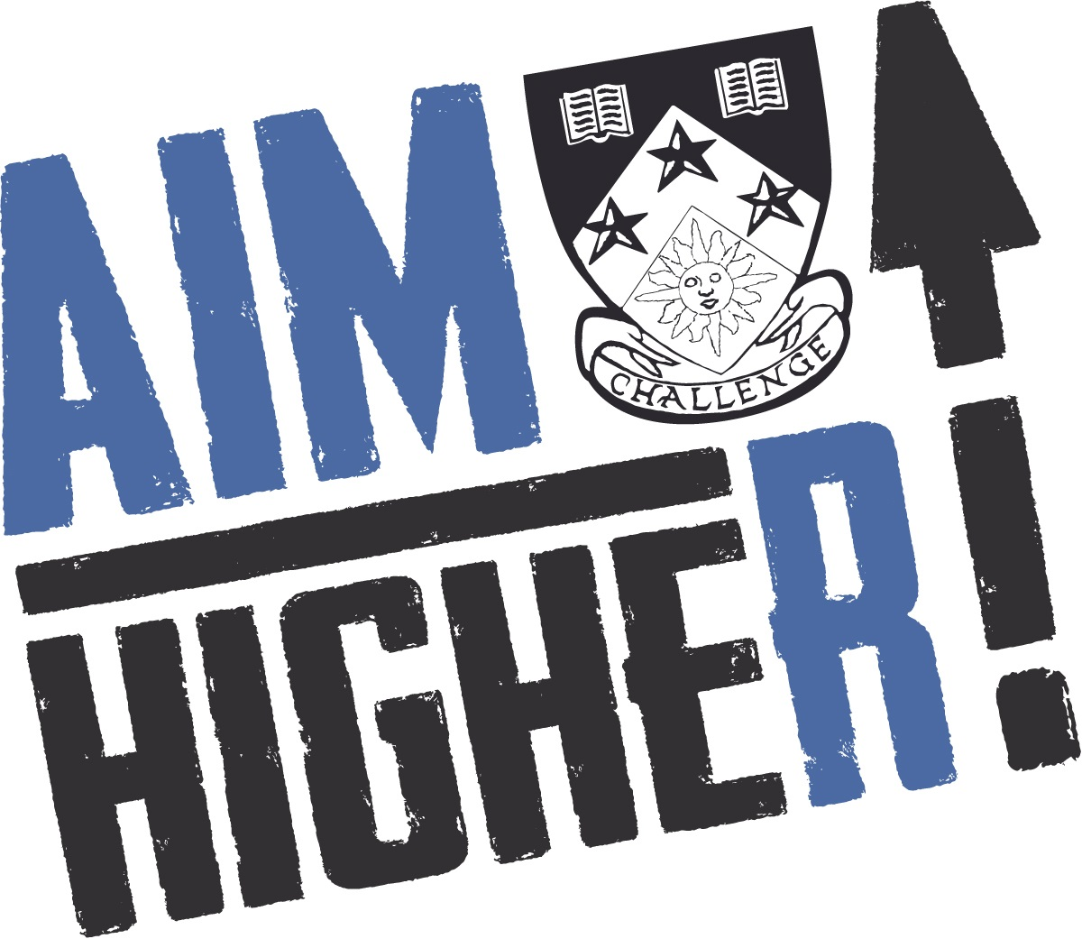
Please do not hesitate to get in touch if you have any questions or would like any of the information above explained further.

Kind regards,
Lisa McKenzie
Principal Teacher of English, Literacy and Media
l.mckenzie@mgfl.net

