11 August 2020

School Return – August 2020

We are very much looking forward to our students returning safely to school. Following two really successful inservice days, staff are excited to help transition and reconnect students back to Newbatttle.

We have to repeat again that to make this a successful return, every student has a responsibility to help keep ourselves and others safe by cooperating. This includes all procedures which have been sent out in the Back to School Booklet on Friday 7th August. Staff will go through this with students during period one of their phased return day. Staff are here to support, care and nurture, but there are also very important messages which we must see from our students from the outset which include:

- all students must help us return to school by following staff instructions first time as well as all of the other guidance
- respecting that everyone has had a different lockdown experience - this includes staff
- regular hand washing and socially distance ourselves where we can
- not to gather and move quickly and directly to the destination
- if students choose to go outside at break/lunch, they must then stay outside until the next lesson starts. Staff will use discretion on very wet days where students must return to their designated base classroom which will be supervised
- be on time - arrive back to school after break/lunch to clean hands and get to the lesson for the start time. Being late will not help the safety procedures and students must take responsibility for this

Taking individual responsibility helps us with our collective responsibility for safety.

Students’ arrival rooms on first day
Please find below where students have to go to when they arrive in school tomorrow, Thursday or Friday. Example here is if your child is in on Wednesday, is in S1 HomeRoom 1.1 then they should go straight to room 231. Staff will be on hand to help with this. S1 students can still use our virtual tour from June to find these rooms. This is on the primary transition tile on our website. 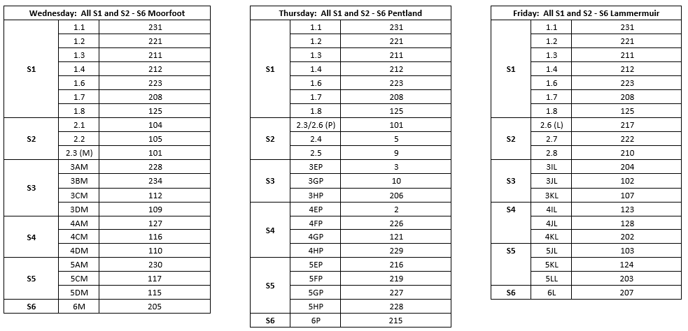

Our Values in Action

Our vision and values place us in a great position to make this return a success together.
Newbattle’s vision encompasses care, nurture, achieving beyond our potential and being ready for our future. Throughout this resilience is key and we show this in abundance.

Our values are below and the bullet points break down into what “I can do”, what “I can do for others” and what “I can do for our community”.

A – ACHIEVE
- I aim beyond my potential.
- I help others see their potential.
- I am ambitious about what we can achieve together.

I – INCLUDE
- I welcome all.
- I look forward to working with everyone.
- I know it’s important to be part of our community.

M – MOTIVATE
- I take every opportunity.
- I encourage others when they need it.
- I make the most of every situation.

R- RESPECT
- I see the best in myself.
- I make others feel valued.
- I show care for our community.

Thank you for what has been a difficult time for us all and your patience has been invaluable. It means a lot to our staff to know that you have supported us throughout and with what is to follow.

Finally before we start the term, staff have worked tirelessly to ensure the best plan is in place and have consulted our Parent Council, Unions, Health and Safety among others throughout. If plans need to change, we will let you know quickly.

We are looking forward to welcoming our students back tomorrow! We have missed our school and are very much looking forward to welcoming all of our students back safely where we will see our values in action once more as a community. #AIMHIGHER.
Newbattle Senior Leadership Team

