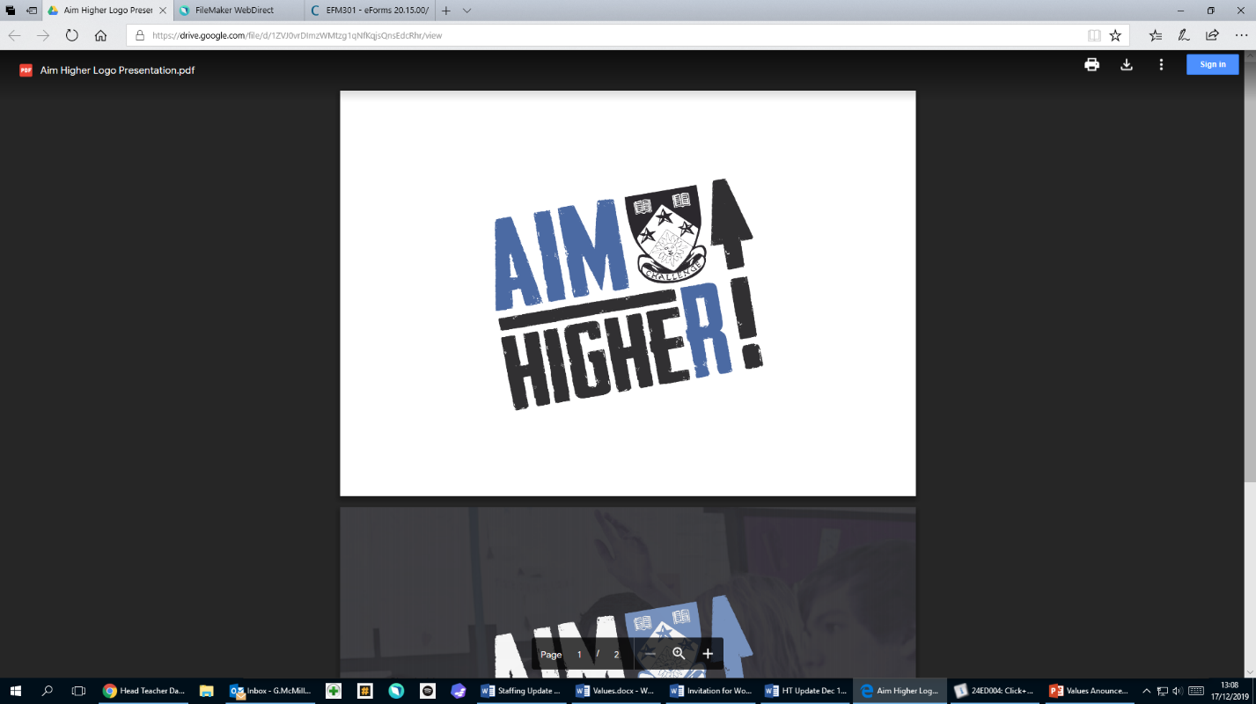****

**Newbattle High School Headteacher Update**

**June 2019**

Dear Parent/Carer,

Thank you for your continued support over the full session. Thank you for continuing learning for our students. It has been tough (I have three kids!), but we appreciate all that you have done.

**Achieve, Include, Motivate and Respect - AIMHIGHER**

We launched our new values before COVID lockdown and never have I seen any values in action more than the last 3 months from all of our community!

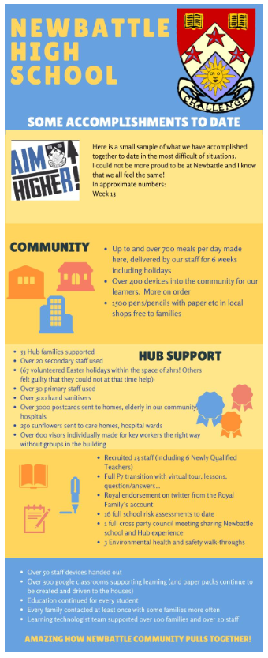

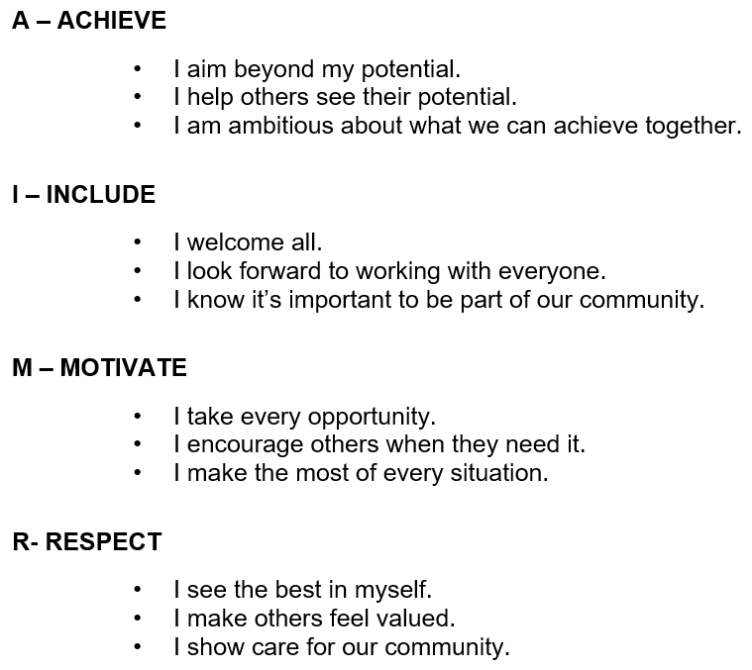

**School Recovery**

After Summer

Current predictions are that we have a full return for all students after summer subject to the Science and rates of infection. More information around this will be given to us all at the end of July after the relevant briefing deadlines through Phase 3 of the Scottish Government’s Route map. We are planning on continuing (and increasing) the number of Masterclasses, study sessions etc to support learning. These may be in school and/or virtual on devices.

Contingency plans and plan B.

Please find attached Midlothian’s Local Phasing Delivery plan which we are in line with. Please be assured that we had a number of contingencies planned ranging from normal full return, 0m with conditions, 1m and 2m social distancing.

The plan, if needed, would be for half the year groups to be in on Monday and Tuesday, the other half Wednesday and Thursday with Friday having identified groups in. This allows the school to have 3 separate groups in limiting cross overs.

If blended learning is required at some stage then we will share the full plan with you in advance. Our model is agile and can to move towards all of our senior phase pupils in school Monday-Friday if staff capacity allows. We would hope to run live lessons, castings and virtual classrooms.

|  |  |  |  |  |
| --- | --- | --- | --- | --- |
| **Monday** | **Tuesday** | **Wednesday** | **Thursday** | **Friday (example only)** |
| Key Worker, Vulnerable and Identified Pupils | | | | |
| *Senior Phase Group 1  Column A | Senior Phase Group 1  Column D | *Senior Phase Group 2  Column A | Senior Phase Group 2  Column D | All Senior Phase Fri Wk 1 - A/B |
| Senior Phase Group 1  Column B | Senior Phase Group 1  Column E | Senior Phase Group 2  Column B | Senior Phase Group 2  Column E | All Senior Phase Fri Wk 2 - C/D |
| Senior Phase Group 1  Column C | Senior Phase Group 1  Column F | Senior Phase Group 2  Column C | Senior Phase Group 2  Column F | All Senior Phase Fri Wk 3 - E/F |
|  |  |  |  |  |
| S1, S2, S3 Group 1 | S1, S2, S3 Group 1 | S1, S2, S3 Group 2 | S1, S2, S3 Group 2 | Targeted pupils |

6 column structure in our Senior Phase

*Senior Phase Group 1 Column A = Senior Phase Column A with half the full senior phase pupils in

*Senior Phase Group 2 Column A = Senior Phase Column A with the other half of the full senior phase pupils in

x3 block day with break and lunch between blocks

If required we would then continue to monitor rooming and staffing capacity across the school in accordance with Local Authority advice and school necessities.  If the capacities allow, the next steps would be:

* Increase the number of days the Senior Phase students are attending school
* Increase the number of days the BGE students are attending school

**S6 and all Leavers**

It is sad not to have had a chance to say a proper farewell to all of our leavers and S6 in particular. We have been proud of this group all year. They have helped embed the new positive ethos in school. They continually went above and beyond helping with school plans, events and encouraging masterclasses. Their voices and suggestions were heard and acted on where we could. Please ask them to stay in touch and we all wish them good luck in their next steps. We look forward to seeing our S6 leavers on 20th November at Prom.

**Staffing Update**

We will again be welcoming a number of new staff to our school this half term.

Non-Teaching Staff

* Mr Cranston – CDT Technician
* Mr Hill – Learning Assistant
* Mr Fodden – Learning Assistant

Teaching Staff;

* Mr Fair has returned from his secondment at the with the South East Improvement Collaborative
* to Depute Head Teacher
* Mr Greig moves to back to PT English and we thank Miss MacKenzie who both acted up brilliantly!
* Miss Docherty – Business Studies
* Mr Balfour – Computing
* Miss McKay stays with us in RME
* Miss MacDonald stays with us in Drama
* Mr Waterhouse stays with us in Music
* Mr Carragher - CDT
* Miss Murray and Mrs Clapperton in Maths are fixed term until Christmas

Newly Qualified Teachers joining us:

* Miss Thoirs – Physics
* Miss Mannion – PE
* Mr Tod – Maths
* Miss Cardle – Art
* Miss Crawford – English
* Miss Mann - Chemistry

**School uniform**

On school return, if normal, our normal school dress code applies as attached at the end here. We have new ties (with a House stripe and our values on them) to hand out free to all pupils. More information closer to August will let you know what the dress code will be. It depends on what the Government announces about COVID.

**Parent Council**

A huge thank you to our parent council who have been a strong link with our plans and suggestions of school return. We appreciate your dedication to helping us. If you would like to join our parent council (help us in some short online meetings), please contact Louise Macleod in our office.

**Parental support**

Here at Newbattle High School we value the support that parents give to the school. The very best schools in Scotland have outstanding partnership working between home and school. It is only when parents and the school work together that we can ensure the very best outcomes for young people, whether that be high level attainment in exam qualifications, ensuring young people develop the skills and qualities to be effective members of society or supporting young people to move on to sustained positive destinations.

**House Points**

Congratulations to…PENTLAND! They are this year’s champions having just pipped Lammermuir and Moorfoot. This was our first year of promoting our new House competitions. Well done to all in Pentland. Miss Craig, Mrs Miller and Mr Burgess are proud.

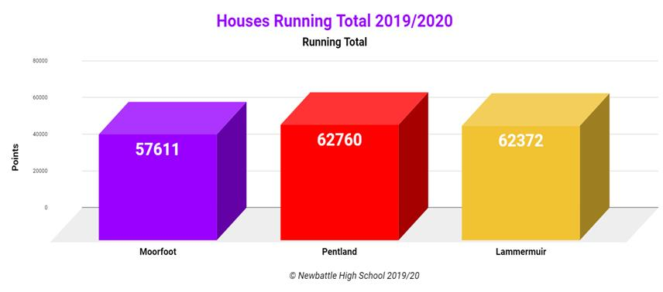

**New Qualifications**

Our award winning curriculum continues to deliver results for senior phase students and we are hopeful for August’s certification by SQA proving a huge increase. For example, this year will see 172 pupils achieve qualifications in our 13 new courses with almost all at level 5 and 6.

**Holidays**

All staff here have been asked to take their holiday and rest over summer having worked above and beyond since February (and through their holidays) preparing for our Inspection and then lockdown planning. We will be back in touch with parent/carers from late July after the numerous announcements on COVID progress, advance notice on SQA, coursing, school calendar year of events, improvement plan etc.

Please take care over summer, we have missed the students and are excited to welcome them back safely in the new session.

***Gib McMillan***

***Headteacher***

School Dress Code 2020 – 2019

# S1 – S3 (Broad General Education)

# S4 – S6 (Senior Phase)

# 

# White self coloured collared shirt and Newbattle tie (given free on first day)

# Black trousers or skirt

Black, un-faded jeans will be accepted but cottons and leggings are not acceptable.

# Black footwear

# Black self coloured jumper or cardigan may be worn

**S4 – S6 (Senior Prefects)**

# As above, but a blazer will be provided

**Please note...**

* Articles of clothing with logos other than the Newbattle crest are not acceptable
* Decisions on compliance with the dress code will be taken by Homeroom Teachers, House Teams, Pupil Care and Welfare Officers, duty support and Leadership staff daily and will involve parents/carers as appropriate
* Uniform may be borrowed, but must be handed back. When not handed back, this is an extra cost to the school out of your child’s learning
* All pupils are expected to bring a schoolbag, the required books and basic stationery to school each day

***Students who have PE during the day should come to school in their uniform and change for PE; they should change back into school uniform after PE***.

**Newbattle HS thank you very much for keeping our standards high and taking pride in our school.**

