Newbattle High School
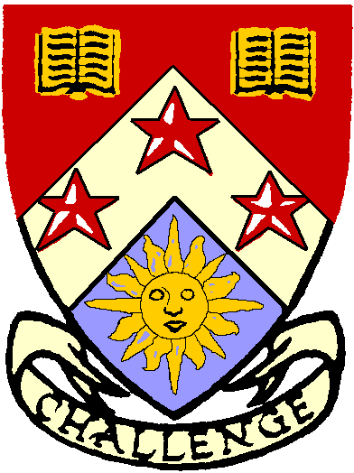

School Dress Code 2019 - 2020

S1 – S3 (Broad General Education)

White self coloured collared shirt and NCHS striped tie

Black trousers or skirt
Black, un-faded jeans will be accepted but cottons (Leggings) not acceptable.

Black footwear

Black self coloured jumper or cardigan may be worn

S4 – S6 (Senior Phase)

White self coloured collared shirt and NCHS crested tie

Black trousers or skirt
Black, un-faded jeans will be accepted, cottons (Leggings) are not acceptable.

Black footwear

Black self coloured jumper or cardigan may be worn

S4 – S6 (Senior Prefects)

As above, but a blazer will be provided

Please note...

- Articles of clothing with logos other than the NCHS crest are not acceptable
- Decisions on compliance with the dress code will be taken by Homeroom Teachers, House Teams, Pupil Care and Welfare Officers, duty support and Leadership staff daily and will involve parents/carers as appropriate
- Uniform may be borrowed, but must be handed back. When not handed back, this is an extra cost to the school out of your child’s learning
- All pupils are expected to bring a schoolbag, the required books and basic stationery to school each day

Newbattle HS thank you very much for keeping our standards high and taking pride in our school.

