Mayfield Sports Day!
Hello everyone and welcome to Mayfield Sports Day!
This year our Sports Day will look a little different but we hope you can still have some fun and take part.
Taking Part:
Have the activities sheet to hand or in view. It follows after this page. It explains all the activities.
Either print off the pupil record sheet, edit it on a laptop or tablet or copy it out onto your own piece of paper.
You will find this in the activities section on Seesaw on Thursday morning, but it is also attached at the end of this document as well.
Gather the equipment you need.
This equipment is everything you need for all the events so that you can be prepared
- A stopwatch/timer (most likely phone or tablet)
- A toilet roll
- Small ball or rolled up ball socks – the socks can be used as a replacement for many of the activities
- Football or larger ball
- Rolled up towel
- Tennis Ball or equivalent
- Large bucket or large cooking pot or empty plant pot.
- Wooden/Metal Spoon
- Hard-boiled egg or small ball (ping pong/golf ball)

Decide what space you are going to do the events in. These can be in the house/flat, garden, safe place on your pavement outside (with an adult). You don’t need too much space for any of the events.
You can work through them in any order and take as many breaks as you need between events.
After you have taken part:
Once you have finished all the activities, send your scores back to the ‘Sports Day’ activity on your child’s class within SeeSaw using the pupil record sheet.
Please have all scores uploaded to the activity by Friday 5th June at 12:15 so that we can collate all the scores. The winners will be announced on Monday 8th June by 10am.
Please remember to send in videos and pictures of you having fun – we are missing you and love seeing you taking part!
Remember, Sports Day is all about taking part and having fun so ENJOY!
Grown-ups… we want to see your best efforts as well, you might even get a special mention on our twitter page!

Mr Wilson.

Activities Sheet

Event 1 | Activity | Description | Equipment Needed | Scoring
 | Jumping Jacks | Complete as many jumping jacks as you can in 2 minutes. You can stop and rest whenever you need to. | A clear space  Stopwatch/Timer | 1 point for each jumping jack that you complete. | 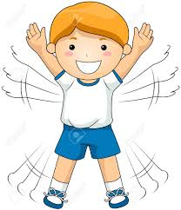

Event 2 | Activity | Description | Equipment Needed | Scoring
 | Speed Bounce | Roll up towel to make a small cylinder shape.  Start with both feet at one side of towel, jump sideways over towel (jump and land with two feet) and back again.  Continue as many times as you can in 30 seconds. | A clear space  Stopwatch/Timer | 1 point for every time you cross the towel. | 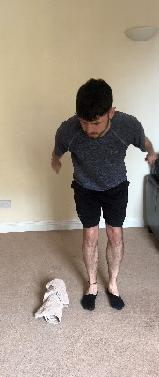  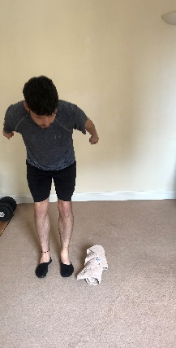

Event 3 | Activity | Description | Equipment Needed | Scoring
 | Bucket Throw | Use a large container (bucket, large cooking pot, empty plant pot).  Make 3 BIG steps away from the bucket.  Count how many times you can throw the ball/socks into it in 2 minutes.  You can have someone behind pot to retrieve ball or socks. | Large bucket/pot/empty plant pot.  A ball or rolled up socks.  Stopwatch/Timer | 1 point for every time you get the socks into the bucket. | 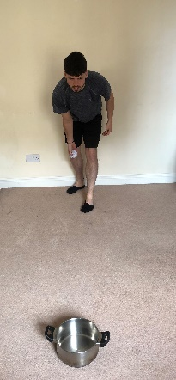

Event 4 | Activity | Description | Equipment Needed | Scoring
 | Throw & Clap | Throw, clap and catch the tennis ball or sock ball as many times as you can in 1 minute.  The ball must go above your head! | Tennis Ball or equivalent  Rolled up ball of socks  Stopwatch/timer. | 1 point for every successful catch. If you drop the ball during an attempt you do not count it as a point. | 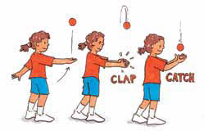

Event 5 | Activity | Description | Equipment Needed | Scoring
 | Toilet Roll Shot Put | Using a toilet roll, see how far you can throw it.  Have a clear start line marked out.  Use a two handed underarm throw (as the demo picture shows).  Measure the distance of your throw with your feet. | Toilet roll.  An object for a start line. | Write down the number of feet between the start line and where the toilet roll first landed (not where it finished) | 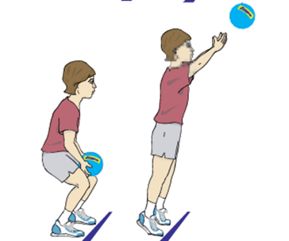

Event 6 | Activity | Description | Equipment Needed | Scoring
 | Egg and Spoon Race | Set out two markers 8 big steps apart.  Walk back and forth between the two markers as many times as you can in 1 minute.  If you drop the egg/ball, pick it back up and continue where you left off e.g 1,2,3 drop, pick it up and start at 4. – you DO NOT need to start again. | Stopwatch/Timer  Wooden/Metal Spoon  Hard-boiled egg or small ball (ping pong/golf ball) | 1 point awarded for every time you get to the marker.  If you drop the egg you do not lose a point - but it will waste some of your time so be very careful with the egg! | 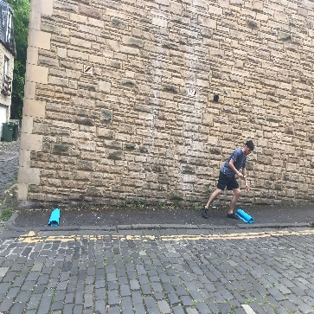

Event 7 | Activity | Description | Equipment Needed | Scoring
 | Around the World | The aim is to pass the ball around your waist as many times as you can in 1 minute.  If you drop the ball, you just continue with your score ie 1,2,3 drop, pick it up and start at 4. You DO NOT need to start from the beginning. | A football (or equivalent)  A cuddly toy can even be used if you do not have other resources. | 1 point awarded for each time you pass the ball/object around your waist without dropping it.

Event 8 | Activity | Description | Equipment Needed | Scoring
 | Stork Balance | Stand with one foot against the inside of your other leg around the knee.  Balance as long as you can! | A clear space  Stopwatch/timer | Scoring is as follows:  Between 1 and 10 seconds = 2pts  Between 11 and 20 seconds = 4pts  Between 21 and 30 seconds =6pts  Between 31 and 40 seconds =8pts  Between 41 and 50 seconds =10pts  51 and over =12pts

Event 9 | Activity | Description | Equipment Needed | Scoring
 | Hockey Static Dribble | Mark two points 1 metre apart get an adult to help judge it or measure with a measuring tape.  Using a spoon, spatula, fish slice move the ball across your body to each point as many times as you can in 30 seconds. | A wooden/metal spoon/spatula/fish slice.  A small ball/pair of rolled up socks.  A stopwatch/timer | 1 point every time you get the ball to one end of the 1 metre line. | 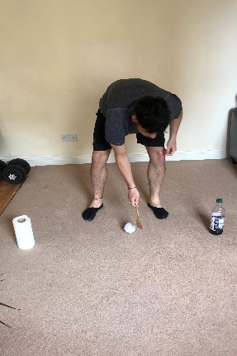

Event 10 | Activity | Description | Equipment Needed | Scoring
 | Toilet roll Keepie-ups | Keep the toilet roll in the air as many times as you can in 1 minute using your feet and legs only.  Every time you drop it just continue your score from where you left off ie 1,2,3 drop, pick it up and start at 4. You DO NOT need to start again from the beginning. | A clear space  A toilet roll  A stopwatch/timer. | 1 point for each for every keepie up. | 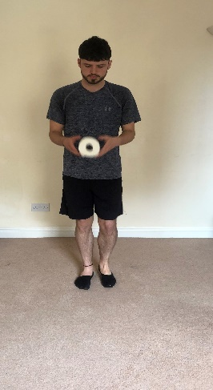

Pupil Record Sheet

Event | Score
- Jumping Jacks
- Speed Bounce

- Bucket Throw

- Throw & Clap

- Toilet Roll Shot Put

- Egg & Spoon Race

- Around the World

- Stork Balance

- Hockey Static Dribble

- Toilet Roll Keepie-Ups

Total Score
(Add all your scores together)

*This is the document you can edit online on Thursday, or you may want to print it off, or, copy it out on paper and send in the photo of your completed scores to Seesaw.

